OSPRI reduces control areas in battle against TB
https://www.farmersweekly.co.nz/news/ospri-reduces-control-areas-in-battle-against-tb/

February 2, 2026
Farms with a change in testing requirements will be notified by letter next month.
OSPRI will adjust its disease control areas on March 1 as it makes progress towards freedom from bovine tuberculosis.
New Zealand is divided into four disease control area (DCA) types, each with different Tb testing frequencies and movement control measures, depending on the risk of Tb being transferred from infected wildlife to cattle and deer.
Simon Andrew, deputy chief executive for strategy and programmes at OSPRI, says reducing Tb movement control areas shows hard work by farmers and OSPRI has continued to pay off. Photo: Supplied

This year specific movement control areas (MCAs) in the Greater Wellington region, Karamea region and the Taramakau/Upper Ahaura region will be removed.
MCAs affecting Marlborough and West Coast’s Mikonui and Tōtara rivers will reduce.
Deputy chief executive for strategy and programmes at OSPRI Simon Andrew said the reduction demonstrates that the programme in those areas is reaching a point where the risk to farmers is reducing.
Ongoing surveillance is still in place across the country in MCAs, he said.
NAIT tagging and registration is key in the fight against Tb, Andrew told Farmers Weekly.
The decision to adjust control areas is made annually in conjunction with OSPRI disease experts, who consider data from surveillance, such as testing on farms and surveillance at slaughter, and pest control, Andrew said.
OSPRI said any farm experiencing a change in testing requirements will be notified by letter next month.
Success in 2025 included another 249,615 hectares declared Tb free, with only 13 Tb-infected herds by the end of 2025.
NAIT stats kept improving, with registration of animals prior to movement at 94%.
Tb testing services became part of OSPRI, saving costs.
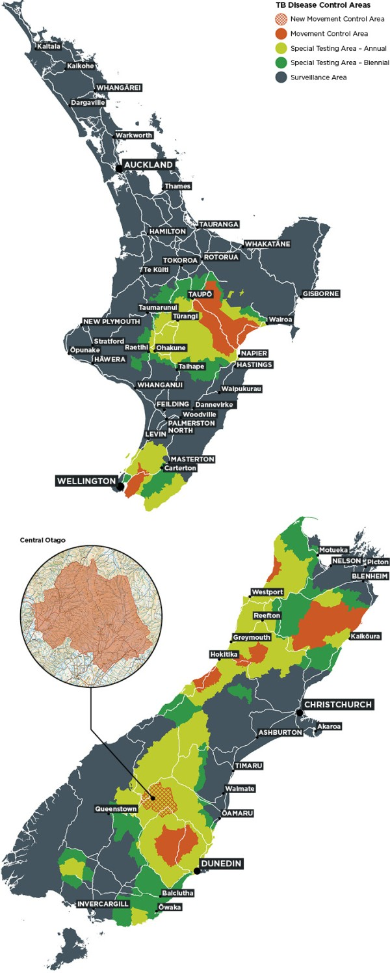
Read the information and answer the questions below.
- What is the main reason OSPRI is reducing some disease control areas (DCAs) and movement control areas (MCAs) in New Zealand?
- Name two regions where MCAs will be removed or reduced.
- Why is NAIT tagging and registration important in the fight against bovine TB?
- How many hectares were declared TB-free in 2025?
- How many TB-infected herds were there at the end of 2025?
- How does OSPRI decide which control areas to adjust?

Answers
- What is the main reason OSPRI is reducing some disease control areas (DCAs) and movement control areas (MCAs) in New Zealand?
  - Because hard work by farmers and OSPRI has reduced the risk of TB, showing progress towards freedom from bovine TB.
- Name two regions where MCAs will be removed or reduced.
  - Greater Wellington, Karamea, Taramakau/Upper Ahaura (any two of these)
  - Also, MCAs affecting Marlborough and West Coast’s Mikonui and Tōtara rivers will reduce.
- Why is NAIT tagging and registration important in the fight against bovine TB?
  - It helps track animals and their movements, which reduces the risk of spreading TB and allows better disease control.
- How many hectares were declared TB-free in 2025?
  - 249,615 hectares.
- How many TB-infected herds were there at the end of 2025?
  - 13 herds.
- How does OSPRI decide which control areas to adjust?
  - By using data from surveillance, including farm testing, slaughter monitoring, and pest control, with advice from OSPRI disease experts.

