Foot and Mouth Disease (FMD)
Watch:
- What you need to know about Foot and Mouth Disease.
- NZ economy could take $10b hit if foot-and-mouth takes hold - Biosecurity NZ | Newshub
Foot and mouth disease (FMD) is a major biosecurity threat to New Zealand. If found here, FMD would have a significant ongoing impact on our agriculture, trade, export and related sectors.
It takes all of us to protect New Zealand from an outbreak of foot and mouth disease. Our best defence is to practise good biosecurity, watch for the signs and respond quickly so we can minimise the risk. This highly contagious disease is easily spread and hard to stop – so prevention and early detection are key.
DairyNZ is working closely with MPI and other industry partners to ensure our policies and procedures are as strong as possible in the event of an outbreak.
Important:
Report suspected foot and mouth disease symptoms immediately to your vet or the MPI pest and disease hotline: 0800 80 99 66. (Tip: Save this number in your phone now in case of an outbreak.)
What is foot and mouth disease?
Foot and mouth disease (FMD) is a highly contagious and infectious viral disease that affects cloven-hooved (two-toed) animals such as cows, sheep, goats and pigs. It is an animal health disease with no significant health impact on humans.
Foot and mouth rarely kills adult animals, but as recovery is often slow and infected animals spread the disease rapidly, quarantine (isolating animals away from others) combined with the slaughter of affected stock is often the only realistic means of control.
Recognise foot and mouth symptoms in cattle
Infected animals are affected differently and may not show all the symptoms.
- Drooling and smacking the lips
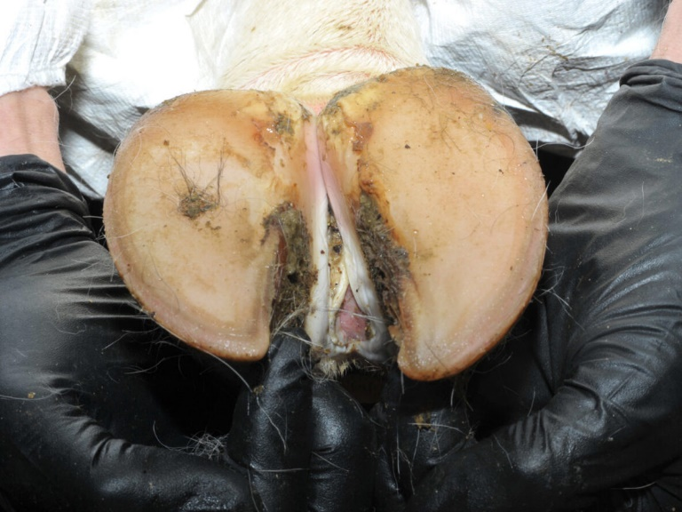
Cow hoof with foot and mouth disease sores.

- Shivering
- Tender feet with sores and blisters
- Raised temperature
- Drop in milk yield and sore teats.
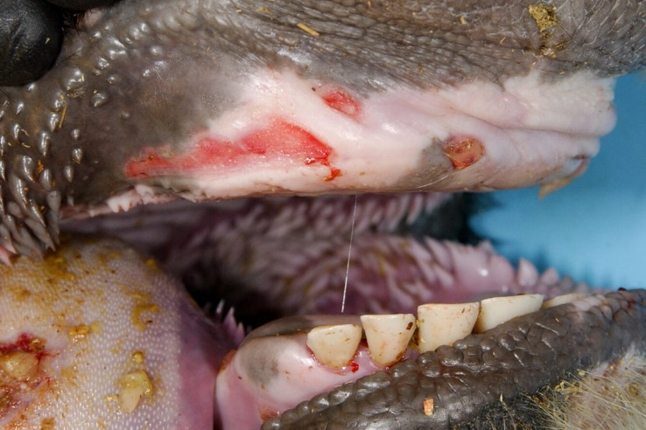
Cow mouth with foot and mouth disease sores.

Read the information on Foot and mouth disease, watch the video then discuss and answer the questions below.
Questions
- What is Foot and Mouth Disease (FMD)?
a) A disease that affects humans
b) A viral disease that affects animals with two toes
c) A plant disease that spreads through soil
- Give two reasons why Foot and Mouth Disease is a serious problem for New Zealand?
- Who should you contact if you think an animal has Foot and Mouth Disease?
- List two symptoms of Foot and Mouth Disease in cattle.
- Why are prevention and early detection important for Foot and Mouth Disease?
Tick the correct answer:
☐ Because it is easy to cure
☐ Because it spreads quickly and is hard to stop
☐ Because it only affects one animal at a time

Read each statement carefully. Write True or False next to each one
- Foot and mouth disease is the largest known biosecurity threat to New Zealand.
- Foot and mouth disease spreads more slowly than most other animal diseases.
- An outbreak of foot and mouth disease would cause New Zealand’s dairy, meat, and pork exports to stop.
- Foot and mouth disease is dangerous to humans and cannot be caught through food.
- Animals such as cattle, sheep, pigs, goats, and deer can get foot and mouth disease.
- Horses, dogs, cats, and birds can also contract foot and mouth disease.
- Foot and mouth disease can spread through animal breath, saliva, milk, and faeces.
- The foot and mouth disease virus can travel long distances through the wind.
- Foot and mouth disease is common in New Zealand and Australia.
- New Zealand uses strict border controls, including detector dogs and screening technology, to reduce the risk of foot and mouth disease.
- Vaccines for foot and mouth disease can be used before the disease is detected in New Zealand.
- Anyone who suspects foot and mouth disease in animals should report it immediately to a vet or the MPI pest and disease hotline.
For more information on FMD
- Read FMD-farm-version-poster
- Read FMD-Fact-Sheet-Sept-2014-PRINT
- Visit DairyNZ and Beef + Lamb NZ
Foot and Mouth Disease – Teacher Answer Sheet
Answers
- What is Foot and Mouth Disease (FMD)?
b) A viral disease that affects animals with two toes
- Give two reasons why Foot and Mouth Disease is a serious problem for New Zealand.
- It would have a big impact on agriculture, trade, and exports.
- It spreads very easily and is hard to stop.
- Who should you contact if you think an animal has Foot and Mouth Disease?
- A vet or the MPI pest and disease hotline (0800 80 99 66).
- List two symptoms of Foot and Mouth Disease in cattle.
- Drooling and smacking the lips
- Sore or tender feet with blisters
(Other correct answers could include shivering, raised temperature, or a drop in milk yield.)
- Why are prevention and early detection important for Foot and Mouth Disease?
☑ Because it spreads quickly and is hard to stop

True or False with explanations
- True
Foot and mouth disease is described as the largest known biosecurity threat to New Zealand.
- False
Foot and mouth disease spreads faster than many other animal diseases.
- True
An outbreak would stop dairy, red meat, and pork exports until the disease was eradicated.
- False
Foot and mouth disease is not considered a risk to human health, and food products are safe for humans.
- True
It affects cloven-hoofed animals such as cattle, sheep, pigs, goats, and deer.
- False
Animals like horses, dogs, cats, and birds cannot get foot and mouth disease.
- True
The virus spreads through breath, saliva, milk, faeces, and animal contact.
- True
The virus can be carried by wind over long distances, especially from piggeries.
- False
New Zealand is free of foot and mouth disease; it is endemic in some overseas countries.
- True
New Zealand uses strict border controls such as screening, inspections, and detector dogs.
- False
Vaccines are only used if foot and mouth disease is detected and must match the virus strain.
- True
Suspected cases must be reported immediately to a vet or the MPI pest and disease hotline.

