Mycoplasma bovis:
Adapted from information from DairyNZ
Mycoplasma bovis, often called M. bovis, is a type of bacteria that affects cattle. It can make cows sick and reduce how well they grow and produce milk. M. bovis does not affect humans, but it is a serious animal health issue for New Zealand farms.
The disease spreads when cattle are in close contact with each other, through contaminated equipment, or when calves drink infected milk. Because it spreads easily, farmers need to practise good biosecurity to protect their animals.
M. bovis can cause several health problems in cattle. These include untreatable mastitis, severe pneumonia in calves, and ear infections that may start with one droopy ear. It can also cause abortions or weak calves, as well as swollen joints and lameness, which can make it painful for cattle to walk.
The first case of M. bovis in New Zealand was found in 2017. In 2018, the government and farming organisations decided to work together to eradicate the disease. This led to the creation of the Mycoplasma bovis Eradication Programme, which aims to remove the disease from New Zealand over time.
Today, the programme is managed by OSPRI, with support from the farming industry and the government. Farmers whose herds are affected can receive support and financial help.
By spotting symptoms early and following good biosecurity practices, farmers and communities can help protect animal health and New Zealand’s farming future.
Visit the OSPRI Mycoplasma bovis info hub for the latest updates and information.
For more information read the mycoplasma-bovis-what-to-look-out-for-a3-poster-updated-2019
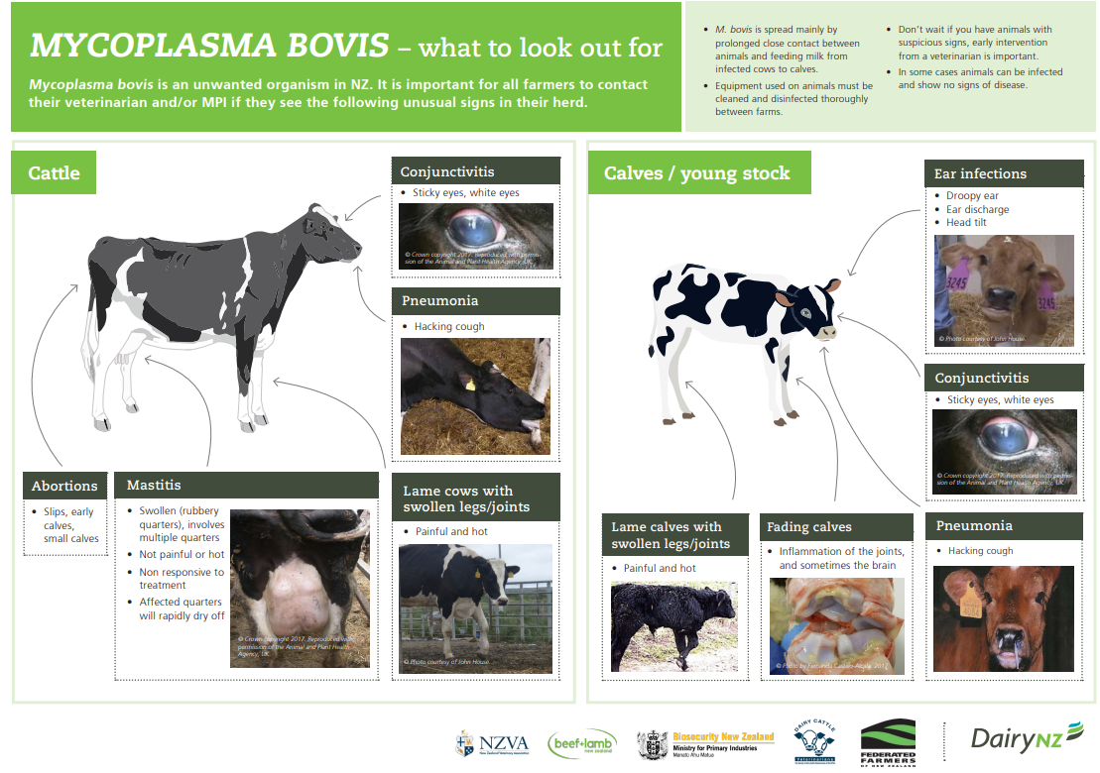
- Draw a line to match each word with the correct meaning.
Word | Meaning
Bacteria | A serious lung infection that makes breathing difficult.
Cattle | How well animals grow, produce milk, or perform.
Mastitis | Made unsafe by contact with germs or disease.
Pneumonia | Farm animals such as cows and calves.
Eradicate | A planned effort to remove a disease from a country.
Contaminated | A painful infection of the udder that affects milk production.
Productivity | To completely remove or destroy something.
Eradication Programme | Very small living organisms that can cause disease.

- Using the words in the box fill in the blanks to complete the summary on Mycoplasma bovis
cattle, swollen, pneumonia, biosecurity, contaminated, infected,
close, mastitis, Eradication, bacteria

Mycoplasma bovis, also called M. bovis, is a type of ________ that affects ________. It can spread when animals are in ________ contact, through ________ equipment, or when calves drink ________ milk.
The disease can cause health problems such as ________, ________, ear infections, and sore or ________ joints. These problems can make it hard for cattle to grow and produce milk.
In New Zealand, a special ________ Programme was created to remove Mycoplasma bovis from farms. By using good ________ practices and reporting sickness early, farmers can help protect animals and stop the disease from spreading.

Key Vocabulary – Mycoplasma bovis
Bacteria – Very small living organisms that can cause disease.
Cattle – Farm animals such as cows and calves.
Mastitis – A painful infection of the udder that affects milk production.
Pneumonia – A serious lung infection that makes breathing difficult.
Eradicate – To completely remove or destroy something.
Contaminated – Made unsafe by contact with germs or disease.
Productivity – How well animals grow, produce milk, or perform.
Eradication Programme – A planned effort to remove a disease from a country.

Summary – Answer
Mycoplasma bovis, also called M. bovis, is a type of bacteria that affects cattle. It can spread when animals are in close contact, through contaminated equipment, or when calves drink infected milk.
The disease can cause health problems such as mastitis, pneumonia, ear infections, and sore or swollen joints. These problems can make it hard for cattle to grow and produce milk.
In New Zealand, a special Eradication Programme was created to remove Mycoplasma bovis from farms. By using good biosecurity practices and reporting sickness early, farmers can help protect animals and stop the disease from spreading.

