Clover Root Weevil
White clover is New Zealand’s most important pasture plant, due its nitrogen-fixing abilities. However, since the introduction of the clover root weevil in the 1990s clover productivity has been severely affected in pastures where the pest has established.

Description
Larvae are small creamy grubs. The larvae range from 1-6mm in length and have a brown head. The adult weevil is mahogany-brown in colour, between 4-6 mm long, and has a short blunt nose.
Clover root weevil damage
Clover root weevil grub
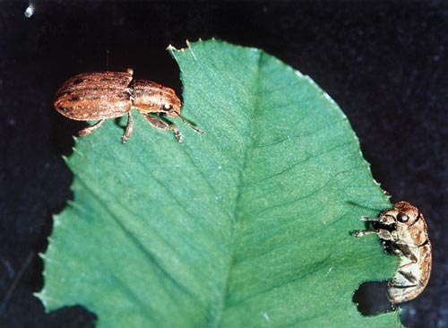

Adult clover root weevil
Adult clover root weevil and
parasitoid wasp.
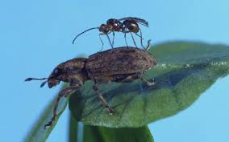
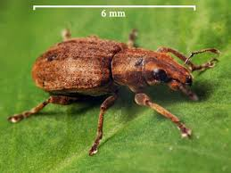

Exercise
- When was the clover root weevil first identified in New Zealand?
- Describe the damage caused by the clover root weevil.
- Explain the impact of clover root weevil on clover dry matter production and how this affects farm productivity.
The best method to reduce clover root weevil is by using a biological control which is a parasitoid wasp.
- Explain how this wasp helps to control clover root weevil.
- Select a pasture or crop pest that is a significant problem in a local farming system you have studied.
- Describe the damaged caused by the pest.
- Discuss how the pest is pest controlled to minimise the impact on the pasture and farm financial returns.

