Fall Armyworm in New Zealand
Adapted from
Information on MPI and Rise in Fall Armyworm Numbers
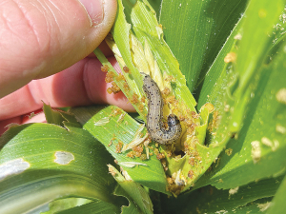
Fall Armyworm in New Zealand
Fall armyworm is an invasive insect pest that was first found in New Zealand in February 2022. It is not native to New Zealand and is a threat to our crops, especially maize and sweetcorn.
Fall armyworm is a moth when it is an adult, but the larvae (caterpillars) cause damage by eating plants. They can feed on over 350 different plant types. Adult moths can fly hundreds of kilometres on the wind, which is how they likely arrived from Australia.
Fall armyworm is a biosecurity risk because it damages food crops, can spread quickly, is hard and expensive to control and can affect farmers’ income and New Zealand’s economy
Biosecurity New Zealand and industry groups tried to stop the pest spreading and remove it. They set traps, monitored crops, and studied how the pest behaved. By April 2023, it was clear that fall armyworm was too widespread to eradicate.
Fall armyworm is now managed through long-term biosecurity management. Farmers and growers scout their crops regularly to look for damage. They use natural predators and only use chemicals when damage reaches a level that could cause big losses
Even though fall armyworm is now established in New Zealand, good biosecurity helps reduce its impact. Early detection, sharing information, and careful management help protect crops, farmers’ jobs and income and New Zealand’s reputation for safe, high-quality food.
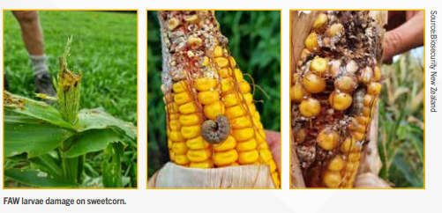
More information on Fall Armyworm Field Guide

Matching Activity: Fall Armyworm Vocabulary
Instructions
Draw a line to match each word in Column A with the correct meaning in Column B.
Words | Meanings
Fall armyworm | Plants grown for food
Invasive | An insect that damages crops
Pest | To move into new areas
Larvae | Protecting a country from harmful pests and diseases
Crops | Young stage of an insect (caterpillar)
Maize | Corn
Biosecurity | Not native and causes harm
Spread | Animals or insects that eat pests
Eradicate | To completely get rid of something
Scout | To check crops carefully for pests or damage
Natural predators | How a country makes and uses money
Economy | An animal or insect that causes damage

Fall Armyworm in New Zealand
Questions
- What is fall armyworm?
- When was fall armyworm first found in New Zealand?
- Which two crops are especially threatened by fall armyworm?
- How do scientists think fall armyworm arrived in New Zealand?
- Why do the larvae (caterpillars) cause damage to plants?
- What does the word biosecurity mean in this article?
- Give two reasons why fall armyworm is a biosecurity risk for New Zealand.
- What did Biosecurity New Zealand and industry groups do at first to stop fall armyworm?
- Why was fall armyworm not able to be completely eradicated?
- Describe two things’ farmers do to manage fall armyworm now?
- Why is early detection of fall armyworm important?
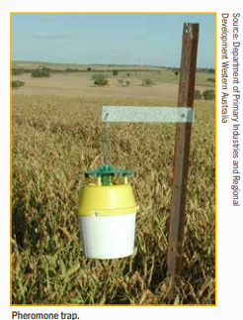
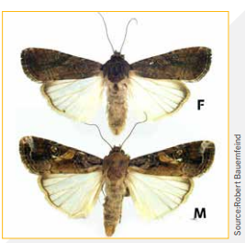
- What could happen if pests like fall armyworm were not managed at all?

Answers: Fall Armyworm in New Zealand
- What is fall armyworm?
Fall armyworm is an invasive insect pest that damages plants and crops.
- When was fall armyworm first found in New Zealand?
Fall armyworm was first found in New Zealand in February 2022.
- Which two crops are especially threatened by fall armyworm?
Maize and sweetcorn are especially threatened.
- How do scientists think fall armyworm arrived in New Zealand?
Scientists think it was blown by the wind from Australia.
- Why do the larvae (caterpillars) cause damage to plants?
The larvae cause damage because they eat the leaves and parts of plants.
- What does the word biosecurity mean in this article?
Biosecurity means protecting New Zealand from harmful pests and diseases.
- Give two reasons why fall armyworm is a biosecurity risk for New Zealand.
  - It damages food crops
  - It spreads quickly and is hard to control
- What did Biosecurity New Zealand and industry groups do at first to stop fall armyworm?
They set traps, monitored crops, and studied the pest to try to stop it spreading.
- Why was fall armyworm not able to be completely eradicated?
It had already spread widely, and more moths could keep arriving on the wind.
- Describe two things’ farmers do to manage fall armyworm now?
- They check (scout) their crops regularly
- They use natural predators and only use chemicals when needed
- Why is early detection of fall armyworm important?
Early detection helps farmers act before the pest causes serious damage.
- What could happen if pests like fall armyworm were not managed at all?
Crops could be badly damaged, farmers could lose money, and New Zealand’s economy could be harmed.

