Grass Grub
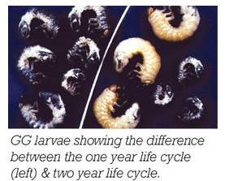
Grass Grub (Costeytra zealandica) is a native insect of New Zealand, which has successfully adapted to feeding on introduced pasture and crop plants. All areas south of Waikato are susceptible to grass grub attack.

LIFE CYCLE AND DAMAGE
Adult Beetles:  These come out of the soil and fly at dusk on mild evenings from October to mid-December.  Females are mated as soon they appear on the surface of the pasture, and lay eggs near there. Beetles feed on leaves of trees, shrubs, brassicas, and pasture plants.
  J | F | M | A | M | J | J | A | S | O | N | D
   |  | Adults
   |  | Eggs
   |  |  |  | Larvae 1
   |  |  |  | Larvae 2
  Larvae 3
   |  | Pupae
Eggs:
These are laid in clusters of 5-50, 8-25cm deep in the soil, throughout the life span of the adult female beetle (2-3 weeks).

Grubs (Larvae):
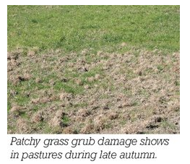
Grubs hatch 16-21 days after eggs are laid. They go through three stages of growth and development. All stages feed on roots, with the second and third gradually eating closer to the ground’s surface. Visible pasture damage occurs from late February until winter. Damaged turf appears as patchy yellowing of the pasture which later develops into extensive brown patches. In autumn, damaged pasture can be lifted and rolled up like carpet.

Pupa:
The fully grown grubs move deeper into the soil and build a earthen cell in the late winter. Pupae are found from late August until October and develop into adults after 4-6 weeks.

CONTROL MEASURES
Insecticides:
Since DDT was banned control of grass grub with insecticides hasn’t been very satisfactory. They are expensive, require a 2-6 week withholding period, are dependent on rainfall and soil type for soaking into the soil, and all except Lindane are ineffective when applied from the air.

Cultivation:
Spring cultivation (September/October) kills a high number of pupae. Autumn cultivation is also effective if the soil’s surface is worked several times.

Winter Treading:
Feeding out hay to cattle on infested pasture in winter helps damaged pasture recover by spreading seeds from the hay. The trampling effect of the cattle kills up to 40% of the grass grubs in the ground.

Plant Tolerance:
Perennial Ryegrass and white clover can be badly affected by Grass grub. Some plants like Tall Fescue, Cocksfoot, and Prairie Grass are more tolerant to grass grub, and so will keep producing feed even if grass grub is a problem.

Nitrogen Fertiliser:
Applying 25kg/hectare of nitrogen fertiliser in autumn or spring to damaged pasture will improve the feed produced, and so reduce the feed lost to the farmer.

Natural Enemies:
These attack grass grub, and include a nematode worm parasite, a bacterium that causes Milky Disease, ground beetles and starlings. Natural enemies don’t kill enough grass grubs to control the pest but could be useful in the future with more research into this “Biological Control”.

Exercise
- What is the effect of grass grub infestation on pasture?
- How would a farmer recognise a grass grub problem?
- Which stage of the life cycle should a farmer aim to target to reduce the grass grub problem?
- Describe the methods that can be used to reduce grass grub infestation.
- Discuss the advantages and disadvantages of each method.
- Farmers use different methods to control grass grub numbers and/or reduce the damage caused by the grub. Two of these methods are pasture renovation using treated seed and the introduction of a biological control. In a badly infected paddock, the farmer decides to renovate the pasture and use treated seed.
- Describe one visible sign that a pasture has a grass grub problem.
- Explain what is meant by biological control.
- Explain why a farmer would select pasture renovation using treated seed to reduce the effect of the grass grub rather than introduce a biological control.

