March of the Armyworm
As a class: Read and discuss the article “March of the armyworm” and do selected activities
Activity 1: Vocabulary
Activity 2: Fact or Opinion?
Activity 3: Comprehension
Activity 4: Persuasive letter

March of the Armyworm Living World ISSUE 183
Written by Gabi Lardies Photographed by Adrian Malloch
Armyworms are ravenous. They decimate crops and will take a thriving vege garden down to stalks overnight. Then they’ll come inside and eat your houseplants. They’ve been in New Zealand a long time but this summer, they boomed—and an even hungrier cousin blew in from over the ditch.
One summer morning near Ruatoria on the East Coast, Doug Lambert wandered across a paddock to little Waiomatatini School, where he was principal. It was the Christmas holidays, but the diesel generator—which also powered his home—had been on the blink. All around, maize rustled on tall stalks, the cobs plump and sweet, ready to be harvested for cattle fodder. The schoolyard was quiet, but as Lambert rounded the buildings, he spotted something he’d never seen before and hasn’t since: an army of caterpillars.
“They were everywhere, hundreds and thousands of them. It was sort of like a biblical crisis.”

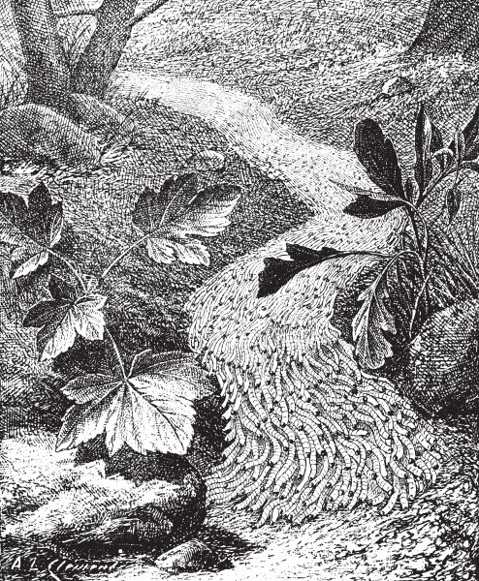
Every now and then, armyworms manage to breed so successfully that they ‘march’, trekking in great numbers as they mow down food source after food source. It’s not a new phenomenon—this illustration was made in 1895—but it’s likely to become more common as the world warms.
The caterpillars, dark green with pale markings and about two centimetres long, were heading northwards. “They looked like an army on the move, but moving at a snail’s pace.” Lambert watched as they crossed the playing field then onto his property, where some attempted to climb his weatherboard house and others headed straight into the chicken run, meeting hens lined up behind the wire netting, ready to gobble them up. The majority, though, headed into the maize paddock next door, “like a plague”.
By the next day, the caterpillars had all passed. Lambert could only imagine they had marched, and munched, right through the night. Amazed by what he’d seen, he called authorities in Gisborne, who knew instantly what he was describing: armyworms. It’s likely these were cosmopolitan armyworm (Mythimna separata), which once regularly wiped-out maize and sweetcorn crops. That same year, 1972, a tiny wasp was introduced from Pakistan to kill the armyworms, and for a while, it felt like we’d mostly won the war against them.
This March, Rhonda and Sam Mojel started nightly patrols of their Auckland vege garden. Tropical armyworms have descended on the plot the Mojels have tended for more than 30 years. Their beds of spinach and kale, which usually produce more than they can eat, were stripped almost bare. For weeks, the couple hunched over in the dark, picking caterpillars off their leafy greens, until Rhonda decided it was enough. Their foe was too numerous, its ranks seemingly endless. “I love insects,” she says, “but this feels like war.”
Liz Heape is a stomper, and she stomps hard. She grows vegetable seedlings in Dargaville, north of Auckland, which she sells to home gardeners. Her pest-control philosophy? “Be brutal. Be a murderer of insects.” Earlier this year, armyworms ate a great many of her seedlings; the only things they didn’t eat were spring onions and leeks. Though Heape stomped on all the caterpillars she found, more kept appearing—and eating.
Further north, Bells Produce grows kūmara, citrus, maize and other crops on 351 hectares of prime land in Pukepoto, Kaitaia. Farm manager John Reed has been in horticulture for 40 years, but last January he was caught off guard. “We went out to the maize crop, and it was just literally crawling—it was just like a plague.” Armyworms, which had not been a problem for decades, had been multiplying under the frost cloth.

“They look evil,” says Sam Mojel of the armyworms. He may be biased: this summer, the caterpillars destroyed much of the garden he and his wife Rhonda have spent decades tending. The pair took to hunting the pests at night, wearing headtorches.

By the time Reed and his team found the hordes, “it was too late. The damage was done.” They tried spraying, but two days later, more larvae would turn up. The team gave up on that block, then relaxed a little as the winter chill seemed to see off the invaders. In October, they peeled back the frost cloth covering their early sweetcorn plants and found caterpillars there. “We were like, ‘Oh shit.’”
Winter is coming
Cold can stop the fall armyworm in its tracks—but many areas are already warm enough for it to survive the winter. These hotspots will act as reservoirs, fuelling the pest’s spread. Where are those hotspots, exactly? Short answer: we’re not sure. And the boundary lines will shift as the climate does.
“It’s going to be more of a pest some years than others,” says Craig Phillips, a senior scientist at AgResearch. “It’s going to be a little bit variable and sporadic, but it is going to be a headache.”
It’s clear that Northland is warm enough for fall armyworm to establish year-round and spread seasonally. In the US, Florida stays warm enough for the pest to overwinter, and from there, reach Canada in summer. Its ability to spread so far “is quite spectacular biology really”, says Phillips. He’s impressed by a statistical model used overseas that works on the basis that if the air stays warmer than 10°C, the fall armyworm will usually truck on through winter. This model predicts that the pest could make it through winters in Auckland northward. There’s also a band around the North Island and the top of the South Island where they will be able to scrape through in warmer winters. This is an area that will expand as the climate warms.
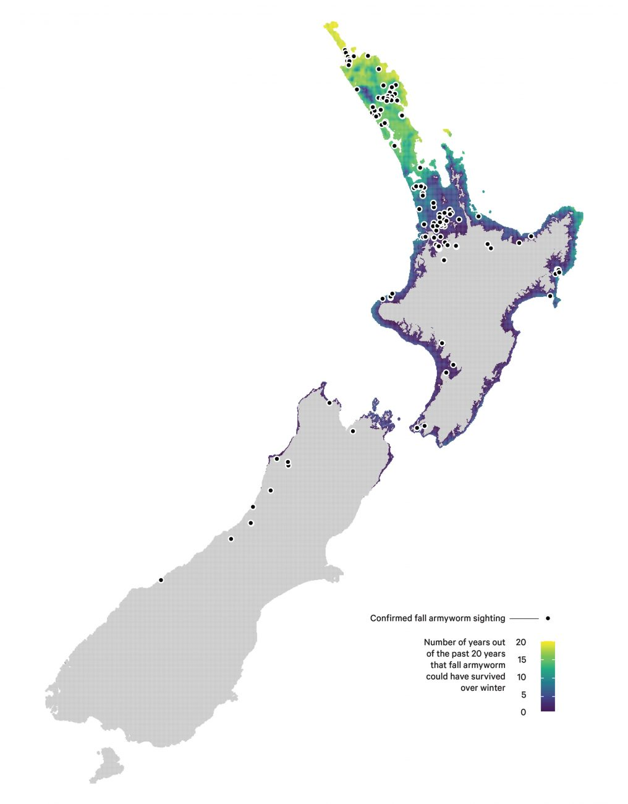
Craig Phillips / AgResearch
Monitoring work happening in Northland and Hokitika this winter will be partly guided by these predictions. Phillips hopes there will also be money for monitoring in places the fall armyworm is not expected to survive; that would let him tweak the temperature threshold on the model and give growers and gardeners an early heads-up of invasions to come.
In Maungatapere, just outside of Whangārei, the Salisbury family runs Old Wheelbarrow Farms, growing all manner of vegetables in long rows protected from the wind by lines of banana trees. On Saturday mornings, they sell carrots, kale, taro leaves and other seasonal produce at the Whangārei Growers Market. They’ve found some armyworms on the farm, but not too much destruction. Dawn Salisbury says to account for bugs eating some of their produce, they grow extra. She sees bugs as part of the ecosystem of the garden and prefers not to spray. The leaves on the table at the market are pristine, being the pick of the bunch.
Murray and Nicci Burns enlisted frogs in their war on caterpillars. In Kauri, north of Whangārei, surrounded by what was once pastoral land and is now lifestyle blocks, they grow all manner of leafy greens in a spray-free, outdoor hydroponic system. In 2022, the couple noticed bright green frogs living in their greenhouse amongst the basil, hunting caterpillars, so when they saw armyworms on their outdoor crops, they popped one adult frog in each net-covered bay. It worked—until Cyclone Gabrielle blew off the nets, the frogs moved on, and a legion of caterpillars proceeded to strip four weeks’ worth of newly planted seedlings. As a result, HydroHealthy has been missing from the Whangārei Growers Market. They’ve had nothing to sell.
This summer, armyworms were once again spotted marching—along footpaths, driveways and even the road. News of their presence has spread through gardening groups and communities, with gardeners at first shocked to find their plots devastated, then frustrated that these caterpillars are such formidable foes. “They’re the worst thing that could have happened,” says Nena Rogers, a gardener in the small community of Ōakura Bay, in Northland. “The worm has just demolished everything.”
Across Northland, armyworms have stripped vege gardens bare, emptied out greenhouses, and made their way indoors, making light work of houseplants. In Whangārei Heads, they’ve laid eggs on the sides of boats, and in Glinks Gully, fluffy egg masses have appeared on houses, washing lines and cars.
The life of an armyworm is tied to heat—the warmer it is, the more they eat and the quicker they reproduce, build up numbers and spread. A warm, wet summer has resurrected an old threat.
There are three types of armyworms in Aotearoa. Cosmopolitan armyworms, which Doug Lambert saw and which are eaten by the introduced wasp; tropical armyworms, which the Northland gardeners and farmers have been battling over the summer; and fall armyworms, which only just got here. Despite the name, they’re actually all caterpillars—and hungry ones at that. They’re notorious crop pests around the world, especially the new arrival.
The fall armyworm’s favourite foods are corn and maize, but it has a taste for a multitude of other plants, depending on what’s available. We don’t yet know what it might eat here, and DOC is worried native plants could be on the menu. Hundreds have been earmarked as potential hosts for the fall armyworm, including kawakawa, tarata, kiekie and kūmara, as well as the endangered ngutukākā. So far, no infestations have been spotted on native plants, but it seems no one has been specifically tasked with looking out for them, either.

One night last March, a tired brown moth flitted around Tauranga, looking for places to lay thousands of eggs. She landed on a slippery green surface, laid a mass of about 200, covered them in furry beige webbing and took off.
On a clear day soon after, a field officer was routinely checking a spongy moth trap. The trap is designed for moths to fly into, but this time, stuck to its outside was a suspicious fluffy splotch—some insect’s audacious “I was here”. The egg mass was sent to a lab to be identified. On March 24, it was confirmed as the calling card of an insect classified as an unwanted organism—one that could “harm New Zealand if [it] arrived”: the fall armyworm.
The fall armyworm has long been waging war in other parts of the world. Its home range is from Argentina to Mexico, where it eats 20 per cent of all maize grown. In the past seven years, it’s invaded almost 50 countries. Not one has been able to eradicate it. In 2020, the caterpillar reached Australia and pinged Biosecurity New Zealand’s radar. Soon, our local farmers were receiving flyers on how to look out for it on their crops.

Activity 1: Vocabulary
Learning objective: Understand and use new scientific and descriptive vocabulary.
Find the following words in the article.
- Use the context to work out their meaning, then write your own definition.

Word | What do you think it means?
decimate
infestation
eradicate
establish
ecosystem
reservoir
invasive
reproduce

- Use each word correctly in a new sentence.
Word | Your sentence
decimate
infestation
eradicate
establish
ecosystem
reservoir
invasive
reproduce

Activity 2: Fact or Opinion?
Learning objective: Identify facts and opinions in an informational text.
Read each statement.
- Decide whether it is a Fact (F) or an Opinion (O). Explain your answer using evidence from the article.
Statement | Fact or Opinion? | Evidence from the article
Armyworms can destroy crops very quickly
"They look evil."
Climate change may increase armyworm outbreaks.
Frogs are the best way to control armyworms.
The fall armyworm is one of the world's most destructive crop pests.
New Zealand should spend more money on monitoring pests

- Write two facts and two opinions of your own about armyworms.
Facts
1
2

Opinions
1
2

Activity 3: Comprehension and critical thinking questions
Learning objective: Read and analyse an informational text to identify key ideas, make inferences, interpret evidence, and evaluate information by answering comprehension and critical thinking questions.
- What are armyworms, and why are they considered a serious pest?
- Describe what Doug Lambert saw near Waiomatatini School in 1972. Why did he compare it to a "biblical crisis"?
- How did armyworms affect the gardens and farms of people such as the Mojels, Liz Heape, and John Reed? Give two examples from the article.
- Why do scientists think armyworm outbreaks may become more common in the future?
- What is the difference between the three types of armyworms found in New Zealand: cosmopolitan, tropical, and fall armyworms?
- How did Murray and Nicci Burns try to control the armyworms without using sprays? Was their method successful? Explain your answer.
- Why are scientists worried about the arrival of the fall armyworm in New Zealand?
- According to the article, what role does temperature play in the life cycle and spread of armyworms?
- Imagine you are a farmer whose crops have been attacked by armyworms. What actions could you take to protect your plants? Use ideas from the article and your own thinking.
- Do you think New Zealand should spend more money on monitoring and controlling invasive pests like the fall armyworm? Explain your opinion using evidence from the article.

Activity 4: Persuasive letter
Learning objective: Write a persuasive argument using evidence from an informational text.
Scenario
The local council is deciding whether to spend more money monitoring and controlling armyworms.
Write a letter (200–250 words) to the mayor explaining your opinion.
Include:
- a clear introduction stating your opinion
- at least three reasons supported by evidence from the article
- facts about how armyworms affect gardens, farms, or native plants
- a conclusion that encourages the council to take action.
Answers
Activity 1: Vocabulary Detective – Sample Answers
- Use the context to work out their meaning, then write your own definition.
Word | What do you think it means?
decimate | To destroy a large part of something.
infestation | A large number of pests invading a place.
eradicate | To completely remove or destroy something harmful.
establish | To become settled and continue living in a place.
ecosystem | A community of living things and their environment.
reservoir | A place where something is stored or continues to exist. In this article, it means an area where armyworms survive and spread from
invasive | A species that spreads into a new area and causes harm.
reproduce | To produce young or offspring.

- Use each word correctly in a new sentence.
Word | Your sentence
decimate | The armyworms decimated the farmer's maize crop in just a few days.
infestation | The gardener discovered an infestation of caterpillars on her spinach plants.
eradicate | Scientists have not been able to eradicate the fall armyworm from invaded countries.
establish | If winters become warmer, fall armyworms may establish permanent populations in northern New Zealand.
ecosystem | Insects, birds, plants, and soil all work together in a healthy ecosystem.
reservoir | Northland could become a reservoir for fall armyworms if they survive the winter.
invasive | The fall armyworm is an invasive pest that threatens crops and native plants.
reproduce | Armyworms reproduce quickly during warm weather, causing their numbers to increase.

Activity 2: Fact or Opinion?
1.
Statement | Fact or Opinion? | Evidence from the article
Armyworms can destroy crops very quickly | Fact | The article describes vegetable gardens being stripped overnight and maize crops being devastated.
"They look evil." | Opinion | This is Sam Mojel's personal view and cannot be proved true or false
Climate change may increase armyworm outbreaks. | Fact | Scientists explain that warmer temperatures help armyworms survive, reproduce, and spread into new areas
Frogs are the best way to control armyworms. | Opinion | The article only describes one successful example. It does not say frogs are the best method.
The fall armyworm is one of the world's most destructive crop pests. | Fact | The article states it has invaded almost 50 countries, damages maize crops, and has not been eradicated where it has spread.
New Zealand should spend more money on monitoring pests | Opinion | This is a recommendation. Different people may agree or disagree.

- Write two facts and two opinions of your own about armyworms.
Facts
1 | There are three types of armyworms found in New Zealand.
2 | Fall armyworms prefer to feed on maize and corn but can eat many other plants.

Opinions
1 | Farmers should receive more government support to control armyworms.
2 | Home gardeners should avoid using chemical sprays whenever possible.

Activity 3: Comprehension
- What are armyworms, and why are they considered a serious pest?
Armyworms are the caterpillar stage of several species of moths. They are called "armyworms" because they sometimes move together in huge groups, or "march," across the land while eating almost every green plant in their path. They are considered serious pests because they can destroy crops, vegetable gardens, and even houseplants in a very short time. Farmers can lose entire fields of maize or sweetcorn, while home gardeners may find that healthy plants have been reduced to bare stalks overnight. Warmer weather allows armyworms to eat more, reproduce faster, and spread further, making them an increasing threat.

- Describe what Doug Lambert saw near Waiomatatini School in 1972. Why did he compare it to a "biblical crisis"?
Doug Lambert saw hundreds of thousands of caterpillars crawling across the school grounds in long lines. The caterpillars were about two centimetres long, dark green with pale markings, and were moving slowly northwards like an army. Some climbed his house, others entered the chicken run where they were eaten by hens, but most marched into a nearby maize field to feed.
He compared the event to a "biblical crisis" because the enormous number of caterpillars looked like a plague, similar to disasters described in the Bible where insects destroyed crops and caused widespread suffering. It was an extraordinary sight that he had never seen before and never saw again.

- How did armyworms affect the gardens and farms of people such as the Mojels, Liz Heape, and John Reed? Give two examples from the article.
Armyworms caused major damage to both home gardens and commercial farms.
- Rhonda and Sam Mojel's vegetable garden in Auckland. The caterpillars stripped their spinach and kale almost completely bare. The couple spent many nights searching for and removing caterpillars with headtorches but, eventually realised there were simply too many to control by hand.
- John Reed's maize farm in Kaitaia. When he discovered the infestation, the maize crop was "literally crawling" with armyworms. The caterpillars had already caused so much damage that spraying was no longer worthwhile. His team had to abandon that crop and later found more caterpillars hiding beneath frost cloth over their sweetcorn.

- Why do scientists think armyworm outbreaks may become more common in the future?
Scientists believe armyworm outbreaks will become more common because of climate change. Armyworms depend on warm temperatures to survive, feed, and reproduce. The warmer the weather, the faster they grow and the more eggs they produce.
As New Zealand's climate becomes warmer, more areas will stay above the temperatures needed for armyworms to survive through winter. Instead of dying out each year, they may establish permanent populations and spread to new regions every spring and summer. Scientists are therefore monitoring where the pests survive so they can warn farmers before outbreaks occur.
- What is the difference between the three types of armyworms found in New Zealand: cosmopolitan, tropical, and fall armyworms?
- Cosmopolitan armyworm has been in New Zealand for many years. It once caused serious damage to maize and sweetcorn crops, but its numbers were reduced after a tiny parasitic wasp was introduced from Pakistan to control it.
- Tropical armyworm caused widespread damage during the recent warm summer, especially in Northland and Auckland. It attacked vegetable gardens, commercial crops, greenhouses, and even houseplants.
- Fall armyworm is the newest arrival. It originally came from the Americas and has spread to many countries around the world. It is considered the greatest threat because it feeds on many different plants, reproduces quickly, and has never been successfully eradicated after invading a new country.

- How did Murray and Nicci Burns try to control the armyworms without using sprays? Was their method successful? Explain your answer.
Murray and Nicci Burns used frogs as a natural form of pest control. They had noticed that bright green frogs living in their greenhouse ate caterpillars, so they placed one adult frog inside each net-covered growing area.
At first, this method worked well because the frogs hunted and ate the armyworms. However, Cyclone Gabrielle blew away the protective nets, allowing the frogs to escape. Without the frogs, the armyworms returned and destroyed four weeks' worth of newly planted seedlings. Therefore, the method was only successful while the frogs remained in the protected growing areas.

- Why are scientists worried about the arrival of the fall armyworm in New Zealand?
Scientists are concerned because fall armyworm is one of the world's most destructive crop pests. It mainly feeds on maize and corn but can also eat hundreds of other plant species. It has spread rapidly across many countries, and no country has been able to completely eliminate it once it became established.
Scientists are also worried that it could begin feeding on native New Zealand plants such as kawakawa, tarata, kiekie, and even endangered species. If this happened, the pest could damage not only farms and gardens but also native ecosystems and biodiversity.

- According to the article, what role does temperature play in the life cycle and spread of armyworms?
Temperature is one of the most important factors affecting armyworms. Warm weather allows them to survive, eat more food, develop faster, and produce more generations each year.
Scientists believe that if winter temperatures remain above about 10°C, fall armyworms can survive until spring. This means warmer regions, especially Northland and Auckland, may become permanent breeding areas. As climate change increases temperatures, armyworms are expected to survive in more places and spread further across New Zealand.

- Imagine you are a farmer whose crops have been attacked by armyworms. What actions could you take to protect your plants? Use ideas from the article and your own thinking.
If my crops were attacked by armyworms, I would inspect my fields regularly so I could find the caterpillars before they became too numerous. I would remove caterpillars by hand where possible and encourage natural predators, such as birds or frogs, to help control them.
I would also work with local agricultural experts to monitor armyworm numbers and use approved pest-control methods if necessary. Covering crops carefully, checking under frost cloth, and reporting unusual infestations would also help.
I would also stay informed about armyworm warnings so I could prepare before large outbreaks occurred.

- Do you think New Zealand should spend more money on monitoring and controlling invasive pests like the fall armyworm? Explain your opinion using evidence from the article.
I believe New Zealand should invest more money in monitoring and controlling invasive pests such as the fall armyworm.
The article shows that armyworms can destroy vegetable gardens, commercial crops, and even threaten native plants. Once the fall armyworm becomes established, it is very difficult or even impossible to eradicate. Monitoring programmes can help scientists detect outbreaks early, allowing farmers to respond before major damage occurs.
Protecting crops also helps ensure food supplies remain reliable and supports farmers' incomes.
Monitoring native plants could prevent damage to New Zealand's unique ecosystems. Although monitoring costs money, it is likely to be much cheaper than dealing with widespread crop losses and environmental damage after the pest has spread.

