Madagascar ragwort
Scientific name: Senecio madagascariensis
Family: Asteraceae
Watch video Protect your place from Madagascar ragwort
https://www.nrc.govt.nz/environment/weed-and-pest-control/pest-control-hub/plant/madagascar-ragwort/
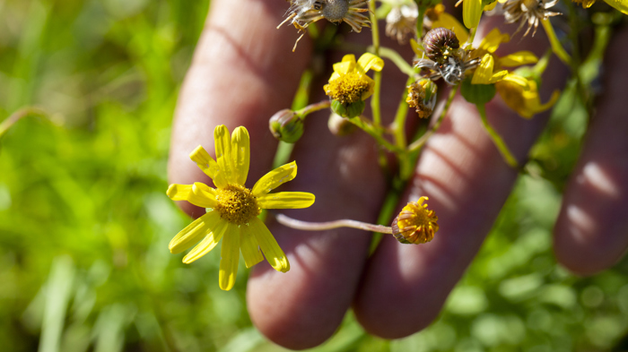
Why is it a pest?
Madagascar ragwort is likely to become the most serious threat to pastoral farming in New Zealand.
A combination of factors mean it is on a different level in terms of its invasiveness and impacts:
- Major impacts on pasture productivity and high direct control and management costs. Documented declines in carcass weights of up to 35%, and 65% losses in milk solids per hectare, where infestations have taken hold.
- Toxic and can be fatal to stock, remaining toxic even in hay or silage, with no treatment available for affected animals.
- Stock avoid grazing near the plant creating a ‘shadow effect’ which contributes to further spread and increasing pasture loss.
- Rapid establishment; a single adult plant can produce 10,000 seeds within 6 weeks of germination.
- Capable of germinating all year round following any warm rain event.
- Difficulty and cost of control; there is no single agrichemical treatment that effectively controls all life stages without damage to beneficial pasture species. Repeated, carefully timed herbicide control, combined with changes to pasture management and pasture improvement are usually required to bring well-established infestations under control.
- Wind dispersed; while most seed drops relatively close to the parent plant, some of the seed can be blown long distances.
- Wide environmental tolerance; evidence from overseas and climate modelling indicate that most of the North Island would be susceptible as well as large areas of the South Island.

Where is it found?
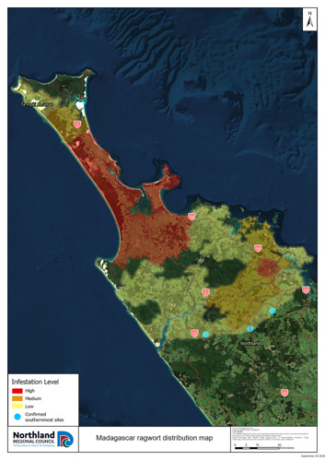
Madagascar ragwort originates from southern Africa and is a major weed in Australia and Hawaii. It is known as ‘fireweed’ in Australia, where it is a Weed of National Significance.
It is currently only known to be in Northland. Madagascar ragwort is currently widespread in the Far North and is spreading rapidly in the mid-north. The current southern edge for confirmed infestations is Pakaraka, Kaikohe and Waima in the Hokianga.
Its distribution is likely to be significantly underestimated. As Madagascar ragwort looks identical to the widespread weed gravel groundsel (Senecio skirrhodon), early invasions into new areas are more likely to go unnoticed.
Evidence from overseas and climate modelling indicate that most of the North Island would be vulnerable to invasion, as well as large areas of the South Island.

What does it look like?
- Produces yellow, daisy-type flowers ,1–2 cm in diameter.
- Each flower has 13–15 petals. Flowers can be present year-round but are most common in autumn and spring.
- Narrow, lance shaped leaves, 2–7 cm long, with finely toothed edges.
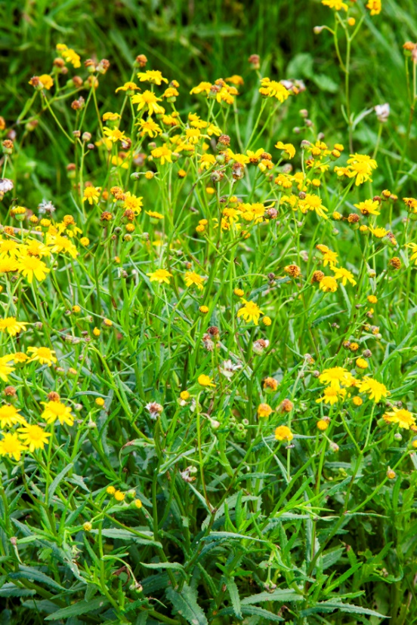
- Leaves are sessile (attached directly to the stem with no obvious stalk) and alternate.
- White, fluffy seedheads. Seeds are small, cylindrical and 2−3 mm long. Each seed has rows of very fine short hairs and a silky pappus (parachute).
- Branching, erect, annual to short-lived perennial herb. Can vary in size and shape depending on environmental conditions

Other similar species
Gravel groundsel (Senecio skirrhoden) is widespread in New Zealand and can look identical to Madagascar ragwort but is more commonly found on roadside and gravelly/sandy areas rather than in pasture. The most reliable way to distinguish the two is the width of the ‘bracts’ around base of the flower head where it attaches to the stalk. Gravel groundsel usually has bracts that are wider than 0.8 mm, whereas Madagascar ragwort has bracts that are 0.8mm or smaller (see pictures). A 10x magnifying glass is usually needed to be able to measure this accurately. The size and shape of the leaves can also be used as an indicator, but these are often unreliable.
From a distance, a paddock of yellow flowering giant buttercup (Ranunculus acris) or creeping butter cup (Ranunculus repens) can look superficially similar to a Madagascar ragwort infestation, but these are easily distinguished by their buttercup-type flower and leaf shape.
Ragwort (Jacobaea vulgaris) has a similar yellow daisy-type flower but has different, more finely divided leaves, and grows as a rosette before becoming a much taller, upright plant.
Madagascar ragwort is also similar to a range of native Senecio species, but these are unlikely to be found in pastures.
How does it spread?
- Wind dispersed. Most seed drops within 100m, but long-range wind dispersal >1km also occurs.
- Hay and baleage and other contaminated fodder crops.
- Stock movements – externally and in gut passage.
- Machinery & vehicles – farm, forestry and other vehicles.
- Contaminated clothing and other equipment.
Control methods
Prevention early detection and intervention is the best way to protect your farm
If you do not already have Madagascar ragwort on your property, preventing a serious infestation from establishing will prevent the worst of the impacts.
- Don’t bring it on to your farm. Good farm biosecurity is essential.
- Ensure your hay and other fodder products are sourced from unaffected areas.
- Ensure any machinery coming on to the farm is clean.
- Utilise a ‘quarantine paddock’ for new stock brought on to the farm. Avoid moving stock from heavily affected areas.
- If you see an unknown yellow flowering plant in or near your pasture, check it out and confirm its identification.
- Ensure everyone on the farm knows what they are looking out for. Carry bags that can be sealed on farm vehicles so that any suspect plants can be carefully bagged then and there.
- If you are unsure of the identification, place a good-sized sample with flowers in a completely sealed bag, and bring it into your local Northland Regional Council office, or to your rural supplies Technical Advisor or farm consultant. Be very careful not to disturb seed heads or spread seeds when transporting it.
Physical control
Hand weeding (pulling or grubbing) can be highly effective when done early in newly infested paddocks with few plants. It needs to be done regularly to prevent plants seeding, or the seed bank and infestation size can quickly become unmanageable.
- Pull carefully so they don’t snap off at the roots, ideally while they are young and before seed forms.
- Plants should be bagged with care taken not to disturb seedheads.
- If done poorly (when plants are seeding) it can spread seed further.
- Carry a bag with you on farm vehicles.
- Plants can be burnt but do not burn in domestic fireplaces due to toxicity.
- When there is a large infestation hand weeding becomes less effective as these paddocks would already have established a seedbank.
Manual control options for large infestations are limited and can carry significant risk of worsening the issue if done poorly. Cut plant material also becomes more palatable to stock but remains toxic and so require withholding periods to avoid stock deaths. In addition, pruned plants can become woody and more resistant to herbicides.
Cultivation and soil disturbance triggers germination in pastures and can rapidly worsen infestation levels so is generally not recommended. As part of a carefully managed herbicide control programme, it could be used to deplete seedbanks.
The AgResearch report ‘Review of current control methodologies of Madagascar ragwort and control trial design ’ provides more information on different manual control approaches as well as discussion on other pasture renewal and cropping considerations.
Chemical control
Despite considerable trial work overseas there is no single agrichemical control method that effectively controls all life stages without impacting on desirable pasture species. Different approaches are required depending on the age of the plants, and the size and density of the infestation and seedbank.
A large, well-established infestation will require a sustained and ongoing programme that is carefully timed around germination peaks, uses a rotation of chemical options, and is integrated with pasture management. Trials to refine and improve control methodologies are ongoing.
The table below summarises the agrichemical methods most commonly in use in New Zealand for Madagascar ragwort control, their efficacy on the different life stages and impact on pasture. Application rates are not included here due to off-label considerations; please speak with your rural supplier’s Technical Advisor or contact Northland Regional Council’s Pest Plant Biosecurity team for advice on your specific situation and application rates.
Further information on other agrichemical control options can also be found in the AgResearch report 'Review of current control methodologies of Madagascar ragwort and control trial design' .
General principles:
- Seedlings and younger plants are far easier to kill than larger plants. Woody adult plants and flowering plants are the most difficult to kill.
- Young plants can be boom sprayed with several options including 2,4-D based mixtures.
- Some of the recommended products and mixtures will damage clover, and some will also impact grass.
- Adult plants need to be spot sprayed with harsher chemicals that will also damage clovers and sometimes grasses.
- For well-established infestations it may be more beneficial to trade-off damage to desirable pasture species in the short-term to more rapidly bring an infestation under control and protect other unaffected parts of the farm.
- Control programmes should be timed around germination peaks to target newly germinated seedling and juvenile plants while they are more susceptible and before they set seed. The main peak is usually in autumn, following the first rains, but can occur throughout most of the year, especially after warm rain events. Plants will usually flower 6 to 8 weeks after germination.
- Sprayed plants can take time to die; do not graze until completely dead and browned off to reduce the risk of poisoning stock.
- To prevent resistance from evolving, unrelated chemical groups with different modes of action should be rotated between and other forms of non-chemical management should be used to drive down the weed seed bank.
- The approach taken needs to be specific to your situation. Please speak with your Rural suppliers, technical advisor or farm consultant or contact the Pest Plant Biosecurity team at Northland Regional Council.
* Clover damage can vary greatly depending on clover growth, time of year and herbicide formulation. Please read the label or talk to your rural supplier’s Technical Advisor for advice.
Pasture and grazing management
Madagascar ragwort grows in all types of soils but has a competitive advantage in low fertility soils and pasture damaged by drought or overgrazing.
- Rotational grazing is more effective than continuous grazing.
- Minimise soil disturbance as this provides an avenue for seedlings to germination and establish.
- Sheep and goats can graze Madagascar ragwort – they are about ten times less susceptible to its toxins than cattle, however they can still be impacted by prolonged or high levels of exposure and milk can be affected.
- Cattle and horses are extremely susceptible to Madagascar ragwort poisoning. While cattle learn to avoid the plant, poisoning can still occur especially when plants are young and stock are unfamiliar with the weed, when it is in contaminated hay, or following control operations when cut or chemically treated material becomes more palatable.
Biocontrol
Biocontrol research on Madagascar ragwort has been underway in Australia for a significant period; however no suitable agents have been identified to date. A Biocontrol feasibility study for New Zealand was commissioned in 2022 which outlines the next steps for research, which includes genetic analysis to identify the original source population for the Madagascar ragwort in New Zealand, and further surveys in the native range to identify potential agents. Northland Regional Council is funding the genetic analysis as the first step in this process.
Where successful, biocontrol can be a highly effective tool for combatting hard-to-manage species. The best example of this is the common ragwort people are familiar with (Jacobaea vulgaris); this pasture pest had a major impact on farming operations up until the successful establishment and spread of biocontrol agents.

Questions
- Why is Madagascar ragwort considered a major threat to pastoral farming in New Zealand?
- What economic impacts can infestations of Madagascar ragwort have on farm production?
- Explain why Madagascar ragwort is especially dangerous to livestock.
- What is meant by the “shadow effect” created by this plant?
- Describe how quickly Madagascar ragwort can reproduce and why this makes it difficult to control.
- Where is Madagascar ragwort currently found in New Zealand, and why might its distribution be underestimated?
- Identify three key physical features used to recognise Madagascar ragwort.
- How can Madagascar ragwort be distinguished from gravel groundsel (Senecio skirrhodon)?
- List four different ways Madagascar ragwort seeds can spread.
- Why is early detection and prevention considered the most effective management strategy?
- What challenges are associated with chemical control of Madagascar ragwort?
- How can pasture and grazing management help reduce the spread and impact of this weed?

Activity: Problem solving
Scenario:
You are a farmer who has just found a small patch of Madagascar ragwort in one paddock.
Task:
In groups discuss the problem and possible solutions. Then write a short plan explaining:
- What you would do immediately
- How you would stop it spreading
- What long-term actions you would take
Samples answers
- Why is Madagascar ragwort considered a major threat to pastoral farming in New Zealand?
Madagascar ragwort is a major threat because it spreads quickly, reduces pasture productivity, and is very difficult and expensive to control. It can grow in many environments and produce large numbers of seeds, allowing it to invade farmland rapidly. Its presence also lowers the amount of usable pasture for livestock.

- What economic impacts can infestations of Madagascar ragwort have on farm production?
Infestations can significantly reduce farm income by lowering animal productivity. For example, carcass weights can drop by up to 35%, and milk production can decrease by up to 65% per hectare. Farmers also face high costs for controlling the weed and restoring damaged pasture.

- Explain why Madagascar ragwort is especially dangerous to livestock.
The plant is highly toxic and can be fatal to livestock such as cattle and horses. It remains poisonous even when dried in hay or silage, making it hard to avoid. There is no effective treatment once animals are poisoned, which increases the risk to farm animals.

- What is meant by the “shadow effect” created by this plant?
The “shadow effect” refers to the way livestock avoid grazing near Madagascar ragwort because it is toxic. This leaves surrounding pasture uneaten, allowing the plant to spread further and reducing the overall usable grazing area.

- Describe how quickly Madagascar ragwort can reproduce and why this makes it difficult to control.
A single plant can produce up to 10,000 seeds within six weeks of germination. These seeds can germinate year-round, especially after warm rain. This rapid reproduction creates a large seed bank in the soil, making it very difficult to eliminate once established.

- Where is Madagascar ragwort currently found in New Zealand, and why might its distribution be underestimated?
It is currently found in Northland, especially in the Far North and mid-north areas. Its distribution may be underestimated because it looks very similar to gravel groundsel, a common plant, so early infestations can be easily overlooked.

- Identify three key physical features used to recognise Madagascar ragwort.
Key features include small yellow daisy-like flowers with 13–15 petals, narrow lance-shaped leaves with toothed edges, and white fluffy seed heads that help the seeds spread in the wind.

- How can Madagascar ragwort be distinguished from gravel groundsel (Senecio skirrhodon)?
The main difference is the width of the bracts at the base of the flower head. Madagascar ragwort has narrower bracts (0.8 mm or less), while gravel groundsel has wider ones. A magnifying glass is often needed to see this clearly. Habitat can also help, as gravel groundsel is more common in sandy or roadside areas.

- List four different ways Madagascar ragwort seeds can spread.
Seeds can spread by
- wind
- contaminated hay or fodder
- livestock movement (on their bodies or through digestion),
- machinery or vehicles.
- carried on clothing and equipment.

- Why is early detection and prevention considered the most effective management strategy?
Early detection allows farmers to remove plants before they produce seeds, preventing large infestations. Once the weed is established, it becomes much harder and more expensive to control due to the large number of seeds in the soil.

- What challenges are associated with chemical control of Madagascar ragwort?
There is no single herbicide that effectively controls all stages of the plant without damaging desirable pasture species. Different chemicals are needed for different growth stages, and repeated applications are required. Some herbicides can also harm clover and grass, making management more complex.

- How can pasture and grazing management help reduce the spread and impact of this weed?
Maintaining healthy, dense pasture reduces the chances of the weed establishing. Rotational grazing helps prevent overgrazing and soil damage, which create conditions for the plant to grow. Minimising soil disturbance also reduces seed germination, and using less-sensitive animals like sheep or goats can help manage the weed.

