Madagascar ragwort adapted version
This summary is adapted from the full article
Scientific name: Senecio madagascariensis
Family: Daisy family - Asteraceae
Watch video Protect your place from Madagascar ragwort
https://www.nrc.govt.nz/environment/weed-and-pest-control/pest-control-hub/plant/madagascar-ragwort/
Madagascar ragwort is dangerous, fast-spreading, and difficult to control, so early detection and prevention are the most important ways to stop it spreading.
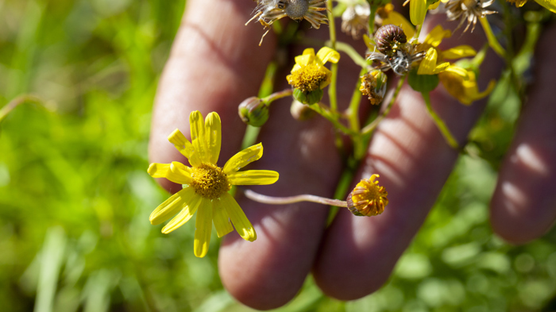
Why is it a problem?
Madagascar ragwort is a serious weed that can harm farms and animals:
- It reduces pasture growth, meaning less food for animals.
- It is poisonous and can kill livestock, even in hay or silage.
- Animals avoid it, leaving empty patches where it spreads more easily.
- It grows and spreads very quickly – one plant can make 10,000 seeds in 6 weeks.
- It is hard and expensive to control.
Where is it found?
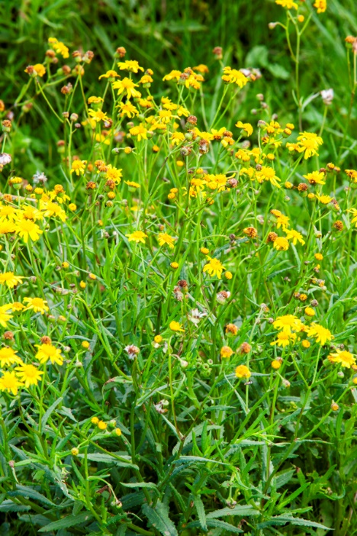
- Originally from southern Africa.
- A big problem in Australia (called “fireweed”).
- In New Zealand, it is currently found in Northland but could spread across much of the country.
What does it look like?
- Small yellow daisy-like flowers (1–2 cm wide).
- Narrow, toothed leaves.
- White fluffy seeds that blow in the wind.
- Can grow all year round, especially after rain.

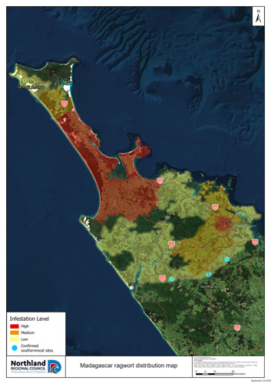
How does it spread?
- Wind (seeds can travel far).
- Contaminated hay or feed.
- Animals, machinery, and clothing.
How can it be controlled?
- Prevention (best option)
- Don’t bring contaminated hay or machinery onto your farm.
- Check new animals before mixing them with others.
- Learn to identify the plant early.
- Physical control
- Pull out plants by hand before they seed.
- Put them in bags to stop seeds spreading.
- Not effective for large infestations.
- Chemical control
- Herbicides can help, but:
  - Different stages of the plant need different treatments.
  - Some chemicals also harm good pasture plants.
  - Needs careful timing and repeated treatment.
- Farm management
- Keep pasture healthy and well-managed.
- Avoid overgrazing and soil damage.
- Sheep and goats can eat some of it, but cattle and horses are very sensitive to the poison.

Questions
- Why is Madagascar ragwort dangerous to farm animals?
- How does Madagascar ragwort spread from one place to another?
- What are two features that help you identify Madagascar ragwort?
- Why is it important to control the plant early?
- Name one-way farmers can prevent Madagascar ragwort from spreading.
Sample answers
- Why is Madagascar ragwort dangerous to farm animals?
It is poisonous and can kill animals, even if it is dried in hay or silage.

- How does Madagascar ragwort spread from one place to another?
It spreads by wind-blown seeds, contaminated hay or feed, and by animals, machinery, and clothing.

- What are two features that help you identify Madagascar ragwort?
It has small yellow daisy-like flowers and narrow, toothed leaves (it also has white fluffy seeds).

- Why is it important to control the plant early?
Because it spreads very quickly and becomes much harder and more expensive to control once it is established.

- Name one-way farmers can prevent Madagascar ragwort from spreading.
Farmers can prevent it by checking hay and machinery for contamination before bringing them onto the farm
or by identifying and removing plants early.

