Wildling pines
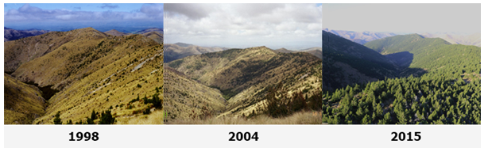
Wilding conifers, also called wilding pines are self-seeded trees, from various species of exotic conifer, growing where they are not wanted. If allowed to spread further, wilding conifers could seriously alter New Zealand's unique landscapes.
Learn about what we're doing to slow the spread of wildings and what you can do.
Visit:
- https://www.wildingpines.nz/about-wilding-pines#What-are-wilding-pines?
- What are wilding pines?
- Why wildings are a problem
- Where do wilding pines come from?
- What parts of New Zealand are threatened by wilding pines?
- What can be done to control wilding pines?

Watch
- Federated Farmers: How Wilding Pines threaten NZ’s landscape | Herald Now
https://www.youtube.com/watch?v=QW75Hr7lTxo
- Managing wilding conifers
https://www.youtube.com/watch?v=40yoEXnp4xQ

- Research wilding pines and their impact on New Zealand farmland. Use the questions below as a guide
- What are wilding pines, and how do they differ from planted trees?
- Why are wilding pines a problem?
- How do wilding pines spread, and why are they considered invasive.
- Where are wilding pines spreading
- What methods are being used to control wilding pines.
- What can communities do to help manage them?

Or
- Working in groups come up with a new idea to stop wilding pines from spreading in your community?

