Fighting a little bee mite
The varroa mite
The varroa mite (Varroa destructor) is a major, established pest for New Zealand honeybees, first detected in 2000, which feeds on bees, spreads viruses, and weakens hives, necessitating routine treatments like oxalic acid or formic acid to prevent colony collapse. All NZ hives are affected (except Chatham Islands), requiring beekeepers to monitor and treat for mites using methods like sugar shakes or alcohol washes, rotating chemicals to manage resistance.
What it is and its impact
- They are an external parasite that feeds on honeybee blood (haemolymph) and reproduces in brood cells, weakening bees and transmitting viruses like Deformed Wing Virus.
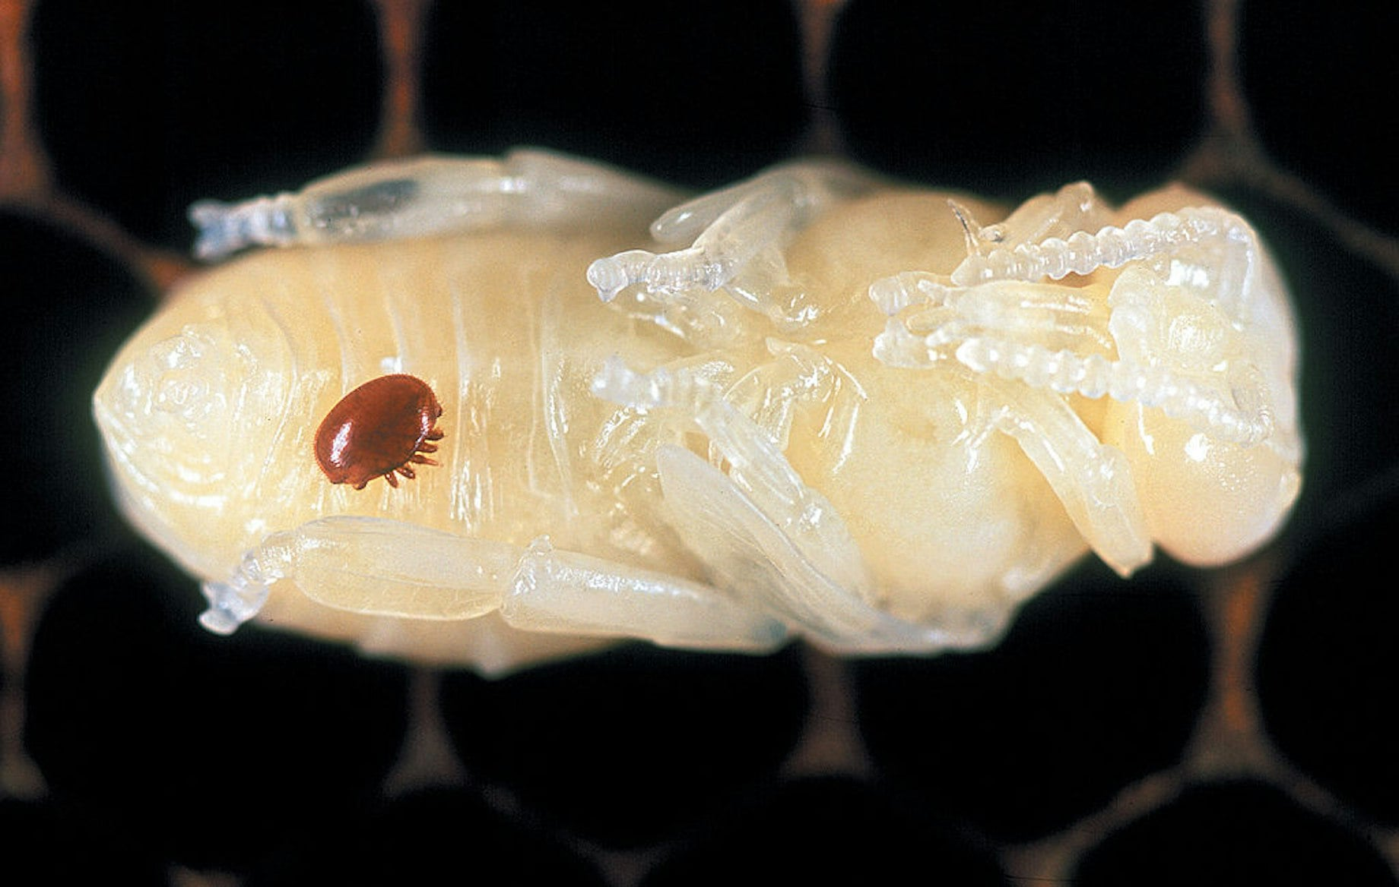
Varroa mote on a honey bee pupa
- They are small (pinhead size), reddish-brown, oval mites visible on adult bees, larvae, or pupae, but hard to spot in early infestations.
- They are a primary cause of honeybee colony death, impacting pollination services crucial to NZ's economy.

For more information visit the Science Learning Hub
Fighting a little bee mite
- Read _https://www.sciencelearn.org.nz/resources/2453-fighting-a-little-bee-mite
- Watch - https://www.sciencelearn.org.nz/resources/2453-fighting-a-little-bee-mite

Using RNAi to control varroa mites
- Read https://www.sciencelearn.org.nz/resources/3251-using-rnai-to-control-varroa-mites

Read: - Varroa mites (Varroa destructor)
https://www.mpi.govt.nz/dmsdocument/50050-Varroa-mite-Varroa-destructor-Fact-sheet

Beekeepers succeeding against varroa mites
May 20, 2025
Bee losses to the mite keep dropping, a national survey shows.
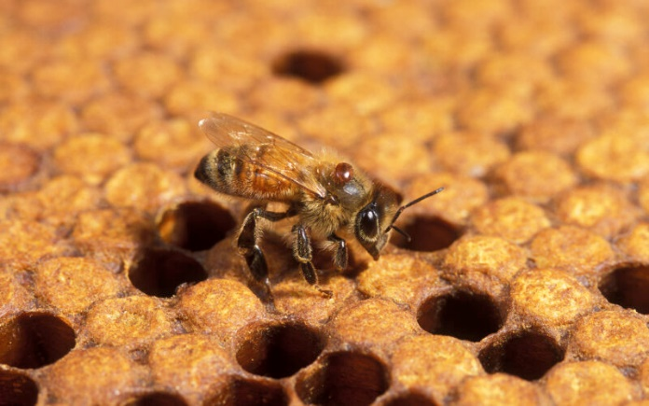
Varroa-related bee losses were the lowest over winter 2024 since a national survey started in 2015. File photo
Beekeepers across the country are gaining the upper hand against varroa mite.
Apiculture New Zealand said results from the New Zealand Colony Loss Survey 2024 show that loss rates caused by varroa mites fell to 4.6% during the 2024 winter, from 6.4% during winter 2023.
Varroa mites were the number one threat to bees over winter for the previous three years.
Chief scientist at Manaaki Whenua and survey director for the NZ Colony Loss Survey, Pike Stahlmann-Brown, said this continues a general downward trajectory since the 2021–2022 surveys.
Many countries have been struggling with colony losses over winter, but loss rates in New Zealand over the cold winter months have been declining.
“Losses to varroa showed a national decline for the first time since we started systematically measuring them [in 2015],” Stahlmann-Brown said.
Beekeepers are doing more monitoring for varroa. This is a useful practice to determine when and how to treat the pest, he said.
Beekeepers who completed the survey cited treating at the wrong time, not treating, reinvasion and ineffective products as reasons for over-winter losses to varroa.
Just over 2800 beekeepers with more than 150,000 hives were surveyed.
Over 70% of beekeepers surveyed said they used more than one product to combat varroa.
Read Beekeepers succeeding against varroa mites and answers the questions
Questions
- What did the 2024 New Zealand Colony Loss Survey find about bee losses caused by varroa mites over winter?
A. Bee losses increased to the highest level ever
B. Bee losses stayed the same as last year
C. Bee losses decreased to the lowest level since surveys began
D. Bee losses were not measured
- How did varroa-related bee losses in winter 2024 compare to winter 2023?
A. They increased from 4.6% to 6.4%
B. They stayed at 6.4%
C. They decreased from 6.4% to 4.6%
D. They dropped to zero
- Which of the following was one reason beekeepers gave for bee losses caused by varroa mites?
A. Too much rain
B. Treating hives at the wrong time
C. Not enough flowers
D. Cold temperatures only
- What has helped New Zealand beekeepers reduce losses from varroa mites?
A. Stopping all treatments
B. Using only one treatment product
C. Monitoring varroa more carefully
D. Moving hives overseas

Answers
- C
- C
- B
- C

