Varroa Mites – The basics
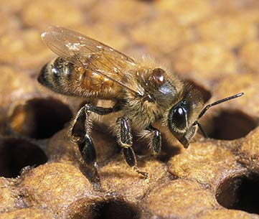
What are varroa mites?
- Varroa mites are tiny parasites that attack honeybees
- Their scientific name is Varroa destructor
- First found in New Zealand in 2000
- They are now found across most of the country
- The Chatham Islands are the only major area in NZ without them

Why are varroa mites dangerous?
- They feed on bees’ body tissues
- They weaken bees and spread bee viruses
- Varroa can quickly take over a hive
- If not controlled, they can cause the death of the whole colony

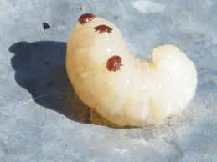
What do varroa mites look like?
- Reddish-brown to dark brown
- Oval shape
- About 2 mm wide
- Found on adult bees, larvae, and pupae
How do beekeepers detect varroa?
- Mites are hard to see, so just looking is not enough
- Beekeepers regularly test their hives using:
  - Drone uncapping
  - Sugar shake
  - Alcohol (ethanol) wash
  - Natural mite fall
- Counting mites helps beekeepers know when to take action

What can varroa be confused with?
- Pollen mites (harmless)
- Braula fly (not wanted in NZ)
- Tropilaelaps mites (very dangerous and not in NZ)

How do varroa mites spread?
- Moving infected hive equipment
- Bees drifting, robbing, swarming, or absconding
- Transporting hives, bees, or queen bees

How can beekeepers control varroa?
Beekeepers use a mix of methods:

Chemical controls (miticides):
- Special treatments that kill mites
- Must be used carefully and correctly
- Different products are rotated to stop mites becoming resistant

Non-chemical controls:
- Removing or trapping brood
- Splitting hives
- Restricting the queen
- Using mesh bottom boards

Why rules matter
- Treatments must follow New Zealand laws
- Products must be approved under the ACVM Act
- Beekeepers must follow instructions to keep:
  - People safe
  - Bees healthy
  - Honey safe to eat

Why learning about varroa is important
- Varroa mites are one of the biggest threats to bees
- Healthy bees help pollinate crops and plants
- Careful management helps protect bees across New Zealand

Quiz: Varroa Mites
Multiple Choice
- What type of pest is the varroa mite?
A. Virus
B. Parasite
C. Bacteria
D. Fungus
- What do varroa mites feed on?
A. Honey
B. Wax
C. Bee body tissues
D. Pollen
- Where in NZ are varroa mites not found?
A. North Island
B. South Island
C. Stewart Island
D. Chatham Islands

True or False
- Varroa mites are easy to see just by looking at bees.
- Varroa mites can spread viruses between bees.
- If untreated, varroa can kill a whole hive.

Short Answer
- Name one-way varroa mites spread.
- Name one method beekeepers use to control varroa.

Flashcards
- What is Varroa destructor?
- When was varroa first found in New Zealand?
- What bees do varroa mites attack?
- Why are varroa mites harmful?
- What size are varroa mites?
- Name one-way varroa spreads.
- What are miticides?
- Why must miticides be rotated?
- Name one non-chemical control method.
Answers
- B
- C
- D
- False
- True
- True

Flashcards
Q: What is Varroa destructor?
A: A parasitic mite that attacks honeybees.
Q: When was varroa first found in NZ?
A: 2000.
Q: What bees do varroa mites attack?
A: Adult bees and developing larvae and pupae.
Q: Why are varroa mites harmful?
A: They weaken bees and spread viruses.
Q: What size are varroa mites?
A: About 2 mm wide.
Q: Name one-way varroa spreads.
A: Moving hive equipment / drifting bees / swarming.
Q: What are miticides?
A: Chemicals used to kill varroa mites.
Q: Why must miticides be rotated?
A: To stop mites becoming resistant.
Q: Name one non-chemical control method.
A: Brood removal, hive splitting, mesh boards.

