Yellow-legged hornet
Yellow-legged hornets (Vespa velutina) are a non-native pest hornet not known to be established in New Zealand. Biosecurity New Zealand wants to hear from anyone who has seen this insect to help find others in the area.
For more information and updates visit MPI Yellow-legged hornets in Auckland
Read: Yellow-legged-hornets-factsheet-v3
Watch
- Biosecurity lays over 100 yellow-legged hornet traps in Auckland | RNZ
https://www.youtube.com/watch?v=Sjao_9Wiz_M
- Yellow-legged hornets are spreading - and there's only a short time to stamp them out | Stuff.co.nz
https://www.youtube.com/watch?v=G5CKCux4R-g
- Learn where to look for yellow-legged hornet nests
https://www.youtube.com/watch?v=jmJbV2QOSoU

Yellow-legged hornets - The basics
Read and discuss the information below then answer the questions.

What is a yellow-legged hornet?
- A large hornet that is a type of wasp that is not from New Zealand
- Recently spotted in Auckland
- Scientists want to make sure it has not spread

Why is it a problem?
- It eats other insects, including honeybees
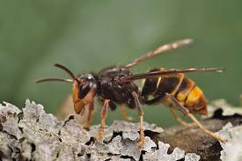
- It can also damage fruit trees
- It may harm nature and farming in New Zealand

What does it look like?
- Big: about 2–3 cm long (much bigger than normal wasps)
- Black head with a yellow face
- Black body with:
  - A thin yellow stripe near the front
  - A yellow fourth segment on its body
  - Yellow lower legs
  - Brown, smoky wings (not clear)

How is it different from common wasps?
- Common wasps in NZ are much smaller
- Yellow-legged hornets are bigger and darker
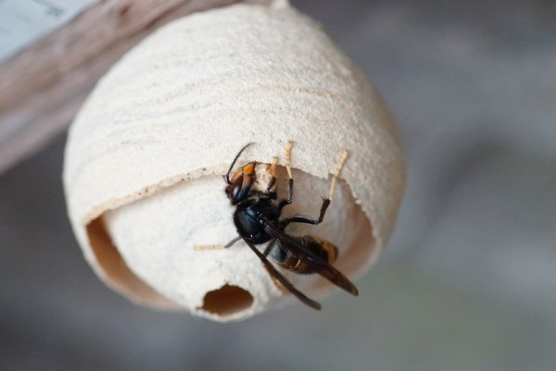
- Their nests are also larger

What do their nests look like?
- Very large nests (up to the size of a football)
- Usually high in trees or under house eaves
- Nests look wrapped and smooth, not open
- Do not touch or disturb the nest

Where might you see one?
- Near houses and buildings
- In gardens, parks, grassy areas
- Around trees and fruit

Are they dangerous?
- They can sting more than once
- They may attack if their nest is disturbed
- Get medical help immediately if:
  - You have trouble breathing
  - You get a bad rash or lots of swelling
  - You are stung on the face, mouth, or neck

What should you do if you see one?
- Do not touch it
- Take a photo (from a safe distance)
- Report it:
  - Online: report.mpi.govt.nz
  - Phone: 0800 80 99 66

Why reporting matters
- Helps protect New Zealand’s environment
- Helps stop the hornet from spreading

Yellow legged Hornet Quiz
- Is the yellow-legged hornet native to New Zealand? Yes or No

- About how big is a yellow-legged hornet?
- 5–10 mm
- 11–16 mm
- 2–3 cm

- Name TWO things the yellow-legged hornet eats.

- What should you do if you see a hornet nest?
- Touch it carefully
- Throw something at it
- Take a photo and report it

- Circle TWO places you might see a yellow-legged hornet:
Houses Gardens Oceans Parks Deserts

- Why is it important to report sightings of yellow-legged hornets in New Zealand?

Answers
- No
- C- 2–3 cm
- Any two of
- Insects
- Honeybees
- Tree sap
- Fruit
- Take a photo and report it
- Correct answers:
- Houses
- Gardens
- Parks
- Sample answer:
To help protect New Zealand’s environment, stop the hornets from spreading, and protect honeybees and plants.

