Strong Biosecurity More Important Than Ever

https://www.beehive.govt.nz/release/strong-biosecurity-more-important-ever
Events over the last few weeks have highlighted the importance of strong biosecurity to New Zealand.
Our staff at the border are increasingly vigilant after German authorities confirmed the country's first outbreak of foot and mouth disease (FMD) in nearly 40 years on Friday in a herd of water buffalo on the outskirts of Berlin.
Hon Andrew Hoggard

“New Zealand recognises the European Union’s protocols to manage FMD are in line with international standards and equivalent to New Zealand’s,” says Biosecurity Minister Andrew Hoggard.
German authorities have notified the World Organisation for Animal Health and have implemented appropriate measures to manage the risks, including establishing a restricted zone for animals and animal products as well as the range of usual protection measures following an FMD outbreak, including biosecurity measures, movement controls, the destruction of affected animals and products, disinfection, and surveillance.
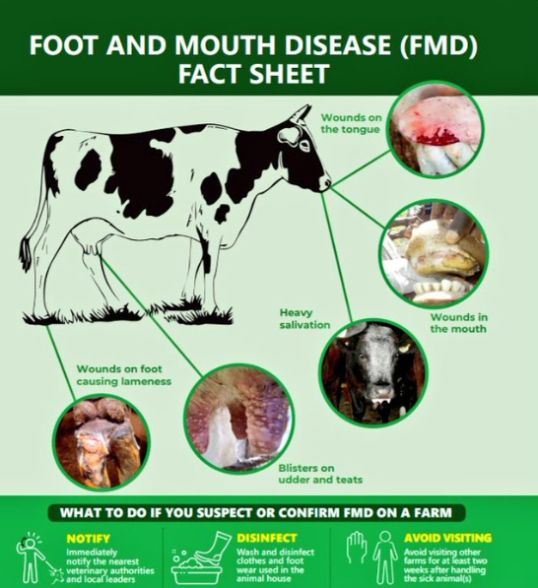
This is why we take biosecurity very seriously here in New Zealand. It's been a busy summer for Ministry for Primary Industries (MPI) staff who have devoted their time and efforts to not only responding to a recent fruit fly detection in South Auckland, but also HPAI (high pathogenicity avian influenza), with decontamination continuing at the single Mainland Poultry site in Otago. In both biosecurity responses, no further issues have been found to date.
“It's a good reminder for all New Zealanders about how vital biosecurity is to us. Incursions of pests and diseases don't take a break and that's why our biosecurity system doesn’t sleep.”
At this stage there are no concerns regarding products imported into New Zealand from Germany. New Zealand and the European Union have agreed procedures in the event of this type of situation. MPI has confidence that appropriate measures are being implemented and is engaging with its EU counterpart officials.
Questions
- What is biosecurity, and why is it important for New Zealand’s economy and environment?
- How can outbreaks like Foot and Mouth Disease (FMD) or Avian Influenza affect the agricultural sector?
- Why do you think New Zealand has such strict biosecurity protocols compared to other countries?
- What might happen if pests or diseases entered the country undetected? How would this effect exports, farmers, and the food supply?
- How do international outbreaks like FMD in Germany affect New Zealand, even if they occur on the other side of the world?
- In what ways can farmers, travellers, and everyday citizens contribute to protecting New Zealand’s biosecurity?
- What role does technology e.g., surveillance, detection, databases play in strengthening biosecurity?

Activity: "Protecting Our Farm Action Plan"
An outbreak of diseases like Bovine Tuberculosis, Foot and Mouth Disease (FMD) and Mycoplasma bovis have or could have serious impacts on farms in New Zealand
Watch videos
- What you need to know about Foot-and-Mouth Disease.
https://www.youtube.com/watch?v=oNwjMD5C29A

- foot-and-mouth takes hold - Biosecurity NZ | Newshub
https://www.youtube.com/watch?v=EF2jqlfGQT4

- Evaluating New Zealand dairy farming biosecurity risks
https://www.youtube.com/watch?v=FAaQBhEJcag

- Biosecurity on NZ dairy farms
https://www.youtube.com/watch?v=qU1YoYmRgd4

- Katherine DeWitt - on-farm biosecurity
https://www.youtube.com/watch?v=v9I1eq9si6A

- NZ's Mycoplasma Bovis eradication programme hits major milestone | Newshub
https://www.youtube.com/watch?v=tOQ2IxQ3rEQ

Objective:
You will explore how a dairy or beef farm can protect its animals and livelihood from diseases by creating a Biosecurity Action Plan.
Instructions:
- Divide the class into small groups.
- Each group takes on the role of a biosecurity team tasked with creating a "Biosecurity Action Plan" for a local dairy or beef farm.
- They need to think about the following in their plan:
- How to prevent diseases entering the farm e.g. through bring in feed, visitors, new animals.
- How to check and monitor animal health and report unusual symptoms.
- What to do during an outbreak i.e. What steps will you take if animals get sick.
- How to teach staff and visitors on biosecurity rules.
- Hygiene protocols e.g., footbaths, disinfection, restricted zones.
- Farm layout ideas to reduce cross-contamination.
- Each group presents their action plan to the class, showing how their strategies could help prevent or manage a biosecurity threat on a dairy farm.

Answers
- What is biosecurity, and why is it important for New Zealand’s economy and environment?
Biosecurity is the set of measures used to prevent the introduction and spread of harmful pests, diseases, and invasive species. It is important for New Zealand because the country’s economy relies heavily on agriculture, horticulture and tourism, all of which can be severely damaged by outbreaks. Biosecurity also protects native plants and wildlife, helping preserve the environment.

- How can outbreaks like Foot and Mouth Disease (FMD) or Avian Influenza affect the agricultural sector?
Outbreaks can cause major losses by killing animals, reducing productivity, and forcing farms to cull livestock. They often lead to trade restrictions and export bans, damaging farmers' incomes and the wider economy. Controlling outbreaks can also be very costly and disruptive.

- Why do you think New Zealand has such strict biosecurity protocols compared to other countries?
New Zealand is geographically isolated and free from many pests and diseases common elsewhere, so strict protocols protect this unique advantage. The country’s economy depends heavily on primary industries like dairy, meat, and horticulture, so preventing outbreaks is critical to maintaining market access and economic stability.

- What might happen if pests or diseases entered the country undetected? How would this effect exports, farmers, and the food supply?
If pests or diseases go undetected, they can spread quickly and become very difficult and expensive to control. This can lead to loss of livestock and crops, decrease food availability, cause export bans, and damage New Zealand’s reputation as a clean and safe producer.

- How do international outbreaks like FMD in Germany affect New Zealand, even if they occur on the other side of the world?
International outbreaks increase the risk that the disease could be accidentally brought into New Zealand through travellers, imports, or cargo. New Zealand must monitor these outbreaks closely and coordinate with other countries to prevent spread, which helps maintain strong border protections.

- In what ways can farmers, travellers, and everyday citizens contribute to protecting New Zealand’s biosecurity?
Farmers can follow hygiene and monitoring protocols and report unusual signs in animals or plants. Travelers should declare any biosecurity risk items and follow rules at the border. Everyday citizens can avoid bringing in plants, animals, or soil from overseas and support biosecurity messages.

- What role does technology (e.g., surveillance, detection, databases) play in strengthening biosecurity?
Technology helps detect pests and diseases early through surveillance tools, sensors, and rapid testing. Databases track outbreaks and movements of animals or products to manage risks. Technology also supports communication and coordination between agencies and farmers for faster responses.

