Using Technology and People to Manage Biosecurity Threats
Adapted from Using algorithms to help manage biosecurity threats
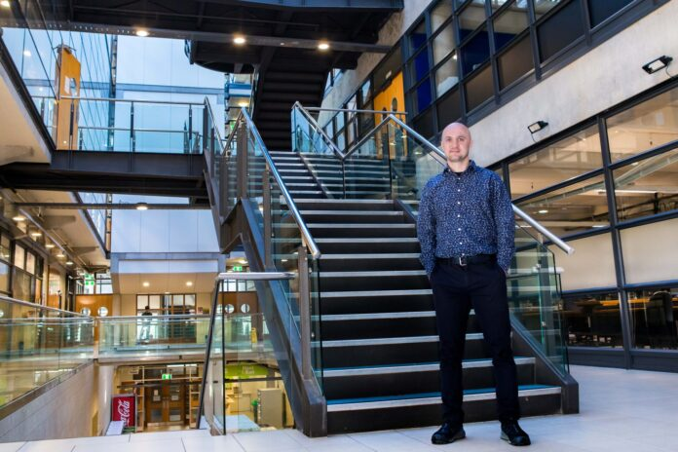
New research in New Zealand is exploring how computer algorithms can help manage serious biosecurity threats, such as foot and mouth disease. This research is being led by Associate Professor Alex Gavryushkin, a data science expert at the University of Canterbury, along with other scientists from the University of Auckland, Massey University, and the Ministry for Primary Industries (MPI).

How can algorithms help?
Algorithms are computer programs that can analyse large amounts of data. In a biosecurity outbreak, they can:
University of Canterbury Associate Professor of Data Science Alex Gavryushkin.

- Predict where a disease might spread
- Show different possible outbreak scenarios, not just the most likely one
- Update predictions in real time as new information becomes available
This helps decision-makers act faster and make better choices to stop diseases spreading.

Why is this important?
New pests and diseases can travel easily in today’s global world. They may arrive by plane, ship, or even wind. In New Zealand, agriculture is very important to the economy. If a serious disease like foot and mouth disease arrived, it could cost the country billions of dollars and damage exports.
Better predictions mean faster responses, which can reduce the damage caused by an outbreak.

Threats can come through the air
Some biosecurity threats don’t arrive through ports at all. Insects, moths, and plant diseases can travel long distances on air currents, even across the Tasman Sea from Australia.
Scientists are using forecasting models to predict when and where these pests might arrive. Interceptions on offshore platforms help test if the predictions are correct.

The role of citizen scientists
Everyday people also play an important role in biosecurity. Citizen scientists (volunteers) help by:
- Reporting unusual insects
- Collecting samples
- Sharing observations
Scientists can even use isotope analysis to find out where insects originally came from.

Why this matters?
By combining technology, science, and help from the public, New Zealand is better prepared to detect and manage biosecurity threats early. This teamwork helps protect farms, forests, and the country’s economy.

