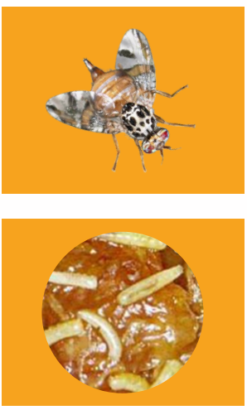
Mediterranean Fruit Fly
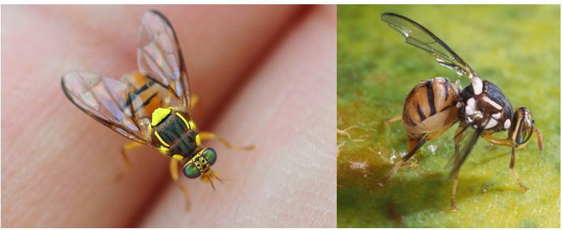
Oriental Fruit Fly
Fight against fruit fly strengthened through biosecurity partnership
Adapted from Fight against fruit fly strengthened through biosecurity partnership
Fruit flies, particularly species such as the Queensland Fruit Fly, Mediterranean Fruit Fly, and Oriental Fruit Fly, are major agricultural pests and pose serious biosecurity risks. Highly invasive and adaptable, they have broad host ranges and can rapidly establish populations if left unchecked. These pests lay their eggs in fruits and vegetables, causing internal damage that renders produce unmarketable. Due to the biological nature of infestation, early detection and swift response are essential for effective control and prevention.
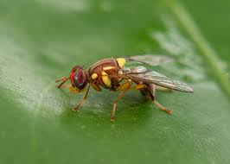
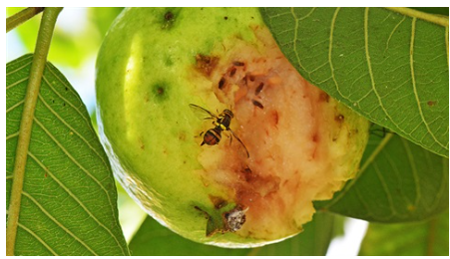
Queensland Fruit Fly

Fight against fruit fly strengthened through biosecurity partnership
https://www.hortnz.co.nz/news-events-and-media/media-releases/fight-against-fruit-fly-strengthened-through-biosecurity-partnership
7 December 2022
A ground-breaking agreement to fight the threat of fruit fly has been renewed and updated by government and eight of New Zealand’s largest horticulture industry groups. The Fruit Fly Operational Agreement, first signed in May 2016, was the first such agreement under the Government Industry Agreement for Biosecurity Readiness and Response (GIA). The agreement sets out the operational requirements for biosecurity readiness and response, as well as cost sharing between the government and affected industries. Its renewal enhances New Zealand’s protection from the threat of fruit flies arriving and ensures that as a country we are well-prepared in the event that a response is required, as happened with the large Auckland Fruit Fly response in 2019.
Fruit Fly Council chair, Matt Dyck, says the parties are very pleased to have finalised the new agreement after a period of re-negotiation and review.
“Renewing the Fruit Fly Operational Agreement illustrates the success of the partnership and will enable Biosecurity New Zealand and the horticulture sector to build on the strong foundations now in place to continue working together to manage and help reduce the impacts of fruit fly on New Zealand,” says Matt. “Fruit flies continue to be one of the biggest biosecurity threats facing horticulture. An unmanaged fruit fly incursion would cost the horticulture industry billions of dollars, and would have significant negative impacts on the economy, the community and New Zealand’s trade relationships. By working together under GIA, government and affected industries have achieved far more than would have been possible working in isolation from each other. By harnessing the collective strengths and experiences of all the affected horticulture sectors, along with the national responsibilities of the government we have created a strong, cohesive partnership that is delivering excellent outcomes for all New Zealanders,” Matt commented.
The new agreement took effect from 1 September 2022 and has a seven-year term. It sets out the outcomes sought by the parties in reducing the threat of fruit flies to New Zealand, and the roles and responsibilities of each of the signatories.
The agreement provides for shared biosecurity readiness activities across all fruit fly species, covers responses and allocates cost shares for the three species of fruit fly expected to have the broadest impact should they establish in New Zealand (Queensland Fruit Fly, Mediterranean Fruit Fly and Oriental fruit fly). The agreement provides the flexibility to enable response activities to get underway rapidly if fruit flies are found, irrespective of the species and the horticultural sectors impacted.
“New Zealand’s partnership between government and primary sector industries for managing biosecurity readiness and response is world leading,” Matt concluded; “the renewal of the Fruit Fly Operational Agreement confirms the commitment of all parties to working together under GIA and ensures that New Zealand is well placed to fight the threat of fruit fly.”
Questions
- What is a fruit fly, and why is it considered a threat to New Zealand's horticulture industry?

- Which three species of fruit fly are mentioned as the most dangerous to New Zealand?

- What could happen to fruit crops if a fruit fly outbreak is not controlled?

- Why is it important to be ready to respond quickly if fruit flies are found?

- How can fruit flies affect New Zealand's local food supply?

- What is the Fruit Fly Operational Agreement, and why was it created?

- What is the role of the Government Industry Agreement (GIA) in this situation?

- What might happen if there was no agreement or plan in place to deal with fruit flies?

- What are some of the immediate costs to horticulture businesses if fruit flies are found in New Zealand?

- How might a fruit fly outbreak affect the ability to sell fresh fruit locally or overseas right away?

- What extra actions or resources would businesses need to pay for during a fruit fly response?

- How could a local community be affected financially during a fruit fly outbreak?

- If fruit flies became established in New Zealand, how might this affect the country's fruit exports over time?

- Why would ongoing fruit fly problems make it harder for New Zealand to trade with other countries?

- How could the cost of growing and protecting fruit crops increase in the long term if fruit flies are not controlled?

- What might happen to jobs in the horticulture industry if growers lose money due to fruit fly issues?

Answers
- What is a fruit fly, and why is it considered a threat to New Zealand's horticulture industry?
A fruit fly is an insect that lays its eggs in fruit. The larvae feed on the fruit, causing it to rot. They are considered a serious biosecurity threat because they can damage or destroy fruit crops, leading to huge economic losses in New Zealand’s horticulture industry.

- Which three species of fruit fly are mentioned as the most dangerous to New Zealand?
- Queensland Fruit Fly
- Mediterranean Fruit Fly
- Oriental Fruit Fly

- What could happen to fruit crops if a fruit fly outbreak is not controlled?
If not controlled, fruit flies can destroy large amounts of fruit crops, making them unsellable due to internal damage. This would severely impact growers' incomes and reduce the amount of fresh fruit available.

- Why is it important to be ready to respond quickly if fruit flies are found?
A fast response can help contain and eliminate the pest before it spreads, minimising crop damage and preventing the pest from becoming permanently established in New Zealand.

- How can fruit flies affect New Zealand's local food supply?
Fruit flies can reduce the availability of fresh fruit, causing higher prices and less variety for consumers. In some cases, fruit may need to be destroyed to stop the spread, creating shortages in the local market.

- What is the Fruit Fly Operational Agreement, and why was it created?
The Fruit Fly Operational Agreement is a formal plan between the government and major horticulture industry groups. It sets out how they will prepare for and respond to fruit fly threats, including who pays for what and what actions will be taken. It was created to protect the horticulture sector and economy from serious biosecurity threats.

- What is the role of the Government Industry Agreement (GIA) in this situation?
The GIA provides a framework for the government and industry to work together on biosecurity readiness and response. It ensures that all parties share responsibilities, decision-making, and costs during a biosecurity event like a fruit fly outbreak.

- What might happen if there was no agreement or plan in place to deal with fruit flies?
Without an agreement:
- Responses would be slower and less coordinated.
- There might be confusion over responsibilities and funding.
- Fruit fly outbreaks could spread more easily, causing greater damage to crops and exports.

- What are some of the immediate costs to horticulture businesses if fruit flies are found in New Zealand?
- Crop loss from fruit needing to be destroyed.
- Suspension of exports.
- Increased costs for monitoring and containment.
- Pest control measures like spraying or using traps.
- Loss of income due to market restrictions.

- How might a fruit fly outbreak affect the ability to sell fresh fruit locally or overseas right away?
A fruit fly outbreak means growers may not be able to sell their fruit in key markets because of:
- An immediate export bans to certain countries.
- Quarantine restrictions locally.
- Loss of trust from overseas buyers.
- What extra actions or resources would businesses need to pay for during a fruit fly response?
- Hiring staff for fruit inspection and pest management.
- Installing traps and carrying out pesticide applications.
- Packaging changes or disinfection processes.
- Public communication and education.
- Biosecurity compliance costs like traceability systems.

- How could a local community be affected financially during a fruit fly outbreak?
- Loss of seasonal jobs in orchards and packing sheds.
- Reduced income for growers and local businesses.
- Increased prices for fresh fruit locally.
- Strain on local councils and community resources during a response.
- Lower tourism if the area is seen as affected.

- If fruit flies became established in New Zealand, how might this affect the country's fruit exports over time?
- Ongoing trade restrictions or bans.
- Need for expensive treatments before exporting.
- Loss of “pest-free” reputation, reducing demand.
- Long-term revenue loss for the export horticulture industry.

- Why would ongoing fruit fly problems make it harder for New Zealand to trade with other countries?
Many countries have strict biosecurity rules. If New Zealand has fruit flies:
- Importing countries may refuse or limit imports.
- Exporters may need to meet extra conditions, increasing costs.
- It would reduce competitiveness in global markets.

- How could the cost of growing and protecting fruit crops increase in the long term if fruit flies are not controlled?
- Growers would need to constantly monitor and spray crops.
- More investment in pest-proof packaging and treatments.
- Ongoing surveillance costs.
- Reduced yields and increased labour costs.
- This could make fruit production less profitable.

- What might happen to jobs in the horticulture industry if growers lose money due to fruit fly issues?
- Fewer seasonal or permanent jobs.
- Some growers may exit the industry.
- Local communities could lose income.
- Affected regions might face higher unemployment rates.

