New Agreement to Protect New Zealand from Fruit Flies
Adapted from Fight against fruit fly strengthened through biosecurity partnership
New Zealand has updated an important agreement to fight fruit flies, which are a big threat to the country’s fruit and vegetable farms. The agreement is between the government and eight of New Zealand’s largest horticulture (fruit and vegetable) industry groups.
The Fruit Fly Operational Agreement was first signed in 2016. It explains how the government and industries work together to be ready for fruit fly problems and how the costs are shared. The updated agreement makes New Zealand even better prepared if fruit flies arrive, like during the big Auckland fruit fly outbreak in 2019.
Matt Dyck, chair of the Fruit Fly Council, says everyone is happy that the new agreement has been finalised after review and talks.
“Renewing this agreement shows that working together works. It helps Biosecurity New Zealand and the horticulture sector manage and reduce the damage fruit flies can cause,” said Matt.
Fruit flies are one of the biggest threats to New Zealand’s fruit and vegetable industry. If they were not managed, they could cost the country billions of dollars and hurt the economy, communities, and trade with other countries. By working together, the government and industries can achieve more than if they worked alone.
The new agreement started on 1 September 2022 and will last for seven years. It explains what each group needs to do to reduce the fruit fly threat and how they will share costs. It covers all types of fruit flies, including the three most dangerous ones:
- Queensland Fruit Fly
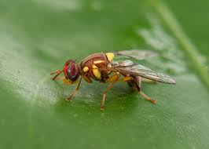
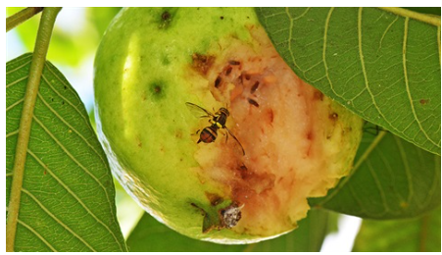
Queensland Fruit Fly
- Mediterranean Fruit Fly
- Oriental Fruit Fly
The agreement also allows teams to act quickly if fruit flies are found, no matter the species or the farms affected.
Matt Dyck said:
“New Zealand’s teamwork between the government and the fruit and vegetable industry is one of the best in the world. This new agreement shows everyone’s commitment to working together to fight fruit flies.”

Vocab exercises
- Match the words on the left with the correct meaning on the right.
Word | Meaning
Agreement | A sudden problem or arrival of something harmful
Horticulture | To make sure something is ready and safe
Biosecurity | A written plan between people or groups
Threat | Growing fruits, vegetables, or plants
Incursion | Something that could cause harm

- Write True or False for each statement
- The Fruit Fly Operational Agreement started in 2016.
- Fruit flies are not a serious problem for New Zealand.
- The new agreement will last for seven years.
- The agreement only covers one species of fruit fly.
- Working together helps the government and farmers stop fruit flies faster.

- Answer the following questions in your own words.
- Why is it important for New Zealand to prevent fruit flies?
- Name the three most dangerous fruit flies mentioned in the article.
- How does the agreement help farmers and the government work together?
- What happened in Auckland in 2019 related to fruit flies?
- How can acting quickly help reduce the damage from fruit flies?

- Answer the questions with your group and discuss:
- Imagine a fruit fly was found in your city/town. What steps should the government and producers take first?
- Why do you think it is better for industries and government to work together instead of alone?
- How might fruit flies affect people who buy and eat fruit in New Zealand?

Vocab answers
- Match words
Word | Meaning
Agreement | A written plan between people or groups
Horticulture | Growing fruits, vegetables, or plants
Biosecurity | To make sure something is ready and safe
Threat | Something that could cause harm
Incursion | A sudden problem or arrival of something harmful

- True or False
- The Fruit Fly Operational Agreement started in 2016. True
- Fruit flies are not a serious problem for New Zealand. False
- The new agreement will last for seven years. True
- The agreement only covers one species of fruit fly. False
- Working together helps the government and farmers stop fruit flies faster. True

- Answer Questions
- Why is it important for New Zealand to prevent fruit flies?
Fruit flies can damage fruit and vegetable crops, cost farmers/ growers/ horticulturalists and the economy billions of dollars, and hurt trade with other countries.
- Name the three most dangerous fruit flies mentioned in the article.
Queensland Fruit Fly, Mediterranean Fruit Fly, Oriental Fruit Fly
- How does the agreement help farmers and the government work together?
It sets out roles, responsibilities, and cost-sharing so everyone can act quickly and effectively to manage fruit flies.
- What happened in Auckland in 2019 related to fruit flies?
There was a large fruit fly outbreak, and a response was needed to control it.
- How can acting quickly help reduce the damage from fruit flies?
It stops the fruit flies from spreading, protecting orchards, gardens, farms, the environment, and the economy.

- Suggested answers; students may give slightly different but reasonable responses.
- Imagine a fruit fly was found in your city/town. What steps should the government and farmers take first?
Quickly locate and remove the fruit flies, alert the public, set up quarantine or control zones, and monitor crops closely.
- Why do you think it is better for industries and government to work together instead of alone?
Working together shares knowledge, resources, and costs, and allows faster action to stop the problem.
- How might fruit flies affect people who buy and eat fruit in New Zealand?
Fruit could become more expensive, harder to find, or lower in quality; some fruit might be destroyed to control the flies.

