Pea weevil eradication believed to be world first
https://www.rnz.co.nz/news/country/409768/pea-weevil-eradication-believed-to-be-world-first

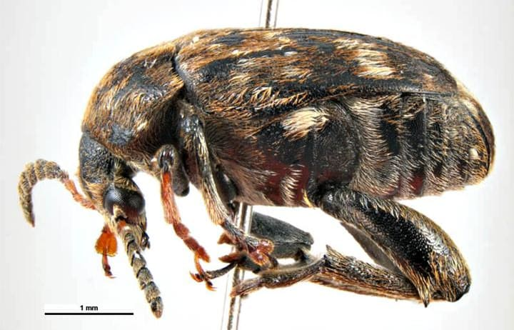
The pest was first discovered in Wairarapa in 2016.
Photo: Australian Biosecurity Image Database / https://creativecommons.org/licenses/by/4.0/ CC-Attribution 4.0

Pea weevil larvae feed on young peas, ruining crops and potentially threatening valuable fresh and seed pea exports.
The official declaration ends a nearly four-year ban on growing peas and use of pea-straw in Wairarapa.
The pest was first discovered in the region in 2016. Two complete seasons of no new finds was required to ensure the pest had been eradicated.
Biosecurity Minister Damien O'Connor said the successful eradication of the noxious pest from Wairarapa was thought to be a world first.
"To our knowledge, this is the first time a pea weevil population has been successfully eradicated anywhere in the world. This just goes to show what can be achieved when government, industry and communities work together.

Wairarapa Pea Weevil Eradicated
19 February 2020
https://www.hortnz.co.nz/news-events-and-media/media-releases/wairarapa-pea-weevil-eradicated
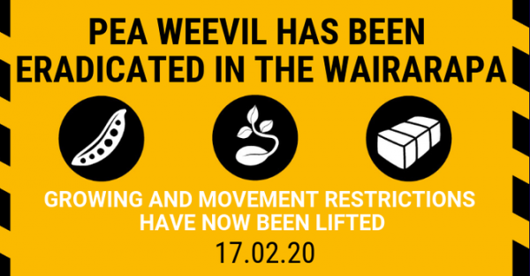
Biosecurity New Zealand are confident they have eradicated pea weevil from the Wairarapa. Minister O’Connor said after two complete seasons of no new finds, Biosecurity New Zealand is confident that there are no pea weevils remaining in Wairarapa, and so New Zealand.
“To our knowledge, this is the first time a pea weevil population has been successfully eradicated anywhere in the world. This just goes to show what can be achieved when Government, industry and communities work together,” says Minister for Biosecurity Damien O’Connor.
Part of the reason for the success of this biosecurity response was that the infestation was found early, and Biosecurity New Zealand took swift, decisive action to contain it and prevent it from spreading to other regions.
The existing controlled area notice (CAN) and conditions will no longer be in place. The CAN has been replaced (link here) with one relating to a further season of monitoring of some commercial pea crops in a 5 km radius from the last detection (in Masterton in December 2017. MPI will continue to monitor commercial crops in this area and will soak test harvests grown for seed. This is to provide additional surety of eradication. MPI will work directly with the relevant growers on this in the coming months.
Restrictions on growing peas and using pea straw across the Wairarapa have been lifted.
- All commercial growers can again plant peas, with no limits on hectares or potential contracts.
- Commercial growers can again sell pea straw with no restrictions.
- All home gardeners can again plant and harvest green peas and use and move pea straw for garden bedding material.
- All garden centres can again sell pea straw.
Biosecurity New Zealand and Process Vegetables New Zealand would especially like to thank Wairarapa growers for their support and co-operation. Through their support and the actions of the community, this threat has been able to be contained, protecting the rest of New Zealand from the impact this pest could have had.

