Psa – Kiwifruit Vine Canker
Adapted from information on MPI, KVH and Science learning Hub
Psa, also called kiwifruit vine canker, is a serious disease that affects kiwifruit vines. It has damaged kiwifruit industries in many countries around the world. In some places, thousands of hectares of kiwifruit orchards have been destroyed, especially gold kiwifruit orchards. The disease spread very quickly and became a worldwide problem in only a few years.
Psa in New Zealand
Psa was first found in New Zealand in November 2010 on a kiwifruit orchard in Te Puke. Since then, it has been detected in most kiwifruit-growing regions of the country.
The disease is caused by a bacterium called Psa-V. It only affects kiwifruit vines and does not harm people, animals, or other plants.
What does Psa do to kiwifruit vines?
When Psa bacteria grow on or inside kiwifruit vines, they can cause:
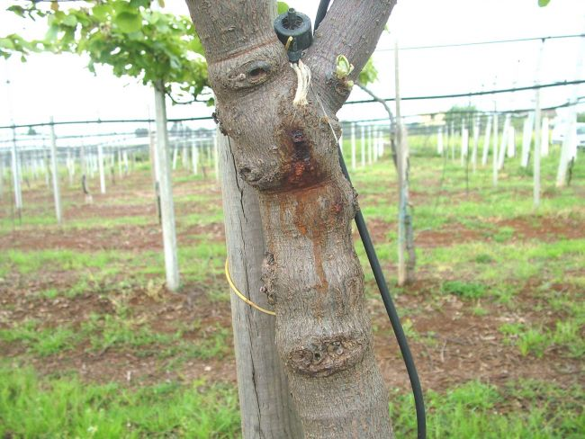
- Spots on leaves
- Dieback of canes and leaders
- Red or white ooze to form on the undersides of leaves, canes, buds, joints of branches, forks, leaf scars, and pruning scars
- Weak growth
- In severe cases, death of the vine
Badly infected vines may also leak a sticky substance called exudate.
How New Zealand has responded?
At first, Psa caused major damage to the New Zealand kiwifruit industry. However, the industry has mostly recovered by:
- Planting new gold kiwifruit varieties that are more tolerant of Psa
- Using better orchard management practices
A lot of money, research, and effort has gone into understanding Psa and learning how to manage it. Scientists and growers work together to reduce the spread of the disease and limit its impact.
Managing Psa today
Advice on how to manage Psa is based on research and real experience from orchards. This information is shared across the industry so everyone can help control the disease.
- Zespri produces and shares best-practice advice for growers
- Growers work together at orchard, regional, and national levels

Protecting the future
Kiwifruit Vine Health (KVH) is the biosecurity agency that manages serious Psa risks in New Zealand. KVH also prepares for any new strains of Psa that could appear in the future.
Because Psa is still a threat, it remains a specified organism under New Zealand’s biosecurity rules. This means the country can continue to control its spread and act quickly if new forms of the disease are found.
Why this matters?
Psa is a reminder of how important biosecurity and science are for protecting New Zealand’s primary industries. Thanks to research, teamwork, and better plant varieties, the kiwifruit industry is now stronger and better prepared for the future.
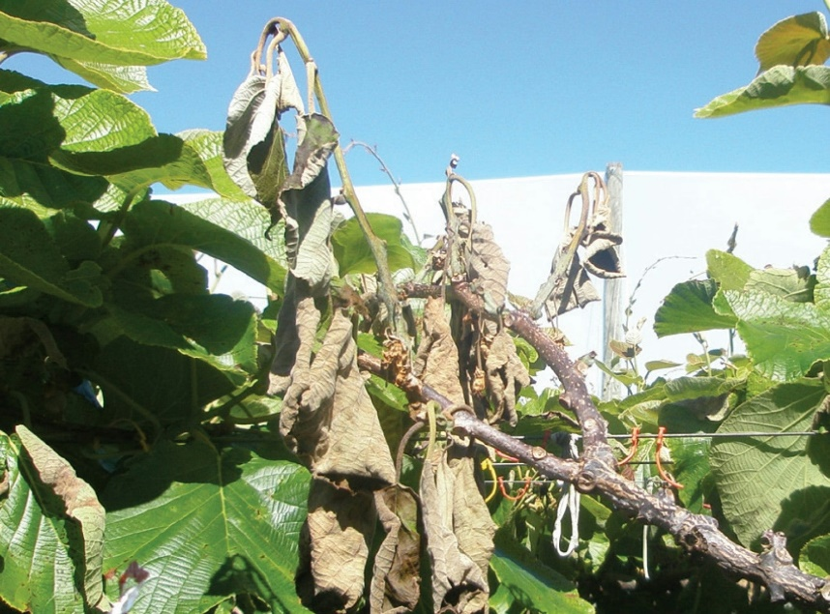

Watch
- How to examine an orchard for kiwifruit Psa
https://www.youtube.com/watch?v=Kzgk-SMe_yY
- Psa Virus Attacks Kiwifruit Industry
https://www.youtube.com/watch?v=h9mebKqn3yM
- Science to Battle Psa - Saving kiwifruit from a bacterial invader
https://www.youtube.com/watch?v=vA-ctI2qVZI
- A disease almost destroyed the Kiwi industry
https://www.youtube.com/shorts/T_OofJ8RmgU
- Plant & Food Research and Zespri – Responding to Psa
https://www.sciencelearn.org.nz/videos/984-plant-amp-food-research-and-zespri-responding-to-psa
- Kiwifruit – learning to live with Psa
https://www.sciencelearn.org.nz/resources/2638-kiwifruit-learning-to-live-with-psa

Activities
- Read the information on Psa and watch the first two videos then, in groups answer the questions
- What is Psa, and what type of plant does it affect?
- Where and when was Psa first discovered in New Zealand?
- List two symptoms that Psa can cause in kiwifruit vines.
- Why does Psa not pose a risk to humans or animals?
- Name two ways the New Zealand kiwifruit industry has responded to Psa.
- Why is Psa still considered a threat in New Zealand today?

- Watch the videos, then working in groups read the scenario and discuss the questions. Each group shares their answers with the rest of the class.
Scenario: A Psa Outbreak at Green Valley Orchard
Green Valley Orchard is a kiwifruit orchard in the Bay of Plenty. It grows both green and gold kiwifruit and supplies fruit to export markets. The orchard has been healthy for several years.
In early spring, the orchard manager notices that some vines in one block have small brown spots on their leaves. A few weeks later, some canes begin to die back, and a red and white sticky ooze appears around pruning scars and joints of the vines.
Soon after, a neighbouring orchard reports similar symptoms. There is concern that Psa may be spreading in the area. If the disease spreads further, it could damage vines, reduce fruit production, and affect growers’ incomes.
The orchard manager contacts Kiwifruit Vine Health (KVH) and follows their advice. Workers are asked to clean tools more carefully, and movement between orchards is limited. Some vines may need to be removed to stop the disease spreading.

- Discussion questions
- What signs suggest that Psa might be present at Green Valley Orchard?
- How could Psa spread from one orchard to another?
- What steps should the orchard manager take immediately to reduce the spread of Psa?
- How can growers work together to manage the outbreak at a regional level?
- Why is it important to involve KVH and follow biosecurity rules during an outbreak?
- What could be done in the future to help prevent another Psa outbreak?

Answers
1.
- What is Psa, and what type of plant does it affect?
Psa is a bacterial disease called kiwifruit vine canker, and it affects kiwifruit vines.

- Where and when was Psa first discovered in New Zealand?
Psa was first discovered in November 2010 on a kiwifruit orchard in Te Puke.

- List two symptoms that Psa can cause in kiwifruit vines.
Psa can cause leaf spots, dieback of canes and leaders, weak growth, ooze on vines, or vine death.
- Why does Psa not pose a risk to humans or animals?
Psa only affects kiwifruit vines and does not harm humans, animals, or other plants.

- Name two ways the New Zealand kiwifruit industry has responded to Psa.
The industry has planted new gold kiwifruit varieties that are more tolerant of Psa and improved orchard management practices.

- Why is Psa still considered a threat in New Zealand today?
Psa can still spread and new strains could appear, so it needs ongoing management and biosecurity controls.

3.
- What signs suggest that Psa might be present at Green Valley Orchard?
The signs include brown spots on leaves, dieback of canes, and red or white sticky ooze around pruning scars and joints of the vines.

- How could Psa spread from one orchard to another?
Psa can spread through infected tools, workers’ clothing and footwear, wind-driven rain, movement of plant material, and people or vehicles moving between orchards.

- What steps should the orchard manager take immediately to reduce the spread of Psa?
The manager should report the symptoms to KVH, clean and disinfect tools, limit movement between orchards, remove infected plant material if advised, and follow biosecurity guidelines.

- How can growers work together to manage the outbreak at a regional level?
Growers can share information, follow the same biosecurity practices, limit movement between orchards, and support regional management plans to reduce the spread of Psa.
- Why is it important to involve KVH and follow biosecurity rules during an outbreak?
KVH provides expert advice and helps manage serious risks. Biosecurity rules help control the spread of Psa and allow quick action if the disease worsens or new strains appear.

- What could be done in the future to help prevent another Psa outbreak?
Planting Psa-tolerant varieties, maintaining good hygiene practices, monitoring vines regularly, training workers, and continuing research can help prevent future outbreaks.

