Growing Asian Greens Case Study
Teachers’ Guide
Introduction to Asian Greens
Asian Greens are a diverse group of fast-growing, nutritious leafy vegetables that belong mainly to the Brassica (mustard and cabbage) family. Popular varieties include bok choy (pak choi), choy sum, gai lan (Chinese broccoli) and wombok (Chinese cabbage). These vegetables are valued for their mild flavour, crisp texture, versatility, and high nutritional value, making them popular in both Asian and Western cuisines.
Asian vegetables have been grown in New Zealand since Chinese settlers introduced them in the late 1800s. Today, hundreds of varieties are grown around the world, although only a smaller selection is commonly available in New Zealand supermarkets and vegetable markets. As New Zealand's population has become more culturally diverse and consumers have become increasingly interested in healthy, fresh, and convenient foods, the demand for Asian Greens has grown steadily.
Asian Greens grow best in cool conditions and have a short growing season, with many crops reaching harvest in just 4–8 weeks. Their rapid growth, high yields, and relatively low production costs make them well suited to both commercial growing and home gardens.
Traditionally, Asian Greens have been grown outdoors in fertile soils. However, increasing demand for year-round, high-quality produce has encouraged many commercial growers to adopt protected cropping and hydroponic production systems. Growing crops in greenhouses protects them from heavy rain, frost, strong winds, and flooding, reducing crop losses and improving reliability. Hydroponic systems allow growers to carefully control water, nutrients, and environmental conditions, producing consistent, high-quality vegetables while improving water-use efficiency and making harvesting and crop management easier for workers.
The popularity of Asian Greens continues to increase as more New Zealanders seek nutritious, quick-to-cook vegetables. Their inclusion in supermarket displays, restaurant menus, meal kit services, and home cooking has introduced many consumers to vegetables such as bok choy, gai lan, and wombok. This growing demand has made Asian Greens an increasingly important part of New Zealand's commercial vegetable industry.

Watch Growing Asian Greens in New Zealand https://www.youtube.com/watch?v=T3J1qI0pCLY
Do: Demand for Asian Greens ramps up by up to 400 percent (WS)
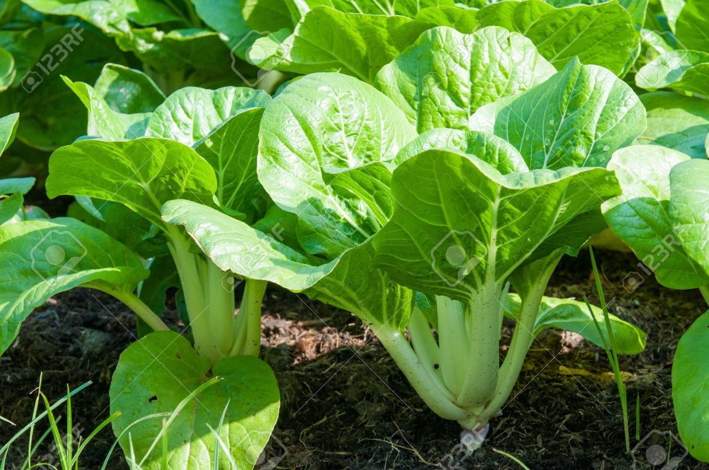
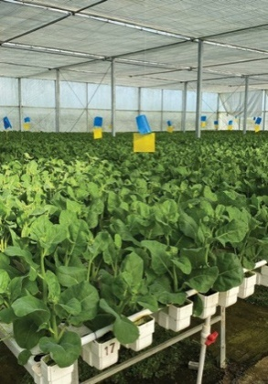
Key learning outcomes: Students will be able to
- Briefly describe the history and importance of Asian Greens in New Zealand,
- Identify the main types of Asian Greens grown commercially in New Zealand
- Explain the market requirements for bok choy and other Asian Greens.
- Describe the environmental conditions required for successful bok choy.
- Discuss where Asian green are commercially grown in New Zealand and why?
- Describe the role of cultivar selection and explain why commercial growers choose different hybrids.
- Describe the main management practices to grow bok choy commercially from cultivar selection to harvesting.
- Identify the environmental, economic, and social challenges facing New Zealand vegetable growers and explain how these challenges affect commercial production.

Supporting resources
- Growing Asian Greens Case Study
- Bok Choy crop CoO.
- Glossary of Terms
- Activity 1 History of Asian Greens.
- Activity 2 Choosing a hybrid
- Activity 3 Practical Investigation Growing Bok Choy
- Activity 4 Soil pH
- Activity 5 Careers in growing a crop
- Activity 6 Role of technology
- Activity 7 Challenges Facing NZ Vege Growers

PowerPoints
- Asian Greens
- Steps involved in sowing seeds.
- Growing Bok Choy
- Bok Choy varieties.
- Brassica Pests & Diseases.

Worksheets
- Bok Choy question (WS)
- Chinese vege growers play a pivotal role in vege prodn (WS)
- Demand for Asian Greens up to 400 percent (WS)
- GROWING An Asian green market (WS).
- Greenhouse Vegetable Growers Pans (WS).
- Sustainable Vegetable Production (WS).
- Growers say Waikato PC1 threatens vegetable supply (WS)
- Field trip to Field Production of Asian Greens (WS)
- Field trip to indoor Asian green grower (WS)
- Asian green wordsearch.

Videos
- Growing Asian Greens in New Zealand https://www.youtube.com/watch?v=T3J1qI0pCLY
- The Fresh Grower https://www.thefreshgrower.co.nz/

Other resources
- Link to Soil Science

References
- The Fresh Grower https://www.thefreshgrower.co.nz/
- booklet_asian_vegetables.pdf
- FLYER_ASIAN_GREENS.pdf
- ASIAN-VEGETABLES-A4.pdf

Acknowledgements
- We gratefully acknowledge The Fresh Grower for sharing their expertise, practical knowledge and guidance on the commercial production of Asian Greens, and for providing photographs to support the development of these resources.

Recommendations
Within each Case Study there are multiple activities for students to complete. We recommend you select the activity or activities that best suit your students.

Find out what your students know.
Using the PPT Asian Greens
- Do you recognise any of these leafy green vegetables.
- Where do these vegetables originally come from?
- How long have these vegetables been grown in New Zealand?
- Where are Asian Greens commercially grown in New Zealand?
- Is there a growing demand for Asian green vegetables in New Zealand?
- Where would you buy Asian green vegetables?
- Who has eaten any of these Asian green vegetables?
- Which plant family do these vegetables belong to?
- Name other vegetables in this plant family.
History of Asian Greens
Asian vegetables have been grown in New Zealand since Chinese settlers first arrived in the late 1800s. Many of these early settlers became market gardeners, supplying fresh vegetables to local communities and introducing crops that were widely eaten in China but were unfamiliar to most New Zealanders.
There are hundreds of different Asian vegetable varieties grown throughout Asia. However, only a small number are commonly produced commercially in New Zealand and sold in supermarkets and fresh produce stores.
The names of Asian vegetables can sometimes be confusing because the same vegetable may have different names depending on the region or language. For example, Chinese white cabbage is also known as wombok, while bok choy may be called pak choi, bok choi, buk choy, or baak choi. The word "choy" (or "choi") simply means leafy vegetable in Chinese.
Chinese market gardeners have made an important contribution to New Zealand's vegetable industry. During World War II, the Government recognised the vital role that commercial vegetable growers played in feeding both the civilian population and New Zealand troops. In 1943, at the suggestion of Prime Minister Peter Fraser, the New Zealand Chinese Growers' Federation (NZCGF) was established to support Chinese market gardeners and help coordinate vegetable production during the war. Chinese growers greatly increased their production to meet the country's food needs.
Today, the NZCGF remains the world's only national Chinese growers' organisation. It continues to support its members, encourage innovation and sustainable farming practices, and promote the vegetable industry. Chinese growers have played a pioneering role in introducing vegetables such as bok choy, gai lan and daikon, many of which have become familiar ingredients in New Zealand kitchens.
Today, Asian Greens are grown commercially throughout New Zealand, particularly in the country's major vegetable-growing regions. The largest production areas are Pukekohe and Levin, where the fertile soils and favourable climate support year-round production. Crops such as bok choy, Shanghai bok choy, wombok, and choy sum are grown outdoors, while some growers also use hydroponic glasshouses to produce premium-quality crops throughout the year.

Major Production Areas
- Pukekohe – New Zealand's largest vegetable-growing region and a major producer of field-grown Asian Greens.
- Levin (Horowhenua) – An important production area supplying crops such as Shanghai bok choy, pak choi, choy sum, and other leafy Asian vegetables.
- Glasshouse production – Some commercial growers use hydroponic glasshouses to produce high-quality Asian Greens year-round, providing a reliable supply regardless of the season.

Commonly Grown Asian Greens in New Zealand
- Bok choy (Pak choi)
- Shanghai pak choy
- Wombok (Chinese cabbage)
- Chinese flat cabbage
- Choy sum
- Gai lan (Chinese broccoli)

Watch
- Growing Asian Greens in New Zealand https://www.youtube.com/watch?v=T3J1qI0pCLY
- The Fresh Grower https://www.thefreshgrower.co.nz/
Do:
- Activity 1: History of Asian Greens
- Chinese vegetable growers play a pivotal role in commercial vegetable production in New Zealand (WS)
- Greenhouse Vegetable Growers Pans (WS)

Markets for Asian Greens
The main market opportunities for Asian Greens include:
- Supermarkets
- Asian vegetable wholesalers
- Food service industry (restaurants and takeaways)
- Food boxes like My food bag, Bargain box, Wonky box

Market requirements
Quality requirements vary depending on the market.
For supermarkets, Asian vegetable wholesalers, restaurants, and premium food box providers such as My Food Bag, the following standards are expected:
- Uniform plant size
- Healthy green leaves
- Crisp stems
- Free from pests and defects
- Chemical-free
For other market opportunities, perfect uniformity in size and shape is not essential. However, freshness, freedom from pests and diseases, and being chemical-free are still important requirements.

Do: GROWING An Asian green market (WS)
Asian Greens growing requirements
Asian Greens are relatively easy to grow. They thrive in well-drained, fertile soils. They require a consistent water supply to produce tender, healthy leaves and grow best in temperate conditions with full sun to partial shade. Many Asian Greens are frost tender and can bolt, or quickly go to seed, in very hot weather. These vegetables are also fast-growing and are usually ready to harvest within 30 days in summer and about 90 days in winter.
As it is not possible to cover all Asian Green crops, this resource will focus specifically on growing Bok Choy.

Bok Choy.
Bok choy (Brassica rapa subsp. chinensis), also known as pak choi or Chinese cabbage, is a fast-growing leafy vegetable that belongs to the mustard and cabbage family (Brassicaceae). It is one of the most widely grown and consumed Asian Greens because of its crisp texture, mild flavour, and versatility in cooking.
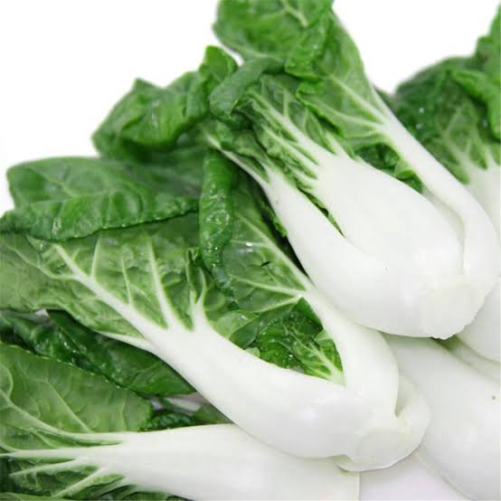
Bok choy has thick, crunchy leaf stalks and smooth, dark green leaves that grow together in a compact cluster. It is often described as looking like a cross between celery and lettuce. The two most common commercial types are the white-stemmed bok choy and the Shanghai bok choy, which has smooth green stems and a slightly sweeter flavour.
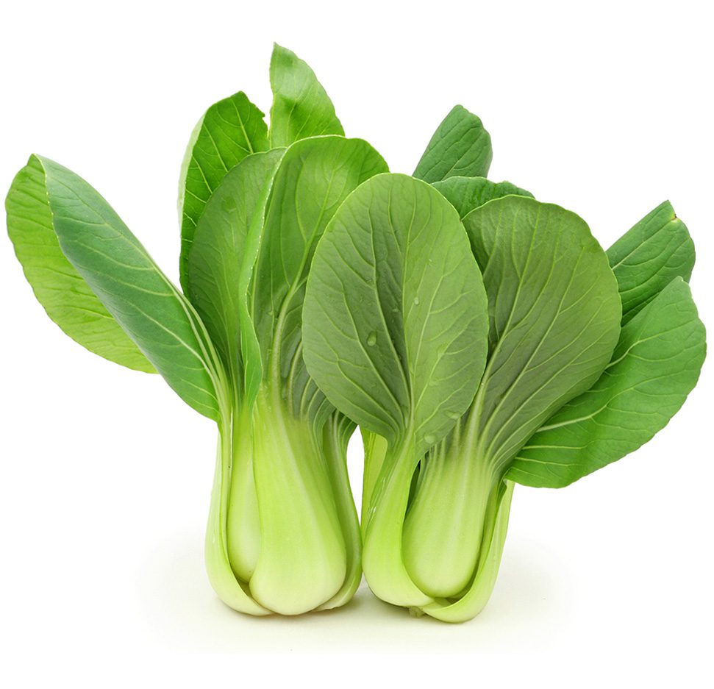
Bok choy is highly nutritious, being an excellent source of vitamins A, C, and K, as well as folate, calcium, and dietary fibre, while being naturally low in calories. It can be eaten raw in salads or cooked by steaming, stir-frying, boiling, or adding to soups, making it a popular vegetable in both Asian and Western cuisines.
Its rapid growth, high nutritional value, and strong consumer demand make bok choy an important commercial vegetable crop in New Zealand and many other countries.
The principles outlined are also applicable to other Asian Greens. For more specific information on growing different varieties, contact or visit a local grower.

Growing Bok Choy
Growing conditions
Bok choy (Brassica rapa subsp. chinensis) is a fast-growing Asian green that performs best in cool to mild conditions, with ideal temperatures of around 15°C–22°C. It can be grown outdoors throughout much of the year in suitable New Zealand regions, although growth is generally faster during warmer conditions.
Bok choy prefers fertile, well-drained loam soils with a soil pH of approximately 6.5–7.0. Good soil drainage is important because the crop has a relatively shallow root system and is sensitive to waterlogging. Waterlogged soils can reduce root health and increase the risk of root diseases.
Consistent soil moisture is essential because bok choy grows rapidly and produces tender, leafy stems and leaves. Irrigation should maintain even soil moisture, particularly during warm or dry weather. However, excessive irrigation and waterlogging should be avoided.
Bok choy is a short-duration crop and can be harvested relatively quickly. Baby plants may be ready for harvest in approximately 30–40 days, while plants grown to a larger marketable size may take around 40–60 days under favourable conditions. During cooler winter conditions, growth is slower and the crop may take longer to reach harvest size about 85 days.
For commercial production, growers carefully select the cultivar and planting time to match seasonal temperatures and the desired harvest size.

Cultivars
PPT Bok choy
Commercial growers select bok choy cultivars based on market demand, growing season, soil type, growing conditions, and disease resistance. Cultivars include green-stemmed and white-stemmed types, as well as baby bok choy varieties that are harvested at a younger stage. Growers look for cultivars that produce uniform plants with dark green leaves, thick, crisp stems, good flavour, and resistance to bolting. Where diseases such as clubroot or downy mildew are a concern, cultivars with improved disease resistance can help reduce crop losses and improve production reliability.
Sumo is a hybrid cultivar commonly grown commercially. It produces uniform plants with consistent size, shape and maturity and has good resistance to bolting. Its disease resistance and reliable performance make it a useful choice for commercial production.

Do: Activity 2: Choosing a hybrid

Calendar of operations site selection to harvest
PPT Bok Choy
The calendar of operations shows the main steps used to grow a commercial crop of field-grown Bok choy, from choosing the growing site through to harvesting.
The exact management practices may vary between growers and regions because of differences in soil type, climate, and available technology.
The information below is based on one crop cycle. Commercial growers repeat this cycle every week with the aim to ensure there is a continuous supply of bok choy ready to harvest throughout the year.
Bok Choy Crop Calendar of Operations
(Sowing weekly all year, Summer 6-8 weeks to harvest, winter 10-12 week to harvest)

Crop establishment
Site selection
Field-grown bok choy is commonly included in a crop rotation system, where different crops are grown in the same field across successive seasons. Rotating bok choy with non-Brassica crops helps maintain soil health and reduces the build-up of soil-borne pests and diseases, including clubroot. Rotation can also assist with weed management and reduce reliance on chemical controls.
An example of a crop rotation is:
Coriander
Spinach
Lettuce
Bok choy

Selecting a suitable site is essential for successful bok choy production. Bok choy grows best in fertile, well-drained soils with a pH above 6.5. Maintaining an appropriate soil pH is particularly important for reducing the risk of clubroot, a soil-borne disease affecting Brassica crops. If soil pH is below the desired level, lime can be applied before cultivation to raise the pH.
A sunny site with good air circulation promotes rapid, healthy growth and helps reduce disease risk. Poorly drained or waterlogged soils should be avoided, as excess water can contribute to root diseases and reduced plant growth.

Seedbed Preparation
Before sowing, residues from the previous crop are mulched and incorporated into the soil, where they are allowed to decompose for several weeks. This helps return organic matter and nutrients to the soil and reduces crop residue that could harbour pests and diseases.
The soil is then cultivated to create a fine, firm, raised seedbed. A well-prepared seedbed provides good seed-to-soil contact, supports even germination, promotes healthy root development, and provides suitable drainage for the shallow-rooted bok choy crop.
Cultivation practices vary between growers depending on soil type and available equipment, but a common approach uses GPS-guided machinery and several passes:
- First pass – Ripper / Subsoiler:
Deep tines break up compacted soil layers, improving soil structure, drainage and aeration.
- Second pass – Finer tines:
These further break up soil clods and create a friable soil structure suitable for planting.
- Third pass – Power harrow and bed maker:
The power harrow produces a fine soil tilth, while the bed maker forms the raised, firm seedbed ready for sowing.
NB - For more information on soil structure - Link to Soil Science
- PPT’s Soil Science and Visual Soil Structure Assessment
Sowing
Bok choy is commonly direct-sown into a carefully prepared seedbed. Pelleted and treated seed are sown using a precision seeder, which places seed at a consistent depth and spacing to produce a uniform crop and reduce the need for thinning.

Seed treatments
- Fungicide-treated seed helps protect young seedlings from diseases such as Pythium and damping-off.
- Depending on the production system, growers may use approved seed treatments or biological alternatives.
- Where birds are a problem, Avipel® may be used as a bird deterrent, according to its approved use and label directions.
To maintain a continuous supply of fresh bok choy, growers use succession sowing, establishing new crops at regular intervals, often with weekly sowings. The frequency of sowing is adjusted according to market demand, growing conditions and expected time to harvest.
Seeds are generally sown approximately 5–10 mm deep into a fine, firm seedbed with good seed-to-soil contact. The shallow sowing depth is suitable for the small seed and allows emerging seedlings to reach the soil surface quickly.
Plant and row spacing are adjusted according to the cultivar, production system and desired harvest size. Closer spacing can be used to produce smaller or baby bok choy, while wider spacing allows plants to develop larger stems and leaves.
Consistent soil moisture is particularly important during germination. The seedbed should be kept evenly moist but not waterlogged to encourage rapid and uniform germination.
As a guide, seed may be precision-drilled at approximately 12.5 cm between plants and 14 cm between rows, with 8 rows per140cm bed. Spacing can be adjusted to suit the cultivar, desired harvest size, growing system and available equipment.

Do
Activity 3: Practical Investigation Growing Bok Choy
PPT Steps involved in sowing seeds

Growth stage
Nutrient management
Bok choy is a fast-growing leafy vegetable with relatively high nutrient requirements, particularly nitrogen, which supports healthy leaf and stem growth. Before sowing, soil testing is carried out to determine soil pH and existing macro and micronutrient levels. The results help growers calculate the appropriate type and amount of fertiliser required for the crop. Because bok choy has a short growing period, much of its nutrient requirement can be supplied through a base fertiliser application with added micronutrients before sowing. However, if heavy rainfall occurs, nitrogen can be lost from the soil through leaching, particularly on light or sandy soils. Where additional nitrogen is required, growers may apply calcium ammonium nitrate (CAN) as a side-dressing during crop growth. Fertiliser applications are based on soil testing, crop requirements and growing conditions to avoid unnecessary nutrient losses.
- Nitrogen (N): Promotes vigorous leaf growth and development. However, excessive nitrogen can negatively affect crop quality and shelf life.
- Phosphorus (P): Supports strong root development and early crop establishment.
- Potassium (K): Supports overall plant health, stem quality and tolerance to environmental stress.
- Calcium (Ca) and magnesium (Mg): Important for healthy plant growth and maintaining good-quality leaves.
- Trace elements: Required in small quantities to support healthy plant development and prevent nutrient deficiencies.
Maintaining the appropriate soil pH (above 6.5) is important for crop health, but pH also affects the availability of some nutrients. Therefore, growers use soil testing and careful nutrient management to ensure nutrients remain available to the crop.

Do: Activity 4: Soil pH
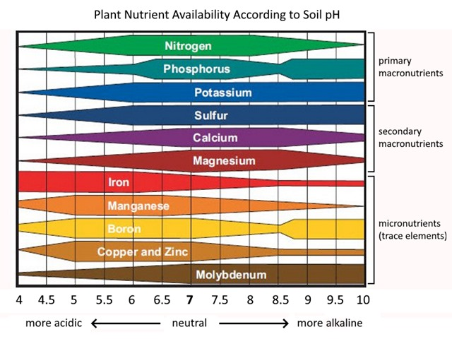

Pest and disease management
PPT Brassica pest & diseases
Bok choy is generally less susceptible to pests and diseases than many other Brassica crops. However, regular monitoring and preventative management are important to maintain crop health and market quality.
Common insect pests include aphids, slugs and caterpillars, including looper caterpillars and diamondback moth. These pests feed on the leaves and can cause damage that reduces both crop quality and marketability. Growers regularly monitor crops and, when necessary, use a combination of biological controls, cultural practices and approved insecticides.
Bok choy is relatively resilient to many diseases, although can be prone to damping-off, downy mildew, clubroot, Alternaria, bacterial leaf spot and white blister. Good management practices can help reduce disease risk, including:
- Maintaining soil pH above 6.5, which also helps reduce the risk of clubroot.
- Crop rotation to reduce the build-up of soil-borne pests and diseases.
- Resistant cultivars, where available.
- Pelleted and treated seed to support healthy crop establishment and reduce the risk of damping-off.
- Well-drained soils to reduce conditions favourable to disease.
- Appropriate plant spacing to improve air movement through the crop.
- Regular crop monitoring to identify pests and diseases early.
- Using approved pesticides and fungicides only when required and according to recommended thresholds.
- Rotating chemical modes of action to reduce the risk of pests and diseases developing resistance.
- Recording all chemical applications as part of Good Agricultural Practice (GAP) certification requirements.
Integrated Pest and Disease Management (IPDM) is an important part of successful commercial bok choy production. It combines regular crop scouting 2-3 times per week, monitoring, prevention, cultural and biological controls, and targeted chemical control when necessary to maintain healthy, high-quality and marketable crops.

Weed Management
Effective weed management is important for producing high-quality bok choy, as weeds compete with the crop for water, nutrients, sunlight and growing space. Weeds can also provide habitat for pests and diseases, making crop management more difficult.
Good weed control begins with careful soil preparation and the formation of a fine, firm seedbed. This provides favourable conditions for rapid and uniform germination and helps bok choy seedlings establish quickly and compete more effectively with emerging weeds.
Growers may also use a pre-emergence herbicide, where appropriate and approved, to reduce early weed growth and competition.

Irrigation
Bok choy is made up of approximately 95% water, so it requires a consistent supply of moisture throughout its growing period. Its shallow root system cannot access water deep in the soil, making it particularly sensitive to dry conditions. During hot, dry, or windy weather, daily irrigation may be necessary to prevent the soil from drying out. Consistent watering promotes rapid growth and helps produce crisp, tender leaves with good flavour, while reducing the risk of stress, bitterness, bolting (premature flowering), and poor-quality crops.

Harvesting
Commercial growers aim to harvest as close to 100% of marketable plants as possible. Bok choy is harvested by hand when plants reach the size and quality required by the target market. Harvesting is carried out regularly, often five days a week, to ensure the crop is harvested at peak freshness and to meet market demand.
Workers carefully select plants with healthy, dark-green leaves and firm white stems, with no significant signs of pest damage, disease or other defects. Plants are cut at the base using a sharp knife, and damaged or discoloured outer leaves are removed.
Harvested bok choy is placed carefully into clean crates or containers to minimise bruising and physical damage. Commercial growers aim to harvest as much of the crop as possible, with plants that do not meet the required quality standards left in the field.

Post-Harvest Handling
After harvest, bok choy is transported to the packhouse as quickly as possible to maintain freshness and quality. At the packhouse, the crop is inspected and damaged or poor-quality leaves are removed. The bok choy may then be washed to remove soil and other contaminants before being rapidly cooled to approximately 3°C to remove field heat.
Rapid cooling helps to:
- Maintain crispness and freshness
- Reduce water loss and wilting
- Slow respiration and deterioration
- Extend shelf life
- Maintain overall product quality

The cooled bok choy is then graded, packed and stored or transported under refrigerated conditions. Rapid movement through the supply chain helps ensure that consumers receive a fresh, high-quality product.

Do
- Bok choy questions (WS)
- Activity 5: careers in growing a crop

Technology
Commercial bok choy growers are increasingly investing in and trialling new technologies to improve efficiency, reduce input use and make better production decisions. GPS-guided machinery is now commonly used for cultivation, planting and spraying, helping growers work accurately and consistently across the field.
Soil moisture probes can measure soil moisture levels and provide information about when irrigation is needed. Growers can use these measurements alongside weather forecasts to adjust irrigation schedules, avoid unnecessary watering before rainfall, and plan for periods of hot, dry weather or longer-term drought.
Digital tools are also being used for pest and disease monitoring. Online disease and pest monitoring services, including BioScout stations, can provide growers with information to help identify disease risks and make more timely management decisions.
Growers are also trialling artificial intelligence (AI) and automated equipment. AI-guided mechanical weeders can identify and remove weeds while reducing the need for manual labour and herbicides. AI-assisted sprayers are also being trialled to identify and target weeds more precisely, potentially reducing chemical use and improving application efficiency.

Do: Activity 6: Role of technology.

Challenges
Vegetable growers play a vital role in supplying fresh, healthy food to people throughout the country. Every day, growers produce vegetables that are sold in supermarkets, restaurants, farmers' markets, and meal kit companies. However, producing vegetables has become increasingly difficult. Growers are facing a combination of environmental, economic, and labour challenges that make it harder to remain profitable while continuing to produce affordable, high-quality food. These challenges include increasing environmental regulations, rising production costs, labour shortages, extreme weather events, pest and disease pressures, limited access to suitable growing land and changing consumer demands.

Do
- Activity 7: Challenges Facing NZ Vege Growers (WS)
or
- Sustainable Vegetable Production (WS).
- Growers say Waikato PC1 threatens vegetable supply (WS)

