Activity 4: Soil pH, Clubroot and Nutrient Availability

Brassica growers carefully manage soil pH because it affects both plant nutrient availability and the risk of clubroot. Maintaining soil pH around 6.5–7.5 is commonly recommended for Brassica production, while raising the pH can help suppress clubroot. However, very high pH can reduce the availability of some nutrients.

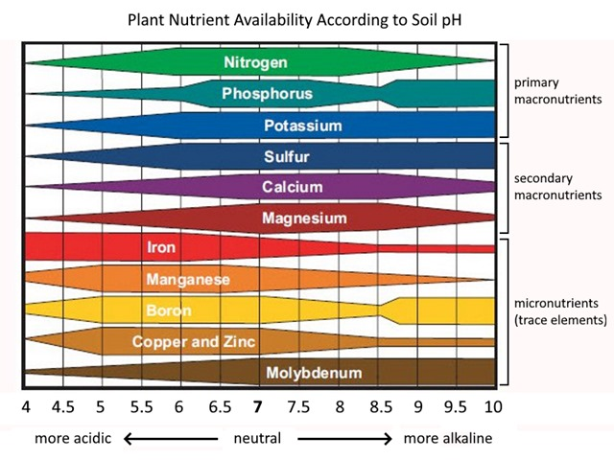

Use your class resources and diagram above to research the answers to the questions on how growers manage soil pH in commercial Bok choy production.

Questions
- How can growers increase soil pH?
- How does soil pH affect nutrient availability?
- Identify two nutrients that may become less available when soil pH is too high.
- Why can raising soil pH help reduce clubroot?
- A grower has a soil pH of 5.8 and plans to grow bok choy.
- What problem could this create?
- What could the grower do to increase the soil pH?
- A different field has a soil pH of 7.5.
- What nutrient availability problems could occur?
- Why would the grower need to carry out soil testing before applying fertiliser?
- How could a grower balance the need to manage clubroot with the need to keep nutrients available to the crop?
- Imagine you are managing a commercial bok choy crop. Your soil test shows that the pH is 6.2. Write a short recommendation explaining:
- Whether the soil pH should be changed.
- What management action you would take?
- Why soil testing is important?
- How you would avoid creating nutrient deficiencies?
Answers
- How can growers increase soil pH?
Growers can increase soil pH by applying lime (calcium carbonate). The amount needed depends on the soil type and soil test results.

- How does soil pH affect nutrient availability?
Soil pH affects how easily plant roots can take up nutrients. If the pH is too low or too high, some nutrients become less available to plants, which can lead to nutrient deficiencies.

- Identify two nutrients that may become less available when soil pH is too high.
Iron (Fe) and manganese (Mn) can become less available at high soil pH. Zinc and phosphorus availability can also be affected.

- Why can raising soil pH help reduce clubroot?
Clubroot is caused by the soil-borne pathogen Plasmodiophora brassicae. Raising acidic soil pH, particularly through liming, can make soil conditions less favourable for the development and spread of clubroot, reducing disease severity.

- A grower has a soil pH of 5.8 and plans to grow bok choy.
- What problem could this create?
The soil is too acidic for optimum bok choy production and may increase the risk and severity of clubroot. Some nutrients may also become less available or more difficult for the plant to use.
- What could the grower do to increase the soil pH?
The grower could apply lime, based on soil test results and the recommended application rate. The lime should be incorporated into the soil before planting.

- A different field has a soil pH of 7.5.
- What nutrient availability problems could occur?
At a high pH, micronutrients such as iron, manganese and zinc can become less available to plants, potentially causing deficiency symptoms.
- Why would the grower need to carry out soil testing before applying fertiliser?
Soil testing shows which nutrients are already present and helps the grower apply the correct fertiliser and amount. This avoids unnecessary applications, reduces costs and helps prevent nutrient losses to the environment.

- How could a grower balance the need to manage clubroot with the need to keep nutrients available to the crop?
The grower could maintain soil pH within a suitable range rather than making the soil excessively alkaline. Regular soil testing can help determine the correct pH and nutrient levels. The grower can then use appropriate fertilisers and other management practices, such as crop rotation and resistant cultivars, to reduce clubroot risk without creating nutrient deficiencies.

- Soil test shows a pH of 6.2 — what would you recommend?
I would recommend slightly increasing the soil pH because 6.2 is below the preferred range for bok choy and Brassica production. The grower could apply lime at the rate recommended from the soil test and allow sufficient time for it to raise the pH before planting. Further soil testing would confirm whether the target pH has been reached.
Soil testing is important because it shows both soil pH and nutrient levels, allowing fertiliser and lime applications to be matched to the crop's needs. I would avoid raising the pH excessively because very high pH can reduce the availability of nutrients such as iron and manganese. Crop rotation and the use of suitable clubroot tolerant/resistant cultivars could also help manage clubroot risk.

