Demand for Asian Greens ramps up by up to 400 percent in recent years

Read “Demand for Asian Greens ramps up by up to 400 percent in recent years, grower says” and answer the questions and do task 1.
- What types of Asian Greens does Woodhaven Gardens grow?
- By how much has the demand for some Asian Greens increased in recent years?
- Why did Woodhaven Gardens decide to increase their plantings of Asian Greens?
- Which traditional vegetables have become less popular compared with Asian Greens?
- According to Jay Clarke, what are some reasons more New Zealanders are eating Asian Greens?
- How have the internet, cooking shows, and meal kit companies helped increase interest in Asian Greens?
- What challenges do growers face when producing Asian Greens?
- Why does Jay Clarke say Asian Greens can be more efficient to grow than vegetables like lettuce and broccoli?

Task 1: Find out more about Asian vegetables
Choose one Asian Green from the article e.g., bok choi or wombok. Create a poster or slideshow that includes:
- What it looks like
- How it is cooked or eaten
- Where it originally comes from
- One interesting fact about it

Demand for Asian Greens ramps up by up to 400 percent in recent years, grower says
https://www.rnz.co.nz/news/country/453079/demand-for-asian-Greens-ramps-up-by-up-to-400-percent-in-recent-years-grower-says
A Levin vegetable grower says demand for Asian Greens has increased by nearly 400 per cent in the last couple of years.
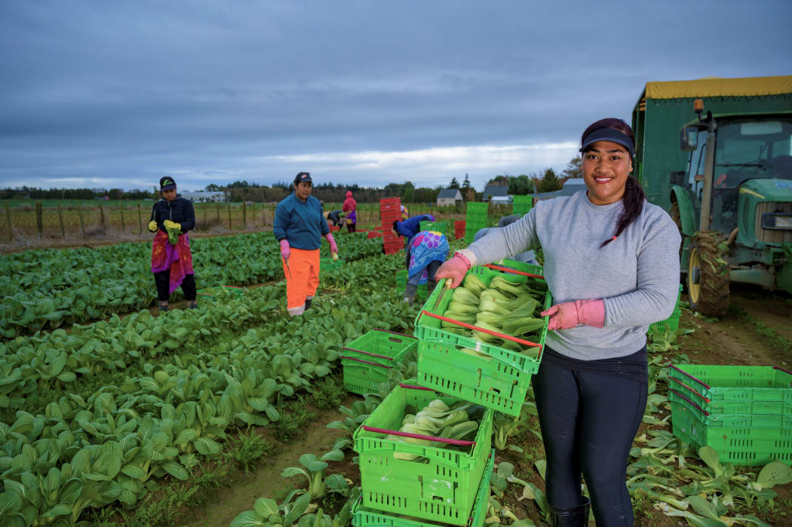
Workers harvesting Asian Greens. Photo: Supplied / Woodhaven Gardens

Woodhaven Gardens has grown some Asian Greens for about 20 years but ramped up plantings four years ago after seeing growing demand in the market.
Company director Jay Clarke said they grew Shanghai bok choi, pak choi, wombok or Chinese cabbage, Saigon turnip and coriander.
"We started with some trials and things have really taken off, we've seen some of our traditional lines coming back in volume and becoming less popular things like green cabbage and iceberg lettuce but the shanghai bok choi, wombok and Saigon turnip have really grown in popularity," Clarke said.
"In the last two to three years we've seen growth of between 300 and 400 percent in those lines."
Clarke believed the growth in demand is being driven by New Zealanders trying new foods and expanding their culinary expertise.
"People are going out there experiencing different foods when they're eating out and then they're bringing those culinary choices into their own home.
"With access to the internet and online cooking shows and even programmes like My Food Bag and HelloFresh they're putting different recipes into New Zealand households so people are exploring more and finding that there are ways to eat fresh, healthy vegetables and tasty dishes that are a little bit different from what we've traditionally done in New Zealand."
Growing Asian Greens did come with difficulties as caterpillars loved to eat them as much as much as consumers do, Clarke said.
"Pest control can be a little problematic but other than that they are fun crops to grow, they're quite handy for us because we can direct drill them rather than transplant so there's a step in the process that we don't have to go through that we do with things like lettuce and broccoli, so they're efficient vegetables to grow."

Answers
- What types of Asian Greens does Woodhaven Gardens grow?
Woodhaven Gardens grows a variety of Asian Greens including Shanghai bok choi, pak choi, wombok (Chinese cabbage), Saigon turnip, and coriander. These vegetables are popular in many Asian dishes and are becoming more common in New Zealand supermarkets and homes.

- By how much has the demand for some Asian Greens increased in recent years?
Jay Clarke said that demand for some Asian Greens has increased by between 300 and 400 percent over the last two to three years. This means many more New Zealanders are buying and eating these vegetables than in the past.

- Why did Woodhaven Gardens decide to increase their plantings of Asian Greens?
Woodhaven Gardens increased their plantings after noticing a growing demand in the market. They first tested growing Asian Greens through small trials and found that customers were becoming more interested in buying them. As popularity increased, the company expanded production to meet customer demand.

- Which traditional vegetables have become less popular compared with Asian Greens?
Jay Clarke explained that some traditional vegetables, such as green cabbage and iceberg lettuce, have become less popular. At the same time, vegetables like Shanghai bok choi, wombok, and Saigon turnip have increased in popularity as people look for different and more exciting food options.

- According to Jay Clarke, what are some reasons more New Zealanders are eating Asian Greens?
Jay Clarke believes New Zealanders are becoming more adventurous with food and are trying different cuisines when eating out. People are also learning new cooking skills and recipes, which encourages them to use a wider variety of vegetables at home. Many people are also looking for fresh, healthy, and tasty meal options.

- How have the internet, cooking shows, and meal kit companies helped increase interest in Asian Greens?
The internet and online cooking shows give people access to recipes and ideas from around the world, making it easier to learn how to cook with Asian Greens. Meal kit companies such as My Food Bag and HelloFresh include these vegetables in their recipes, helping families try new foods and cooking styles. This exposure has helped Asian Greens become more familiar to New Zealand households.

- What challenges do growers face when producing Asian Greens?
One major challenge is pest control because caterpillars like to eat Asian Greens. Growers need to carefully manage pests to protect their crops and maintain good-quality vegetables. Even though pests can be a problem, Jay Clarke says Asian Greens are still enjoyable crops to grow.
- Why does Jay Clarke say Asian Greens can be more efficient to grow than vegetables like lettuce and broccoli?
Jay Clarke says Asian Greens are efficient because many of them can be direct drilled, meaning the seeds are planted straight into the soil instead of first being grown as seedlings and then transplanted. This saves time, labour, and extra steps in the growing process compared to other crops such as broccoli.

