GROWING A MARKET FOR ASIAN GREENS
Watch https://nzfetrust.org.nz/stories/peter-and-michelle-pan-of-healthy-and-fresh/
Read “Growing a Market for Asian Greens “and answer the questions.
Questions
- How do Peter and Michelle grow Asian Greens using hydroponic systems and greenhouses?
- What are three reasons Peter and Michelle chose to invest in growing Asian Greens hydroponically instead of using traditional farming methods?
- What sustainable practices does Healthy & Fresh use to reduce waste and protect the environment?
- Why is the demand for Asian Greens increasing in New Zealand?
- What are the advantages of growing vegetables inside greenhouses compared with growing them outdoors?
- How are supermarkets, food kits, and restaurants helping introduce more New Zealanders to Asian Greens?
- Why does Peter believe wong bok could become as popular as cabbage in the future?
- What skills and qualities do you think Peter and Michelle need to successfully run their business?
- What do you think this business will need in the future to remain viable and productive?

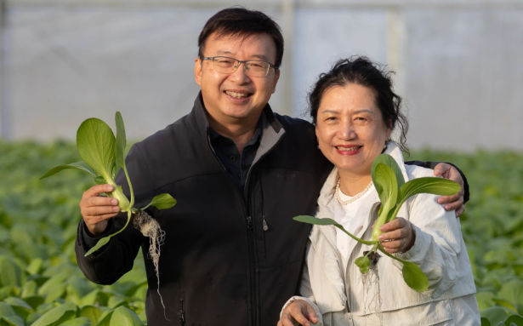

Growing a Market for Asian Greens
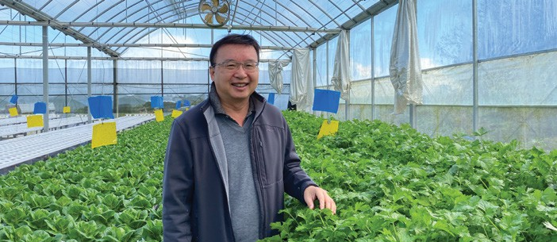
NZ Grower August 2024
Grower Peter Pan in one of the new greenhouses developed at Karaka, south of Auckland

After many years of working with fresh produce, it wasn’t until 2020 that Peter and Michelle Pan started growing fruit and vegetables commercially.
HELENA O’NEILL talks with Peter about the growing interest in Asian Greens and why the couple opted for hydroponics.
In rural Karaka, south of Auckland, Peter and Michelle Pan own Healthy & Fresh, a business growing Asian Greens hydroponically. They grow around 25 different crops in 15 greenhouses at the Karaka site.
Initial capital costs for a hydroponic operation were large, but Peter says traditional methods of farming are resource intensive and taxing on the environment. Hydroponic farming is a more sustainable way of farming, reducing the use of many unnecessary components of traditional farming, such as soil, pesticides and excess fertiliser. Additionally, using greenhouses means that crops are less susceptible to weather damage, reducing wastage.
“It also offers more precise growing,” Peter says.
Hydroponic systems allow better control over supply, along with standardising crops and products. The tabletop heights also reduce back injuries, and working in greenhouses means that staff avoid working in the rain or having harvesting hampered by weather conditions, he adds.
Asian Greens grow well in the hydroponic system, with a small number of pests controlled by sticky insect cards.
Setting up a large number of greenhouses in 2020 offered a significant set of challenges posed by the Covid-19 pandemic and its many restrictions. As one example, Peter says a truck arrived on site from Christchurch with a large number of huge pipes that needed to be unloaded, but the building crews had already removed their machinery from the site.
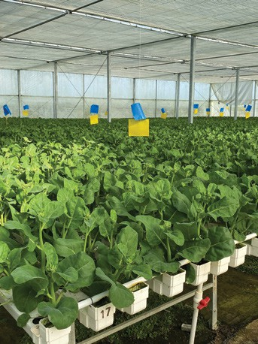
Thankfully Peter was able to source some help from the previous owner of the property, who used his tractors to roll the pipes off the truck.
It was a stressful start to the project, he says.
While the size of the pipes added some logistical challenges, Peter was relieved that their size allowed the greenhouses to avoid being flooded in last year’s adverse weather events.
“If we can get through Covid, we can get through anything.
Gai Lan (Chinese broccoli) grown hydroponically
Produce is packed on-site, and rainwater supplies a large storage pond, also allowing for water from inside the greenhouses to be recycled. The business also completed building a new 9000 square metre distribution centre in Mangere in January.
We also import dragon fruit and pomelo from Vietnam, ginger and durian from Thailand, and so on. We are expanding our import operations, our cooler at the distribution centre is very big so we have room to expand. We’re also looking for more land to add greenhouses on.
“We do have a passion. We would like to change the way things are grown. You see how tomatoes used to be grown outdoors but are now all grown indoors, the same for capsicums and cucumbers.”
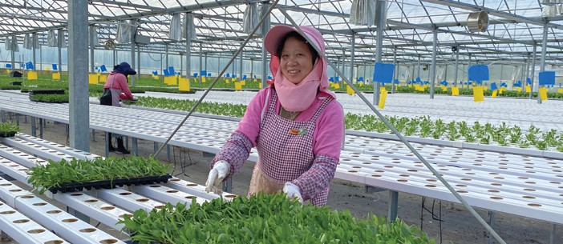
Now with several seasons under his belt, Peter says it has been heartening to see increasing interest in Asian Greens. Their three most popular products are Shanghai bok choy, fancy lettuces and wong bok (Chinese cabbage).
Healthy & Fresh grow 26 varieties of Asian Greens across 15 greenhouses

“We’re here to make a dollar, but we want to offer Kiwis more options for their plates. Asian Greens are nice eating vegetables, and many are quick to cook. In my heart, I believe that one day wong bok will take over from cabbage. I can see the growth in demand for wong bok. We are creating a market.”
Healthy & Fresh supplies supermarkets and fruit and vegetable stores across the country, including air freighting products to Queenstown. They are also supplying some chain restaurants.
He says the Kiwi palate has adapted to include more Asian Greens, with a marked increase over the past five years.
Food kits like My Food Bag also help introduce more people to Asian Greens, Peter says, with something like broccolini sometimes replaced with gai lan (also called Chinese broccoli or Chinese kale).
“It can be a good way to introduce new or different vegetables to people. They might be surprised to have it [in their box] but there’s no harm in trying it.”
Reflecting on his time in the produce sector, Peter says the early 1990s were a challenging time.
“The economic situation was so bad that restaurants were closing, so we set up fruit and vegetable stores because people need to eat. We expanded to eight stores in the Vege World days.”
Later becoming part of Fruit World, it became the biggest chain of fruit and vegetable supermarkets with stores across Auckland and south to Cambridge.
“My whole working life has been in produce, and I still enjoy it.”
Peter has also played a significant role in developing the Asian Greens market working with others in the food industry like Foodstuffs to develop pack sizes and build up Asian produce categories.
Earlier this year Foodstuffs North Island head of produce and butchery, Brigit Corson told NZGrower that Asian Greens continue to grow in popularity with their customers, with a 19 percent increase in customers regularly buying Asian Greens last year. Shanghai bok choy is the most popular produce with great supply year-round which
helps drive sales.
Last season the business trialed growing watermelons to make the most of the quick growing time over the less busy Christmas period.
“They grow really well indoors, we control the temperature between 35 and 40 degrees Celsius, dropping to normal outdoor temperatures at night. The variance in temperature makes them very sweet. We give them enough water, so they are very juicy compared with melons grown outdoors.”
Peter says growing watermelons in an existing vegetable system utilises the space that would otherwise be under-utilised. Hydroponically grown melons are cleaner, faster and don’t affect the soil.
He has discovered that some crops perform better if planted in an alternating pattern, and other crops require more space to flourish, while others need to be grouped closer together to grow evenly.
He says they are always learning and enjoy experimenting with new varieties of crops and adjusting growing techniques.

Answers
- How do Peter and Michelle grow Asian Greens using hydroponic systems and greenhouses?
Peter and Michelle grow Asian Greens hydroponically, which means the plants are grown in water with nutrients instead of soil. The crops are grown inside 15 greenhouses at their Karaka property south of Auckland. The greenhouses protect the vegetables from bad weather and help control temperature and growing conditions. The hydroponic system allows the plants to receive the right amount of water and nutrients, helping them grow evenly and quickly. They also use sticky insect cards to control pests instead of relying heavily on pesticides.

- What are three reasons Peter and Michelle chose to invest in growing Asian Greens hydroponically instead of using traditional farming methods?
- Hydroponics is more environmentally sustainable because it uses less soil, water, pesticides, and fertiliser.
- Growing crops in greenhouses protects them from weather damage such as heavy rain or flooding, reducing waste and crop loss.
- Hydroponic systems allow more precise growing conditions, helping produce consistent, high-quality vegetables while also making work easier and safer for staff.

- What sustainable practices does Healthy & Fresh use to reduce waste and protect the environment?
Healthy & Fresh uses several sustainable practices. They collect rainwater and store it in a pond for irrigation. Water from inside the greenhouses is recycled and reused, reducing waste. Hydroponics also reduces the need for soil, excess fertiliser, and pesticides. Growing crops in greenhouses lowers the risk of weather damage, which means fewer vegetables are wasted. They also make efficient use of greenhouse space by growing different crops during quieter seasons.

- Why is the demand for Asian Greens increasing in New Zealand?
The demand for Asian Greens is increasing because more New Zealanders are interested in healthy, fresh, and quick-to-cook vegetables. Asian foods and flavours have become more popular, and many people now enjoy trying different vegetables such as bok choy, gai lan, and wong bok. Supermarkets, restaurants, and food kit companies like My Food Bag are also introducing customers to Asian Greens through recipes and meal boxes. Peter says the Kiwi palate has changed over the past five years, leading to higher demand.

- What are the advantages of growing vegetables inside greenhouses compared with growing them outdoors?
Greenhouses protect crops from bad weather such as heavy rain, wind, or flooding. This reduces damage and food waste. Greenhouses also allow growers to control temperature and growing conditions more carefully, helping plants grow evenly and consistently. Workers benefit too because they can work indoors without being affected by rain or poor weather. Crops can often be grown faster and with fewer pests inside greenhouses.

- How are supermarkets, food kits, and restaurants helping introduce more New Zealanders to Asian Greens?
Supermarkets are selling more Asian Greens and creating larger produce sections for them. Restaurants are using Asian Greens in meals, allowing customers to try them in different dishes. Food kit companies like My Food Bag help people cook with unfamiliar vegetables by including them in recipe boxes with instructions. For example, gai lan may be included instead of broccolini, encouraging customers to try something new at home.

- Why does Peter believe wong bok could become as popular as cabbage in the future?
Peter believes wong bok could become as popular as cabbage because it is healthy, versatile, and easy to cook. As more New Zealanders try Asian Greens, demand for wong bok continues to grow. He thinks people are becoming more open to different vegetables and flavours, and wong bok can be used in many meals such as stir-fries, soups, and salads.

- What skills and qualities do you think Peter and Michelle need to successfully run their business?
Peter and Michelle need strong problem-solving skills, especially when facing challenges like Covid-19 restrictions and severe weather. They also need knowledge about growing crops hydroponically, business management skills, and the ability to adapt and experiment with new growing techniques. Persistence, teamwork, innovation, and a passion for fresh produce are also important qualities that help them succeed.

- What do you think this business will need in the future to remain viable and productive?
To remain successful in the future, the business will need to continue adapting to customer demand and experimenting with new crops and growing methods. They may need to expand their greenhouse space and import operations to meet increasing demand. Continuing to use sustainable practices will also be important as people become more environmentally aware. Building strong relationships with supermarkets, restaurants, and food companies will help the business keep growing and remain competitive.

