Greenhouse Vegetable Growers Peter and Michelle Pan
Watch: the video and read “Greenhouse Vegetable Growers Peter and Michelle Pan” and answer the questions.
Video: https://nzfetrust.org.nz/stories/peter-and-michelle-pan-of-healthy-and-fresh/
Questions
- Healthy and Fresh uses hydroponic nutrient film technique (NFT) systems, natural sunlight, and innovative pest control methods in its greenhouses.
Describe each of these practices and explain how they help the business produce leafy Greens more sustainably.
- The Pans have planted more than 100,000 native trees and shrubs along riparian areas and aim to produce vegetables that are less dependent on weather conditions.
Explain how these practices help protect the environment and improve the long-term sustainability of their business.
- Peter and Michelle Pan believe that using new agricultural technologies will improve New Zealand's food security.
Using evidence from the article and video, explain how greenhouse production and hydroponic growing can help provide a reliable supply of fresh vegetables while reducing environmental impacts.

Greenhouse Vegetable Growers Peter and Michelle Pan
Watch https://nzfetrust.org.nz/stories/peter-and-michelle-pan-of-healthy-and-fresh/

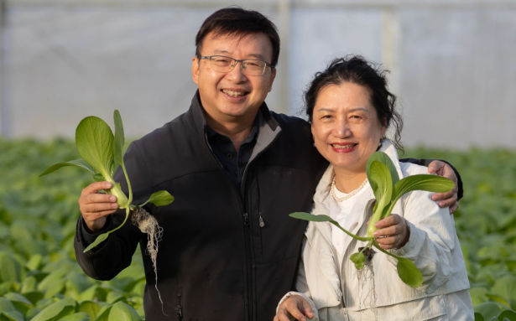
Healthy and Fresh14 Feb 2022025 Auckland Regional Supreme Winner: Peter and Michelle Pan of Healthy and Fresh – Horticulture
This family-owned company established in 2008 has grown into a major supplier of fresh produce and ethnic food to supermarkets across New Zealand.
Healthy and Fresh is led by Managing Director Peter Pan, with management support from Director Michelle Pan. They lead a team that manages two divisions – a distribution centre in Mangere and a farm division in Karaka.
The 28ha farm features 15 greenhouses that span 60,000 square meters. In 2020, the company embarked on an ambitious project to establish the largest hydroponic farm for leafy Greens in New Zealand. This led to the implementation of a cutting-edge hydroponic nutrient film technique system that ensures efficient water and nutrient use.
Energy efficiency is prioritised, with sunlight used as the primary energy source. Meanwhile, innovative pest control methods minimise the need for spraying.
More than 100,000 native trees and shrubs have been planted along riparian areas, stabilising the soil, reducing erosion and supporting the sustainability of the broader ecosystem’s waterways.
Healthy and Fresh specialises in leafy Greens and melons, cultivating 30 different varieties. The team is striving to introduce more varieties of Asian Greens to Kiwi households, enriching their meals with fresh and diverse produce.
Driven by a strong interest in innovative agri-technologies, the team plans to further refine its sustainable farming model. Ultimately, their aim is to achieve a consistent supply of safe and healthy vegetables that is less dependent on weather conditions. They believe this will enhance New Zealand’s food security and contribute to a more sustainable food system.
Healthy and Fresh exemplifies the potential of sustainable agriculture, demonstrating that high-quality, locally grown produce can be successfully produced while minimising the impact on the environment.
Peter and Michelle were the winners of the Ballance Agri-Nutrients Soil and Nutrient Management Award, Bayleys People in Primary Sector Award, Hill Labs Agri-Science Award, Norwood Farming Efficiency Award, NZFET Innovation Award, and the Auckland Regional Supreme Winners 2025.

Answers
- Healthy and Fresh uses hydroponic nutrient film technique (NFT) systems, natural sunlight, and innovative pest control methods in its greenhouses. Describe each of these practices and explain how they help the business produce leafy Greens more sustainably.
- Hydroponic nutrient film technique (NFT): In this system, plants are grown without soil. Their roots sit in a shallow stream of water containing carefully balanced nutrients. This allows plants to receive exactly the water and nutrients they need, reducing waste and using water much more efficiently than traditional farming.
- Natural sunlight: Instead of relying mainly on artificial lighting, the greenhouses use sunlight as the primary energy source. This reduces electricity use, lowers energy costs, and decreases greenhouse gas emissions.
- Innovative pest control: The farm uses modern pest management methods that reduce the need for chemical sprays. This helps protect beneficial insects, reduces chemical residues on crops, and lowers the environmental impact of growing vegetables.

- The Pans have planted more than 100,000 native trees and shrubs along riparian areas and aim to produce vegetables that are less dependent on weather conditions. Explain how these practices help protect the environment and improve the long-term sustainability of their business.
Planting more than 100,000 native trees and shrubs along riparian areas helps stabilise the soil, reducing erosion and preventing sediment from entering streams and rivers. The vegetation also improves water quality and provides habitats for native birds, insects, and other wildlife, increasing biodiversity.
Growing vegetables in greenhouses makes production much less dependent on weather conditions such as heavy rain, strong winds, frost, or drought. This means crops are more reliable and less likely to be damaged by extreme weather.
These practices protect natural ecosystems while allowing Healthy and Fresh to produce a consistent supply of vegetables. This improves the long-term sustainability and profitability of the business.

- Peter and Michelle Pan believe that using new agricultural technologies will improve New Zealand's food security. Using evidence from the article and video, explain how greenhouse production and hydroponic growing can help provide a reliable supply of fresh vegetables while reducing environmental impacts.
Greenhouse production and hydroponic growing help improve food security by allowing vegetables to be grown consistently throughout the year, regardless of weather conditions. This means supermarkets and consumers can continue to receive fresh vegetables even when outdoor crops are affected by storms, droughts, or frost.
Hydroponic systems use water and nutrients very efficiently by delivering them directly to the plant roots. This reduces water waste and ensures plants receive the correct amount of nutrients for healthy growth.
Greenhouses also protect crops from pests and harsh weather, reducing crop losses and helping growers produce reliable harvests. Using sunlight as the main energy source and reducing the need for chemical sprays further lowers the farm's environmental impact.
Combining greenhouse production, hydroponic technology, and environmentally friendly farming practices, Healthy and Fresh can produce safe, high-quality vegetables while protecting natural resources. This helps ensure there is a reliable supply of fresh food now and into the future.

