Sustainable Vegetable Production – The Fresh Grower

As a class, read Allan Fong and the Fresh Grower family - The Fresh Grower.
Discuss and answer the following questions.
Questions
- The Fong family describes their land as their "factory." What do you think they mean by this, and why is caring for the soil essential for the long-term success of their business?
- Describe at least four farming practices the Fong family uses to protect soil health and reduce environmental impacts.
- Explain how each practice contributes to sustainable vegetable production.
- The Fresh Grower has reduced fertiliser use by 25% and designed paddocks with silt traps to reduce runoff. Explain how these practices benefit both the environment and the business.
- How does technology help the Fong family farm more sustainably?
- The article states that crops are grown in rotation and cover crops are planted when paddocks are not being used. Explain why these practices are important for maintaining healthy soils and reducing pests and diseases.
- Imagine you are advising another vegetable grower who wants their business to be successful for the next 60 years. Based on this article, what lessons could they learn from the Fong family? Use evidence from the article to justify your answer.

Allan Fong and the Fresh Grower family- The Fresh Grower
https://nzfetrust.org.nz/stories/allan-fong-the-fresh-grower-family-of-the-fresh-grower/
15 Mar 2023
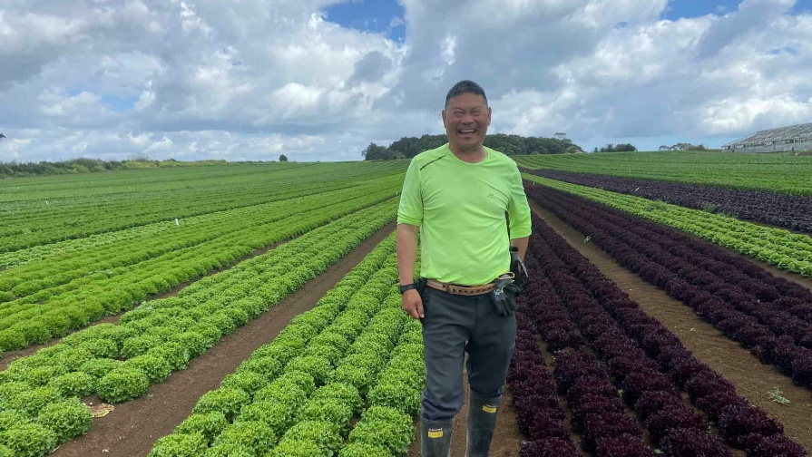
2023 Finalists: Allan Fong and the Fresh Grower family of The Fresh Grower – Horticulture
The team at The Fresh Grower are focused on protecting and nurturing their rich Pukekohe soil as they strive to continue producing top-notch produce for consumers.
Led by Allan, Colin, Cameron and Daniel Fong, and Garry Yee, this family business has been successfully producing vegetables for 60 years, primarily for the domestic market.
This means the team has a deep knowledge of their market, their business and the 200ha property’s soils. They see the land as their factory, with all practices aimed at improving and enhancing this natural environment.
Among their most successful environmental initiatives is a 25% reduction in fertiliser use, achieved by tailoring inputs to seasons, crops and soils. They’ve also significantly reduced runoff by designing paddocks where the water flows through soil silt traps.
Every paddock’s soil is tested annually and biochar added to increase carbon levels. Cover crops ensure the soil is never left bare, while ploughing techniques are tailored to help maintain soil structure.
Practises and techniques have been altered to reduce the amount of soil lost through cultivation. By using GPS in tractors, they have reduced the number of passes – an approach that also uses less fuel. The direction of planting matches the prevailing wind, reducing spray drift onto adjacent properties.
Technology and knowledge guide the management of a huge variety of crops which are grown on rotation. All farm activity is recorded – from seed to harvest – providing valuable data to inform future growing and for consumers.
Being in tune with the needs of their 100 staff has resulted in an excellent team culture which contributes to the success of the business.
By continuing to care for the land, the team’s aim is to sustain production for future generations, and to continue surprising consumers with new products, textures and flavours.
Answers
- The Fong family describes their land as their "factory." What do you think they mean by this, and why is caring for the soil essential for the long-term success of their business?
The Fong family describes their land as their "factory" because it is the place where all of their vegetables are produced. Just as a factory must be maintained to keep producing products, the farm's soil must be kept healthy so it can continue growing high-quality crops year after year.
Caring for the soil is essential because healthy soil supplies plants with nutrients, stores water, supports beneficial organisms, and provides good conditions for root growth. If the soil becomes degraded or loses fertility, crop yields and quality will decrease. By protecting their soil, the Fong family ensures they can continue producing vegetables for future generations while maintaining a profitable business.

- Describe at least four farming practices the Fong family uses to protect soil health and reduce environmental impacts.
- Reducing fertiliser use by 25% through careful management.
- Testing the soil in every paddock each year.
- Adding biochar to increase soil carbon.
- Growing cover crops so the soil is never left bare.
- Rotating different crops between paddocks.
- Using ploughing methods that protect soil structure.
- Building silt traps to reduce runoff.
- Using GPS-guided tractors to reduce the number of machinery passes and save fuel.
- Recording all farm activities from seed to harvest to improve future decision-making.

- Explain how each practice contributes to sustainable vegetable production.
- Reducing fertiliser use decreases pollution and lowers production costs while still providing crops with the nutrients they need.
- Annual soil testing allows fertiliser to be applied only where needed, preventing waste and protecting the environment.
- Adding biochar increases soil carbon, improves soil structure, and helps the soil retain water and nutrients.
- Cover crops protect the soil from erosion, add organic matter, improve soil fertility, and suppress weeds.
- Crop rotation reduces the build-up of pests and diseases while improving soil health.
- Careful ploughing techniques reduce soil erosion and maintain good soil structure.
- Silt traps prevent valuable soil and nutrients from washing into streams and rivers.
- GPS-guided tractors reduce soil compaction, lower fuel use, and decrease greenhouse gas emissions.
- Keeping detailed records helps growers improve production methods and make better management decisions each season.

- The Fresh Grower has reduced fertiliser use by 25% and designed paddocks with silt traps to reduce runoff. Explain how these practices benefit both the environment and the business.
Using less fertiliser reduces the amount of excess nutrients that can wash into rivers and streams, helping protect water quality and aquatic ecosystems. It also means fewer chemicals are used, reducing the farm's environmental impact.
Silt traps slow down water movement and catch soil before it leaves the paddock. This prevents valuable topsoil from being lost and reduces sediment entering waterways.
These practices also benefit the business because they reduce fertiliser costs, keep valuable soil on the farm, improve soil productivity, and help ensure the land remains productive for many years.

- How does technology help the Fong family farm more sustainably?
- GPS-guided tractors reduce the number of passes across the paddock, saving fuel, reducing greenhouse gas emissions, and minimising soil compaction.
- Annual soil testing helps determine exactly how much fertiliser each paddock needs, avoiding unnecessary applications.
- Detailed record keeping from seed to harvest allows the growers to monitor crop performance, improve future growing practices, and provide traceability for consumers.
- Using information about soils, seasons, and crops helps apply resources more efficiently and sustainably.

- The article states that crops are grown in rotation and cover crops are planted when paddocks are not being used. Explain why these practices are important for maintaining healthy soils and reducing pests and diseases.
Growing different crops in rotation helps prevent pests and diseases from building up because many pests only attack certain crops. Changing crops interrupts their life cycles and reduces the need for chemical controls.
Cover crops protect the soil when commercial crops are not growing. They reduce erosion caused by wind and rain, add organic matter to the soil, improve soil structure, increase biological activity, and help suppress weeds.
Together, crop rotation and cover crops improve soil fertility, protect the environment, and support long-term sustainable farming.

- Imagine you are advising another vegetable grower who wants their business to be successful for the next 60 years. Based on this article, what lessons could they learn from the Fong family? Use evidence from the article to justify your answer.
A grower wanting long-term success should focus on protecting the soil and using sustainable farming practices. The Fong family shows that healthy soil is the foundation of a successful vegetable business.
The grower should regularly test soil, apply fertiliser only when needed, use crop rotation and cover crops, reduce soil erosion with silt traps, and adopt technologies such as GPS-guided tractors to improve efficiency. Keeping detailed farm records can also help improve future decisions and production.
The article also shows that caring for employees and continually looking for ways to improve the business are important. By protecting natural resources while using technology wisely, growers can reduce costs, protect the environment, and continue producing high-quality vegetables for future generations.

