Growing Broccoli Case Study
Teachers’ Guide

Introduction to Commercial Brassica Production in New Zealand
Brassica crops are among the most important vegetables grown in New Zealand. They belong to the cabbage family (Brassicaceae) and include crops such as broccoli, cauliflower, cabbage, kale, brussels sprouts, bok choy / pak choi, Chinese cabbage, swedes, turnips, and radishes. These vegetables are valued for their high nutritional content, providing important vitamins, minerals, fibre, and antioxidants that contribute to a healthy diet.
Commercial brassica production supplies fresh vegetables to supermarkets, farmers' markets, food service businesses, and processors. Brassicas are grown throughout the year by carefully selecting varieties suited to different seasons and by staggering planting dates so that a continuous supply of fresh produce is available.
The main commercial brassica-growing regions in New Zealand include Pukekohe in South Auckland, Horowhenua, Canterbury, Hawke's Bay, Waikato, and Manawatū. These regions have fertile soils, reliable water supplies, and favourable climates that support high-quality vegetable production. Some crops are also grown in Marlborough, Nelson, Gisborne, and other regions where local conditions are suitable.
Growing brassicas commercially requires careful management throughout the production cycle. Growers must select suitable varieties, prepare fertile soils, manage irrigation and fertiliser programmes, control weeds, pests, and diseases, and harvest crops at the correct stage to ensure high quality. Many brassicas mature quickly, allowing several crops to be grown on the same land each year, making them an important part of New Zealand's vegetable industry.
Brassica production also contributes significantly to New Zealand's economy by providing employment in growing, harvesting, transport, packing, processing, research, and marketing. As consumers continue to demand fresh, healthy vegetables, brassica crops remain an essential part of both New Zealand commercial vegetable production and the diets of people across the country.

Key learning outcomes: Students will be able to
- Describe the history of brassica crops and explain how selective breeding changed wild plants into the vegetables we eat today.
- Identify and classify common vegetables in the brassica family.
- Describe the growing requirements of broccoli.
- Explain why growers select different broccoli cultivars.
- Explain the main steps involved in growing broccoli commercially using a seasonal calendar of operations.
- Identify common pests and diseases affecting broccoli and other brassicas and describe management strategies used.
- Investigate the people, technology and careers involved in producing, harvesting, packing and supplying broccoli to consumers.
- Discuss some of the challenges faced by brassica growers.
- Describe ways growers manage these challenges to keep crops healthy and businesses successful.
- Use correct agricultural and horticultural vocabulary when discussing brassica production.

Supporting resources
- Growing Broccoli Case Study
- Glossary of Terms
- Find out what students know- answers
- Activity 1 History of brassica (LIT).
- Activity 2 Careers growing broccoli
- Activity 3 Soil pH.
- Activity 4 Investigating a scientific trial.
- Activity 5 Using technology.
- Activity 6 AI Research Biological control
- Activity 7 Making management decisions
- Activity 8 broccoli field to supermarket (NUM)
- Activity 9 Seasonal Broccoli price (NUM)
- Broccoli crop CoO.

PowerPoints
- Brassica Crops
- Broccoli cultivars.
- Brassica Pests and Diseases
- Growing Broccoli.

Worksheets
- Field trip to Brassica grower (WS)
- Prevent pests with seedling drench (WS)
- Clubroot Drenching Treatment (WS)
- Stalking wasted produce (WS)
- Sustainable vegetable production (WS)
- Your vegetables were grown in NZ (WS)
- Growing Broccoli Questions (WS)
- Brassica wordsearch (WS)

Videos
- Broccoli - Planting to plate https://www.youtube.com/watch?v=lUYdOYKFi1o

Websites
- Bayer Vegetables New Zealand
- Fairbanks Seeds
- South Pacific Seeds NZ
- Lwfroy Valley
- Leaderbrand
- VegetablesNZ

Other resources
- 2024-07-18-Beneficial-insects-in-New-Zealand-brassica-crops_23_02_2024.pdf

References
- Vegetables NZ

Acknowledgements
We gratefully acknowledge Leaderbrand for sharing their expertise, practical knowledge and guidance on the commercial production of broccoli, to support the development of these resources.

Recommendations
Within each case study there are multiple activities for students to complete. We recommend you select the activity or activities that best suit your students.

Find out what your students know.
Use these selected questions to brainstorm ideas and encourage discussion about commercial brassica growing in New Zealand.
- Can you name any vegetables that belong to the brassica family?
- Which brassica vegetables have you eaten before?
- Why do you think broccoli and other brassica crops are important in New Zealand?
- Where in New Zealand do you think brassica crops are grown, and why?
- How long do you think it takes to grow a broccoli plant from seedling to harvest?
- What jobs do growers need to do before planting a broccoli crop?
- What machinery or technology might be used on a commercial brassica farm?
- Why do growers plant crops in rows?
- What pests might damage brassica crops?
- What weather events could affect crop growth?
- What do you think happens to broccoli after it is harvested?
- Why is it important for growers to produce high-quality vegetables?
- What challenges do you think brassica growers are facing today?
- What skills do you think someone needs to be a successful grower?

FUN FACT
Did you know?
Broccoli means ‘little sprouts’ in Italian

Do: Name and group brassica crops
PPT Brassica crops

The Amazing History of Brassica’s
The genus Brassica includes many of the world’s most familiar and nutritious vegetables, such as broccoli, cabbage, cauliflower, and kale. Its story stretches back 4,000 to 6,000 years to wild ancestors growing along the Mediterranean coast. These early plants looked very different from today’s cultivated vegetables, they had small, tough, and bitter leaves that bore little resemblance to the produce found in modern kitchens.

Origins and domestication
Domestication likely began in regions such as Greece and the Aegean Islands. Early farmers selectively bred wild plants for improved flavour, larger leaves, and greater productivity. This deliberate process of artificial selection marked the beginning of a transformation that would eventually produce a remarkable diversity of crops.
One of the most important species, Brassica oleracea, gave rise to many well-known vegetables, including cabbage, broccoli, cauliflower, kale, and Brussels sprouts. Another key species, Brassica rapa, was domesticated in the Hindu Kush region covering parts of present-day Pakistan, Afghanistan, and India and later produced turnips, bok choy, and broccoli rabe.

Diversification over time
Centuries of selective breeding led to dramatic physical differences within the same species. Farmers selected for specific plant parts, leaves, buds, stems, or flower clusters resulting in vegetables with distinct shapes, textures, and flavours.
The historical timeline of these developments is particularly interesting:
- Kale became popular around the 5th century BC.
- Cabbage was widely cultivated by the 1st century AD.
- Cauliflower and broccoli appeared during the 15th century.
- Brussels sprouts emerged in the 18th century.

Cultural and historical importance
Brassica vegetables have played important roles in cultures around the world. Ancient Greek and Roman societies valued cabbage not only as a food source but also for its supposed medicinal benefits. In China, bok choy and related greens have been cultivated for thousands of years. Across Europe, kale served as a reliable dietary staple for centuries.

Modern significance
Today, brassica crops remain essential to global agriculture. Beyond their nutritional value, they are the subject of ongoing scientific research aimed at improving climate resilience, disease resistance, and food security. The evolution of brassica vegetables stands as a powerful example of how human selection and plant adaptability can transform a single wild species into hundreds of diverse and productive cultivars.

Varieties of Brassica
Through centuries of artificial selection, Brassica oleracea has diversified into several major cultivation groups. By selecting for different plant parts, leaves, terminal buds, lateral buds, stems, and inflorescences (flowers) growers produced vegetables with dramatically different appearances and culinary uses.
From its modest beginnings as a bitter Mediterranean wild plant, Brassica has evolved into one of the most agriculturally significant plant genera in the world. Its history reflects thousands of years of human cultivation, cultural exchange, and agricultural innovation. Today, brassica vegetables continue to nourish billions of people, demonstrating the extraordinary potential contained within a single species shaped by careful selection and time.
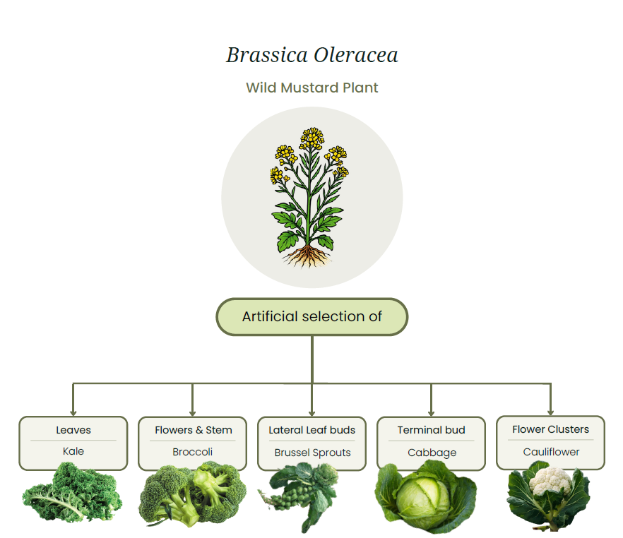

Do: Activity 1: History of brassicas (LIT)

Markets for Brassica crops
The main market opportunities for commercially grown brassica crops include:
- Supermarkets
- Fresh produce wholesalers
- Food service industry (restaurants, cafés, and catering businesses)
- Vegetable processors (for products such as frozen broccoli, coleslaw, and prepared vegetables)
- Food box companies such as My Food Bag, Bargain Box, and Wonky Box

Market requirements
Quality requirements vary depending on the market.
For supermarkets, fresh produce wholesalers, food service businesses, and premium food box providers, growers are expected to supply brassica crops that have:
- Uniform size and shape
- Fresh, healthy leaves or heads
- Good colour typical of the variety
- Firm, compact heads or stems (where appropriate)
- Freedom from pests, diseases, and physical damage
- Produce that meets food safety standards, including acceptable chemical residue levels
For processing and some alternative markets, perfect size and appearance are less important. However, crops must still be fresh, safe to eat, free from serious pest and disease damage, and meet the processor's quality specifications.

Brassica crop growing requirements
Brassica crops grow best in fertile, well-drained soils with a soil pH of approximately 6.5–7.5. They require a reliable supply of water throughout the growing season to produce high-quality heads. Most brassicas perform best in cool to mild temperatures with plenty of sunlight. While many brassicas tolerate light frosts, prolonged hot weather can reduce quality by causing poor head development, bitterness, or premature flowering (bolting) in some crops.
Commercial brassica crops vary in the time they take to mature. Fast-growing crops such as bok choy and pak choi may be ready to harvest in 4–8 weeks, while crops such as broccoli, cabbage, and cauliflower generally take 10–20 weeks, depending on the variety, season, and growing conditions. Careful variety selection and staggered planting allow New Zealand growers to supply fresh brassica vegetables throughout the year.
Brassica growing regions
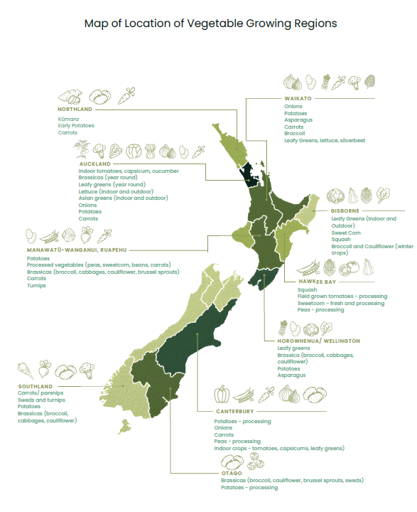
Commercial brassica growing in New Zealand is a year-round, intensive industry centred in fertile regions of both the North and South Islands.
Broccoli
In New Zealand, brassicas are grown commercially by growers in the field. The management practices to grow brassicas is similar so this is section will focus on the commercial production of broccoli for the fresh domestic market.

As it is not possible to cover all brassica crops, this resource will focus specifically on growing Broccoli.
Note:
The following information on growing broccoli commercially is purposefully generalised. For specific and regional information contact and visit a local grower. The Field trip to a broccoli grower worksheet is a set of questions that you can revise to suit your class and the purpose of the field trip.
Field trip to a local grower (WS)

Introduction to Broccoli
Commercial broccoli growing in New Zealand is a year-round, intensive industry centred in fertile regions of both the North and South Islands, including Pukekohe, Gisborne, Horowhenua, and Canterbury. Large growers use staggered weekly plantings to maintain a continuous supply to supermarkets and fresh produce markets throughout the year.
Broccoli is a high-input crop that usually takes around 70–100 days from planting to harvest depending on the variety and climatic conditions. Because the heads must be picked at the correct stage of development, harvesting is by hand. Successful production also requires careful irrigation, fertiliser management, and regular pest control, especially against pests such as the white butterfly and diamondback moth.
Although broccoli grows best in cool conditions below 25°C, New Zealand’s climate allows it to be produced in all seasons by selecting varieties suited to different temperatures and growing conditions. The crop performs particularly well during autumn, winter, and spring, when cooler weather supports better head development and quality.
Watch: Broccoli - Planting to plate https://www.youtube.com/watch?v=lUYdOYKFi1o

Calendar of operations site selection to harvest
The calendar of operations below outlines the key management practices used to produce a commercial crop of broccoli. Depending on the cultivar and growing conditions, broccoli generally takes 70–100 days from transplanting to harvest. Management practices may vary between growers and regions depending on soil type, climate, seasonal conditions, available technology and production systems.
Broccoli seedlings are planted two to three times per week to maintain a continuous, year-round supply. The time from transplanting to harvest is typically 70–100 days, depending on the cultivar and growing conditions. During cooler winter temperatures, broccoli grows more slowly and may take longer to reach harvest maturity.
Broccoli Crop Calendar of Operations
(Seedlings transplanted 2-3 times per week to ensure year-round supply)
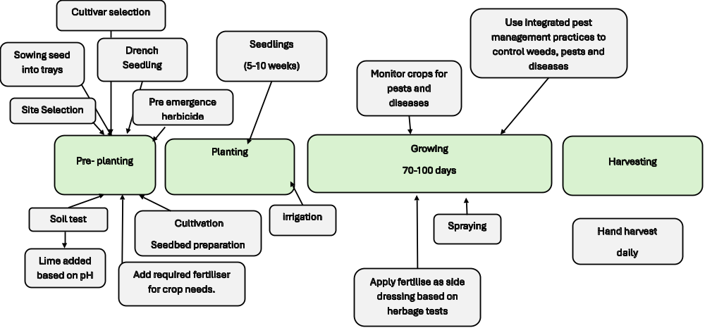

Do Activity 2: Careers growing broccoli

Markets and market requirements
Broccoli is grown throughout the year in New Zealand to supply domestic markets and meet consumer demand. Most broccoli is sold through supermarkets, fresh produce retailers, and food service suppliers, which require vegetables to meet strict quality standards. Some broccoli however is grown for processing.
To be accepted for sale, broccoli heads must:
- Have tight, compact buds that are dark green or purple-green in colour.
- Have firm, crisp stalks with a fresh appearance.
- Be clean and free from dirt, decay, rot, or yellowing.
- Be free from damage caused by pests, diseases, bruising, or poor handling.
- Be harvested and cooled quickly to maintain freshness, shelf life and flavour during transport and storage.

Broccoli cultivars
PPT Broccoli cultivars.
To maintain a reliable, year-round supply of broccoli, growers carefully select cultivars that are suited to local growing conditions and specific harvest periods.
Commercial growers generally use hybrid broccoli cultivars because they can provide more uniform plants, consistent head size and quality, strong growth, high yields and improved resistance or tolerance to some diseases and environmental conditions.
Growing several cultivars helps growers spread production risk and maintain a consistent supply when weather conditions vary throughout the year.
Plant breeders continue to develop new broccoli cultivars with improved characteristics, including:
- improved disease resistance
- better heat or cold tolerance
- consistent head quality
- higher marketable yields
- greater adaptability to changing growing conditions

Examples of broccoli cultivars grown by season.
Season | Broccoli cultivars
Spring | Beany, Marques
Summer | Brumby, Denali, Mclaren
Autumn | Brumby, Denali
Winter | Beany, Medley

Crop establishment
PPT Growing broccoli
Site selection
Fields for growing broccoli are carefully selected as part of a crop rotation programme. Growers generally avoid growing broccoli and other Brassica crops in the same field too frequently. A 3–4-year rotation can help reduce the build-up of soil-borne pests and diseases, particularly clubroot. Crop rotation also helps maintain soil health and reduce disease problems in other crops grown on the market garden.
Broccoli grows best in fertile, well-drained soils with a pH of around 7.0- 7.5 Maintaining a suitable soil pH is particularly important for reducing the risk of clubroot. If the soil is too acidic, lime can be applied before cultivation to raise the pH to a more suitable level.
An example of a crop rotation is:
Broccoli
Spinach
Oats
Lettuce
Carrots
Potatoes

Oats or pasture are included in the crop rotation to add organic matter to the soil. This helps maintain good soil structure and soil health.

Soil Testing
Before preparing the seedbed, growers test the soil to measure its pH and nutrient levels. This information helps growers make informed decisions about pH, lime and fertiliser, while reducing the risk of soil-borne diseases such as clubroot.
Maintaining a suitable soil pH is an important part of managing clubroot, a serious soil-borne disease that affects broccoli and other Brassica crops. Where clubroot is a concern, growers may aim to raise the soil pH to around 7.2–7.5 using lime. A higher, more alkaline soil pH can reduce the germination of Plasmodiophora brassicae resting spores and reduce the severity of clubroot.
However, liming alone will not eliminate clubroot. Growers use an integrated approach that includes:
- Crop rotation – avoiding growing Brassica crops in the same field too frequently.
- Lime application – raising soil pH to above 7.2 where appropriate.
- Good drainage and irrigation management – avoiding conditions that favour disease development.
- Growing suitable cultivars - resistant to clubroot
- Planting healthy seedlings.
Soil pH also affects how easily plants can take up nutrients. Therefore, growers use soil testing and careful nutrient management to maintain a pH that helps the broccoli crop access the nutrients it needs for healthy growth.

Do: Activity 3: Soil pH
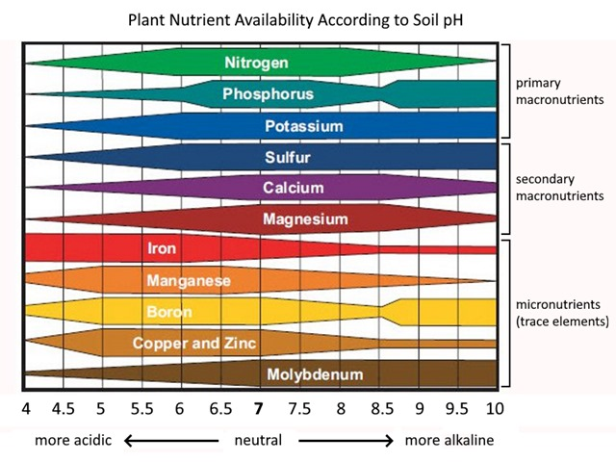

Seedbed preparation
Before planting, the soil is cultivated to create a fine, firm and weed-free seedbed. Good seedbed preparation provides seedlings with the best conditions for quick and even establishment.
Growers may form raised beds to improve soil drainage and reduce the risk of waterlogging, particularly during wet weather. The size and shape of the beds depend on the machinery and equipment used on the growing operation.
Before planting, growers apply a base fertiliser according to the results of soil testing. The fertiliser supplies the macro- and micronutrients needed for healthy broccoli growth. Applying the correct amount helps provide nutrients for strong root development and plant growth while avoiding unnecessary fertiliser use.

Seedling production
Broccoli seedlings are either grown in the grower’s own nursery or purchased from a commercial seedling supplier. Starting with healthy, strong seedlings is important for good crop establishment and uniform growth after transplanting.
Depending on the season, cultivar and growing conditions, seedlings are usually 5–10 weeks old when they are ready for transplanting. Before planting, seedlings may be treated with a seedling tray drench approximately 48 hours before transplanting to help protect them from early pest or disease problems.

Drenching seedlings
Before brassica seedlings are transplanted into the field, growers may apply a seedling drench to help protect young plants from pests and diseases. A seedling drench is a liquid treatment applied to the growing medium in the seedling tray. The treatment is taken up by the roots before the seedlings are planted in the field.
Seedling drenches are one tool growers can use as part of an integrated pest and disease management (IPM) programme. The choice of treatment depends on the crop, pest or disease present, growing conditions and product label requirements.
Growers can choose from a range of biological and chemical products, depending on the pests, diseases and growing conditions on their growing operation. When using pesticides, growers may rotate products with different modes of action to help reduce the risk of pests and diseases developing resistance.

Biological products
Some seedling treatments use naturally occurring organisms to help protect plants.
- Trichoderma – beneficial fungi that can colonise the root zone and compete with harmful pathogens for space and nutrients. This can help protect young roots from some soil-borne diseases.
- Beauveria bassiana – a naturally occurring fungus that infects certain insect pests. It is used as a biological control against pests such as aphids, whiteflies and thrips.
- Metarhizium – another naturally occurring soil fungus that can infect and kill some insect pests. Both Metarhizium and Beauveria are examples of biological control agents.

Chemical products
Some chemical products are used to protect seedlings from specific pests or diseases.
- Amishield® – a fungicide used to help control clubroot and damping-off in brassica crops. It targets diseases rather than insect pests. It may be used as part of a programme with compatible insecticides where protection from both diseases and insect pests is required.
- Nurprid 350 SC – a systemic insecticide used for the control of aphids in vegetable brassica and lettuce transplants. It is absorbed by the plant and can protect young plants from target insect pests.
Young seedlings are particularly vulnerable to pests and diseases. Protecting them during the early stages of growth can help establish a fast growing, uniform crop.
Do:
- Clubroot Drenching Treatment (WS)
- Prevent pests with seedling drench (WS)
- Activity 4: Investigating a scientific trial
Transplanting seedlings
Broccoli seedlings are usually transplanted into the field when they are 5–10 weeks old and have developed 4–6 true leaves. Commercial growers use a mechanical transplanter to plant large numbers of seedlings efficiently and consistently. Workers check the transplanted seedlings to make sure seedlings are correctly positioned and planted at the desired spacing.
At transplanting, seedlings may be given water and nutrients to help reduce transplant stress and encourage rapid establishment. Irrigation is also applied after planting to settle the soil around the roots and ensure good root-to-soil contact.
Plant spacing varies depending on the cultivar, season and desired head size. Broccoli plants are commonly spaced about 35–45 cm apart within rows, with rows approximately 45–50 cm apart. Correct spacing gives plants enough room to develop, improves air circulation and can help reduce the spread of some diseases.

Growth stage
Nutrient management
Broccoli needs a balanced supply of nutrients to produce strong plants and high-quality heads. Nitrogen is particularly important for leafy growth and building the plant frame, while phosphorus and potassium support root development, head formation and overall plant health.
Because broccoli is grown in soils with a high pH (7-7.5), some nutrients may become less available to plants. Growers therefore use soil testing to determine which nutrients are needed and apply fertiliser at the correct rates.
Nutrients are commonly supplied in several applications during the growing season. A base fertiliser dressing may be applied before or at planting, followed by additional side dressings as the crop develops. For example, growers may apply two side dressings during summer production and up to three during slower winter growth. The timing and amount depend on soil test results, crop requirements and growing conditions.
Effective nutrient management provides broccoli with the right nutrients, in the right amounts and at the right time, while avoiding unnecessary fertiliser use.

Key Nutrients
- Nitrogen (N): Promotes leaf growth and helps the plant develop a strong frame capable of supporting a large head.
- Phosphorus (P): Supports healthy root development and contributes to head initiation and development.
- Potassium (K): Supports overall plant health, water regulation and tolerance to environmental stress.
- Boron (B): An important micronutrient that helps with cell development and can reduce problems such as hollow stems and poor head development.
Irrigation
Broccoli has a relatively shallow root system and requires a consistent supply of soil moisture for healthy growth. Water stress can reduce plant growth, head size and yield. During dry summer conditions, particularly in the North Island, irrigation may be essential to maintain crop growth and quality.
Growers use information such as soil moisture measurements, weather forecasts and crop water requirements to decide when irrigation is needed. Increasingly, digital tools and modelling systems are being used to help growers plan irrigation more accurately and avoid unnecessary water use.
The irrigation system used depends on the growing operation, soil type, crop requirements and available technology. Travelling booms and irrigation guns are commonly used in field-grown vegetable production. Some growers are also adopting more automated and precise systems, such as drip irrigation, which can deliver water directly to the soil around the plant roots.
Efficient irrigation helps growers:
- provide the crop with enough water for healthy growth
- maintain consistent soil moisture
- reduce water wastage and runoff
- use soil moisture and weather data to make better irrigation decisions
- maintain crop quality and yield.
Do:
Activity 5: Using technology to grow a commercial brassica crop

Pest and disease management
PPT Brassica Pests and Diseases
Brassica crops are vulnerable to a range of insect pests, diseases, and nutrient disorders that can reduce plant growth, lower crop quality, and decrease yields. Common insect pests and disease include:
Pests | Diseases
- White butterfly caterpillars  - Diamondback moth caterpillars  - Leaf miner  - Aphids  - Thrips  - Rabbits  - Pukekos | - Clubroot  - Downy Mildew  - Sclerotinia  - Black rot  - White blister  - Brown Heart / Hollow Stem

To minimise these risks, commercial growers use Integrated Pest and Disease Management (IPDM). IPDM combines cultural, biological, and chemical control methods to protect crops while reducing reliance on pesticides and minimising environmental impacts.
Cultural controls
Cultural controls help prevent pests and diseases from becoming established. These include:
- Rotating crops to reduce the build-up of soil-borne diseases.
- Removing crop residues (left over plant material) and controlling weeds that can harbour pests and pathogens.
- Planting resistant hybrid varieties where available.
- Seedling drenching with a systemic insecticide and a fungicide.
- Maintaining good field hygiene.
- Using well-drained soils, correct plant spacing, and careful irrigation to reduce disease development.
- Regularly scouting and monitoring crops so problems can be identified and managed early.

Biological controls
Biological control involves conserving or encouraging beneficial organisms that naturally reduce pest populations. For example, ladybirds feed on aphids, while parasitic wasps attack caterpillars such as diamondback moth. Protecting these natural enemies helps reduce pest numbers and supports a balanced ecosystem.

Biochemical controls
Growers increasingly use biological products, alongside other integrated pest and disease management (IPDM) methods, to help prevent and manage pests and diseases. These products use naturally occurring organisms or substances and can reduce reliance on conventional chemical pesticides where suitable.
Examples include:
- MycoForce – contains beneficial mycorrhizal fungi that can support root growth and nutrient and water uptake.
- Aureo Gold – a BioGro-certified biological product used to help protect plants from some diseases.
- Bacillus thuringiensis (Bt) – a naturally occurring bacterium used to control caterpillars and other target insect larvae.
- Bacillus subtilis – a beneficial bacterium used in some products to help suppress plant diseases.
- Bio-fungicides – products containing beneficial Bacillus species can help prevent or suppress some fungal and bacterial diseases.

Chemical controls
When monitoring shows that pest or disease levels have reached the economic threshold (the point where losses outweigh the cost of control), growers may apply approved insecticides or fungicides. These products are carefully selected, applied only when needed, and rotated between different modes of action to reduce the risk of pesticide resistance.
By combining cultural, biological, and chemical controls, IPDM enables growers to produce healthy, high-quality brassica crops while protecting the environment and maintaining sustainable production.
DO:
Activity 6: AI Research Biological control.

Weed management
Effective weed management is essential for producing healthy, high-yielding broccoli crops. Weeds compete with broccoli for water, nutrients, sunlight, and growing space, reducing plant growth, head size, and overall yield. They can also harbour insect pests and diseases, making crop management more difficult.
Successful weed control begins with thorough soil preparation and the creation of a well-prepared seedbed, providing broccoli plants with the best conditions for rapid establishment. Growers apply pre-plant herbicides to reduce weed populations before transplanting, helping to minimise weed competition during the critical early stages of crop development.

Harvesting and Post Harvest Handling
Broccoli is carefully hand-harvested into crates, often five days a week, to ensure a regular supply of fresh, high-quality produce for the market.
Growers aim to harvest as many marketable heads as possible. However, typically only 80–90% of harvested heads meet the required market standards for size, colour, shape and quality.
Once harvested, broccoli is transported to the packhouse, where it is cooled, and prepared for distribution. Rapid cooling helps maintain freshness and quality and extends shelf life.
Do
- Growing Broccoli Questions (WS).
- Activity 7: Making Management Decisions

Challenges
Vegetable growers in New Zealand are facing a range of serious challenges that are affecting how they produce food and stay in business. These include strict environmental regulations, pressure on land use, rising production costs, and low returns from supermarkets. At the same time, growers must manage pests, diseases, and soil health while meeting high standards for food quality and environmental care. These combined pressures make it difficult to maintain profitable and sustainable vegetable production, even though fresh vegetables are essential for New Zealand’s food supply and food security.
Do:
- “Your vegetables were grown in New Zealand” (WS)
  - There are two tasks based on the article. Select the task that best suits your class.
    - Task 1: Comprehension
    - Task 2: Risks to Vegetable Growers and Consumers
- Stalking wasted produce (WS) Read the article “Stalking wasted produce!” as a class and discuss the questions below then do tasks 1 and 2.
- Sustainable vegetable production (WS)
Activity 8: From Broccoli Field to Supermarket (NUM)
Activity 9: Seasonal Price of Broccoli (NUM)

