Activity 1: History of brassicas (LIT)
Read “The Amazing History of Brassicas” as a class. Discuss the questions below and completed the tasks.
- Discussion questions
- What vegetables belong to the brassica family?
- Why might humans change plants through selective breeding?
- How do you think vegetables today are different from wild plants long ago?

- Draw a line to match the word to the correct meaning.
Word | Meaning
Domestication | Different forms or types of a plant
Selective breeding | Choosing plants with useful traits to reproduce
Cultivated | Plants grown and cared for by people
Variety | The process of changing wild plants into farmed crops
Resilience | The ability to recover from difficult conditions

- Reading comprehension questions.
Answer in full sentences.
- Where did wild brassica plants originally grow?
- What did early wild brassica plants look like?
- Which species produced broccoli, cabbage, and cauliflower?
- In what region was Brassica rapa first domesticated?
- Which brassica vegetable became popular around the 5th century BC?
- Why did farmers selectively breed brassica plants?
- Why do you think brassica vegetables became important around the world?
- How has selective breeding changed brassica crops over time?

The Amazing History of Brassica’s
The genus Brassica includes many of the world’s most familiar and nutritious vegetables, such as broccoli, cabbage, cauliflower, and kale. Its story stretches back 4,000 to 6,000 years to wild ancestors growing along the Mediterranean coast. These early plants looked very different from today’s cultivated vegetables, they had small, tough, and bitter leaves that bore little resemblance to the produce found in modern kitchens.

Origins and domestication
Domestication likely began in regions such as Greece and the Aegean Islands. Early farmers selectively bred wild plants for improved flavour, larger leaves, and greater productivity. This deliberate process of artificial selection marked the beginning of a transformation that would eventually produce a remarkable diversity of crops.
One of the most important species, Brassica oleracea, gave rise to many well-known vegetables, including cabbage, broccoli, cauliflower, kale, and Brussels sprouts. Another key species, Brassica rapa, was domesticated in the Hindu Kush region covering parts of present-day Pakistan, Afghanistan, and India and later produced turnips, bok choy, and broccoli rabe.

Diversification over time
Centuries of selective breeding led to dramatic physical differences within the same species. Farmers selected for specific plant parts, leaves, buds, stems, or flower clusters resulting in vegetables with distinct shapes, textures, and flavours.
The historical timeline of these developments is particularly interesting:
- Kale became popular around the 5th century BC.
- Cabbage was widely cultivated by the 1st century AD.
- Cauliflower and broccoli appeared during the 15th century.
- Brussels sprouts emerged in the 18th century.

Cultural and historical importance
Brassica vegetables have played important roles in cultures around the world. Ancient Greek and Roman societies valued cabbage not only as a food source but also for its supposed medicinal benefits. In China, bok choy and related greens have been cultivated for thousands of years. Across Europe, kale served as a reliable dietary staple for centuries.

Modern significance
Today, brassica crops remain essential to global agriculture. Beyond their nutritional value, they are the subject of ongoing scientific research aimed at improving climate resilience, disease resistance, and food security. The evolution of brassica vegetables stands as a powerful example of how human selection and plant adaptability can transform a single wild species into hundreds of diverse and productive cultivars.

Varieties of Brassica
Through centuries of artificial selection, Brassica oleracea has diversified into several major cultivation groups. By selecting for different plant parts, leaves, terminal buds, lateral buds, stems, and inflorescences (flowers) growers produced vegetables with dramatically different appearances and culinary uses.
From its modest beginnings as a bitter Mediterranean wild plant, Brassica has evolved into one of the most agriculturally significant plant genera in the world. Its history reflects thousands of years of human cultivation, cultural exchange, and agricultural innovation. Today, brassica vegetables continue to nourish billions of people, demonstrating the extraordinary potential contained within a single species shaped by careful selection and time.
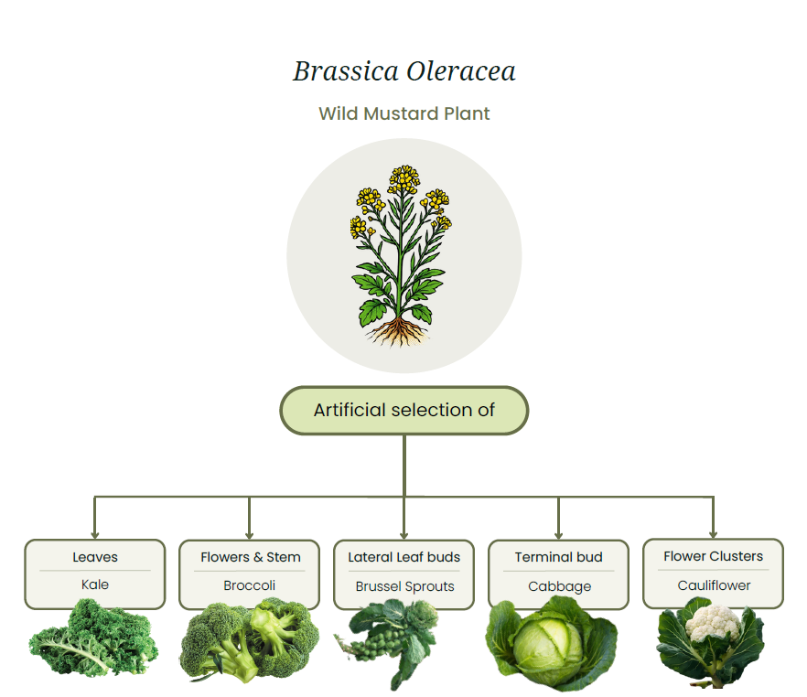

Answers
- Discussion questions
- Vegetables that belong to the brassica family include broccoli, cabbage, cauliflower, kale, Brussels sprouts and bok choy.
- Humans might change plants through selective breeding to improve their size, taste, colour, productivity, and resistance to pests and diseases.
- Vegetables today are different from wild plants long ago because they are usually larger, tastier, less bitter, and produce more food due to many years of selective breeding.

- Match the word to the correct meaning
Word | Meaning
Domestication | The process of changing wild plants into farmed crops
Selective breeding | Choosing plants with useful traits to reproduce
Cultivated | Plants grown and cared for by people
Variety | Different forms or types of a plant
Resilience | The ability to recover from difficult conditions

- Reading comprehension questions
  - Where did wild brassica plants originally grow?
Wild brassica plants originally grew along the Mediterranean coast.
  - What did early wild brassica plants look like?
Early wild brassica plants had small, tough, and bitter leaves that looked very different from modern vegetables.
  - Which species produced broccoli, cabbage, and cauliflower?
The species Brassica oleracea produced broccoli, cabbage, and cauliflower.
  - In what region was Brassica rapa first domesticated?
Brassica rapa was first domesticated in the Hindu Kush region, which includes parts of present-day Pakistan, Afghanistan, and India.
  - Which brassica vegetable became popular around the 5th century BC?
Kale became popular around the 5th century BC.
  - Why did farmers selectively breed brassica plants?
Farmers selectively bred brassica plants to improve their flavour, size, productivity, and appearance.
  - Why do you think brassica vegetables became important around the world?
Brassica vegetables became important around the world because they are nutritious, versatile, and can grow in many different climates.
  - How has selective breeding changed brassica crops over time?
Selective breeding changed brassica crops over time by creating vegetables with different shapes, sizes, flavours, and edible parts such as leaves, stems, buds, and flower heads.

