Activity 4: Investigating a Scientific Trial
Aim: To understand how scientists use the scientific method to test whether a new product works.
Instructions
Read the article "Durivo® Trial Protects Young Brassica Crops" and answer the questions below.
- Identify the scientific method by completing the table.
Step of the scientific method | Example from the Durivo® Trial
Question | What were the researchers trying to find out?
Hypothesis | What do you think the researchers predicted would happen?
Method | How was the trial carried out? Include where it took place, what crop was used, and what was compared.
Results | What were the main findings of the trial?
Conclusion | What did the researchers conclude about using Durivo®?

- Thinking like a scientist
- Why did the researchers include an untreated control group in the trial?
- Why was cabbage chosen for this experiment?
- Why is it important that all Durivo® treatments were compared under the same growing conditions?
- How did the researchers measure whether Durivo® was successful? List at least two things they assessed.

- Challenge
Imagine you are a scientist testing a new insecticide for broccoli.
Write a simple investigation plan by answering these questions:
- Question: What do you want to investigate?
- Hypothesis: What do you predict will happen?
- Method: How will you test it?
- Data: What measurements will you collect?
- Conclusion: How will you decide if the treatment worked?

Seedling drench trial gives growers confidence
14 Nov 2025
https://www.agribusinessmagazine.co.nz/blog/seedling-drench-trial-gives-growers-confidence
Words: Syngenta Crop Protection NZ
Early in 2025, Vegetables NZ and Syngenta Crop Protection NZ initiated a trial to evaluate performance of Durivo insecticide applied by multiple methods, compared to an untreated control.
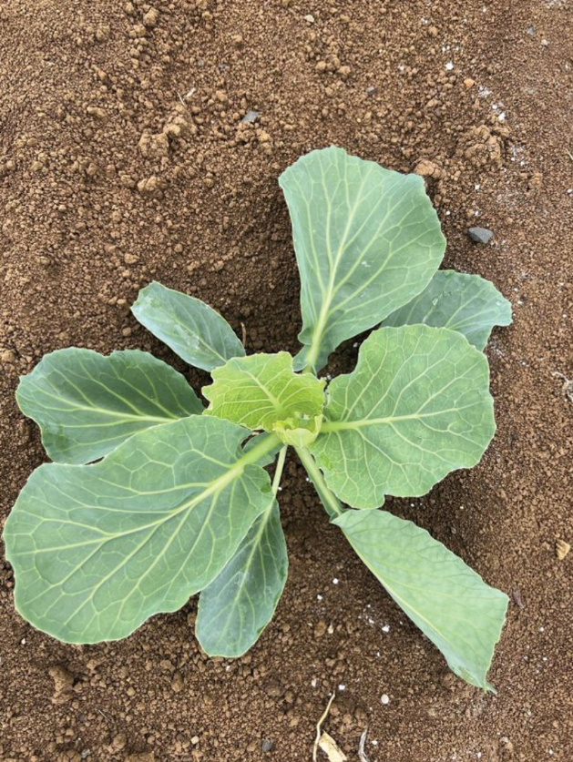
Durivo treated seedling.
The trial was conducted in Pukekohe at Te Ahikawariki – Vegetable Industry Centre of Excellence (VICE).
Eurofins Kalyx was contracted to assess each of the treatments for plant vigour and key brassica pests: Diamondback moth, white butterfly, soybean looper, aphids, greenhouse whitefly and onion thrips.
Cabbage (cv. Lambada) was selected due to commercial relevance and extended crop cycle, allowing for robust pest assessments.
Transplants were sourced from three different North Island nurseries to compare different commercial applications of Durivo. A hand-treated application of Durivo was also made at the label rate for comparison.

Key findings included:
- All Durivo treatments provided effective diamond back moth control until 26 days after application (DAA). Efficacy had declined by 33 DAA.
- All Durivo treatments provided control of aphid nymphs at 26 DAA. The sharp drop in aphid incidence in the untreated control at 33 DAA was likely due to a significant rain event (26 mm) three days prior.
- All Durivo treatments exhibited higher vigour scores at both assessment timings, compared to the untreated control.
All Durivo treatments were comparable for diamond back moth larvae and aphid nymph incidence along with plant vigour. This gives growers confidence in their use of Durivo as a seedling tray drench.
The control of diamond back moth from Durivo for up to four weeks gives seedlings time to establish before other control options are required and during high diamond back moth pressure periods, such as summer, the application of Durivo offers growers peace of mind that pests will be controlled during that initial four-week period after planting.
Best use recommendations
- Apply to leafy vegetables and leafy brassicas at 15 ml/1000 seedlings, and vegetable brassicas require a rate of 25 ml/1000 seedlings.
- Use correctly calibrated equipment to apply as a seedling tray drench and ensure Durivo is washed into the root ball.
- If seedlings require watering following the Durivo application, take care to avoid leaching the product from cells which reduce the duration of control.
- For resistance management against DBM, do not follow a Durivo application with another Group 28 product on that crop.
Durivo (Group 4A, Group 28) is a broad-spectrum, systemic insecticide for the control of key insect pests in leafy vegetables, brassica leafy vegetables and vegetable brassicas.
Applied as a seedling tray drench prior to transplanting, Durivo is readily taken up by the roots of the transplants and rapidly translocated throughout the plant, to give lasting protection and an ‘energy boost’ right from the start.
The Vegetable Industry Centre of Excellence research and demonstration farm has been set up on the Balle Bros property in Pukekohe. This site is also the home of the Plant and Food Research offices and facilities, and the Lighter Touch demonstration site.

Answers
1
Step of the scientific method | Example from the Durivo® Trial
Question | Does applying Durivo® as a seedling tray drench protect cabbage seedlings from insect pests and improve plant growth?
Hypothesis | The researchers predicted that cabbage seedlings treated with Durivo® would have fewer insect pests and grow more vigorously than untreated seedlings.
Method | Cabbage (cv. Lambada) seedlings were treated with Durivo® using different commercial application methods and compared with untreated plants.  Researchers measured insect pests and plant vigour over several weeks.
Results | All Durivo® treatments controlled diamondback moth for up to 26 days and controlled aphids over the same period.  Treated plants also had higher vigour scores than untreated plants.
Conclusion | Durivo® successfully protected young cabbage plants from insect pests during the critical establishment period, improved plant vigour, and reduced the need for early insecticide sprays.

2. Thinking like a scientist
- Why did the researchers include an untreated control group in the trial?
The untreated control group allowed the researchers to compare treated and untreated plants. This showed whether any differences in pest numbers and plant growth were caused by Durivo® rather than by other factors.

- Why was cabbage chosen for this experiment?
Cabbage was chosen because it is an important commercial brassica crop and has a long growing season, allowing researchers to monitor insect pests and plant growth over a longer period.

- Why is it important that all Durivo® treatments were compared under the same growing conditions?
Using the same growing conditions made the trial a fair test. It meant that any differences in pest control or plant growth were most likely due to the Durivo® treatment rather than differences in weather, soil, or management.

- How did the researchers measure whether Durivo® was successful? List at least two things they assessed.
The researchers measured:
- The number of diamondback moth larvae.
- The number of aphid nymphs.
- Plant vigour (how healthy and vigorous the plants were).

3. Challenge – Sample Answers
Question:
Does treating broccoli seedlings with a new insecticide reduce insect damage?
Hypothesis:
Broccoli seedlings treated with the new insecticide will have fewer insect pests and grow better than untreated seedlings.
Method:
Plant two groups of broccoli seedlings under the same conditions. Treat one group with the insecticide before transplanting and leave the other group untreated. Monitor both groups for four weeks.
Data:
Record:
- Number of insect pests on each plant.
- Amount of leaf damage.
- Plant height.
- Plant vigour.
Conclusion:
If the treated plants have fewer pests, less leaf damage, and better growth than the untreated plants, the insecticide can be considered effective.

