Activity 5: Using technology to grow a commercial brassica crop
Modern primary production combines scientific knowledge, technology, data and practical experience to help growers make informed decisions.
A commercial broccoli grower does not simply ask: “Does my crop need water?" They can ask:
"What do the soil, weather, crop and historical data tell me about the crop's water requirements, and what is the most appropriate irrigation decision?"

Learning objectives: Students will:
- Identify technologies used in modern commercial brassica production.
- Explain how technology can help growers make better production decisions.
- Understand how data can be used to monitor crop conditions.
- Investigate how technology can improve water, fertiliser and pest management.
- Evaluate the benefits and limitations of using technology in commercial agriculture.
Scenario: You are the grower
You are managing the growing of a commercial broccoli crop. Your broccoli is growing well, but the weather has been unusually dry. You need to decide when and how much to irrigate.
In the past, growers relied mainly on visual observations and weather forecasts. Growers today can use technology to collect information about the crop, soil and weather.
Your growing operation has access to:
- Soil moisture sensors – measure the amount of water in the soil.
- Weather stations – record information such as rainfall, temperature, humidity and wind.
- Irrigation controllers – can automatically turn irrigation systems on and off.
- Satellite imagery or drones – can provide information about crop growth and variation across a field.
- Data analysis – allows growers to compare information and identify patterns.

In groups, decide how technology could help you manage the broccoli crop and decide when irrigation is needed.
- Identify the technology
Match each technology with the information or job it can provide.
Technology | What could it be used for?
Soil moisture sensor
Weather station
Irrigation controller
Drone
Satellite imagery
GPS-guided machinery
Variable-rate fertiliser application
Data analysis

- The irrigation decision
Your broccoli crop requires a reliable supply of water to produce good-quality heads.
You collect the following information:
Information | What does it tell the grower?
Soil moisture
Rainfall
Temperature
Humidity
Wind speed
Crop growth stage
Weather forecast

Discuss with your group:
- Which pieces of information would you use to decide whether the broccoli needs irrigation?
- Why would it be better to use several pieces of information rather than relying only on looking at the plants?
- What could happen if the grower irrigates when the soil already contains enough water?
- What could happen if the grower does not irrigate when the crop needs water?
Soil Moisture Monitoring
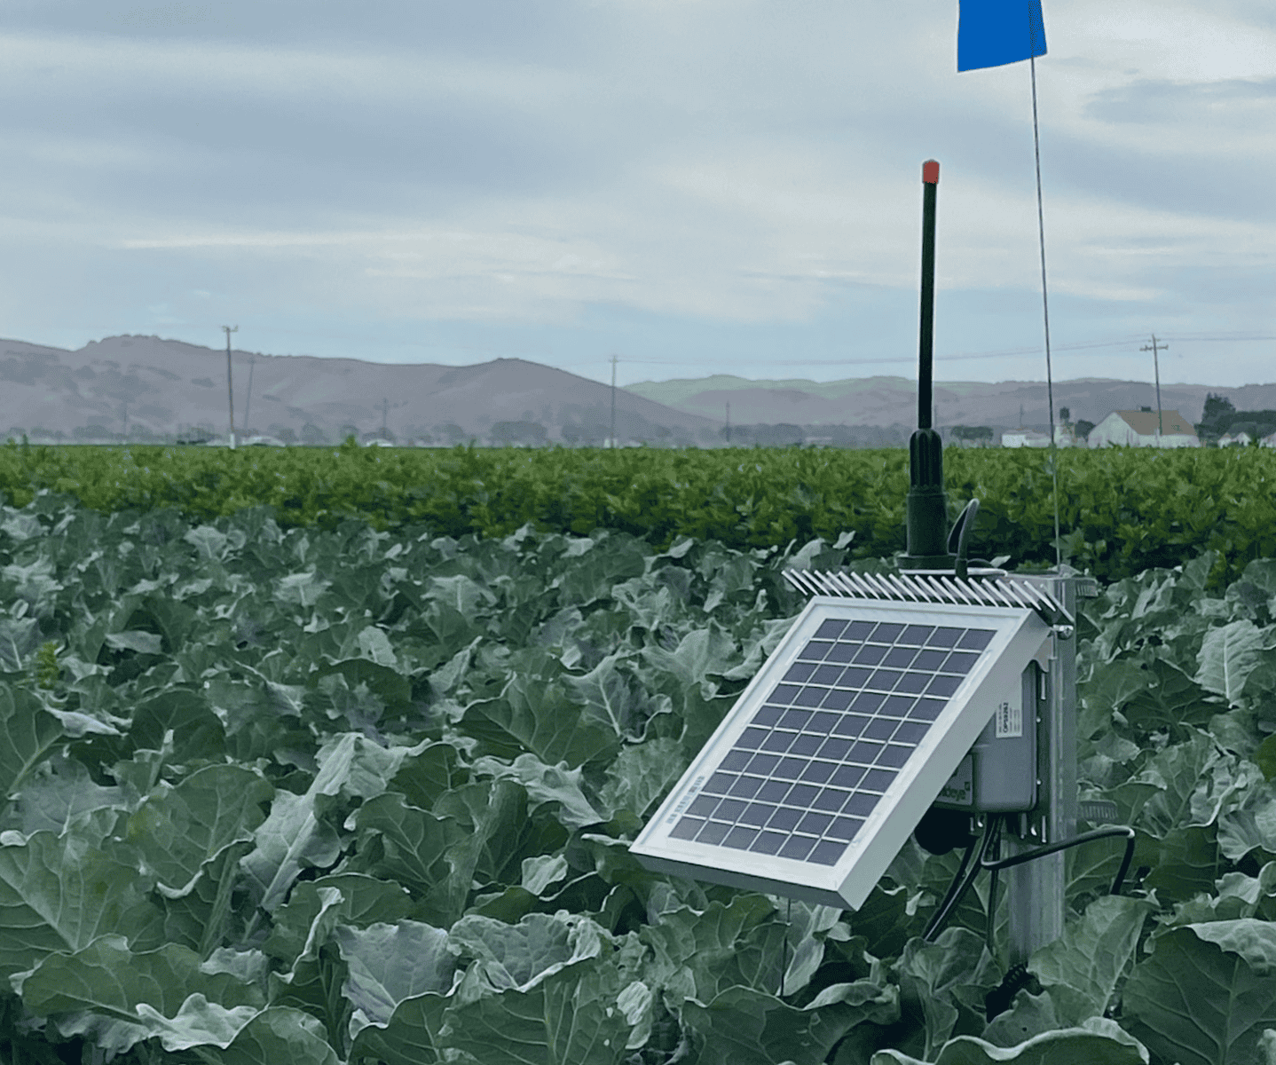
CropX Soil Sensor Data
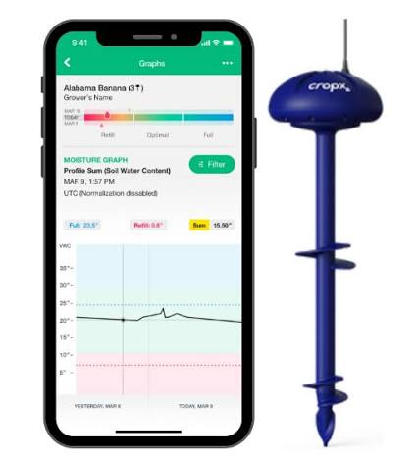

- Use of technology
A commercial brassica grower could use several technologies together. Complete the flow diagram by answering the questions.
Make a decision
Does the crop need irrigation?

Analyse the information
What does the data tell us about the crop?

Collect information
Soil moisture sensors + weather station + crop observations

Collect information
↓

Monitor the crop
Check soil moisture and plant growth again
Take action
Irrigate the crop if required.

Question: Why is it useful for the grower to continue collecting data after irrigation?

- Beyond irrigation
Technology can be used to manage many other aspects of a commercial brassica crop.
Choose three technologies from the list below and explain
- how each could be used in growing broccoli?
- what benefits it could provide?
- GPS-guided machinery
- Variable-rate fertiliser application
- Soil sensors
- Weather stations
- Irrigation controllers
- Drones
- Satellite imagery
- Robotics
- Automated greenhouses
- Plant breeding technologies
- Controlled-environment agriculture
- Data analysis

- Make a recommendation
Imagine you are advising the broccoli grower.
Write a short recommendation answering:
How could technology help this grower produce a high-quality broccoli crop while using water and other resources efficiently?
Your recommendation should include:
- At least three technologies
- How each technology could be used
- One benefit of using technology
- One possible limitation or disadvantage

- Is technology always better?
Technology can provide growers with valuable information, but it also has costs and limitations.
Discuss: Should every commercial brassica grower use the latest agricultural technology?
Consider:
- Cost of equipment
- Accuracy of information
- Training required
- Maintenance
- Farm size
- Potential savings
- Environmental benefits
- Availability of reliable internet or data
- Whether the technology actually improves the grower's decision-making

Explain why technology should be used as a tool to support the grower's decision-making rather than simply replacing the grower's knowledge and experience.
Answers
  - Use of technology
Collect information
Soil moisture sensors, weather stations and crop observations are used to collect information about the broccoli crop.

Monitor the crop
The grower continues to check soil moisture and plant growth after irrigation. This shows whether enough water has been applied and helps the grower decide when the crop may need water again.

Take action
If irrigation is needed, the grower applies the appropriate amount of water to the broccoli crop. An irrigation controller could be used to control when the irrigation system operates.

Make a decision
The grower decides whether irrigation is needed based on the information collected. If the soil is too dry and the crop is approaching a stage when it needs plenty of water, irrigation may be required.

Analyse the information
The grower looks at the soil moisture data, recent rainfall, temperature, weather forecast and the condition of the broccoli plants. If the soil moisture is low and little rain is expected, the crop is likely to need irrigation.

Question: Why is it useful for the grower to continue collecting data after irrigation?
It is useful because the grower can see whether the irrigation has provided enough water for the broccoli crop. Monitoring the soil moisture after irrigation can help prevent under-watering or over-watering. The information can also help the grower make better irrigation decisions in the future and use water more efficiently.

