Activity 7: Making Management Decisions in Commercial Broccoli Production
Broccoli Crop Calendar of Operations
(Seedlings transplanted 2-3 per week to ensure year-round supply)
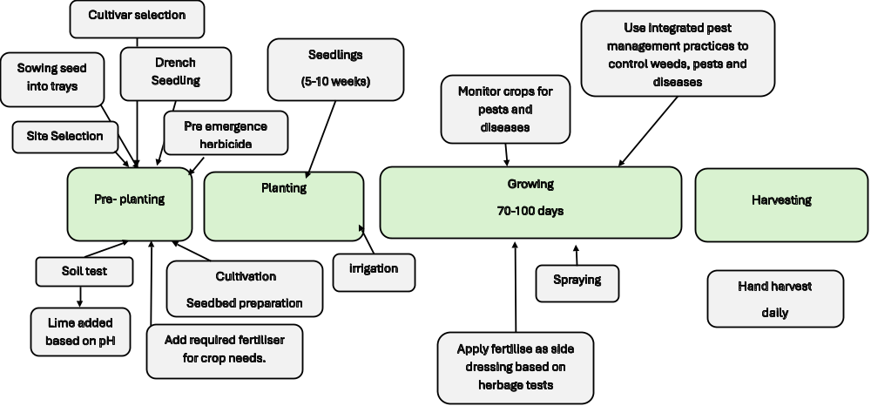

- Using the broccoli Calendar of Operations as a guide, discuss the decisions a commercial grower makes from planting through to harvest.
Discuss each question in groups. Record the main points from your discussion.
- What factors would a grower consider when selecting broccoli cultivars for a particular season?
- Why might a grower choose one cultivar rather than another?
- What nutrients does a broccoli plant need for healthy growth and head development?
- Why is soil pH important when growing broccoli?
- How does photosynthesis provide the energy and materials a broccoli plant needs to grow?
- What information could a grower use to decide when to irrigate the crop?
- Why does irrigation need to be carefully managed?
- How can pests and diseases affect broccoli yield and quality?
- What strategies can growers use to reduce pest and disease damage?
- How can GPS-guided machinery improve the efficiency of broccoli production?
- How can growers use technology and data to make better production decisions?
- What practices can growers use to protect waterways while continuing to produce food?
- Why does broccoli need to be harvested at the correct stage of maturity?
- Why is broccoli cooled soon after harvest? How does cooling help maintain product quality?
- Make a management decision
Imagine you are a broccoli grower. You need to produce a high-quality crop while keeping costs down and reducing environmental impacts.
Choose three management decisions from the questions above.
For each decision, explain:
- What decision would you make?
- What information would you use to make the decision?
- Why is the decision important?
- What could happen if the decision was made incorrectly?

- Developing better broccoli cultivars
Plant breeders are continually developing new broccoli cultivars that may be better suited to particular growing conditions.
Discuss:
How could plant breeders develop broccoli cultivars that are better suited to New Zealand growing conditions?
Research and explain the following breeding approaches:
1. Selective Breeding
How could breeders select plants with desirable characteristics, such as good head quality, high yield or better tolerance to weather conditions, and use them to produce future generations?
2. Hybridisation
How can breeders cross two different parent plants to combine desirable characteristics in a new hybrid cultivar?
3. Biotechnology
How can biotechnology help breeders identify, study or select useful characteristics in plants?
4. Genetic Modification
What is genetic modification, and how could it potentially be used to introduce a specific characteristic into a crop?

Question
Which breeding method do you think could be most useful for developing broccoli suited to future New Zealand growing conditions? Explain your choice.

