Activity 9: Seasonal Price of Broccoli

- Use the monthly data on the price of broccoli per head to produce a line graph to show seasonal price variation.
Price of Broccoli
 | $/head
June | 2.00
July | 2.50
August | 1.80
September | 1.20
October | 1.80
November | 1.00
December | 0.90
January | 1.00
February | 1.10
March | 1.50
April | 1.20
May | 1.60

Make sure your graph includes:
- A title
- Correct axis labels
- Even scales

- Calculate the average price across the year, round to two decimal places.

- Describe the trends shown in your graph.
- Which months have the highest prices?
- Which months have the lowest prices?
- Are there any noticeable seasonal patterns?

- Explain why the price of broccoli changes during different months of the year.

- A supermarket sells a head of broccoli for $2.50. Explain why broccoli might cost this much?

- If you were a commercial broccoli grower, during which months would you aim to harvest your crop? Use evidence from the price data to justify your answer.

- If a head of broccoli sells for $2.50 in a supermarket, does the grower receive the full $2.50? Explain your answer.

Answers
- Use the monthly data on the price of broccoli per head to produce a line graph to show seasonal price variation.
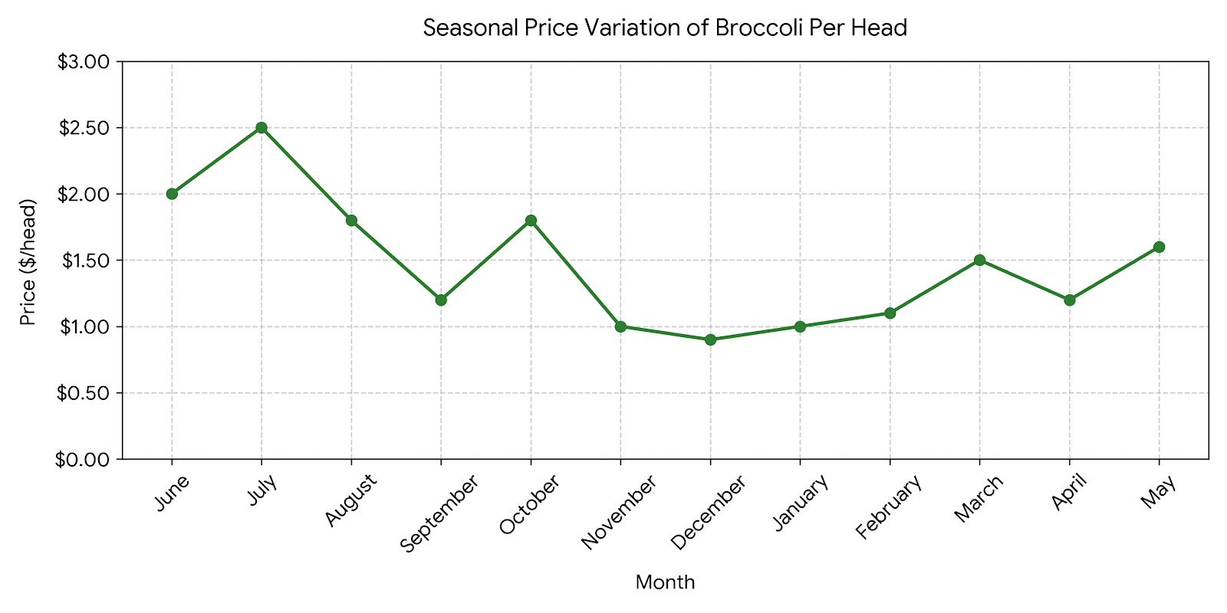
- Calculate the average price across the year.
Add the 12 monthly prices together and divide by 12.
Formula: Average price = Total of monthly prices ÷ 12
$17.60 ÷ 12 =$1.47

- Describe the trends shown in your graph.
- July has the highest price at $2.50 then June at $2.00.
- December has the lowest price at 90 cents per head followed by November at $1.00 per head.
- Prices are higher in the cooler winter months compared to warmer months.

- Explain why the price of broccoli changes during different months of the year.
The price of broccoli can change because the amount available changes throughout the year. Weather, temperature, rainfall, pests and diseases can affect crop growth and the amount harvested. When supply is low, but demand remains high, prices may increase. When more broccoli is available, competition between growers can increase and prices may fall.

- A supermarket sells a head of broccoli for $2.50. Explain why broccoli might cost this much?
The $2.50 supermarket price includes much more than the cost of growing the broccoli. The price must cover costs such as:
- Seed and seedlings
- Fertiliser and crop protection
- Irrigation and water
- Labour
- Machinery and fuel
- Harvesting
- Packaging
- Transport
- Cooling and storage
- Packing and distribution
- Supermarket operating costs
- The supermarket's profit margin

The supermarket price also needs to cover broccoli that is harvested but does not meet market requirements or is lost during transport and storage.

- If you were a commercial broccoli grower, during which months would you aim to harvest your crop?
I would aim to harvest during the months when the price per head is highest, provided the crop can be reliably grown and harvested at that time.
Higher prices could increase the grower's potential income. However, a grower would also need to consider production costs, weather, crop maturity, labour availability and the risk of producing broccoli when other growers are also harvesting.

- If a head of broccoli sells for $2.50 in a supermarket, does the grower receive the full $2.50? Explain your answer.
No. The grower does not normally receive the full $2.50.
The $2.50 is the retail price paid by the consumer. Money from the sale must cover costs and margins throughout the supply chain, including harvesting, packing, transport, distribution and the supermarket's operating costs and profit. The grower receives the price agreed with the buyer or wholesaler, which is only part of the final supermarket price.

