Using DURIVO® to Protect Brassica Seedlings
Read “Prevent pests with seedling drench” and discuss the questions.
- What is DURIVO®, and when is it applied to brassica seedlings?
- Name four insect pests that DURIVO® helps control in young vegetable crops.
- Explain how DURIVO® protects seedlings after it has been applied as a seedling tray drench.
- Why is DURIVO® considered compatible with Integrated Pest Management (IPM) programmes?
- Why is it important for growers to apply DURIVO® evenly using calibrated equipment and avoid overwatering seedlings after application?

Prevent pests with seedling drench
https://www.syngenta.co.nz/news/vegetables/prevent-pests-seedling-drench
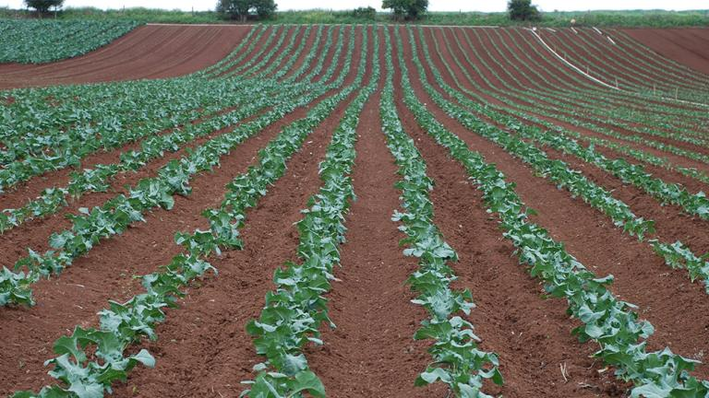

Widely used by growers across New Zealand to protect leafy vegetables, brassica leafy vegetables and vegetable brassica crops, DURIVO® insecticide provides an excellent alternative to repeated applications of foliar insecticides, particularly early in the crop growth cycle when numerous insect pests try to become established on growing seedlings.
DURIVO® is applied as a pre-planting drench to vegetable seedling trays 12 to 24 hours prior to transplanting, and effectively controls white butterfly, diamondback moth, aphids, greenhouse whitefly and onion thrips. The insecticide can provide season-long control of aphids and control of white cabbage butterfly and diamondback moth caterpillars for four to six weeks.
Raeleen Watherston, Syngenta New Zealand Customer Marketing Lead, says the two powerful active ingredients (thiamethoxam and chlorantraniliprole, Group 4A and Group 28 respectively) in DURIVO® are taken up by the roots and rapidly translocated through the plant to give long lasting and rainfast insect control.
“This reduces the need for early foliar insecticide applications, saving time and money,” says Raeleen.
“This also makes DURIVO® compatible with integrated pest management programmes because there is no risk to beneficial insects being exposed as they don’t feed on plants the way sucking and chewing pest pests do. Growers know their crops are protected during the critical establishment phase.”
Raeleen notes that poor application techniques can lead to a shorter period of pest control in the field. “It’s recommended to use dedicated nursery spray equipment such as a calibrated hydraulic boom, rather than watering cans, handguns or sprinklers where application may be uneven or generate undesirable run-off.”

DURIVO® best use recommendations
- Apply to leafy vegetables and brassica leafy vegetables at 15 mL per 1,000 seedlings, while vegetable brassicas require a rate of 25 mL per 1,000 seedlings.
- Use correctly calibrated equipment to apply as a seedling tray drench and ensure DURIVO® is washed into the root ball.
- If seedlings require watering following the DURIVO® application, take care to avoid leaching the insecticide from the tray cells as this will reduce the duration of pest control.
- The pre-harvest interval for DURIVO® on leafy vegetables and brassica leafy vegetables is 18 days, and 56 days for vegetable brassicas, enabling growers to use DURIVO® as a seedling tray drench on shorter rotation crops.
- For resistance management against diamondback moth, do not follow a DURIVO® application with another Group 28 product on that crop.

Answers
- What is DURIVO®, and when is it applied to brassica seedlings?
DURIVO® is a systemic insecticide used to protect young leafy vegetables and brassica crops from insect pests. It is applied as a seedling tray drench 12–24 hours before the seedlings are transplanted into the field.

- Name four insect pests that DURIVO® helps control in young vegetable crops.
DURIVO® helps control:
- White butterfly
- Diamondback moth
- Aphids
- Greenhouse whitefly
- Onion thrips.

- Explain how DURIVO® protects seedlings after it has been applied as a seedling tray drench.
After being applied to the seedling tray, DURIVO® is absorbed by the roots and moves throughout the plant. This provides long-lasting protection against sucking and chewing insect pests, reducing damage during the important establishment stage of crop growth.

- Why is DURIVO® considered compatible with Integrated Pest Management (IPM) programmes?
DURIVO® is compatible with IPM because it mainly affects pests that feed on the plant. Beneficial insects, such as predators and pollinators, are not exposed to the insecticide because they do not feed on the plant in the same way as insect pests.

- Why is it important for growers to apply DURIVO® evenly using calibrated equipment and avoid overwatering seedlings after application?
Applying DURIVO® evenly ensures that every seedling receives the correct amount of insecticide and is properly protected. Growers should avoid overwatering after application because excess water can wash (leach) the insecticide out of the seedling trays, reducing how long the plants remain protected from pests.

