Reducing waste.
Read the article “Stalking wasted produce!” as a class and discuss the questions below then do tasks 1 and 2.
- Why are large amounts of broccoli being thrown away in New Zealand households?
- How many tonnes of broccoli stems are estimated to go to landfill each year?
- What surprising fact about broccoli stems does Richard Burke highlight?
- What financial impact does food waste have on the average New Zealand household each year?
- How could eating more parts of vegetables like broccoli help both families and the environment?
- What nutrients do broccoli stems and florets provide, and why are they important for health?

Task 1: Write True or False for each statement
- Broccoli stems can be eaten. (T / F)
- Only the broccoli florets have nutrients. (T / F)
- Food waste can cost families money. (T / F)
- Throwing away food has no impact on the environment. (T / F)
- Broccoli stems can be used in cooking. (T / F)

Task 2: Design a poster - Title: “Don’t Waste the Broccoli!”
Create a poster that includes:
- At least 3 ways to reduce broccoli waste
- A message encouraging people to eat the whole vegetable
- A drawing / picture of broccoli showing different edible parts (florets and stems)

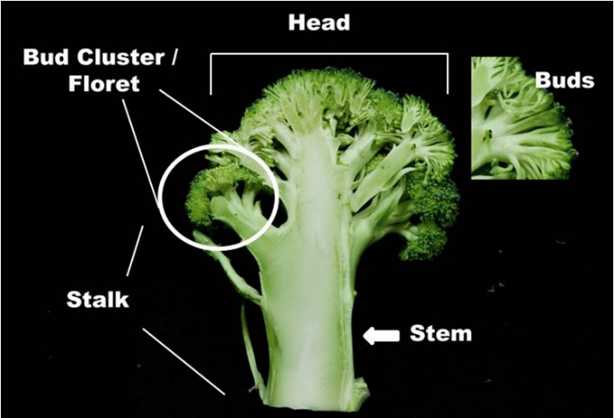
Stalking wasted produce!

https://www.ruralnewsgroup.co.nz/hort-news/hort-management/stalking-wasted-produce

LeaderBrand’s Richard Burke says broccoli stalks are edible, taste great and throwing them away is such a waste.

The humble broccoli, a New Zealand family favourite, is currently being thrown away in staggering amounts.
It appears that New Zealanders are mimicking the infamous stance of former US president George H W Bush, during his tenure as the 41st president.
Bush frequently mentioned his distaste for broccoli, famously saying: "I do not like broccoli. And I haven't liked it since I was a little kid. Now I'm president of the United States, I'm not gonna eat any more broccoli!"
Each year, more than 282 tonnes of broccoli stems are being added to this country's household landfill waste.
LeaderBrand's Richard Burke, a large grower of broccoli, says that this is a staggering amount of waste and a huge waste of money.
"It might come as a surprise, but broccoli stalks are edible and they taste great," he says. "A third of us (37%) are throwing them away! It's such a waste."
Food scraps make up almost half the weight of the average Auckland household's rubbish. Recently, new figures came out that indicate New Zealanders throw out more than $3 billion worth of food each year - more than $1,500 per household per year.
Burke says all the talk about the increase in the cost of living could be helped if people made a few simple changes. He suggests buying in-season produce or not throwing away edible parts of veggies, would see people get better value out of fresh produce.
"Eating every part of the vegetable that you've bought makes financial sense," he adds. "Why not try maximising every inch of this nutrition powerhouse to make meals go further. It tastes great, adds texture to your meal, plus, you'll also be helping the environment."
5 + A Day - a charitable trust committed to increasing the consumption of fresh fruit and vegetables for better health in all New Zealanders - trustee and principal scientist and team leader at Plant and Food Research, Dr Carolyn Lister says broccoli stems are just as important as the head, or floret of the plant.
"Broccoli stems and florets are an excellent source of nutrition, they're an important part of a healthy diet to support your wellbeing in the winter months," she says.
"The stems and the florets provide valuable nutrients such as vitamin C, which supports immunity, and folate which helps the body form red blood cells, plus they're a great source of dietary fibre which keeps you feeling full for longer."
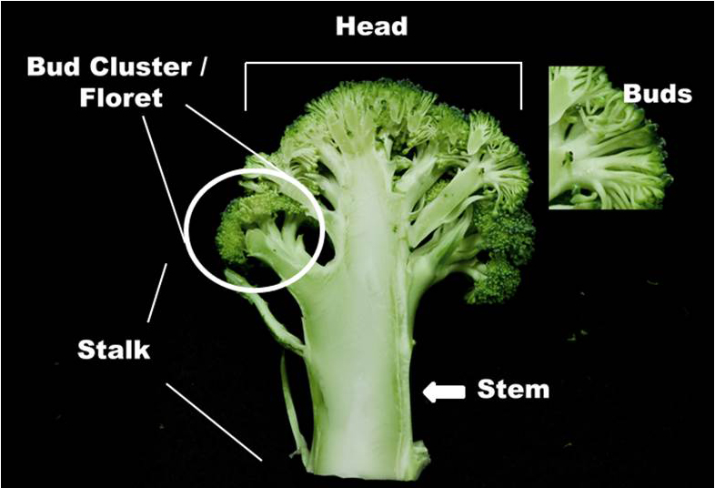

Answers
- Why are large amounts of broccoli being thrown away in New Zealand households?
Large amounts of broccoli are being thrown away because many people do not eat the stalks or stems, even though they are edible. This shows that some consumers are wasting parts of the vegetable due to preference, habits, or lack of awareness.

- How many tonnes of broccoli stems are estimated to go to landfill each year?
More than 282 tonnes of broccoli stems are estimated to be added to New Zealand’s household landfill waste each year.

- What surprising fact about broccoli stems does Richard Burke highlight?
Richard Burke highlights that broccoli stems are actually edible and taste good, even though many people throw them away. He emphasises that they are nutritious and can be used in cooking instead of being wasted.

- What financial impact does food waste have on the average New Zealand household each year?
Food waste costs New Zealand households more than $1,500 per year on average, contributing to a national total of over $3 billion worth of food wasted annually.

- How could eating more parts of vegetables like broccoli help both families and the environment?
Eating more parts of vegetables reduces food waste, helps families save money, and makes food last longer. It also helps the environment by reducing the amount of waste sent to landfill and making better use of resources used to grow food.

- What nutrients do broccoli stems and florets provide, and why are they important for health?
Broccoli stems and florets provide important nutrients such as vitamin C, which supports the immune system, and folate, which helps the body produce red blood cells. They are also a good source of dietary fibre, which helps digestion and keeps people feeling full for longer.

Task1: Write True or False for each statement
- Broccoli stems can be eaten. (T)
- Only the broccoli florets have nutrients. (F)
- Food waste can cost families money. (T)
- Throwing away food has no impact on the environment. (F)
- Broccoli stems can be used in cooking. (T)

