Sustainable Vegetable Production
Watch the video about Mike Arnold and LeaderBrand South Island https://nzfetrust.org.nz/stories/mike-arnold/
Using the information in the video and the article Mike Arnold and LeaderBrand South Island
Do:
- Working in groups, brainstorm and create a list of the management practices LeaderBrand uses to protect the environment and ensure the business remains successful in the future.
- As a class, compare your lists and discuss which practices you think have the greatest impact on sustainability.
- Answer questions.

Questions
- LeaderBrand uses practices such as grid soil sampling, variable-rate fertiliser application, cover crops, and crop stacking. Describe at least four of these practices and explain how they help protect the soil and improve sustainable vegetable production.
- LeaderBrand believes that looking after its workers is an important part of sustainability. Explain how the company supports its employees and describe how this benefits both the workers and the business.
- LeaderBrand has planted riparian strips, created ecological corridors, monitors beneficial insects, and uses solar energy. Choose three of these initiatives and explain how each one helps protect the environment and supports sustainable farming.
- Modern technology plays an important role at LeaderBrand. Give three examples of technology used on the farm and explain how each one improves efficiency, reduces environmental impacts, or helps produce high-quality crops.
- Imagine you are managing a vegetable farm. Based on the video and article, identify the three most important sustainability practices used by LeaderBrand. Explain why you chose them and how they could help keep a vegetable business productive and profitable for many years.

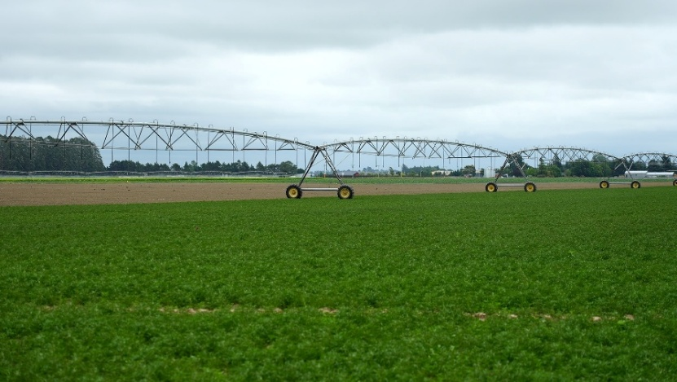
Mike Arnold- LeaderBrand South Island
4 Feb 2026 https://nzfetrust.org.nz/stories/mike-arnold/
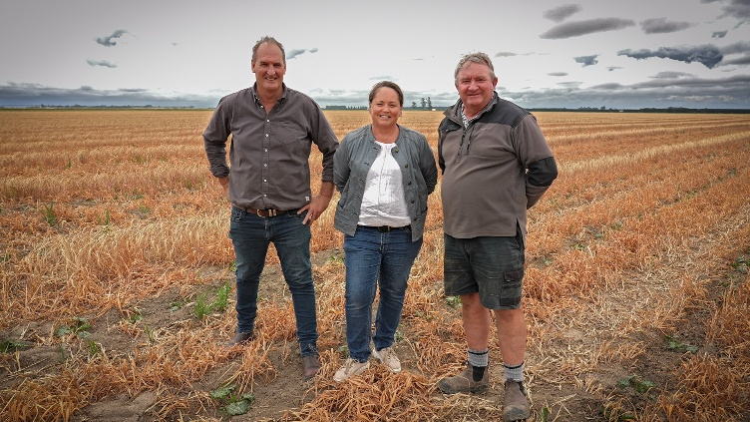
A blend of advanced soil science, biodiversity and a deep commitment to people is safeguarding the future of LeaderBrand South Island which supplies fresh vegetables to retailers year-round.
A 20-year-old equity partnership is behind the 450ha (400ha effective) Canterbury operation. Under the guidance of partners Michael Arnold, Greg Lovett, and Murray McPhail, the business demonstrates how intensive horticulture can be successfully balanced with leading sustainable practices.
Day-to-day operations are managed by Mike, Niel Redelinghuys and Michelle Kelly. The judges were impressed by the team’s proactive approach to soil health, including the sophisticated use of grid sampling and variable-rate applications for precision nutrient management.
Techniques such as cover crops and crop stacking are actively mitigating erosion, stimulating biological activity and building crucial organic matter.
In addition, the team is focused on cultivating a genuinely people-focused culture. Employing 23 permanent and up to 80 seasonal staff, the operation is aligned with workers from around the world. The management team champions family values and provides a safe, secure, and supportive environment, successfully attracting and retaining talent who embrace their sustainable practices out of pride – not obligation.
Further future proofing is illustrated by extensive environmental initiatives. Riparian plantings and ecological corridors are flourishing, supported by an active insect monitoring programme that encourages beneficial species.
The property boasts excellent infrastructure and technology, including an on-site greenhouse with automated irrigation and fertiliser systems, alongside solar installations to reduce environmental footprint.
The judges were impressed by how this positive approach extends into the wider community by offering a strong example of a sustainable, forward-looking practice that others can learn from and be inspired by.
The team’s commitment to the land, people and the use of smart technology looks set to ensure the business remains profitable and productive for years to come – providing fresh, healthy food for New Zealanders while enhancing the surrounding ecosystem.
Answers
- LeaderBrand uses practices such as grid soil sampling, variable-rate fertiliser application, cover crops, and crop stacking. Describe at least four of these practices and explain how they help protect the soil and improve sustainable vegetable production.
- Grid soil sampling involves testing soil from different parts of each paddock. This helps growers understand where nutrients are needed so they can manage each area more accurately.
- Variable-rate fertiliser application uses the soil test results to apply different amounts of fertiliser across the paddock. This reduces waste, lowers costs, and prevents excess fertiliser from polluting waterways.
- Cover crops are planted between vegetable crops to protect the soil from erosion, reduce weed growth, add organic matter, and improve soil fertility.
- Crop stacking means growing different crops in sequence or making better use of the land throughout the year. This helps improve soil health, increases productivity, and keeps living roots in the soil for longer, which supports beneficial soil organisms.

- LeaderBrand believes that looking after its workers is an important part of sustainability. Explain how the company supports its employees and describe how these benefits both the workers and the business.
LeaderBrand provides a safe, secure, and supportive workplace for its employees. The company values family, respects workers from many different countries, and creates a positive workplace culture where staff feel appreciated.
Supporting employees benefits workers because they feel safe, valued, and motivated in their jobs. It also benefits the business by helping attract and retain skilled workers, improving teamwork, increasing productivity, and encouraging employees to take pride in producing high-quality vegetables and caring for the environment.

- LeaderBrand has planted riparian strips, created ecological corridors, monitors beneficial insects, and uses solar energy. Choose three of these initiatives and explain how each one helps protect the environment and supports sustainable farming.
Riparian planting: Trees and plants are grown alongside streams and waterways. These plants reduce soil erosion, filter nutrients and sediment before they reach waterways, improve water quality, and provide habitats for wildlife.
Ecological corridors: These connected areas of vegetation allow native birds, insects, and other wildlife to move safely through the landscape. They increase biodiversity and create healthier ecosystems.
Beneficial insect monitoring: LeaderBrand monitors insect populations to encourage beneficial insects, such as predators and pollinators, which naturally control pests. This can reduce the need for insecticides and supports environmentally friendly pest management.
Solar energy: Solar panels produce renewable electricity that reduces reliance on fossil fuels, lowers greenhouse gas emissions, and decreases the farm's energy costs.

- Modern technology plays an important role at LeaderBrand. Give three examples of technology used on the farm and explain how each one improves efficiency, reduces environmental impacts, or helps produce high-quality crops.
- Grid soil sampling technology measures soil nutrient levels across the farm, allowing fertilisers to be applied more accurately.
- Variable-rate fertiliser equipment applies only the amount of fertiliser needed in each area, reducing waste, lowering costs, and protecting the environment.
- Automated irrigation and fertiliser systems in the greenhouse supply crops with the correct amount of water and nutrients, improving plant growth while reducing water and fertiliser use.
- Solar panels generate renewable energy, lowering electricity costs and reducing carbon emissions.

- Imagine you are managing a vegetable farm. Based on the video and article, identify the three most important sustainability practices used by LeaderBrand. Explain why you chose them and how they could help keep a vegetable business productive and profitable for many years.
The three most important sustainability practices I would use are:
- Protecting soil health
Healthy soil is the foundation of successful farming. I would use cover crops, soil testing, and careful nutrient management to improve soil fertility and reduce erosion. Healthy soil produces stronger crops and remains productive for future generations.
- Using precision technology
I would use technologies such as grid soil sampling, variable-rate fertiliser application, and automated irrigation. These technologies reduce waste, save money, improve crop quality, and reduce environmental impacts by applying only the resources that crops need.
- Protecting the environment
I would plant riparian strips, create habitats for beneficial insects, and use renewable energy such as solar panels. These practices protect waterways, increase biodiversity, reduce pollution, and make the farm more environmentally sustainable.
By combining these practices with a strong focus on employee wellbeing, the business would be more productive, environmentally responsible, and profitable over the long term while continuing to supply high-quality vegetables to consumers.

