Growing Carrots Commercially in New Zealand Case Study
Teachers’ Guide
Introduction
Carrots are one of the most popular vegetables in the world. They are well known for their bright orange colour, crunchy texture, and sweet taste. Carrots are also healthy because they contain vitamins and nutrients that help keep our bodies strong.
In New Zealand, carrots are grown commercially from Northland to Southland. Commercial growers, grow carrots in many different regions because New Zealand’s climate and fertile soils are suitable for carrot production.
Each year, about 2,000 hectares of carrots are grown in New Zealand. These carrots are used for:
- Fresh vegetables sold in supermarkets and other vegetable shops
- Processed foods such as frozen
- Export markets overseas
- Carrot seed production
Key learning outcomes: Students will be able to
- Know a brief history of the colourful carrot.
- Discuss where carrots are grown commercially and explain why.
- Outline the market opportunities for carrots.
- Discuss the management practices in a calendar of operations for growing carrots commercially
- Briefly discuss 1 or 2 challenges growers are facing and what they are doing to minimise these.

Supporting resources
- Topic 6 Vegetable Plant Structure
- Field Trip to a Carrot grower (WS)
- Carrot Glossary of terms
- Activity 3 History of carrots
- Activity 5 Sample answers
- Activity 8 Pelleted Seed Investigation
- Activity 9 Carrot thinning investigation
- Activity 12 Growing Carrots (WS)
- Activity 14 Weather a challenge for consistent carrot supply (WS)
- Carrot harvesting on a giant scale (WS)
- LaserWeeding Carrots in Southland (WS)
- Timaru carrot juice gone global (WS)
- Pelleted Seed Technology for Carrots (WS)
- Weather a challenge for consistent carrot supply (WS)
- Growing Carrots (WS)
- Zapping Weeds in Southland
- Growing carrots word search
- All about carrots crossword
PowerPoints
- History of carrots
- Carrot markets
- Growing Carrots
- Carrot pest and diseases
Videos
- Wilcox Growing carrots in NZ-
- Country Calendar - Growing organic carrots - Feb 26
- Harvest Fresh Carrot Production (no commentary) https://www.youtube.com/watch?v=wTBthCAB5C0&t=1s
- Processing carrots South Canterbury Read & Watch
1 billion kg of carrots One billion kg of carrots have disappeared in the Juice Products Washdyke factory and come out the other end as various products
https://www.thepress.co.nz/nz-news/360951807/quiet-powerhouse-timaru-juice-factory-marks-major-milestone
- Processing carrots (American) https://www.youtube.com/watch?v=MRhMmYchFGk How Carrots are Harvested & Processed | Modern Carrot Processing Technology | Food Factory
References
- Balle brothers https://www.ballebros.co.nz/
- Sofresh https://www.sofresh.co.nz/carrots
- Premier Seeds – Carrot Varieties
- Terranova Seeds – Carrot Product Range
- Pests, diseases and disorders of carrots, celery and parsley- A Field Identification Guide: Jenny Ekman and Len Tesoriero
Recommendations
Within each case study, there are multiple activities for students to complete. We recommend you select the activity or activities that best suit your students.

Find out what your students know.
Ask selected questions to brainstorm ideas on growing carrots commercially in New Zealand.
Fun fact:
Carrots weren’t originally orange!
The first cultivated carrots, grown over 1,000 years ago in regions around modern-day Afghanistan, were usually purple, yellow, red, or white.

- What colour do you usually think of when you hear the word “carrot”?
- What colours can carrots grow?
- Do carrots grow above or below the ground?
- What type of crop are carrots?
- Where are carrots grown commercially in New Zealand?
- Growers produce carrots for supermarkets and other vegetable retailers. What are some other uses for carrots?
- What conditions do carrots need to grow well?

Sample answers
- Most people think of orange when they hear the word “carrot,”
- Carrots can grow in several colours, including orange, purple, yellow, white, and red.
- Carrots grow below the ground.
- Carrots are a root vegetable (a root crop).
- In New Zealand, carrots are grown commercially in regions with good soil and climate conditions, including places like Northland, Pukekohe, Ruapehu, Waikato, Canterbury, and Southland.
- Other uses for carrots include processing into foods like frozen vegetables, soups, juices, and baby food, as well as being used for animal feed.
- Carrots need good soil, water, sunlight, space to grow, and suitable temperatures to grow well.

Activity 1: Brainstorm
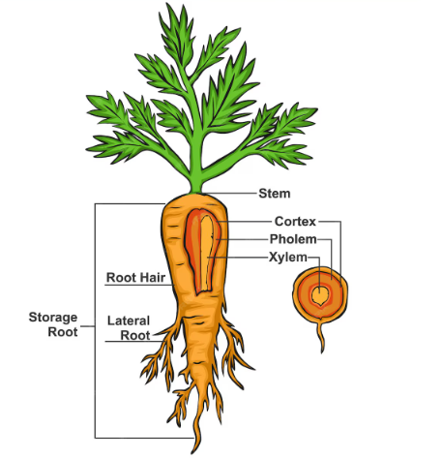
Work in groups to discuss, share and write down your ideas
- What other questions do you have about growing carrots?
- Make a list of things you are curious to learn more about carrots?

Activity 2: Carrots are root crops.
To refresh understanding of the function of roots - refer to Topic 6 Vegetable Plant Structure

The Colourful History of Carrots
Refer PPT History of carrots
Carrots are one of the most familiar vegetables in the world today, known for their bright orange colour and sweet taste. However, carrots have not always looked or tasted the way they do now. Their story is a long journey of change, shaped by nature and by people.
Carrots began as wild plants growing across Europe, North Africa, and Western Asia. These early carrots were very different from modern ones. They had small, thin, white roots that were tough, forked, and often bitter. Because they looked similar, carrots were often confused with parsnips. It was not until the scientist Carl Linnaeus classified plants that carrots and parsnips were clearly identified as separate species.
The first domesticated carrots were grown around the 9th and 10th centuries in Central Asia, in regions that are now Afghanistan and Iran. These early farmed carrots were not orange. Instead, they were usually purple or yellow. Purple carrots contained natural pigments called anthocyanins, while yellow carrots contained carotene. Purple varieties were often valued for their strong flavour, although they had the disadvantage of staining cooking pots and water.
As people travelled and traded, carrot seeds spread to new regions. Carrots moved west into North Africa and Europe, and east into other parts of Asia. Over time, farmers continued to select and grow the best plants.
By the 15th and 16th centuries, orange carrots began to appear in parts of Europe such as Spain and Germany. These carrots were developed from yellow varieties through careful selection. Farmers chose carrots that were sweeter, less bitter, and had smoother roots. Orange carrots quickly became popular because they were more pleasant to eat and did not stain when cooked.
In the 1600s, Dutch farmers improved orange carrots even further. They developed larger, straighter, and more reliable varieties that became the basis of many modern carrots. Although there is a popular story that orange carrots were created to honour a Dutch royal family, historians believe they were mainly developed because of their better taste and quality.
For much of history, carrots were often used as animal feed rather than human food. As their flavour and texture improved, they became more widely eaten and eventually became an important part of diets around the world.
Today, carrots are grown in many countries and are one of the most important root vegetables. Modern breeding continues to improve carrots by making them sweeter, reducing bitterness, enhancing colour, and increasing resistance to pests and diseases.
Carrots were introduced to New Zealand by early European settlers in the early 1800s. They grew well in the country’s conditions and soon became an important crop. Today, New Zealand produces large quantities of carrots. Fresh market crops average about 70 tonnes per hectare, while processing crops can average around 96 tonnes per hectare. In the best conditions, yields can exceed 100 tonnes per hectare.
The history of the carrot shows how much a plant can change over time. From a small, bitter, white root, the carrot has become a large, sweet, and colourful vegetable enjoyed all over the world.
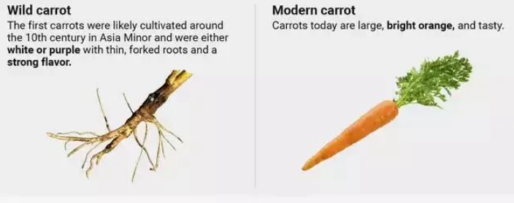
Activity 3: Read the article on the history of carrots, then complete the tasks below.
- Timeline challenge
Put these events in the correct order (1–5)
- Orange carrots are developed in Europe
- Wild carrots grow in Europe, Asia, and North Africa
- First purple and yellow carrots are farmed in Central Asia
- Carrots spread through trade to Europe and other regions
- Carrots are improved in the Netherlands

- Comprehension
- What did wild carrots originally look like, and how did they taste?
- Why were carrots and parsnips often confused in the past?
- Where and when were the first domesticated carrots grown?
- What colours were the earliest cultivated carrots, and what gave them these colours?
- Why did orange carrots become more popular than purple and yellow varieties?
- How have scientist and growers improved carrots today?

- Design task
Design your own “future carrot”!
Draw what you think carrots might look like in 100 years. Label at least two features, for example:
- Colour
- Taste
- Size
- Resistance to pests
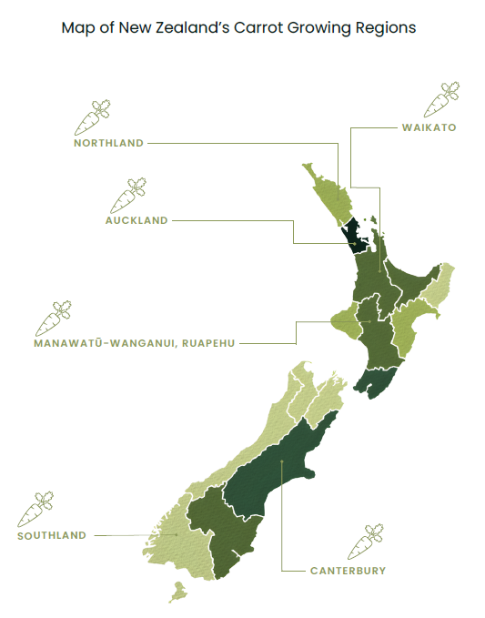
Approximately 2000ha of carrots are grown in New Zealand per year for fresh, processing and export markets and seed. In 2025, 800ha was in sown in process carrots. Fresh facts 2025

Growing requirements
Carrots grow best in full sun in deep, loose, well-drained loam soil that is free of stones and clumps. The ideal soil pH is 6.0–6.8, which supports good nutrient uptake and healthy root development. Before sowing, the soil is cultivated to a depth of 30–40 cm to prevent misshapen or forked roots. Pelleted carrots seed is sown 1–2 cm deep, 42-45mm apart in rows spaced 30–50 cm apart, with a precision drill. The soil needs to be kept consistently moist during germination.
Carrots grow best in cool temperatures between 15–20°C, which help produce sweet, smooth, and well-shaped roots. They require regular watering to maintain even growth and prevent splitting or bitterness, but soils must not become waterlogged. Correct spacing, along with good nutrient, weed, and pest management, is essential for producing high-quality carrots.
Growing Carrots
Note:
The following information on growing carrots commercially is purposefully generalised. For specific, regional information contact and visit a local grower. The field trip to carrot grower worksheet provides a set of questions that you can revise to suit your class and the purpose of the field trip.
Field trip to carrot grower (WS)

The New Zealand carrot industry operates year-round, using staggered sowing and harvesting schedules to maintain a continuous supply for both fresh and processing markets. Some commercial growers also export fresh carrots, targeting periods when importing countries have low domestic supply, allowing them to take advantage of favourable market conditions.
Carrots typically take between 12–20 weeks (3–5 months) to reach maturity, depending on the variety, season, and growing conditions.
Growers aim to grow long cylinder-shaped carrots with smooth skin and bright orange in colour. To achieve this, growers implement several management practices to produce, high-yielding, and high-quality carrot crops, including:
- Careful site selection with well-drained, deep, stone-free soils, often as part of a planned crop rotation to reduce disease and pest build-up.
- Preparation of a fine, even seedbed to ensure straight root development, along with maintaining optimal soil pH and fertility.
- Precision sowing to achieve uniform spacing and consistent root size.
- Regular crop monitoring, including the use of integrated pest management (IPM) strategies to control pests and diseases.
- Targeted irrigation and nutrient management to support steady growth and prevent defects such as splitting or forking.
- Effective weed control, particularly during early growth stages when carrots are less competitive.
- Efficient harvest management, using mechanical harvesters to maintain quality and minimise damage.

Calendar of operation for commercial production of carrots
Note:
The calendar of operations below outlines the key management practices used to produce a commercial carrot crop. These practices and their timing may vary slightly between growers within a region, as well as across different regions.
Some large-scale growers operate in multiple regions to ensure a consistent, year-round supply that meets market demand. Carrots are typically sown from April through to October, enabling continuous production for both the New Zealand fresh and processing markets. Depending on growing conditions, carrots generally take around 100–150 days to reach maturity after sowing.

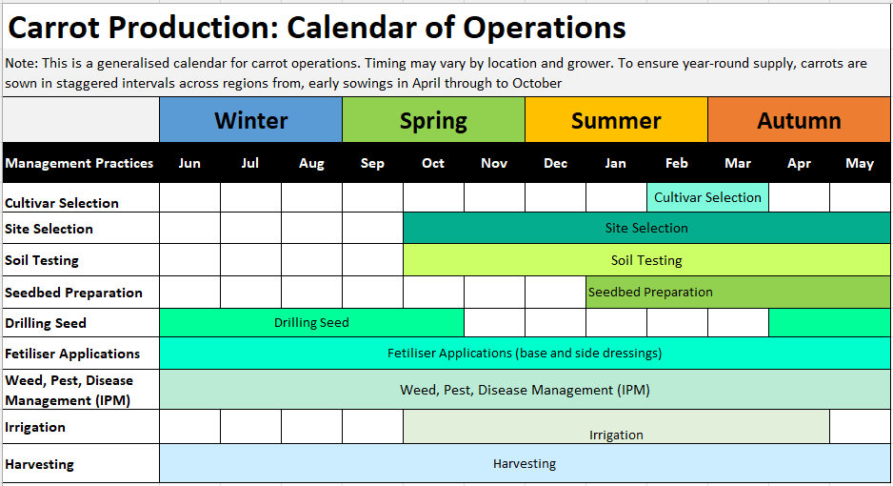

Watch Video: Wilcox Growing carrots in NZ-
Activity 4: Develop a calendar of operations for a local carrot grower
Visit a local carrot grower and investigate how they manage their production system throughout the year. Using the information you gather, create a detailed calendar of operations that outlines the key stages of carrot production, from seedbed preparation through to harvesting.
Include:
- Major management practices e.g. soil preparation, sowing, irrigation, pest and weed control, harvesting
- The timing of each activity across the year
Present your calendar in a clear format e.g. table, timeline, flow diagram or spreadsheet.
Markets and market requirements- Refer to PPT Carrot Markets
Activity 5 - Brainstorm markets and market requirements
In groups
- Make a list of the main markets for carrots.
- Make a list of what these markets want from growers.
- Make a list of products made from carrots.
- What are consumers wanting?

Domestic
In the domestic retail market, carrots must meet high quality standards to appeal to consumers. They are expected to have a uniform, long cylindrical shape and consistent size, a bright orange colour, and smooth, blemish-free skin. Carrots should also be free from defects such as cracks, splits, or damage.
In addition to these traditional requirements, there is a growing demand for
- convenience products, with more consumers choosing peeled, shredded, or baby-cut carrots that are ready to eat or easy to prepare.
- niche products such as bunch carrot (orange, yellow, purples rainbow) and organically grown carrots
Companies such as Taylor farms, Wilcox, Southern Fresh and So Sweet have diversified and or expanded into producing these convenience and niche products.

Processing
About 800 hectares of carrots are grown for processing into frozen products, baby food and concentrated juice.
Growing carrots for processing is typically done under a contract with a processor such as Wattie's, or Juice Products New Zealand. This contract is agreed upon and signed before the crop is planted, giving growers certainty about production requirements and income.
The contract usually outlines:
- the specific variety of carrot to be planted,
- the required harvest time, and
- the price that will be paid per tonne.
It may also include detailed conditions regarding crop quality standards e.g. free from major defects and diseases, and a brix sugar content 6-15⁰ and the quantity the processor agrees to purchase, helping ensure both the grower and the processor have clear expectations from the start.

Export
New Zealand’s carrot export market focuses on premium, high-quality fresh produce, as well as processed products such as concentrated carrot juice. Key export destinations include Fiji, the United Arab Emirates, Saudi Arabia, Japan, and other Asian markets.
Market access can sometimes be challenging, especially when importing countries have enough of their own supply. Because of this, New Zealand exporters carefully time their shipments to match periods when supply is low in those markets.
Exporting carrots from New Zealand requires following strict rules and phytosanitary requirements to ensure the product is safe and meets the standards of the importing country. These steps help ensure New Zealand carrots are high-quality, meet market specifications, and are accepted internationally.

Activity 6: Research
- Do - Timaru carrot juice gone global (WS)
- Research the products and the company mission of Juice Products New Zealand (JP-NZ)

Carrot Varieties
There are many carrot varieties available, and growers choose a variety based on local growing conditions, intended harvest timing, and market requirements. Different varieties offer advantages such as root uniformity, colour, flavour, storage ability, disease resistance, and suitability for either the fresh or processing market.
Fresh market varieties
Nairobi is one of the most widely grown carrot varieties for the fresh market. It is a Nantes-type carrot, producing highly uniform, medium-sized cylindrical roots that are rounded at both the shoulder and tip. Typically growing to 12–18 cm in length, Nairobi combines an attractive appearance with excellent eating quality. Nantes cultivars are renowned for their sweet flavour, tender texture, and smooth roots, making them particularly popular with consumers.
Nairobi's consistent root shape and size contribute to a high proportion of marketable yield. It is also valued for its excellent internal and external colour, good flavour, and strong root strength, which helps minimise damage during harvest and handling. In addition, Nairobi has strong bolting tolerance and can be successfully stored in the ground over winter when established from a main-season sowing.
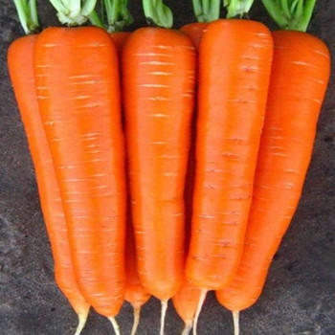
Other varieties commonly grown for the fresh market include Nipomo, Explorer, Paramount, and Speedo, each offering different combinations of yield, root quality, maturity, and adaptability to growing conditions.
Processing market varieties
Carson is a popular variety for the processing market. It is a high-yielding carrot with strong, healthy foliage and uniform, long, bulky roots. Carson produces roots with excellent external and internal colour, making it well suited to processing applications where colour and consistency are important.

Further information
Detailed information on carrot varieties and their characteristics can be found from New Zealand seed suppliers:
- Premier Seeds – Carrot Varieties
- Terranova Seeds – Carrot Product Range
These resources provide current information on variety performance, maturity, root characteristics, disease resistance, and suitability for different markets and growing regions.

Crop establishment
Site selection
Carrots are commonly grown in rotation with other vegetable crops such as potatoes, lettuce, cauliflowers, broccoli and onions. 3–4-year rotation is implemented to manage pests and diseases.
Carrots are grown on a wide range of soil types although sandy loam soils are favoured because of better root quality and ease of harvesting.

Seedbed preparation
A deep fine firm bed is used to grow carrots to ensure good root development. Three or four double rows of carrots are usually sown per bed with 30-50cm between each row of the double row.
- Raised beds are common, especially in areas with drainage concerns.
- Fertiliser is applied based on soil tests.

Sowing
Pelleted carrot seeds are sown just below the soil surface, spaced approximately 42-45mm apart in rows spaced 30–50 cm apart, depending on the variety, as each type has slightly different spacing requirements. Optimal plant densities for fresh carrot production range from 50 to 80 plants per square metre, depending on the crop’s yield potential.
If seeds are sown too closely together, harvesting becomes more difficult, and air movement through the leaf canopy is reduced, which can increase the risk of disease.
In warmer regions such as Northland and Pukekohe, carrots are typically sown between April and September and harvested from October to January. In cooler regions such as Ohakune and the South Island, sowing occurs from September to December, with harvesting taking place between January and October.
This staggered sowing and harvesting schedule allows fresh carrots to be available all year round.

Activity 7: Pelleted seed
In groups, discuss
- Discuss how pelleted seed technology can improved carrot yields.
- Explain why carrot seeds are pelleted before sowing and how this helps with precision sowing.
- Describe benefits of pelleted carrot seeds for growers, including how they help protect young plants and improve growth.
- Do Pelleted Seed Technology for Carrots (WS)

Activity 8: Investigation: Germination experiment with pelleted and unpelleted carrot seeds.
Activity 9: Sow carrot seed and do the “Carrot thinning investigation”.

Growing
Nutrient management
Carrots require low-to-moderate nitrogen (N) and high phosphorus (P) and potassium (K) for root development. Fertilizer is applied prior to sowing based on soil test, then again as small, split doses side dressings as required.
Macronutrients:
- Nitrogen (N): Essential for foliage but excessive amounts lead to split roots and excessive leafy growth.
- Phosphorus (P): Critical for root development, typically applied at 60–80 kg/ha.
- Potassium (K): Strengthens plants, improves shelf life, and boosts yield, with high requirements of 150-200 kg/ha.
Micronutrients: Carrots need boron (B), magnesium (Mg), and manganese (Mn) for quality and health.

Pest and disease management
Effective pest and disease management in carrots relies on an integrated approach that combines preventative, cultural, and chemical control measures. Key practices include maintaining a 3–5-year crop rotation, using high-quality disease-free seed, and ensuring good soil drainage to minimise conditions that favour disease development.
Where soil-borne pests such as nematodes are a concern, nematicides may be applied before sowing. For maximum effectiveness, carrot seed should typically be sown within 24–48 hours of application, allowing the treatment to provide early protection during crop establishment. Good crop hygiene, including the removal of crop residues and control of volunteer plants and weeds, can also help reduce sources of pest and disease inoculum.
Regular crop monitoring is essential for the early detection of pests and diseases. Frequent field inspections enable growers to assess crop health, identify emerging issues, and make timely management decisions. When disease pressure is high or environmental conditions favour disease development, fungicides may be applied as part of an integrated disease management programme. Combining monitoring with appropriate cultural and chemical controls helps minimise crop losses, maintain root quality, and maximise marketable yields.

Some Common Carrot
Pests, Diseases and Disorders
Pests | Diseases | Disorders
Aphids  Carrot Rust Fly  Root-Knot Nematodes  Slugs and snails  Wireworms | Alternaria leaf blight  Bacterial Soft Rot  Black Rot  Crown Rot  Sclerotium Rot | Cracking  Bolting
For more information on carrot pests and diseases refer to PPT Carrot Pest and Diseases.

Weed management
Carrots are slow-growing and poor competitors, so effective weed management is essential to achieve high yields. Weed control requires an integrated approach, including careful seedbed preparation. Traditional methods involve the use of the stale seedbed technique, where weeds are encouraged to germinate after cultivation and then removed using a registered herbicide before sowing. A registered post-emergence herbicide may be used to manage the weed population until row closure.

AI laser technology
Some growers are investing in AI laser technology, such as the LaserWeeder, because it offers several advantages over traditional weed control methods.
This technology reduces the need for herbicides. Many growers want to reduce their reliance on chemicals or eliminate their use altogether to protect the environment and meet consumer demand for chemical-free produce.
Laser technology also saves time and labour. Weed control has traditionally required a lot of manual work, such as hand weeding, which is slow, expensive, and physically demanding. The AI laser system can perform this task automatically, reducing labour costs and freeing workers to focus on other jobs.
Weeds compete with crops for sunlight, water, and nutrients. By removing weeds quickly and accurately especially when they are very small. This technology helps crops grow better, which can increase overall production.
Unlike mechanical weeding, the laser system does not disturb the soil. This helps maintain soil structure, reduces erosion, and prevents new weed seeds from being brought to the surface.
The AI system can identify and target individual weeds with very high accuracy, resulting in less waste and better outcomes. It can also operate for long periods and may eventually become fully automated.
Investing in this technology helps growers stay competitive and adopt more sustainable practices. It allows them to produce higher-quality crops more efficiently, with less reliance on chemicals and manual labour.

Activity 10: LaserWeeding
Watch Country Calendar - Growing organic carrots - Feb 26
Do LaserWeeding Carrots in Southland (WS)

Irrigation management
Carrot crops require careful water management throughout their growth cycle. Adequate soil moisture is particularly important during germination, as carrot seeds are small and are sown close to the soil surface, where they can dry out rapidly. Seeds that do not receive sufficient moisture may fail to germinate, resulting in uneven crop establishment and reduced plant populations.
Care must also be taken during irrigation to avoid displacing seeds or causing soil crusting. Heavy irrigation can disturb newly sown seed, while the formation of a hard soil crust as the surface dries can impede seedling emergence and reduce establishment success.
During the vegetative growth and root development stages, soil moisture levels should be carefully monitored and maintained. Carrots require a consistent supply of water to support healthy root enlargement and achieve high yields. Prolonged periods of moisture stress can reduce growth and lead to defects such as root splitting, cracking, misshapen roots, and bitter flavour. Excessive soil moisture, however, can increase the risk of disease and reduce root quality.
Irrigation Scheduling
Irrigation scheduling should be based on regular monitoring of soil moisture levels and crop water requirements. Soil moisture sensors, tensiometers, or manual soil assessments can be used to determine when irrigation is required. The aim is to maintain adequate moisture within the root zone while avoiding waterlogging or excessive fluctuations in soil moisture.
During periods of high evapotranspiration, such as warm, dry weather, irrigation may need to be applied more frequently. As the crop approaches harvest, maintaining consistent soil moisture remains important to preserve root quality and minimise the risk of cracking. Effective irrigation scheduling helps optimise water use efficiency, promotes uniform crop growth, and supports the production of high-quality marketable carrots.
Harvest
Fresh-market carrots are harvested from October to January in warmer regions and from late January to October in main crop growing cooler regions. In these main crop areas, carrots can be left in the ground for longer because cooler temperatures slow deterioration.
Carrots are harvested mechanically. A harvester undercuts the roots and lifts them out of the soil by gripping the leaves. The carrots then move along a series of belts, where a set of knives removes the tops. They are transferred into storage containers for transport to packhouse facilities.

Activity 11: Harvesting
Watch: Harvest Fresh Carrot Production https://www.youtube.com/watch?v=wTBthCAB5C0&t=1s
Do: Carrot harvesting on a giant scale (WS)

Packhouse
At the packhouse, carrots are cleaned, washed, graded, and packed for delivery to supermarkets. Throughout harvesting, washing, and packing, carrots are handled carefully to avoid damage to the roots.

Storage
Commercial carrot growers use both in-ground and post-harvest storage methods to maintain a consistent supply and preserve quality. Many carrots are left in the soil after reaching maturity, a practice known as in-ground storage. This allows growers to “store” the crop naturally until it is needed, helping to spread harvest over time and reduce the need for immediate processing. However, this method depends heavily on suitable weather conditions, as excessive rain can cause rotting, splitting, or disease. Once harvested, carrots are transported to packhouses where they are washed, sorted, and stored in controlled environments. These storage facilities are typically kept at low temperatures with high humidity to prevent dehydration and maintain freshness. This combination of in-ground and refrigerated storage enables growers to supply carrots to markets year-round while managing quality and reducing waste.

Activity 12: Comprehension exercise - Do “Growing carrots (WS)”
Activity 13: Risk and challenges for growers
In groups
- Brainstorm a list of challenges you think commercial carrot growers are facing. Consider environmental, economic, production and market challenges.
- Which challenges pose the biggest risks in carrot production? Discuss and rank the top 3.
- Which challenge has the greatest impact on grower profitability?
- Choose one challenge and brainstorm a risk management plan to minimise the challenge.
- Which challenge do you think will have the greatest impact on the future of the carrot industry and why?

Ideas
- Climate variability
- Water restrictions
- Rising input costs
- Labour shortages
- Disease pressure
- Control of nematodes- due to reduce chemical control options
- Land availability
- Managing waste
- Environmental regulations
- Meeting changing consumer demand

Do: Weather a challenge for consistent carrot supply (WS).
Activity 14: “Grower for a Day: Solving Real Challenges at A S Wilcox”

