LaserWeeding Carrots in Southland

Summary of “Zapping weeds in Southland”
A Southland farming company called So Sweet has introduced new technology to help grow carrots more efficiently and with fewer chemicals. The company is using a machine called the Carbon Robotics LaserWeeder, which uses artificial intelligence (AI), cameras, and precision lasers to remove weeds.
The machine works by scanning the paddock and identifying weeds. If it detects a weed, it fires a very accurate laser at it, destroying the plant’s cells with a small burst of heat and a puff of smoke. The carrots are not damaged, and the soil is left undisturbed. This makes the process faster and more environmentally friendly than hand weeding or using herbicides.
The LaserWeeder can kill thousands of weeds in a short time and is especially effective when weeds are very small. It is powered by a diesel tractor and can operate in most weather conditions except heavy rain.
Traditionally, weed control in carrot farming involved chemical sprays and a lot of manual labour, including hand weeding. This was time-consuming and difficult work. The new technology reduces the need for herbicides and manual labour, and the company hopes to produce carrots that are completely spray-free.
The farm also expects small improvements in crop yield and is testing whether the machine can help with thinning carrot plants as well. Over time, the technology could allow farmers to grow more food on less land, which may benefit soil health and water use.
The company plans to label its produce as spray-free in the future, showing how modern robotics and AI are changing agriculture in New Zealand.
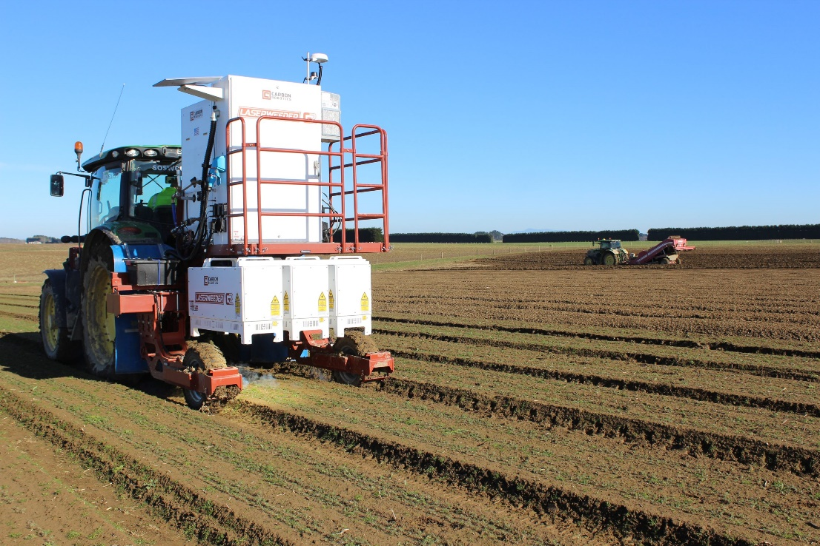

Watch
Country Calendar - Growing organic carrots - Feb 26
Discussion
- In groups brainstorm the;
- benefits and challenges for growers investing in a Carbon Robotics LaserWeeder.
- environmental advantages of managing and controlling weeds using this technology.
And or
Read the full article “Zapping weeds in Southland” and answer the following questions.
Questions
- What problem is the LaserWeeder designed to solve when growing crops like carrots?
- How does the LaserWeeder identify and remove weeds?
- What happens to a weed when it is hit by the laser?
- Why are the carrots not damaged by the laser system?
- What are two benefits of using lasers instead of herbicides?
- How does this technology reduce the need for manual labour when growing carrots commercially?
- In what way does the LaserWeeder help improve environmental sustainability?
- Why is it an advantage that the soil is not disturbed during weed removal?
- How could this technology potentially improve crop yields for growers?
- What are two long-term benefits for growers using AI and robotic weed control systems?

Sample answers
- What problem the LaserWeeder designed to solve when growing crops like carrots?
The LaserWeeder is designed to solve the problem of weed control in carrot farming. Carrots grow slowly and are poor competitors against weeds, so weeds can easily reduce crop growth and yield. Traditionally, this required chemical herbicides or a lot of manual labour, both of which are time-consuming and costly.

- How does the LaserWeeder identify and remove weeds?
The machine uses high-resolution cameras and artificial intelligence (AI) to scan the crop field. It analyses what it sees and decides whether a plant is a weed or a carrot. If it identifies a weed, it uses a precision laser to target and destroy it.

- What happens to a weed when it is hit by the laser?
When the laser hits a weed, it targets the centre of the plant and destroys its cells using heat. This causes the plant tissue to burn and die, often producing a small puff of smoke. The weed is completely killed without affecting the surrounding soil or crops.

- Why are the carrots not damaged by the laser system?
Carrots are not damaged because the AI system is trained to accurately distinguish between weeds and carrot plants. The lasers are extremely precise and only target the centre of weeds, avoiding the crop plants entirely. The accuracy is measured at sub-millimetre level.

- What are two benefits of using lasers instead of herbicides?
Two benefits are that it reduces chemical use in food production and helps produce spray-free crops. It also avoids potential environmental harm caused by herbicides, such as soil and water contamination.

- How does this technology reduce the need for manual labour when growing carrots commercially?
Previously, weeds were often removed by hand, which was slow, expensive, and physically demanding. The LaserWeeder automates this process by removing weeds using AI and lasers, significantly reducing the need for people to do hand weeding.

- In what way does this technology help improve environmental sustainability?
It improves sustainability by reducing or eliminating herbicide use, which lowers chemical pollution. It also avoids disturbing the soil structure and may help farmers grow food more efficiently on less land, reducing environmental pressure.

- Why is it an advantage that the soil is not disturbed during weed removal?
Not disturbing the soil helps maintain soil health and structure. It also reduces erosion risk and prevents bringing new weed seeds to the surface, which could otherwise lead to more weed growth.

- How could this technology potentially improve crop yields for growers?
The technology can improve yields by removing weeds more effectively and earlier in the growing process, reducing competition for water, nutrients, and sunlight. The farm also expects around a small yield increase (about 3%) due to improved weed control.

- What are two long-term benefits for growers using AI and robotic weed control systems?
Two long-term benefits include reduced reliance on herbicides and lower labour costs. It may also allow growers to grow higher yielding crops on less land and improve efficiency through automated systems that can operate continuously with minimal human input.

