Activity: Carrot Juice concentrate
Read “Timaru carrot juice gone global” and answer the following questions.
Questions
- Why has carrot juice become popular in Japan, and how is it commonly consumed there?
- What role does Juice Products New Zealand (JP-NZ) play in the global carrot juice industry?
- How has growing carrots for juicing benefited the Tayler brothers’ farming operation?
- What challenges does JP-NZ face in producing carrot juice, and how do they manage them?

Timaru carrot juice gone global
https://www.stuff.co.nz/rural/350302665/timaru-carrot-juice-gone-global
Not every farmer can say their produce ends up in vending machines in Japan, but the Tayler brothers can, who grow juicing carrots in Winchester, South Canterbury.
Bags of potato chips and carrot juice-boxes are two end products for Michael and Nick Tayler’s operation, with the carrot juice sold in Japan and potato chips on home soil in New Zealand.
They’ve been in the carrot juicing game for 16 to 17 years, approached by Juice Products New Zealand (JP-NZ) to grow juicing carrots.
The JP-NZ factory is based in Washdyke, Timaru, and is the second biggest carrot juicing company in the world, chief executive officer Chris Renfree says, putting South Canterbury on the world map.
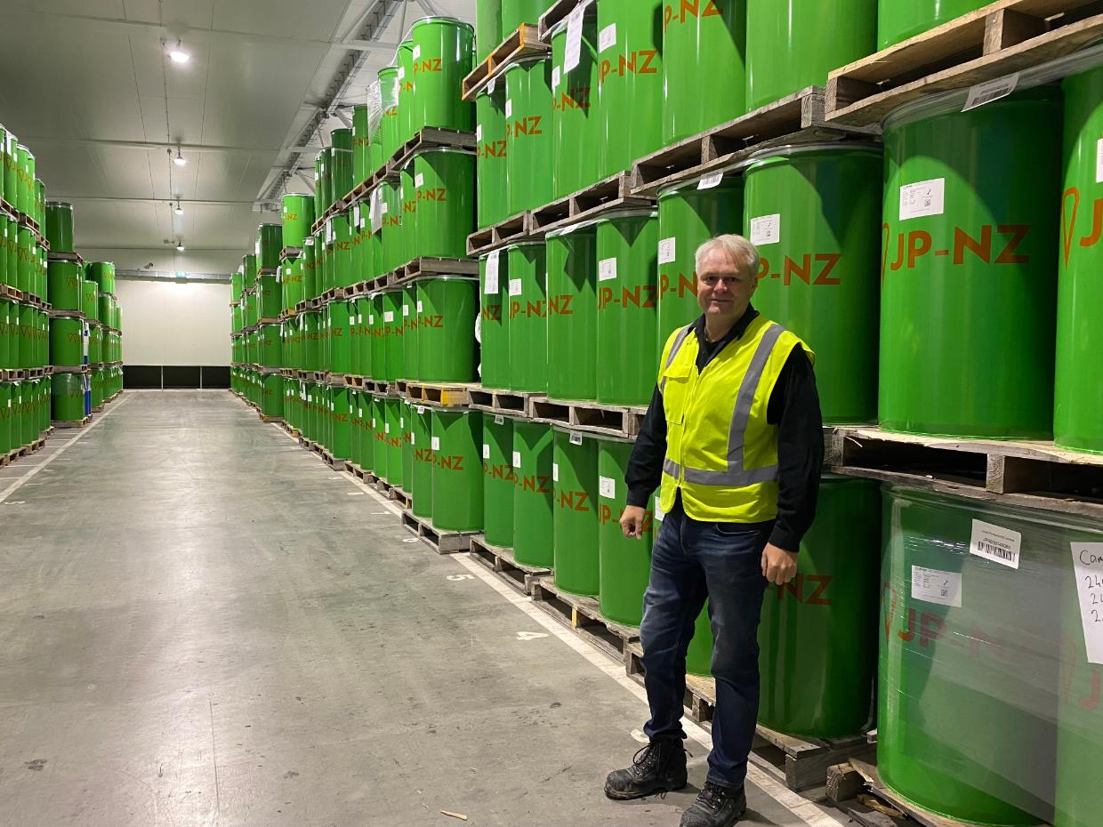
Chris Renfree, chief operating officer of JP-NZ, says out of their seven months of operating 24/7, they usually have three days without operating due to production issues. This year, they've successfully had no days off. Photo: Eve Hyslop / Stuff

JP-NZ was acquired by major Japanese company Sumitomo Corporation in 2014 and is a leading processor of raw carrots into high quality carrot juice concentrates. It exports its juice to North America, Asia and Australia. Their largest consumer is Japan.
Health is front of mind for Japanese consumers, so rather than a classic bottle of lemonade, you’d find a box or bottle of carrot juice in a standard Japanese vending machine, or even on a Japanese cocktail menu.
“They’re really big on health and drinking healthy products, they use a lot of it for mixers and spirits,” Nick says.

From left: Nick and Mike Tayler have been supplying their carrots to JP-NZ for 16 to 17 years now and say it has made better use of their yield. Photo: Federated Farmers / Supplied
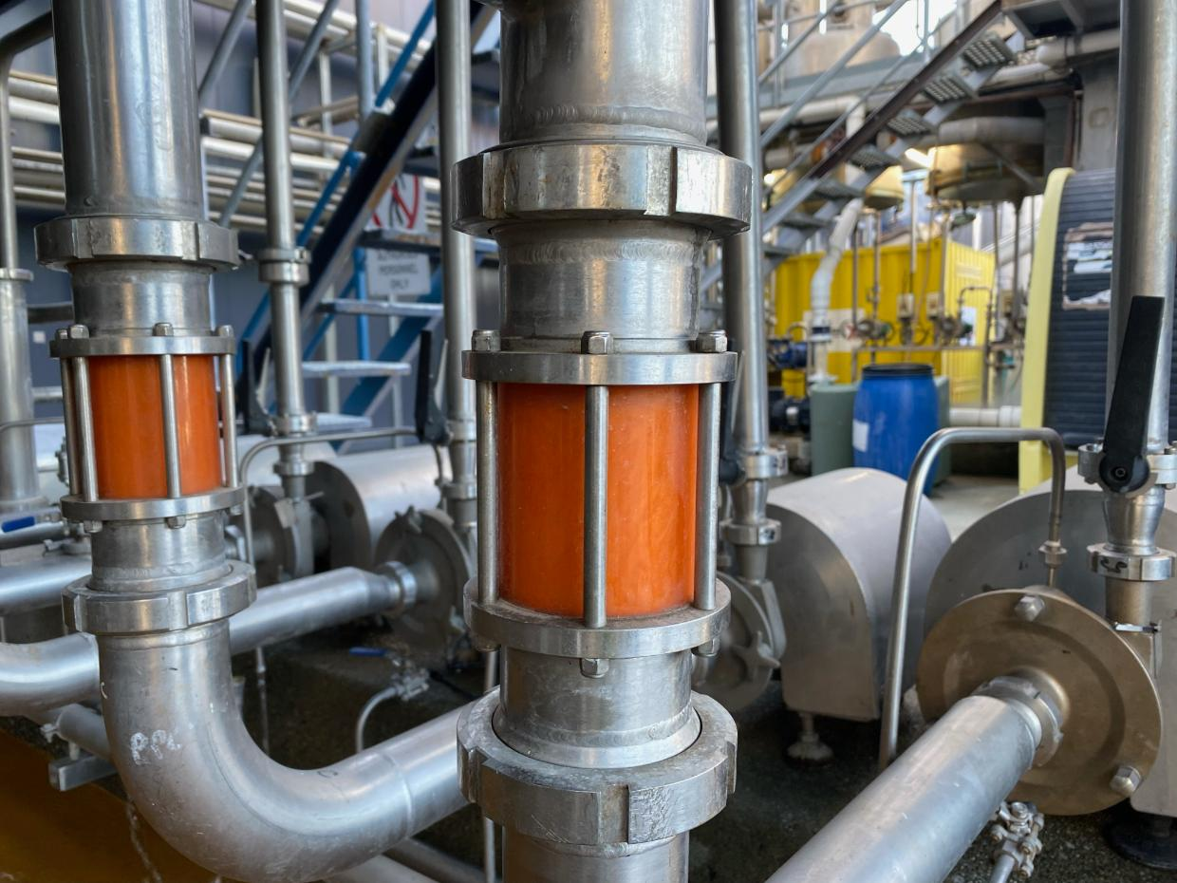
Carrot juice is susceptible to colour deterioration, so JP-NZ consistently monitor their production lines to maintain the colour of their juice. Photo: Eve Hyslop / Stuff

“They like the flavour so much that they’ll buy a 100% carrot juice and drink it like any other branded drink,” Renfree says.

Sample answers
- Why has carrot juice become popular in Japan, and how is it commonly consumed there?
Carrot juice has become popular in Japan largely because of the country’s strong focus on health and nutrition. Japanese consumers are very conscious about what they eat and drink, and they tend to prefer beverages that offer health benefits rather than sugary soft drinks. Carrot juice is seen as a natural and healthy option, rich in vitamins and nutrients. It is commonly consumed in everyday settings, such as from vending machines, where it is sold in bottles or cartons like any other drink. It is also used in more creative ways, including as a mixer in cocktails and alcoholic drinks, showing its versatility and appeal in both casual and more sophisticated settings.

- What role does Juice Products New Zealand (JP-NZ) play in the global carrot juice industry?
Juice Products New Zealand (JP-NZ) plays a significant role as one of the largest carrot juice processors in the world, the second biggest globally. Based in Washdyke, Timaru, the company processes raw carrots into high-quality juice concentrates. These concentrates are then exported to international markets including Japan, North America, Asia, and Australia. Since being acquired by Sumitomo Corporation in 2014, JP-NZ has expanded its global reach and strengthened its position in the market. The company’s work helps put South Canterbury on the map as an important hub for carrot juice production.

- How has growing carrots for juicing benefited the Tayler brothers’ farming operation?
Growing carrots for juicing has provided the Tayler brothers with a reliable and efficient use of their crops. Instead of relying solely on fresh produce markets, they can supply carrots specifically for processing, which allows them to make better use of their overall yield. This means that carrots that might not meet the visual standards for fresh sale can still be valuable when used for juice production. As a result, their farming operation becomes more sustainable and economically stable, with multiple income streams including carrot juice for export and potatoes for chips sold locally in New Zealand.

- What challenges does JP-NZ face in producing carrot juice, and how do they manage them?
One of the main challenges JP-NZ faces is maintaining the quality of the carrot juice, particularly its colour. Carrot juice is prone to colour deterioration during processing, which can affect its visual appeal and perceived quality. To manage this, the company closely monitors its production lines to ensure the juice maintains a consistent and appealing colour. Another challenge is maintaining continuous production, as the factory operates 24/7 for most of the year. Despite this, they aim to minimise downtime and have even achieved a year with no production stoppages, demonstrating strong operational management and efficiency.

