Growing Lettuce in New Zealand Case Study
Teachers’ Guide
Introduction to leafy greens
Leafy green vegetables are a diverse group of crops where the edible leaves are harvested and consumed either raw or lightly cooked. They are an essential part of a healthy diet, valued for their high nutrient content, freshness, and versatility across a wide range of culinary uses.
In New Zealand, leafy greens are an important segment of commercial vegetable production. They are widely grown by commercial producers due to strong and consistent consumer demand, supported by their adaptability to different growing regions, climates, and production systems across the country.
New Zealand growers supply a broad range of leafy greens to both retail and food service markets, from well-established staples to more modern and specialty varieties. Key commercially grown leafy greens include:
- Lettuce
- Spinach
- Rocket (Arugula)
- Kale
- Asian greens (covered in Asian greens case study)

As it is not possible to cover all leafy green crops, this resource will focus specifically on growing lettuces.

Lettuce Case Study
Introduction
Commercial lettuce production in New Zealand plays an important role in supplying fresh, high-quality leafy greens to the domestic market. Growers produce a wide range of lettuce varieties throughout the year, taking advantage of regional growing conditions and modern production systems to ensure a consistent supply and high product quality.
The industry is strongly focused on meeting changing consumer demand for convenience, freshness, and variety. This includes traditional types such as iceberg and cos (romaine), as well as butterhead, oakleaf, and coral lettuces. It also includes premium and value-added products such as baby cos, little gem, and Salanova. Specialty greens like rocket are also grown for use in ready-to-eat salad mixes.
By producing a diverse range of lettuce types, commercial growers are able to meet the needs of supermarkets, the food service sector, and consumers who increasingly expect healthy, convenient, and varied fresh produce options.
New Zealand growers use both traditional field production methods and innovative systems such as hydroponics and covered growing structures. These protected systems have become increasingly popular due to their efficiency and sustainability benefits. Hydroponic and covered cultivation allow for year-round production, with precise control over nutrients and growing conditions. This leads to more consistent yields while also reducing water use.
The New Zealand lettuce industry has evolved significantly in response to changing consumer preferences and advances in growing technology. This case study will explore the main lettuce varieties grown in New Zealand, key production regions, common growing systems, and packaging practices designed to meet consumer expectations.
Key learning outcomes: Students will be able to,
- Describe the importance of lettuce as a commercial vegetable crop in New Zealand.
- Identify the main lettuce growing systems used in New Zealand, including field production, hydroponics, and protected cropping.
- Identify common commercial lettuce varieties and explain why different cultivars are grown in different seasons.
- Explore new technologies and innovations used in modern lettuce production.
- Discuss how growers are responding to changing consumer demands and market trends.
- Describe the management practices involved in growing field grown lettuces.
- Apply their knowledge to select suitable lettuce cultivars for different growing seasons and justify their choices.
- Evaluate management practices used in commercial lettuce production and recommend solutions to common production problems.

Supporting resources
- Growing Lettuce Case Study.
- Activity 2 Supermarket investigation
- Activity 3 Choosing the right iceberg lettuce cultivar
- Activity 4 Grow lettuce.
- Activity 6 Research thrips in lettuce
- Activity 7 Investigating lettuce prices.
- Activity 8 Design the lettuce growing system of the future
- Lettuce crop CoO.
- Lettuce Terminology.
PowerPoints
- Lettuce varieties
- Lettuce and leafy green growing systems
- Growing field grown lettuce.
- Lettuce Pests and diseases
- Steps involved in sowing seeds.
Videos
- Growing leafy greens in NZ; https://www.youtube.com/watch?v=Om6QyUwXcXsandt=11s
- LeaderBrand Salad House; https://www.youtube.com/watch?v=1Tdu4XY3S-A
- Southern Fresh - leafy green growing and processing; https://southernfresh.co.nz/
Worksheets
- Southern Fresh hydroponics puts Waikato on the map (WS)
- Technology and innovation (WS)
- Undercover crops the way to beat adverse weather (WS)
- LeaderBrand rolls out cutting (WS)
- Growing lettuce in Taranaki (WS)
- Field Trip to indoor lettuce grower (WS)
- Field trip to field grown lettuce grower (WS)
- Biodiversity (WS)
- Growing lettuce question WS.
Other resources
- VegetablesNZ https://www.vegetables.co.nz/vegetable-a-z/vegetables-a-z/lettuce-retehi
- Junior Unit of Work - Unit 3 Seeds
- Junior Unit of Work - Unit 4 Biodiversity
References
- Bayer vegetables NZ

Recommendations
Within each case study, there are multiple activities for students to complete. We recommend you select the activity or activities that best suit your students.

Find out what your students know.
Ask selected questions to find out what students know about lettuce and growing lettuce in New Zealand.
- Is there only one type of lettuce?
- Can you name different types of lettuce?
- Why do people include lettuce in their diet?
- What do lettuce plants need to grow well?
- Where do you think lettuce is usually grown in New Zealand?
- Have you heard of hydroponics? What do you think it means?
- Some growers use covered structure systems to grow lettuce. Why?
- Why do supermarkets need lettuce all year round?
- What problems might growers face when growing lettuce on a large scale?
- How could weather affect lettuce production?
- What would you do to keep lettuce fresh after it is picked?
- How do you think lettuce gets from the market garden to the supermarket?

Fun Fact:
Lettuce is about 95% water, which is why it stays so crisp and refreshing but, it also means it can wilt quickly if it isn’t kept cool and fresh!

Lettuces
Lettuce, scientifically known as Lactuca sativa, belongs to the Asteraceae family. It is mainly grown for its leaves, which are the part most commonly eaten, but it can also be grown for its stem and seeds.

Growing systems for lettuce
PowerPoint: Lettuce and leafy green growing systems
Activity 1: Brainstorm – Growing systems for lettuce
In groups,
- Discuss and write a list of where you think the lettuce in your supermarket comes from.
Watch
- Growing leafy greens in NZ: https://www.youtube.com/watch?v=Om6QyUwXcXsandt=11s
- LeaderBrand Salad House; https://www.youtube.com/watch?v=1Tdu4XY3S-A
- Southern Fresh - leafy green growing and processing; https://southernfresh.co.nz/
Lettuce in New Zealand is produced using a range of growing systems designed to ensure a consistent, high-quality supply throughout the year. Growers select different methods depending on climate, location, and market demand, balancing efficiency, cost, and environmental control. The three main systems used are traditional field production, hydroponics, and protected cropping, each offering distinct advantages and challenges in commercial lettuce production.
Field production
Traditional field production remains an important method of lettuce production in New Zealand, providing a reliable and efficient approach for large-scale commercial growing. Growers commonly use raised bed systems to improve soil drainage and create optimal growing conditions, while carefully adjusting row spacing to suit different lettuce varieties.
Although field production is cost-effective and widely used, it is more exposed to environmental changes such as weather variability and seasonal conditions. It can also face greater pressure from pests and diseases compared to more controlled growing systems.
Hydroponic systems
Hydroponic lettuce production has become increasingly popular in New Zealand, particularly among growers located near major urban centres such as Auckland, Hamilton and New Plymouth. This system allows lettuce to be grown without soil, using nutrient-rich water solutions to support plant growth.
Hydroponic systems offer several key advantages:
- Year-round production, independent of seasonal conditions
- Efficient use of water and nutrients
- Reduced risk of pests and diseases
- Consistent quality, size, and yield across crops
Protected cropping
Some lettuce growers in New Zealand grow lettuces in soil in protected cropping systems such polytunnels to shield crops from extreme weather conditions. This approach helps create a more stable growing environment and reduces the impact of seasonal variability.
Protected cropping enables year-round production while allowing growers to better control key factors such as temperature, humidity, and pest pressure. As a result, it can improve crop consistency, quality, and overall reliability of supply.
Some grower may use a combination of field and indoor growing systems to produce lettuces and supply the domestic market year-round.

Do: Worksheets
Select from the worksheets below to read and discuss with your class.
- Southern Fresh hydroponics puts Waikato on the map (WS)
- Growing lettuce in Taranaki (WS).
- Undercover crops the way to beat adverse weather (WS)
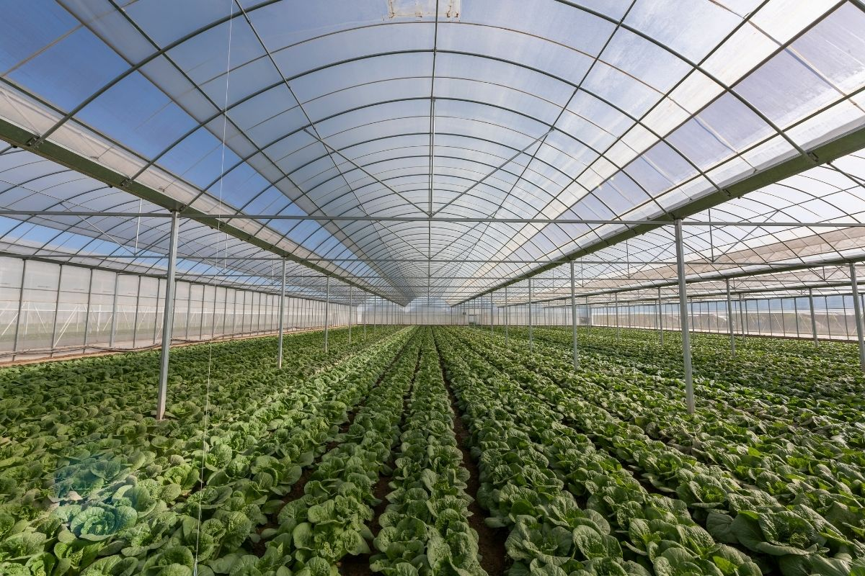
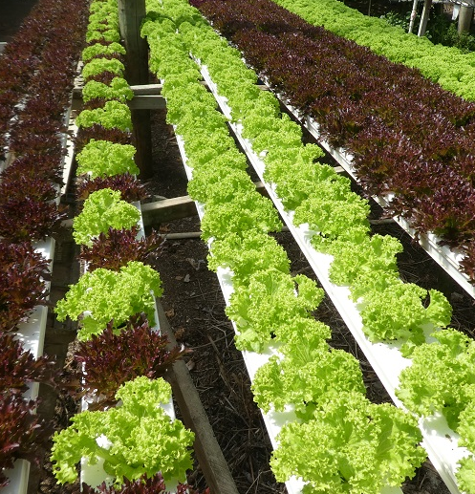
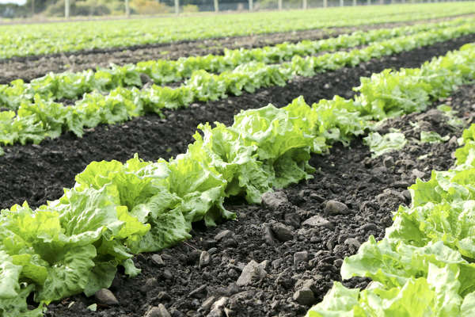
Lettuce varieties
A wide variety of lettuce is grown in New Zealand, adapted for year-round production, including popular commercial types like Iceberg and Cos, alongside gourmet loose-leaf varieties.
Power point: Lettuce varieties

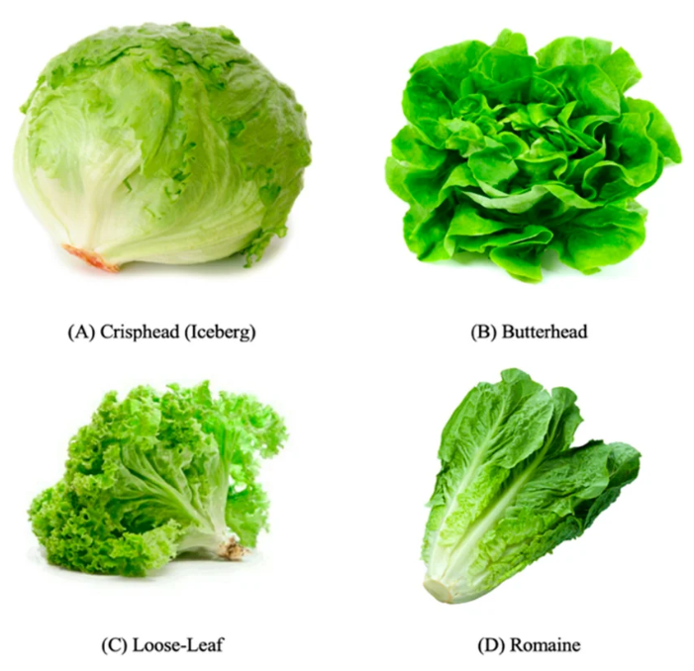
Markets and market requirements
New Zealand’s domestic lettuce market is primarily supplied to supermarkets, fresh produce retailers, and the food service sector, including cafés, restaurants, fast food outlets and catering businesses. These markets require a consistent year-round supply of fresh, high-quality lettuce that meets strict standards for appearance, taste, and shelf life. Consumers expect lettuce to be clean, crisp, and free from damage, with minimal waste and convenient packaging options such as pre-washed or ready-to-eat salad mixes. Supermarkets in particular, demand reliable supply chains, uniform product sizing, and varieties that support changing consumer preferences for convenience, health, and variety. As a result, growers must carefully manage production, harvesting, and post-harvest handling to ensure lettuce remains fresh, safe, and visually appealing.

Activity 2: Supermarket Investigation: Investigating different types of lettuce sold in supermarkets and how packaging helps protect, market, and sell fresh lettuce.

Growing Iceberg lettuce
This case study will focus predominately on the growing of Iceberg lettuce commercially. The following information is purposefully generalised. For specific growing requirements and regional information contact and visit a local grower. The worksheets below provide a set of questions that you can revise to suit your class and the purpose of the field trip.
- Field trip to field grown lettuce grower (WS)
- Field trip to indoor lettuce grower (WS)

Iceberg lettuce
Iceberg lettuce is one of the most widely grown and eaten lettuce varieties. It is valued for its crisp texture, mild flavour, and long shelf life, making it a popular choice for supermarkets, restaurants, and consumers.
To ensure a reliable year-round supply, growers carefully select cultivars that are suited to local microclimates and specific harvest windows. They also consider factors such as maturity time, tolerance to temperature extremes, and resistance to disorders such as tipburn and bolting.
Plant breeders continue to develop new cultivars that are stronger, more disease-resistant, and better able to cope with changing weather conditions.
Examples of common iceberg cultivars
Season | Iceberg Cultivars | Average time to maturity
Spring | Archer | 6- 8 weeks
Summer | Greenmoon | 5 weeks
Autumn | Archer | 6-8 weeks
Winter | Winguard | 10-12 weeks

Seasonal planting guide
Archer
- Best grown in spring and autumn.
- Produces large, firm, crunchy heads.
- Grows well in changing weather.
- Slow to bolt, making it a reliable choice.
Greenmoon
- Best grown in summer but also performs well in spring and autumn.
- Handles hot weather very well.
- Produces dense green heads.
- Resists sun damage and tipburn.
Winguard
- Best grown in late autumn and winter.
- Bred to grow well in cold conditions.
- Produces compact, high-quality heads.
Growing different cultivars in different seasons helps New Zealand growers produce fresh, high-quality iceberg lettuce throughout the year.

Calendar of operations site selection to harvest
The calendar of operations shows the main steps used to grow a commercial crop of field-grown iceberg lettuce, from choosing the growing site through to harvesting.
The exact management practices may vary between growers and regions because of differences in soil type, climate, and available technology.
The information below is based on one crop cycle. Commercial growers repeat this cycle every week by planting new seedlings. This ensures there is a continuous supply of mature lettuces ready to harvest throughout the year.
Seedlings are transplanted at different ages depending on the season:
- Summer: Seedlings are transplanted at about 5 weeks old because warm temperatures encourage faster growth.
- Winter: Seedlings are transplanted at about 8 weeks old because cooler temperatures slow growth.

Activity 3: Choosing the right iceberg lettuce cultivar.

Crop establishment of Iceberg lettuce crop
PPT Growing lettuce
Growing Iceberg Lettuce Outdoors
Crop Calendar of Operations (Repeated weekly)

Site Selection
Field-grown iceberg lettuce is often grown as part of a crop rotation system. This means growers plant different crops in the same field each season. Crop rotation helps maintain soil health and reduces the build-up of pests and diseases.
Choosing the right site is important because lettuce grows best in the right environmental conditions.
Iceberg lettuce grows best when:
- the weather is cool and sunny
- the soil is moist but well drained
- the soil is fertile and rich in nutrients
- the soil pH is between 6.2 and 7.0, allowing plants to absorb nutrients effectively.
With the correct cultivars, iceberg lettuce can be grown throughout the year.

Seedbed Preparation
Before transplanting, the soil is prepared into fine, firm, raised seedbeds. A well-prepared seedbed helps seedlings establish quickly and develop strong root systems.
Raised beds have several advantages:
- improve drainage and prevent waterlogging
- increase soil aeration, allowing roots to get oxygen
- encourage healthy root growth
- help plants absorb water and nutrients more efficiently.
Raised beds are usually 90–120 cm wide, depending on the machinery and production system being used. Lettuce is planted in widely spaced rows on the beds. The rows are often aligned with the prevailing wind to improve airflow around the plants. Better airflow reduces humidity around the leaves, helping to lower the risk of fungal diseases.

Transplanting seedlings
Iceberg lettuce are grown from seedlings rather than being sown directly into the field. The seedlings are raised in trays using disease-free seed by either a commercial seedling nursery or the grower.
Seedlings are transplanted into the field using a mechanical transplanter:
- Summer: Seedlings are transplanted when they are about 5 weeks old.
- Winter: Seedlings are transplanted when they are about 8 weeks old because cooler temperatures slow their growth.
The seedlings are planted in three rows on each raised bed, with 40 cm between plants. This spacing gives each plant enough room to grow into a large, healthy head. It also improves airflow around the plants, reducing humidity and lowering the risk of diseases
Activity 4: Grow Lettuce - PPT: Steps involved in sowing seeds
- For more information about seeds and how they grow, see Junior Unit of Work - Unit 3 Seeds
Growth stage
Nutrient requirements and fertiliser management
Lettuce needs high levels of nitrogen (N) to support fast, healthy leafy growth and produce lush green leaves. Avoid excessive nitrogen fertiliser application, which can result in lush, succulent plants that are more prone to bacterial infection.
It also needs other important nutrients:
- Potassium (K): helps keep plants strong and healthy.
- Phosphorus (P): supports strong root development.
- Calcium, magnesium, and boron. This helps to prevent nutrient deficiencies and support overall plant growth and quality.

Fertiliser application
A balanced NPKS fertiliser (nitrogen, phosphorus, potassium, and sulphur) containing trace elements (micronutrients) is applied when the seedlings are transplanted. This is called a base dressing. The amount applied is based on soil test results, so growers only add the nutrients the soil needs. Complex is commonly used.
During the growing season, a side dressing of fertiliser, such as calcium ammonium nitrate (CAN), is applied. This provides extra nitrogen and calcium to support healthy leaf growth and strong plant development.
Every 10–14 days, the crop is sprayed with a mixture of approved fungicides, insecticides (when needed), and trace elements. These foliar sprays help protect the lettuce from pests and diseases while supplying nutrients that are quickly absorbed through the leaves.

Ballance Agri- nutrients- Complex
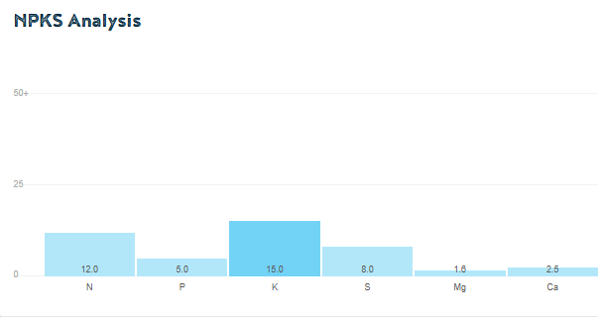

Irrigation (Dry summer conditions)
Lettuces are 95% water so requires consistently moist soil due to its shallow roots. Daily irrigation is often required to keep the soil consistently damp, during hot, sunny weather. Consistent water is essential for crisp, sweet, and fast growth. Over watering must be avoided to reduce disease and pest problems.
Irrigation should be carried out preferably in the morning and early afternoon to allow plants to dry out as soon as possible.
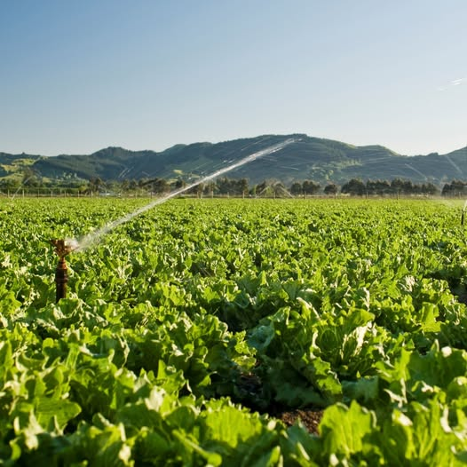

Pest and Disease Management
PPT Lettuce pest and disease
Lettuces can be affected by a range of pests, diseases, and growing disorders that can reduce plant growth, damage leaves, and lower crop quality.
Some Common Lettuce
Pest | Diseases | Disorders
Aphids  Slugs  Thrips  Caterpillars  Rabbits  Pūkeko  Possums | Downy mildew  Sclerotinia (white mould)  Bacterial leaf spot | Tipburn  Bolting

Integrated Pest and Disease Management (IPM/IDM)
Growers use Integrated Pest and Disease Management to protect crops by combining different control methods. The aim is to prevent problems, protect beneficial organisms, and reduce the need for chemical sprays.
Management Strategies
- Choose and grow resistant varieties that are naturally resistant to some pests, diseases and disorders.
- Use disease free seeds and seedlings.
- Use transplant drenching for insect pests especially in spring, summer and autumn. Transplant drenching is the practice of pouring a large amount of liquid—infused with water, nutrients, or protective treatments—directly onto the soil around a plant's root zone right when it is moved. This method achieves three main goals: moisture delivery, air pocket elimination, and pest or disease prevention.
- Encourage beneficial insects such as ladybirds, lacewings, and parasitoid wasps naturally control pests.
- Increase biodiversity – Plant flowering plants to provide food and shelter for beneficial insects.
- Monitor crops regularly for pests, diseases, and beneficial insects so problems can be managed early.
- Manage water carefully and avoid keeping leaves wet.
- Improve airflow between plants to reduce disease risk.
- Rotate crops to prevent diseases building up in the soil.
- Apply targeted pesticides or fungicides only if other methods are not enough.

Do:
- Am I a friend or foe
- Biodiversity (WS).
- For more information about biodiversity, see Junior Unit of Work - Unit 4 Biodiversity
Activity 6: Research thrips in lettuce

Weed Management
Effective weed management is important for producing healthy lettuce crops because weeds compete with lettuce for water, nutrients, light, and space. They can also provide a habitat for pests and diseases.
Good weed control starts with careful soil preparation and proper seedbed formation, which helps create the best possible growing conditions for lettuce.
Grower also use pre-planting herbicides to reduce weed growth before the lettuce plants establish. These methods help minimise competition from weeds during the early stages of growth, when lettuce is most vulnerable. Weed management helps ensure high-quality crops and better yields.

Harvesting
Field-grown iceberg lettuce is harvested by hand every day to ensure it is picked at the correct stage of maturity. Harvest workers carefully select only lettuces that meet market quality standards for size, shape, and firmness.
The lettuce is trimmed, packed into crates in the field, and handled carefully to avoid bruising or damage. Commercial growers aim to harvest more than 90% of the crop, with only a small number of plants left behind because they do not meet quality standards.

Post Harvest Handling
After harvest, the lettuce is transported to the packhouse within one hour to maintain freshness.
At the packhouse, the lettuce is blast cooled to about 2°C to quickly remove field heat. Rapid cooling helps keep the lettuce crisp, fresh, and safe to eat while extending its shelf life.
The cooled lettuce are distributed to supermarkets and other markets, usually within 24 hours of harvest.

Do: Growing lettuce questions (WS)

Challenges
Commercial lettuce growers face ongoing challenges in maintaining a reliable year-round supply for markets. These challenges include limited land availability and increasing competition for suitable growing areas from other crops. Changing climatic conditions and the increasing frequency of extreme weather events can also affect crop growth and production. Rising production costs, including higher labour expenses and labour shortages, add further pressure on growers. Lettuce crops are particularly vulnerable to a wide range of pests, diseases, and wildlife damage, which can reduce both yield and quality. Growers must also compete with other seasonal vegetables in the marketplace, making efficient production and supply management essential for maintaining lettuce as a profitable and sustainable crop.

Activity 7: Investigating lettuce prices

Technology
Innovation and technology are changing the way lettuce is grown in New Zealand. As consumers expect fresh, high-quality produce all year round, growers are using new tools and equipment to improve efficiency, reduce waste, and farm more sustainably. Modern technologies such as artificial intelligence (AI), laser weeders, hydroponic systems, electric harvesting equipment, and protected growing structures help growers produce consistent crops, while reducing their impact on the environment. These innovations can improve soil health, lower carbon emissions, save water and fuel, and increase productivity. By adopting new technology, lettuce growers can meet market demands while producing healthy food in a more sustainable way for the future.

Do
- LeaderBrand rolls out cutting (WS).
- Technology and innovation (WS)
Watch: LeaderBrand Salad House https://www.youtube.com/watch?v=1Tdu4XY3S-A
Activity 8: Design the lettuce growing system of the future

