Activity 6: Thrips in Lettuce
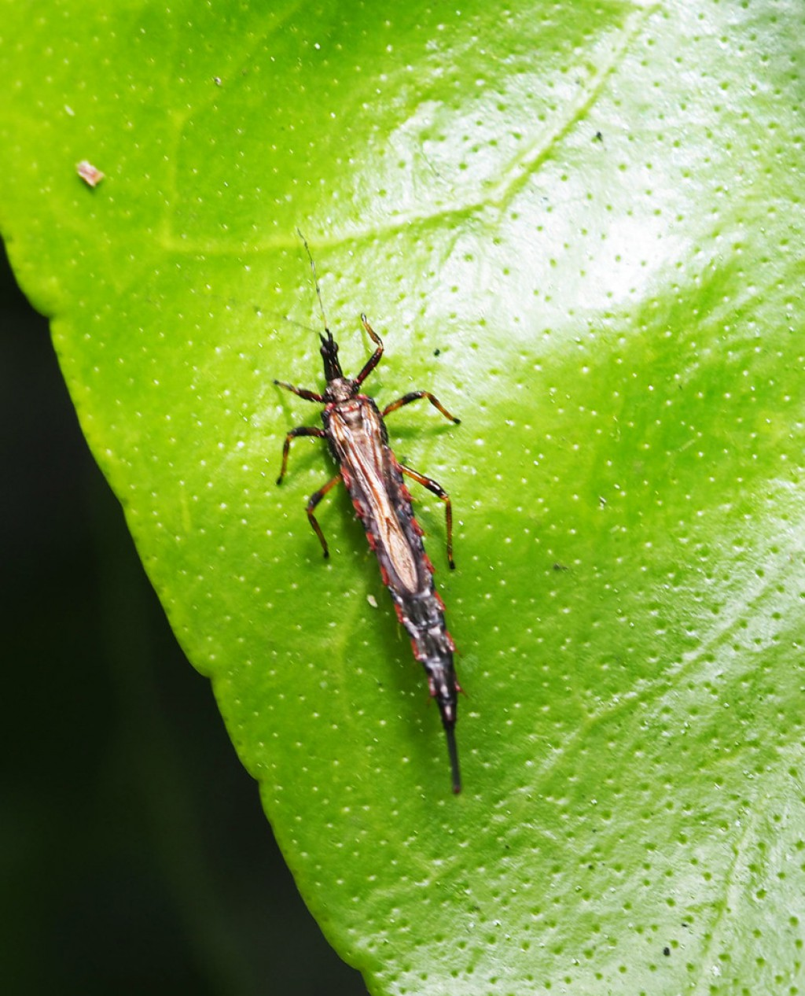
Topic: Find out how thrips affect lettuce and how growers manage this pest.
Background information
Thrips are tiny insects that feed on lettuce leaves. They can damage plants by sucking plant sap and can reduce the quality and appearance of lettuce heads. Thrips are more common during warmer months and can be difficult to control because they are very small.
Research questions
Use books, websites, or class resources to answer the questions below.
- Identifying thrips
- What do thrips look like?
- How big are they?
- Where on the lettuce plant are they usually found?
- Damage caused by thrips
- What symptoms show that a lettuce plant may have thrips?
- How can thrips affect the quality of iceberg lettuce?
- Thrips life cycle
Research the life cycle of thrips.
Include:
- Where are the eggs laid?
- How do thrips develop?
- How quickly can the populations increase?
- Managing thrips in lettuce
Find three ways growers can reduce thrips problems.

- Challenge
- A lettuce grower notices thrips damage in a summer crop of iceberg lettuce. What steps should the grower take before applying an insecticide? Explain why.
- Create a one-page information poster called: "Thrips: A tiny pest with a big impact on lettuce".
Include:
- A picture of thrips
- Damage symptoms
- How growers monitor for thrips
- Ways to manage the pest

