Activity 7: Investigating lettuce prices
Objective: Students analyse real data, identify trends, calculate statistics, and explain possible reasons for changes in prices.

Month | Lettuce prices per kg
Feb 2025 | 4.53
Mar 2025 | 4.48
Apr 2025 | 4.38
May 2025 | 5.40
Jun 2025 | 6.36
Jul 2025 | 6.71
Aug 2025 | 7.79
Sep2025 | 6.75
Oct 2025 | 4.60
Nov 2025 | 3.64
Dec 2025 | 3.07
Jan 2026 | 4.15
Feb 2026 | 5.35
Figure.nz https://figure.nz/chart/WNZOpEoBKRyz4hBh-hVAZeXw1rjX1jpkl

- Graphing the data
- Draw a line graph using the data.
- Label the horizontal axis with the months.
- Label the vertical axis with the price in dollars per kilogram.
- Give your graph a suitable title.

- Using the data answer the following questions.
- What was the highest lettuce price? In which month did it occur?
- What was the lowest lettuce price? In which month did it occur?
- Calculate the difference between the highest and lowest prices.
- During which months did the price increase?
- During which months did the price decrease?
- Describe the trend in lettuce prices over the 13-month period.
- Calculate the average (mean) price of lettuce.
- Calculate the range of the data.
- Estimate the median price.
- Calculate the percentage increase from April 2025 to August 2025.
- Calculate the percentage decrease from August 2025 to December 2025.
- Write a short paragraph explaining why lettuce prices change. Use the questions below to help you organise your ideas and support your answers with evidence from the data.
- Why do you think lettuce prices increased during winter?
- Why might lettuce prices have fallen towards the end of the year?
- How might factors such as weather, transport costs, and the supply of lettuce affect food prices?

- Imagine you are a supermarket manager. Write three sentences explaining:
- When you would expect to make the most profit from selling lettuce,
- When customers would probably buy the most lettuce, and
- One strategy you could use if lettuce prices became very high.

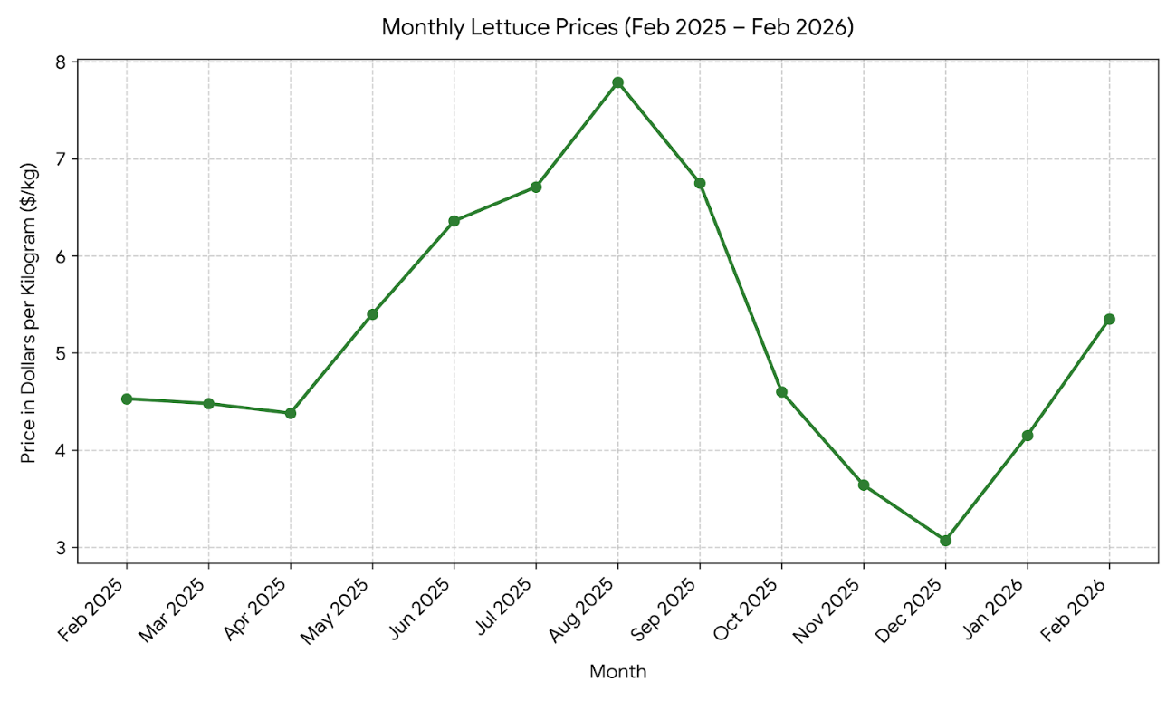
Sample Answers

- Using the data answer the following questions.
- What was the highest lettuce price? In which month did it occur?
$7.79/kg in August 2025.

- What was the lowest lettuce price? In which month did it occur?
$3.07/kg in December 2025.

- Calculate the difference between the highest and lowest prices.
$7.79 − $3.07 = $4.72/kg

- During which months did the price increase?
- April → May
- May → June
- June → July
- July → August
- December → January
- January → February

- During which months did the price decrease?
- February → March
- March → April
- August → September
- September → October
- October → November
- November → December

- Describe the overall trend in lettuce prices over the 13-month period.
Prices decreased slightly from February to April, increased steadily to a peak in August, then fell sharply until December before rising again in January and February 2026.

- Calculate the average (mean) price.
Total of all prices:
4.53 + 4.48 + 4.38 + 5.40 + 6.36 + 6.71 + 7.79 + 6.75 + 4.60 + 3.64 + 3.07 + 4.15 + 5.35 = 67.21
Mean: 67.21 ÷ 13 = 5.17/kg

- Calculate the range.
Range = Highest − Lowest
= 7.79 − 3.07 = $4.72/kg

- Estimate the median price.
Ordered data:
3.07, 3.64, 4.15, 4.38, 4.48, 4.53, 4.60, 5.35, 5.40, 6.36, 6.71, 6.75, 7.79
There are 13 values, so the 7th value is the median = $4.60/kg

- Calculate the percentage increase from April 2025 to August 2025.
Increase = 7.79 − 4.38 = 3.41
Percentage increase
= (3.41 ÷ 4.38) × 100 ≈ 77.9% Approximately 78%

- Calculate the percentage decrease from August 2025 to December 2025.
Decrease = 7.79 − 3.07 = 4.72
Percentage decrease
= (4.72 ÷ 7.79) × 100 ≈ 60.6% - Approximately 61%

- Write a short paragraph explaining why lettuce prices change. Use the questions below to help you organise your ideas and support your answers with evidence from the data.
Lettuce prices increased during winter because colder weather can reduce crop growth and lower the supply of fresh vegetables. When supply decreases but demand remains similar, prices usually increase. Prices fell towards the end of the year as growing conditions improved, more lettuce became available and supply increased. Transport costs, floods, droughts, or storms can also affect the amount of lettuce available and therefore its price.
- Imagine you are a supermarket manager. Write three sentences explaining:
I would expect to make the most profit in August because lettuce prices were the highest. Customers would probably buy more lettuce in November and December because prices were much lower. If prices became very high, I could promote alternative salad vegetables or reduce waste by ordering smaller amounts.

