Salad Brother growing lettuce in Taranaki

Read as a class “Taranaki business putting crunch into lunchboxes across the region and beyond” and discuss the questions.
Questions
- What changes did Salad Brothers make when they took over the Waverley site?
- Why did the business decide to build a new 900 square metre tunnel house?
- How does the computer-controlled climate system help the lettuce grow better?
- What is hydroponics, and how is it used in the Salad Brothers operation?
- How does recycling water in the hydroponic system help the business and the environment?
- Why do you think Salad Brothers grows different types of lettuce instead of just one variety?
- How does the business help supply local cafes and food companies in the region?
- What are some advantages of working for a local food production business like Salad Brothers?

Taranaki business putting crunch into lunchboxes across the region and beyond
https://www.rnz.co.nz/news/country/521190/taranaki-business-putting-crunch-into-lunchboxes-across-the-region-and-beyond
Salad Brothers
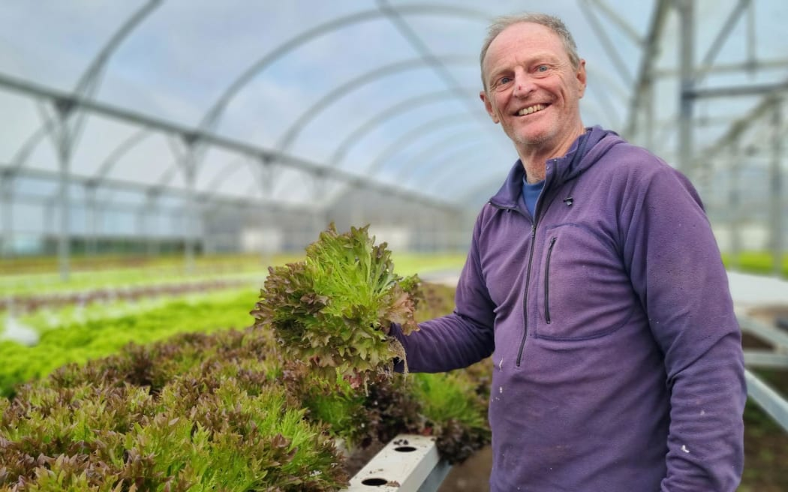
Salad Brothers co-owner Garth Archibald says business was quite rundown when they took over 18 months ago. Photo: RNZ / Robin Martin

Tucked away on a Waverley side street, a South Taranaki business has cut the ribbon on a 900 square metre state-of-the-art tunnel house aimed at putting the crunch into sandwiches across the region and beyond.
Salad Brothers took over the 1.1-hectare site about 18 months ago and aims to produce half a million lettuces a year.
Leafy greens have been a quiet contributor to the Waverley economy for most of the last 40 years, but as Salad Brothers co-owner Garth Archibald explained the Lupton Street operation had seen better days.
"When we first arrived, it had been left vacant for a while, so it was head high weeds all through here. There was another tunnel house like these wooden ones here and that was half collapsed and we had to remove it.
"And we've only just a year later got this replacement up and running which is why we had an opening party last week."
Salad Brothers was bringing the farm into the 21st century, beginning with the $350,000 tunnel house.
"It's a step into the future. It's got computer-controlled climate control where this vent along the top opens in relation to temperature and wind speed and certainly helps to keep the whole place at a more even temperature."
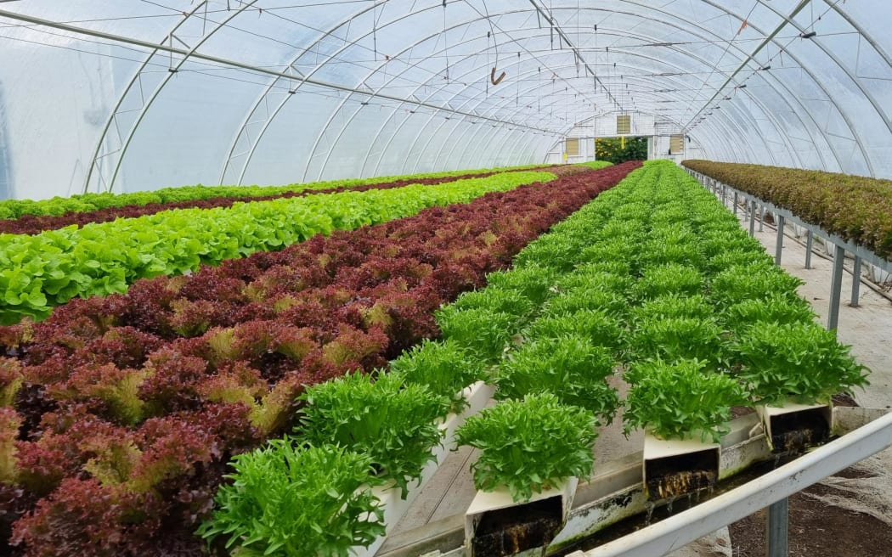
Salad Brothers raises up to 60,000 lettuces at a time or about a half a million a year.
Photo: RNZ / Robin Martin
The new tunnel can hold 60 percent more plants - referred to as pots - than the old one and was designed to make harvesting easier.
There was lettuce in every direction.
"There's 16,000 what we call pots in here. We're just sticking to the green frilly in here at the moment. I think about half of all our lettuce is this green frilly. We've got another 30,000 down there and another 20,000 in the six house that are up here and as you'll see down here, we go into all the different reds and spiky varieties."
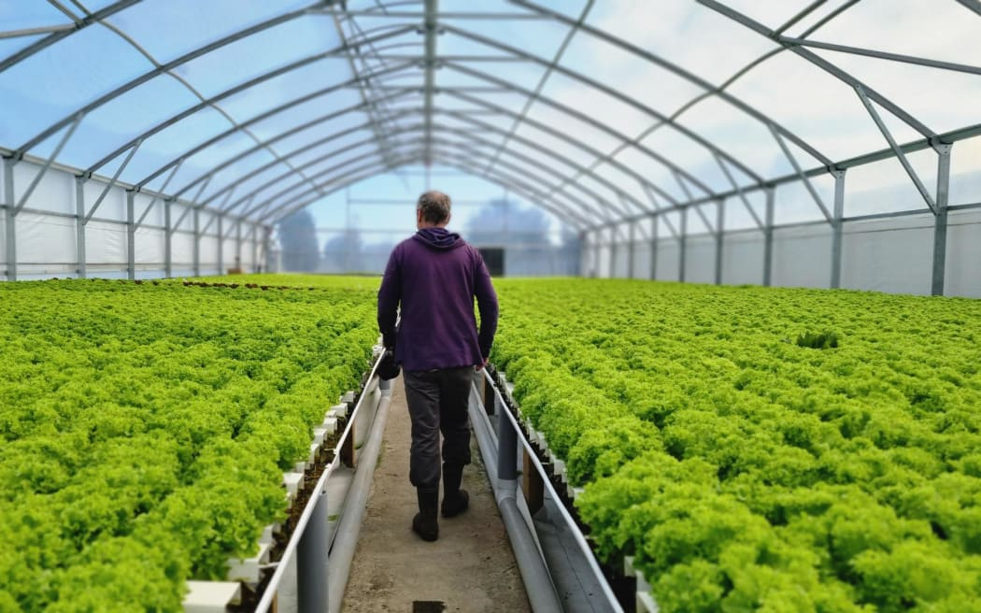
The new 900sqm $350,000 state-of-the-art tunnel house features computer-controlled temperature regulation. Photo: RNZ / Robin Martin
Salad Brothers grew about 60,000 lettuces at a time, or about half a million a year.
It was a nutrient fall technique hydroponics operation.
"As the water flows through, the plants feed and so when the water gets to this end the nutrients are depleted and it all flows back under the ground to the sump at the end here and just gets pumped around and around and then every month or so we just swap it out.
"It's kept at within a pH range and concentration of fertiliser by dosing machines working with sensors," Archibald said.
Another innovation was how some of the seedlings were being raised in the new tunnel house.
"We're using rock wool which is kind of like a rock candy floss little squares and you just drop the seed in that. It's a totally different system as well it doesn't get sprayed from above, it's on an ebb and flow table and gets watered every few hours by the water rising up and then flowing away, so we're trying different things."
The business employed one full-time driver and two part-timers, and five casuals in the busy packing operation.
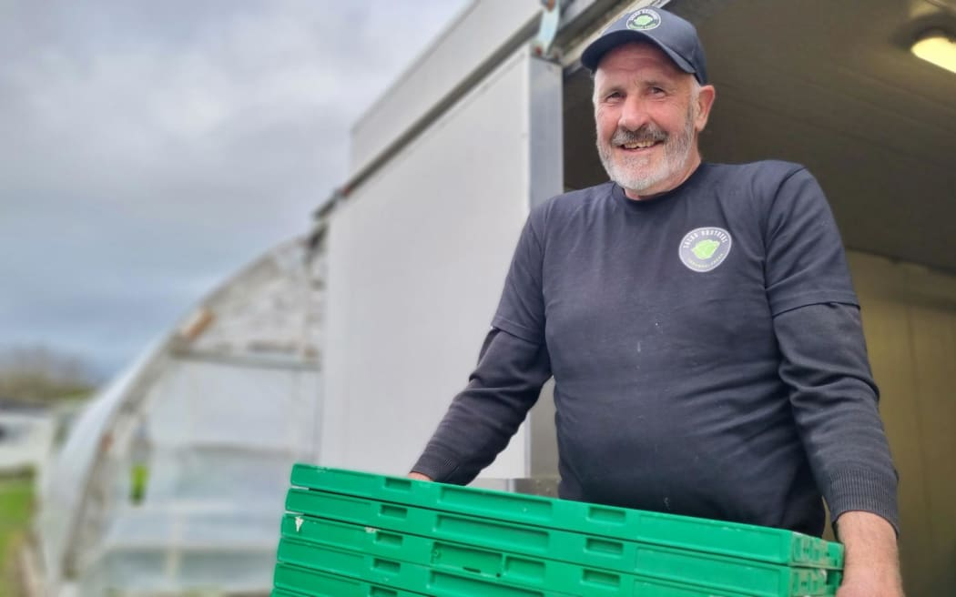
Salad Brothers driver Brent Dallison says it's great to be able to work locally. Photo: RNZ / Robin Martin
Brent Dallison was responsible for deliveries around Taranaki Maunga.
"It's about 20 all tolled. Yeah, it just depends on who orders. Bidfoods, Spuds, Crazy Pumpkin. There are quite a few cafes and things like that. It's a small order today, but like we normally deliver 200 to 250 trays. They're always happy to see me when I turn up. They say it's good and fresh and a good service."
Dallison was happy to be able to work locally and not looking for a change.
"Until they sack me, yeah. Nah, nah, they're really good to work for and really efficient."
Salad Brothers turned over just under a half a million dollars in its first year of operation and was aiming to double that.

Answers
- What changes did Salad Brothers make when they took over the Waverley site?
When Salad Brothers took over the site, they had to rebuild and modernise it because it was in poor condition. The land had been left unused, with head-high weeds and old tunnel houses that were partly collapsed and needed to be removed. They cleaned up the site and rebuilt it, including constructing a new state-of-the-art tunnel house. This helped turn an old, rundown farm into a modern production facility.

- Why did the business decide to build a new 900 square metre tunnel house?
The business built the new tunnel house to increase production, improve efficiency, and modernise the farm. The new structure allows them to grow more lettuce at once (about 60% more plants than before) and makes harvesting easier. It also helps protect crops and provides better growing conditions, which supports their goal of producing around half a million lettuces per year.

- How does the computer-controlled climate system help the lettuce grow better?
The computer-controlled climate system regulates temperature and airflow inside the tunnel house. Vents open and close depending on temperature and wind speed, helping keep conditions stable. This is important because lettuce grows best in consistent conditions. By reducing extreme temperature changes, the system helps improve crop quality, growth rates, and overall reliability of production.

- What is hydroponics, and how is it used in the Salad Brothers operation?
Hydroponics is a method of growing plants without soil, using water that contains dissolved nutrients. At Salad Brothers, they use a nutrient flow technique where water moves through the system, feeding the plants as it passes. The water is then collected, rebalanced with nutrients and pH levels using sensors and dosing machines, and reused in a continuous cycle. This makes production efficient and reduces waste.

- How does recycling water in the hydroponic system help the business and the environment?
Recycling water allows Salad Brothers to use less fresh water because the same water is continuously reused in the system. This reduces water waste and lowers operating costs. It is also better for the environment because it conserves natural water resources and reduces runoff of fertilisers or nutrients into the surrounding environment.

- Why do you think Salad Brothers grows different types of lettuce instead of just one variety?
Growing different types of lettuce allows the business to meet different customer preferences and market demands. Some people or businesses may prefer green frilly lettuce, while others want red or spiky varieties for salads and sandwiches. Offering variety also helps the business stay competitive and reduces risk, because if demand drops for one type, others can still be sold.

- How does the business help supply local cafes and food companies in the region?
Salad Brothers delivers fresh lettuce to a range of local businesses such as cafes, food distributors, and restaurants. They supply companies like Bidfood and local cafés, ensuring fresh produce is delivered regularly. Their driver delivers around 20 stops, depending on orders, helping connect the farm directly with food businesses across the region.

- What are some advantages of working for a local food production business like Salad Brothers?
Working for a local business like Salad Brothers allows people to stay in their community rather than travelling far for work. Employees can enjoy stable jobs in farming, packing, and delivery roles. It also supports the local economy and creates opportunities for a variety of workers. Staff may also benefit from a positive work environment where they are part of a small, community-focused team producing fresh food for local customers.

