Southern Fresh hydroponics puts Waikato on the map
https://www.hortnz.co.nz/news-events-and-media/media-releases/southern-fresh-hydroponics-puts-waikato-on-the-map
Watch video: Southern Fresh https://southernfresh.co.nz/

Read the article “Southern Fresh hydroponics puts Waikato on the map” and discuss the questions.
Questions
- Why did Southern Fresh decide to invest in a large glasshouse operation?
- How did wet winters affect Southern Fresh’s outdoor farming business?
- What are the advantages of growing crops indoors in a hydroponic glasshouse?
- What are some benefits of continuing to grow crops outdoors as well as indoors?
- How does hydroponic farming increase productivity compared to traditional outdoor farming?
- What modern technologies does Southern Fresh use to make production more sustainable?
- How does collecting rainwater and reusing CO₂ help the environment?
- Why was it important for Southern Fresh to provide a consistent supply of vegetables to customers?
- What is the main focus of Southern Fresh’s business when producing and selling vegetables and herbs?

Southern Fresh hydroponics puts Waikato on the map
The past 20 years have been a busy time for the Dunn family. What began as a family cut-flower operation near Cambridge in the Waikato has blossomed into one of New Zealand's leading suppliers and processors of baby vegetables, fresh herbs and gourmet salad greens. GEOFF LEWIS reports.
Owned by Pat Dunn and his son Jeremy, Southern Fresh started as an outdoor growing operation and recently transitioned to indoor growing in one of the largest glasshouse operations in the Waikato – with options to expand.
The family’s growing operation has always had the advantage of its growing area being based on the highly productive Horotiu sandy loam – some of New Zealand's best horticultural soil. However, several consecutive winters of wet weather led to the decision to go indoors.
''The 2017–18 seasons affected our ability to supply,” says Jeremy, general manager of Southern Fresh. “We looked at our options and tried growing in other regions but concluded that we needed to put a roof over a big part of our production. Then we would not be subject to the vagaries of the weather. That was the only way we could get consistent supply for our customers. We now have seven hectares under cover.''
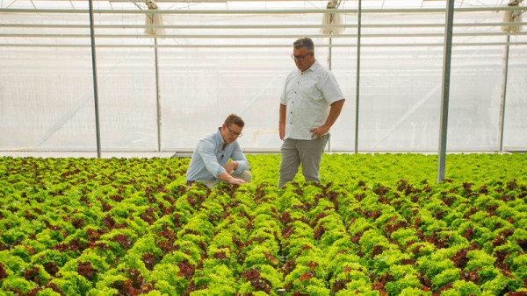
Brock (left) and Greg Dunn, father and son, checking the growing progress of trio lettuces.
Key crops in the indoor farm include pak choy, herbs and lettuce. Indoor cropping manager, Greg Dunn, oversees production.
Outdoors, the Dunns grow a range of field crops across their six farm blocks (229ha), including baby spinach, mesclun, wild rocket, baby carrots, beetroot, turnips, leeks and fresh basil.
Outdoor growing is managed by Carl Hodgson. A Kiwi, also originally from Cambridge, who brings experience in horticulture from Queensland where he had been involved in growing many of the same crops. Brock Dunn, sales and marketing manager, says Carl's unique experience adds to their combined knowledge.
The 2020 lockdowns interrupted initial plans to bring in international experts to support the construction of the new 20,000 sqm glasshouse. Instead, the Dunns turned to local businesses and had the whole project consented and built in 12 months.
''We were committed in early 2019 and started the foundations in November with companies due to come from overseas and install the boiler and piping from Europe and Asia,” says Jeremy. “But Covid hit us, so we found the right people locally and got stuck in and did it ourselves.''
The Ministry for Primary Industries’ (MPI) Sustainable Food and Fibre Futures Fund (SFFF), has allowed Southern Fresh to trial new technologies and alternative ways to make the farm more sustainable, including the installation of LED (light-emitting diode) lighting and the use of CO₂ from its natural gas heating system to boost plant growth. Water comes from bores and rainwater collected and stored from the facility's two-hectare roof.
Southern Fresh now has one of the few automated hydroponic operations in New Zealand.
''We have innovated and embraced modern technology which has enhanced our service promise to our customers,” Jeremy says. “We have built New Zealand’s first automated hydroponic system and grow the only Trio lettuce in our country.''
''The difference between indoor and outdoor is, that inside we can produce crops for 52 weeks of the year with very little change to the length of growth period,” Greg says. “Outdoors, it's 15-week cycles with potential losses due to the environment, versus three to four weeks indoors. Annual production from one-hectare of hydroponics equates to the yield from 40ha outdoors, which is a significant increase in crop yield.''
Brock says fresh vegetables have become the 'cuisine heroes' and central focus on the plate where in previous times they had simply been relegated to the edges. Baby spinach, at one time generally disregarded, has become a top-selling line.
''Our approach to growing is front to back – we believe that what we grow on our farms should be determined by what you want on your fork.''
The increasing sophistication of the Kiwi culinary market has been a driver behind product development. Hundreds of tonnes of fresh basil, grown indoors and outdoors, is processed and used in the manufacturing of food products by other enterprises.
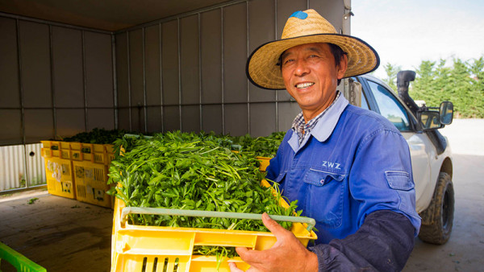
Zhidao Chang unloading freshly picked parsley for transfer to the cool store.
Southern Fresh regards convenience of use and food-safety of its fresh products as high priorities. In their state-of-the-art packing facility, the fresh baby vegetables and gourmet salad greens are washed and prepared to a standard where they can be used and consumed directly from the packaging.
Spotting a gap in the market, Southern Fresh began airfreighting twice weekly to top-end food service companies in the United Kingdom and now export to Taiwan and Singapore too. In the domestic space, produce from Southern Fresh indoor and field crops in Cambridge are harvested, washed, chilled, packed and air freighted around New Zealand – from Mangere to as far south as Queenstown – and all within 24 hours. While Southern Fresh does not deal directly with restaurants, it supplies food service companies and specialist retail markets such as Moore Wilson’s, Farro and more recently, Progressive Enterprises and Foodstuffs.
Taking a family approach to its staffing, Southern Fresh employs 120 full-time staff, increasing to 160 employees at peak season including workers from more than a dozen nationalities. An ownership mindset and pursuit of excellence is engrained in their culture and is evident in their daily operations.
''We have good relationships with other growers around New Zealand and in the UK and Europe. We are regularly in contact with them to discuss global trends as well as anything from harvesting to seed suppliers, packaging and labour.''
Meanwhile, the Dunns have their eyes on the future and have recently gained resource consent to construct a further four hectares of covered growing area.

Answers
- Why did Southern Fresh decide to invest in a large glasshouse operation?
Southern Fresh invested in a large glasshouse operation because several years of wet winters made outdoor farming unreliable. Bad weather affected the company’s ability to supply vegetables consistently to customers. The Dunn family realised that putting crops under cover was the best way to protect production from unpredictable weather and ensure they could provide a stable supply of fresh produce all year round.

- How did wet winters affect Southern Fresh’s outdoor farming business?
Wet winters made it difficult to grow and harvest crops outdoors. Excess rain and poor weather conditions reduced crop quality and interrupted supply to customers. Because the business depended on regular deliveries, these weather-related problems created financial and production challenges. The repeated wet seasons showed the company that relying only on outdoor farming was too risky.

- What are the advantages of growing crops indoors in a hydroponic glasshouse?
Indoor hydroponic growing allows crops to be produced in a controlled environment where temperature, water, and growing conditions can be carefully managed. This protects crops from bad weather, pests, and seasonal changes. Crops grow faster indoors, with growth cycles of only three to four weeks compared to 15 weeks outdoors. Indoor growing also allows production for 52 weeks of the year, giving the company a reliable and continuous supply of vegetables.

- What are some benefits of continuing to grow crops outdoors as well as indoors?
Outdoor farming still allows Southern Fresh to grow a wide variety of crops across large areas of land, including spinach, basil, carrots, beetroot, and leeks. Outdoor growing can be more cost-effective for some crops and takes advantage of the fertile Horotiu sandy loam soil in the Waikato. By combining indoor and outdoor farming, the company can increase the range of products it supplies while reducing risks caused by weather.

- How does hydroponic farming increase productivity compared to traditional outdoor farming?
Hydroponic farming is much more productive because crops grow faster and can be produced continuously throughout the year. One hectare of hydroponic production can produce the same yield as 40 hectares of outdoor farming. Indoor crops also have shorter growth cycles, allowing more harvests each year. This means Southern Fresh can grow more vegetables in a smaller area with greater efficiency.

- What modern technologies does Southern Fresh use to make production more sustainable?
Southern Fresh uses several modern technologies to improve sustainability, including automated hydroponic systems, LED lighting, and the reuse of CO₂ from heating systems to boost plant growth. The company also collects and stores rainwater from the glasshouse roof for irrigation. These technologies help reduce waste, improve efficiency, conserve resources, and lower environmental impacts.

- How does collecting rainwater and reusing CO₂ help the environment?
Collecting rainwater reduces the need to take fresh water from natural sources such as rivers or groundwater supplies. This helps conserve water resources and reduces waste. Reusing CO₂ from the heating system helps plants grow more effectively instead of releasing the gas into the atmosphere. This improves efficiency and helps reduce greenhouse gas emissions, making the operation more environmentally friendly.

- Why was it important for Southern Fresh to provide a consistent supply of vegetables to customers?
Customers such as supermarkets, food service companies, and export markets rely on regular deliveries of fresh produce. If Southern Fresh could not supply products consistently, customers might buy from other suppliers. A reliable supply helps the company maintain strong business relationships, protect its reputation, and remain competitive in both local and international markets.

- What is the main focus of Southern Fresh’s business when producing and selling vegetables and herbs?
Southern Fresh focuses on producing high-quality, fresh, safe, and convenient food for consumers. The company aims to grow products that customers want to eat and make them easy to use by washing, chilling, and packaging them ready for consumption. They also focus on innovation, sustainability, and meeting changing consumer tastes, especially the growing demand for healthy fresh vegetables and herbs.

