LeaderBrand Technology and Innovation
https://www.ruralnewsgroup.co.nz/hort-news/hort-general-news/leaderbrand-goes-electric
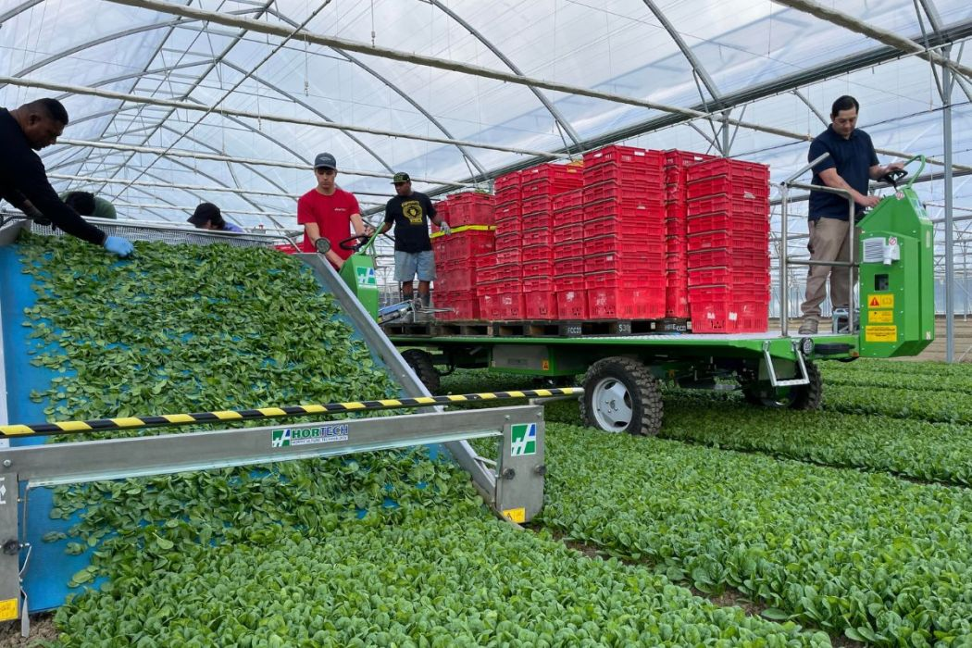
Watch https://www.youtube.com/watch?v=cEL75qJd0C0
Read “Leaderbrand Technology and Innovation” and discuss the questions
Questions
- Why did LeaderBrand introduce an electric harvester and cargo platforms into its greenhouse operation?
- How does the electric harvester help reduce environmental impact compared to diesel machinery?
- What are some advantages of using electric equipment inside the greenhouse?
- Why might electric farming equipment be more difficult to use in open fields than in greenhouses?

LeaderBrand Technology and Innovation

LeaderBrand has introduced an electric harvester and two self-propelled cargo platforms to operate in its new mega greenhouse. This is the company's way of leading towards a healthier future by reducing carbon emissions.
The new Hortech eco-slide electric harvester and Hortech cargo platform are the first in New Zealand. These are specifically designed to suit LeaderBrand's indoor environment and cropping system.
Reducing emissions, fuel and oil, and finding ways to farm sustainably with new technology are essential focuses for LeaderBrand.
"We're always looking for different ways we can be more climate-friendly, and this is another step in the right direction," said LeaderBrand's General Manager of Farming, Gordon McPhail.
The electric harvester is less noisy than diesel engines, which helps to improve communication and safety for teams in the greenhouse.
"The greenhouse is the right environment for us to trial and test if electric equipment will work in our business. We designed the front packhouse of the facility with an electric harvester in mind, getting the wiring and outlets built into the greenhouse before we'd commissioned the equipment.".
With overnight charging, the harvester has a 12-hour run time, more than enough power to get through the day.
Technology and innovation continue to advance in the electric space. However, much research is still needed around scenarios involving work in the open field, potentially far from charging stations.
LeaderBrand was awarded an EECA grant, which has helped with some of the cost of investing in an electric harvester.
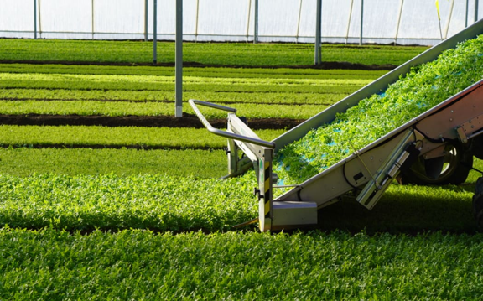
Answers
- Why did LeaderBrand introduce an electric harvester and cargo platforms into its greenhouse operation?
LeaderBrand introduced the electric harvester and cargo platforms to reduce carbon emissions and make its farming practices more environmentally friendly. The company wants to find sustainable ways to grow vegetables while reducing the use of diesel fuel and oil. The greenhouse was designed to support electric technology, showing that LeaderBrand is investing in innovation and preparing for a cleaner future in farming.

- How does the electric harvester help reduce environmental impact compared to diesel machinery?
The electric harvester produces fewer carbon emissions because it runs on electricity instead of diesel fuel. This helps reduce air pollution and lowers the company’s overall environmental footprint. Electric equipment also reduces the need for oil and fuel, making farming operations more sustainable. By charging overnight and running for 12 hours, the harvester can complete a full workday efficiently without using fossil fuels.

- What are some advantages of using electric equipment inside the greenhouse?
Electric equipment is quieter than diesel machinery, which improves communication between workers and makes the greenhouse a safer workplace. It also creates less pollution inside the enclosed greenhouse environment. The greenhouse is well suited for electric machinery because charging stations and electrical systems can be easily installed nearby. In addition, electric machines can help lower fuel costs and support more sustainable farming practices.

- Why might electric farming equipment be more difficult to use in open fields than in greenhouses?
Open fields can be far away from charging stations, making it harder to recharge electric equipment during the day. Large farms may also require machines to work for long periods or travel long distances, which could drain batteries quickly. In a greenhouse, machinery works in a smaller controlled area where charging facilities are close by. This makes greenhouses a better place to test and develop electric farming technology before using it in larger outdoor farming operations.

