Onion Production in New Zealand Case Study
Teachers’ Guide

Introduction
New Zealand’s onion industry has developed a strong international reputation, built on decades of innovation, quality improvement, and export focus. Growers have prioritised key traits such as long storage life, appealing appearance, and strong flavour, with modern hybrid varieties continuing the legacy of earlier successes like the Pukekohe Long Keeper (PLK) onion. Today, around 75 growers cultivate approximately 4,700 hectares across regions including Northland, Waikato, Hawke’s Bay, and Canterbury. Thanks to a staggered harvest that begins in January in the North Island and finishes in the South Island about a month later, New Zealand can reliably supply onions to global markets through to September. This export-driven industry relies on ongoing research to maintain freshness during long sea journeys and to improve production, storage, and transport systems. While demand remains strong in key markets such as the European Union, particularly Germany and the Netherlands, recent fluctuations in export value highlight the challenges of maintaining competitiveness in an increasingly dynamic global market.
Key learning outcomes: Students will be able to
- Know a brief history of onion growing in New Zealand.
- Describe the structure and anatomy of an onion plant in basic terms.
- Identify and recognise vegetables in the allium family.
- Discuss where onions are grown commercially and explain why.
- Discuss the management practices in a calendar of operations for growing onions commercially.
- Briefly discuss challenges onion growers are facing and the impact on their business.
- Discuss how they are managing these challenges.

Supporting resources
- Onion Activities 1-4
- Activities 5 & 6 Pelleted Seeds.
- Activity 7 Growing Onions Questions (WS)
- Alliums Poster
- Field trip to onion grower (WS)
- Find out what your students know (Answers)
- Onion Growing Glossary
- Onion Growing Regions
- Pelleted Seed Technology for Onions (WS)
- Smart tech reduces fungicide use (WS)
- White Rot Control in Onions (WS)
PowerPoints
- Growing Onions.
- Onion Activities 1-3.
- Onion pest and diseases.
- Onion varieties.
Videos
- Growing onions in New Zealand - Pukekohe https://www.youtube.com/watch?v=M1c3MhQ4Gqs
- Family Farm Onions - Ashburton https://www.youtube.com/watch?v=qtT65N4g_Kc&t=46s
- Harvest Fresh Onion Production https://www.youtube.com/watch?v=G-H1Qd3huA8&t=2s (no commentary)
- Planting onions (no commentary) https://www.youtube.com/watch?v=WNh7C533mhI
- ST Growers onion harvest 2018 (no commentary) https://www.youtube.com/watch?v=ja7QItli9ts&t=5s
Challenges
- Auckland floods (WS)
- NZ Onion Industry Challenges (WS)
- Strong Quality and Reliable Exports Drive NZ Onion Season (WS)
- Strong onion crop in Hawkes Bay (WS)
- NZ Onion Export Trade Summary
- Summary of challenge facing the onion industry
- Hort exporters eye Indian market
- No more tears for onion exporters
- An industry that knows its onions
References
- Sofresh New Zealand https://www.sofresh.co.nz/onions
- Onions New Zealand INC https://www.onionsnz.com/all-about-onions-2/onion-production/
- Growers gallery https://www.nzgrowers.co.nz/gallery

Recommendations
Within each case study, there are multiple activities for students to complete. We recommend you select the activity or activities that best suit your students.

Find out what your students know.
Ask selected questions to brainstorm ideas on commercial onion growing in New Zealand.
- Do you think onions are an important commercial crop in New Zealand? Why or why not?
- What plant family do onions belong to?
- Where in New Zealand are onions grown? Can you name any regions?
- Why do you think onions are grown in these areas? What makes them suitable?
- What conditions do onions need to grow well?
- Can you name any different types or varieties of onions?
- How long do you think it takes to grow an onion from seed to harvest?
- What steps do onion growers take to grow onions on a commercial scale?
- What machinery is used to grow onions on a commercial scale?
- What challenges do you think onion growers are facing?
- What are growers doing to make onion growing more environmentally friendly?
See Find out what your students know (Answers)

Activity 1: Brainstorm
Work in groups to discuss, share and write down your ideas
- What other questions do you have about growing onions?
- Make a list of things you are curious to learn more about growing onions?
Fun Fact:
Onions make you cry because they release a tiny chemical weapon!
When you cut an onion, you break its cells, which releases enzymes that create a gas called syn-propanethial-S-oxide. When that gas reaches your eyes, it reacts with the moisture there to form a mild acid. Your eyes respond by producing tears to wash it out—so technically, the onion is defending itself from being eaten.

A Brief History of Onion Growing in New Zealand
Onions have been grown in New Zealand since European settlers arrived in the 1800s. Growers quickly realised that the country’s rich soils and mild climate were perfect for growing onions. What began as small local industry has grown into a major export industry. Today, onions are New Zealand’s most valuable fresh vegetable export.
In the early 1900s, onion growing became more organised, especially in Pukekohe, an area known for its fertile volcanic soil. In 1923, a grower named John Turbot developed a special type of onion called the Pukekohe Long Keeper (PLK).
This onion became famous because it could be stored for up to 10 months without spoiling. This made it perfect for shipping long distances to other countries. It soon replaced older onion types and helped New Zealand build a strong reputation for high-quality onions.
Today, onions are grown in many parts of New Zealand, including Northland, Waikato, Hawke’s Bay, and Canterbury. The harvest season starts in the North Island in January and finishes in the South Island about a month later.
Because of this staggered harvest, New Zealand can supply onions to overseas markets from January through to September.
New Zealand began exporting onions in the 1960s. At first, only small amounts were sent overseas. In the 1970s, Japan became a major buyer, but when Japan grew more of its own onions, New Zealand had to find new markets.
Growers then focused on countries in Europe, especially the United Kingdom, and more recently on Asian markets like Indonesia and Malaysia. New Zealand onions are popular because they are available when Northern Hemisphere countries are not producing them.
New Zealand growers have worked hard to improve onion quality. They focus on traits such as long storage life, good appearance, and strong flavour. New varieties, including modern hybrids, continue to build on the success of the PLK onion.
Today, onions are shipped all over the world and must stay fresh during long sea journeys. Ongoing research helps improve growing, storage, and transport methods.
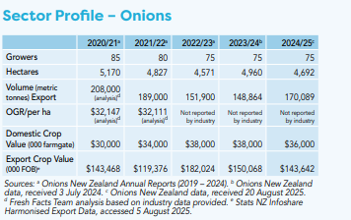
Data source Fesh Facts
In 2024/25, there were 75 onion growers in New Zealand, growing onions on about 4,700 hectares.
From early settlers to today’s innovative growers, onion growing has become an important part of New Zealand’s primary sector. Thanks to innovation and a focus on quality, New Zealand onions are now known and trusted around the world.
Do Activity 2: History of growing onions in NZ comprehension exercise (PPT Onion activities 1-3)
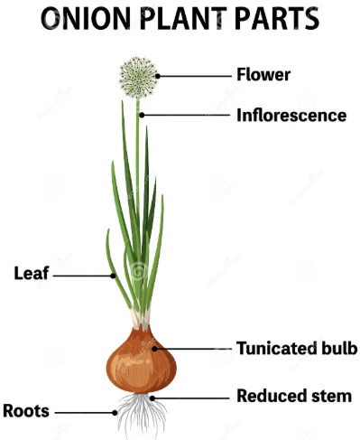
Onion plants
Onions belong to the Allium family, a large and diverse group of plants known for their strong flavours and characteristic smell.
The scientific name for the common onion is Allium cepa.

Structure of an onion
An onion is classified as a tunicate bulb, which is a type of underground storage organ.
Although we often think of an onion as a root vegetable, it is made mostly of modified leaves. These leaves have become thick, fleshy, and swollen to store nutrients and water for the plant.

Onion anatomy
- The layers (modified leaves)
The edible white, yellow, or purple layers are called scale leaves. These are modified leaves that store food and water for the plant.
- The outer skin (dry leaves)
The thin, papery brown outer covering is made of dry, dead leaves. These protect the inner fleshy layers from:
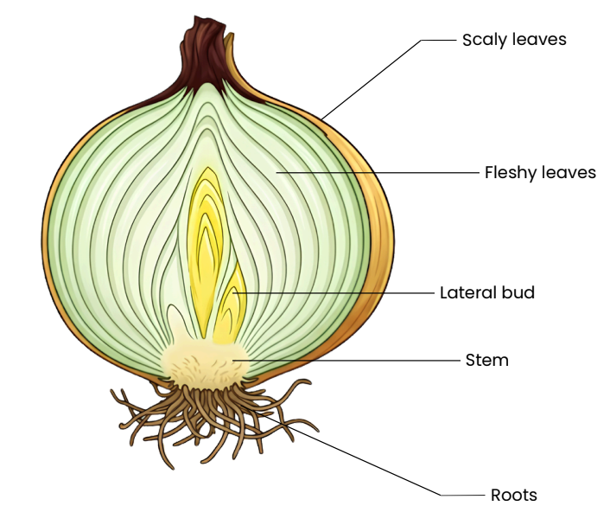
- Water loss
- Disease
- Physical damage
- The base (compressed stem)
The hard, flat disc at the bottom of the onion is the stem base. It is a very short, compressed stem from which:
- Roots grow downward
- Leaves grow upward

Do Activity 3: Investigation Onion Anatomy (PPT Onion activities 1-3)

Other members of the allium family
The Allium family includes several important food crops which are shown on the Alliums poster.
- Garlic
- Shallots
- Leeks
- Chives
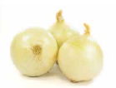
- Spring onions

Common onion types
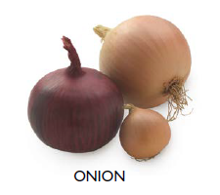
Onions are commonly grouped by colour and flavour:
- Brown onions
- Red onions
- White onions

Brown onions
Brown onions are the most common onion variety grown. The papery skins on these onions are golden to brown in colour and the flesh is white. These onions have a-low water content, so they store well in cool, well-ventilated place that is preferably dark.
Varieties include Pukekohe Long Keeper, Early Long Keeper, Kiwi Gold, and Rhinestone.
The Pukekohe Long Keeper and hybrids of this variety are the most widely grown onions in New Zealand. These brown storage onions are valued for their excellent keeping qualities, firm bulbs, and suitability for both local and export markets.

Red Onions
Red onions are gaining in popularity. Red onions have red to burgundy coloured papery skins and red tinged flesh. The shape of red onions varies with variety.
Varieties include Sweet Red, 903M, and Rubillion.

White Onions
Not grown commercially in New Zealand.
Refer to PPT “Onion varieties” for more information.
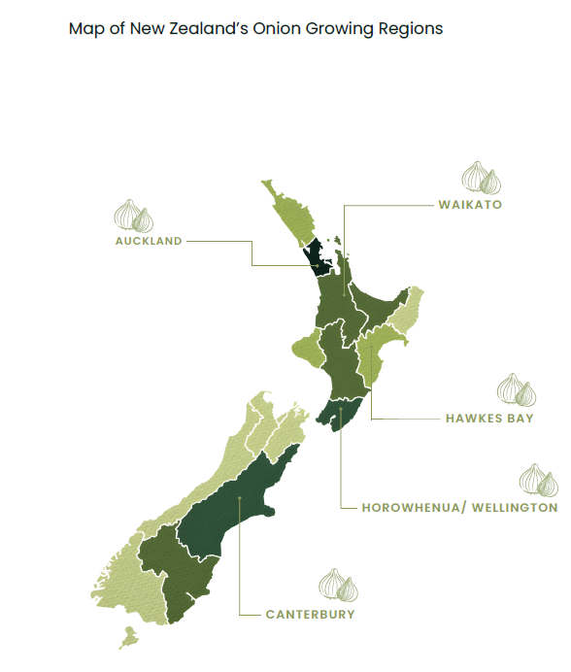The main onions growing regions include Northland, Waikato, Hawke’s Bay, and Canterbury. A small amount is grown in Horowhenua.
Onions grow best in a temperate climate with plenty of sunlight and consistent moisture, with ideal temperatures ranging between 13°C and 24°C. They require well-drained, loose loam soils with a slightly acidic to neutral pH of around 6.0–7.0 to support nutrient uptake and healthy bulb development. Regular rainfall or irrigation, balanced nutrients, and good weed control are essential, as onions are sensitive to competition and waterlogging. With the right growing conditions, including proper spacing and pest management, onions can produce a high yield of quality bulbs.
Growing onions
Note:
The following information on growing onions commercially is purposefully generalised. For specific and regional information contact and visit a local grower. The Field trip to onion grower worksheet is a set of questions that you can revise to suit your class and the purpose of the field trip.
Activity 4: Field trip to a local grower (WS)

The New Zealand onion industry operates year-round, using staggered seeding and harvesting to supply the domestic market continuously and meet the demands of targeted export markets. Onion bulbs typically take between 6-7 months to mature and be ready for harvest.
Growers implement several key management practices to produce sustainable, high-yielding, high-quality onion crops, including:
- Careful site selection based on a planned crop rotation
- Establishment of a fine, firm seedbed with optimal soil pH and fertility
- Staggered seeding using precision equipment
- Ongoing crop monitoring and the use of integrated pest management techniques
- Targeted nutrient and water management
- Efficient harvest management
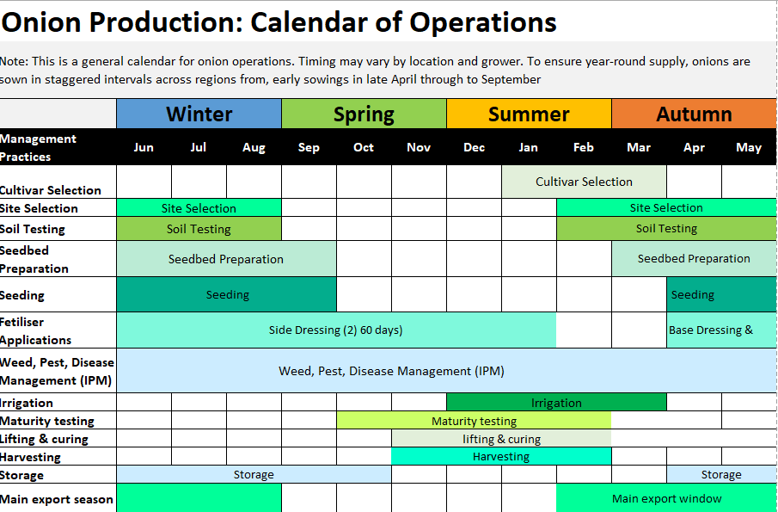
Market requirements
Domestic
The domestic New Zealand market requires firm clean onions with dry skins and a medium size range of ≥70 mm.

Export markets
Export onion growers must meet strict quality standards, including appropriate size, firmness, and dry, clean skins. In addition, they must comply with the phytosanitary requirements of importing countries, particularly those related to diseases such as onion smut. To prevent the spread of onion smut, some overseas markets impose additional plant health restrictions. Size requirements also vary by region. Asian markets generally prefer larger onions (greater than 100mm), while European markets typically require onions in the 70-90mm size range.

Crop establishment - See PPT Growing onions
Watch
- Growing onions in New Zealand - Pukekohe and or Family Farm Onions - Ashburton

Site selection
Selecting the right site is critical for successful commercial onion production. Key factors growers consider, to ensure high yields and good-quality bulbs include crop rotation, soil conditions, and climatic factors. Onions are an annual crop that takes approximately 6–9 months to reach maturity.
A typical crop rotation involves a 4–6-year break between onion crops, with onions planted after clean or pasture-based crops to minimise disease risk and maintain high commercial yields. This long break helps prevent the build-up of soil-borne diseases and pests, supporting long-term soil health and productivity.
Onions grow best after crops that leave the soil clean of weeds and diseases and help maintain or improve soil structure. Common preceding crops include long-term pasture, cereals (such as wheat, barley, and oats), and some brassicas, provided disease risks are carefully managed.
Soil type is also important. Onions grow best in friable, well-drained, and fertile soils that support easy bulb development. The ideal soil pH is between 6.0 and 7.0, which ensures optimal nutrient availability and supports strong bulb formation. Poorly drained or compacted soils should be avoided, as they can reduce yield and increase the risk of disease.
Climate is another important factor, as onions require a long, warm growing season with adequate sunlight and a relatively dry period during harvest to allow for proper curing and storage quality.

Seedbed preparation
Onions require a fine, firm, and well-prepared seedbed to ensure uniform germination, strong root establishment, and proper bulb development. A good seedbed allows small onion seeds to make good contact with the soil, which is essential for even emergence and consistent crop growth.
The method of cultivation depends on soil type and the previous crop grown. Heavy or compacted soils may require deeper cultivation and careful breaking up of clods, while lighter soils need less intensive preparation but must still be firmed to prevent drying out.
The soil is cultivated using GPS guided equipment and a range of cultivation implements to create a smooth, weed-free, and well-drained seedbed while minimising the number of field passes, reducing soil compaction and preserving soil structure. This approach improves operational efficiency, promotes moisture retention, and supports uniform onion bulb development.
These seedbeds are typically formed at the end of our summer and then soils are given a chance to rest prior to planting of the new crops.

Pelleted seed and seeding
Watch: Planting Onions
Onion seed is naturally very small, so it is often coated with a clay-based material to form pelleted seed. This improves seed uniformity and allows it to flow easily through precision seeders, enabling accurate spacing and consistent crop establishment.
Pelleted seed is typically sown at a depth of 1–2 cm into a well-prepared seedbed. Within-row spacing is usually 2–5 cm, with row spacing adjusted according to production system and desired bulb size required by each market. Correct spacing ensures each plant has sufficient light, nutrients, and space for healthy bulb development.
Pelleted onion seed
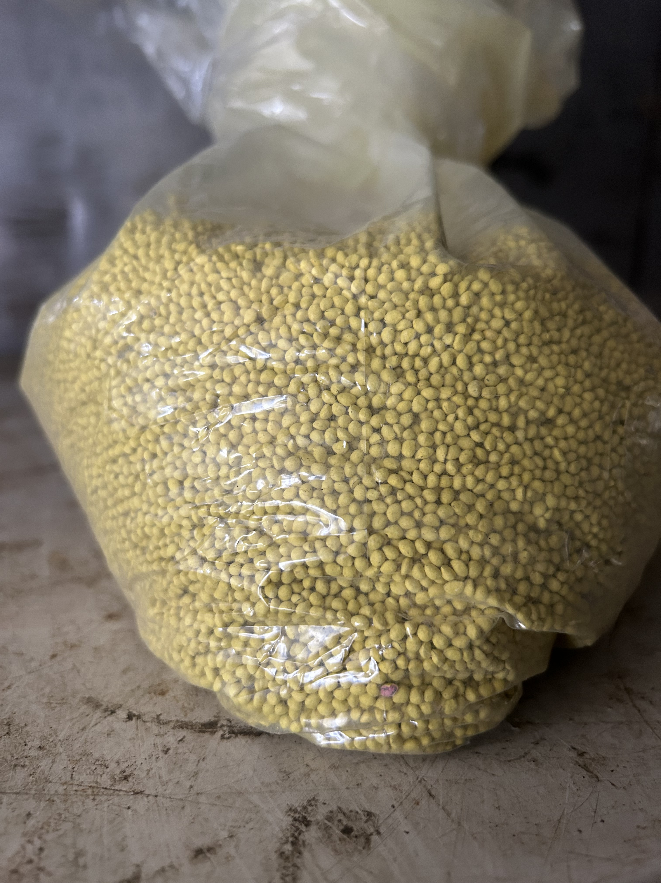

In New Zealand, onion sowing occurs during winter. Seeding begins as early as May in the North Island and is generally completed nationwide by September. The crop then takes around 6-7 months to mature before harvest.
Pelleted seed technology improves planting accuracy, enhances germination, reduces seed waste, and helps minimise weed competition and disease pressure, supporting higher-quality and more uniform yields.

Activity 5: Pelleted seed discussion questions
In groups,
- Discuss how pelleted seed technology has improved onion yields for growers in New Zealand?
- Explain why onion seeds are pelleted before planting and how this helps with precision sowing?
- Describe three benefits of pelleted onion seeds for growers, including how they help protect young plants and improve growth.
- Do Pelleted Seed Technology for Onions in New Zealand (WS).

Activity 6: Investigation: Germination experiment with pelleted and unpelleted onion seeds

Crop growth
Throughout the growing season, onion crops are carefully monitored to ensure plants receive the correct balance of nutrients and water. Regular monitoring allows growers to identify and respond quickly to issues such as pest and disease pressure, nutrient deficiencies, or moisture stress. This proactive management helps optimise plant health, maximise yield, and ensure the production of high-quality onions for the market.
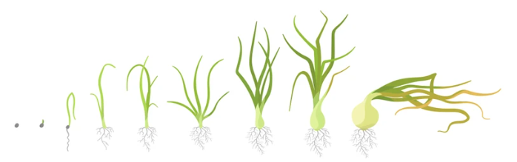
Nutrient management
Nutrient management is essential for achieving high yields and quality in commercial onion production in New Zealand. Onions require a balanced supply of key nutrients, particularly nitrogen (N), phosphorus (P), and potassium (K), to support healthy growth and bulb development. Nitrogen is important during early growth for leaf and root development, but excessive nitrogen later in the season can delay bulb formation and reduce storage quality. Phosphorus supports strong root establishment, while potassium is critical for bulb size, firmness, and overall quality.
Fertiliser programmes are typically based on soil testing to ensure nutrients are applied in the correct amounts and at the right time. Split applications of nitrogen are often used to improve efficiency and reduce leaching. Careful nutrient management helps optimise yield, improve bulb quality, and minimise environmental impacts.

Water and irrigation management
Water management is essential for successful commercial onion production in New Zealand, as onions require a consistent and reliable moisture supply throughout their growth. Adequate water is particularly important during bulb formation, when rapid cell expansion determines final bulb size and yield. However, onions have shallow root systems and are sensitive to both water stress and excess moisture. Insufficient water can lead to small bulbs and reduced yields, while over-irrigation or poorly drained soils can cause root diseases and bulb rot.
Growers typically use irrigation systems to maintain even soil moisture, especially in drier regions or during periods of low rainfall. Irrigation is carefully managed and often reduced or stopped before harvest to allow bulbs to dry and cure properly, improving storage life and quality.

Pest and disease management
Pest and disease management is a key part of commercial onion production in New Zealand, as onions are susceptible to a range of insects and diseases that can reduce yield and bulb quality. Common pests include onion thrips and aphids, which damage leaves and reduce plant growth, while diseases such as downy mildew and bulb rots can develop under humid or wet conditions.
Growers use an integrated pest management (IPM) approach, which combines regular crop monitoring, crop rotation, resistant varieties, and careful use of pesticides when necessary.
Good field hygiene, including removing crop residues and controlling weeds, also helps reduce sources of infection. By managing pests and diseases effectively, growers can protect crop health, maintain high yields, and ensure quality onions suitable for fresh and export markets and storage.
See PPT Onion pest and diseases
Do Worksheets
- White Rot Control in Onions (WS)
- Smart tech reduces fungicide use (WS)

Weed management
Weed management is critical in commercial onion production in New Zealand because onions are poor competitors, especially during early growth stages. Weeds compete for light, nutrients, and moisture, which can significantly reduce bulb size, yield, and crop quality.
Effective weed control begins before planting with good site selection and crop rotation, followed by the preparation of a clean, weed-free seedbed. Growers typically use a combination of pre-emergence herbicides to prevent weed establishment and carefully timed post-emergence herbicides to control weeds during crop growth. Mechanical methods, such as inter-row cultivation, may also be used, but must be done carefully to avoid damaging shallow onion roots. Early and consistent weed control is essential to ensure successful crop establishment and maximise yield and bulb quality.

Maturity
Onions are ready for harvest when the tops naturally fall over and begin to dry, and the bulbs feel firm and well-formed to the touch. This indicates that growth has finished and the bulbs have reached full maturity.
Main crop onion harvest typically occurs in December- January in the North Island and continues into February in the South Island, depending on planting time and local conditions.
At maturity, the tops and roots are cut, and the bulbs are carefully lifted from the soil to avoid damage. Early season onions are often hand clipped to maintain quality to meet market requirements. Later in the season onions are machine harvested.
The timing of harvest is crucial, as it directly affects bulb quality, storage life, and the ability to meet domestic and export market specifications.

Crop harvest, processing and storage
Watch
- Harvest Fresh Onion Production https://www.youtube.com/watch?v=G-H1Qd3huA8&t=2s
- A short section of ST Growers onion harvest
During harvest, onion bulbs are lifted from the soil and laid in rows on top of the beds to dry in the sun between 14 and 28 days depending on weather conditions. This process helps form the dry outer skins that protect the onion.
Once sufficiently dry, the bulbs are mechanically lifted from the beds into bins and transported to the packhouse, where they are stored and graded. Growers aim to minimise the time onions remain in the field for curing, as unfavourable weather can slow drying and reduce skin quality.
Onions are transported from the field to the packhouse in wooden bins or bulk trailers.

In the packhouse
After harvest, onions are held in field bins for a minimum of 10 days but generally 3 weeks to allow the natural curing process to continue.
Once cured, the onions pass over a grading system where they are sorted by size and quality to meet the requirements of different markets. Grading also removes waste material, such as excess skins and damaged bulbs.
After grading, onions are stored in ventilated sheds using ambient air temperature, ready for distribution. In some cases, cool storage is used to maintain freshness for onions intended for later sale on the domestic market.

Ready for Market
Domestic market
Onions are supplied fresh to retailers and consumers across the country. This can be in bulk bins or in bags for convenience.

Export market
When orders are received, onions are packaged according to market requirements. Export packaging options include 20 kg mesh bags, 1.2-tonne bulk bags, and export bins.
The mesh bags are stacked onto wooden pallets for shipping. A single 1.2-tonne bag is placed on each pallet, while 20 kg bags are stacked to meet weight and handling limits. Pallets allow for efficient handling and transport within the packhouse and throughout the export supply chain.

Shipping to Export Markets
Most onions are shipped in containers using ambient air temperature, although red onions and some brown onion varieties are transported in refrigerated containers.
Shipping times vary from a few days to up to six weeks, depending on the destination. For example, onions exported to Europe may spend around six weeks in transit. Advances in onion quality and shipping container airflow systems ensure that New Zealand onions arrive in overseas markets in excellent condition, maintaining the same quality as when they left the country.

Do Activity 7: Growing Onion Questions (WS)

Challenges facing onion growers
New Zealand's onion industry is an important part of the country's horticultural sector, supplying both domestic and international markets. Onion growers produce high-quality crops that are exported around the world, contributing significantly to New Zealand's economy. However, growing onions is becoming increasingly challenging due to a range of environmental, economic, and social pressures.
One of the biggest challenges facing growers is climate change, which has led to more frequent extreme weather events such as floods, cyclones, droughts, and heatwaves. Events like Cyclone Gabrielle in 2023 caused severe crop losses and damaged valuable farmland and infrastructure. At the same time, growers must deal with rising costs for fertiliser, fuel, labour, machinery, and packaging, which reduce their profits.
The industry also faces challenges in accessing international markets. Shipping delays, container shortages, trade barriers, and competition from overseas producers can make it difficult to export onions successfully. In addition, growers must manage pests, diseases, and biosecurity risks that threaten crop health and productivity.
As pressure increases to grow crops more sustainably, onion growers must also meet stricter environmental regulations while reducing waste and protecting soil and water resources. Despite these challenges, the industry continues to invest in new technologies, research, and sustainable farming practices to improve resilience and ensure a successful future. Understanding these challenges helps explain the complex decisions growers must make to continue producing high-quality onions for New Zealand and the world.

Activity 8: Onion industry challenges
- In groups, brainstorm and create a list of challenges that onion growers have faced in the past and continue to face today.
- Give one or two of the worksheets listed below to each group to read and discuss.
  - NZ Onion Industry Challenges (WS)
  - Strong onion crop in Hawkes Bay (WS)
  - Auckland floods (WS)
  - Strong Quality and Reliable Exports Drive NZ Onion Season (WS)
- After reading the worksheets, add any new challenges to your list. Then brainstorm and record possible strategies that growers could use to reduce or manage these challenges.
- Share your group's ideas and findings with the class.

