Pelleted Seed Technology for Onions in New Zealand Worksheet
Pelleted seed technology is an important tool used by onion growers to make sowing easier and more accurate. By coating onion seeds with special materials, growers can improve planting precision, support early plant growth, and reduce problems caused by pests and diseases.
Seed pelleting is a process in which layers of powder and liquid are applied around a seed to form a smooth, round pellet. This coating makes the seed larger and heavier, typically increasing its weight by 500–800% compared with the original seed.
Because onion seeds are naturally very small and irregularly shaped, they can be difficult to sow evenly. Pelleting solves this problem by creating seeds that are uniform in size and shape, making them easier to handle and plant accurately.
Benefits of pelleted onion seeds
- Precision seeding
- The larger, round pellets move smoothly through precision sowing equipment.
- This allows seeds to be spaced evenly in the soil, improving crop uniformity and making harvesting easier.
- Better seedling establishment
- Pelleted seeds can include protective coatings that help seedlings survive challenging conditions, such as cold soils or early-season disease pressure.
- Protection from pests and diseases
- The coating may contain small amounts of fungicides or insecticides.
- These treatments protect the seed during germination and early growth, reducing the need for additional chemical applications.
- Improved seeder performance
- The smooth, uniform surface of pelleted seeds improves flow through precision seeders.
- This reduces blockages and enables faster, more reliable sowing with consistent seed spacing.

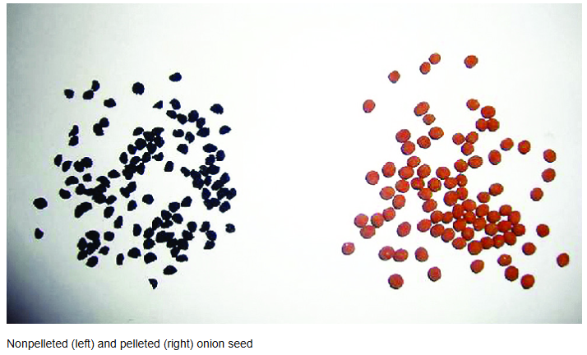
Questions
- What is pelleted seed?
- Why is using pelleted seed important for onion growers?
- A grower notices that onion plants are emerging unevenly across a paddock. Some areas have plants growing very close together, while others have large gaps. How could using pelleted seed help solve this problem?

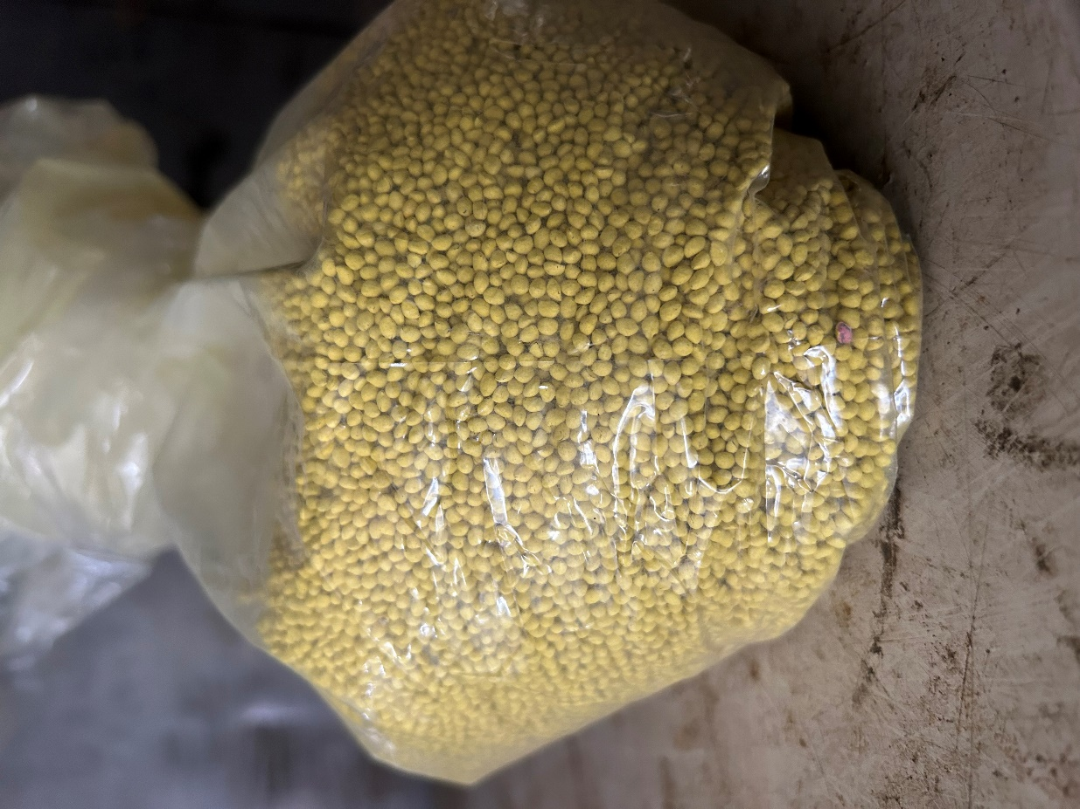
Answers
- What is pelleted seed?
Pelleted seed is seed that has been coated with layers of powder and liquid to form a larger, smooth, and round pellet. This makes the seed easier to handle and sow accurately.

- Why is using pelleted seed important for onion growers?
Pelleted seed improves sowing accuracy, promotes uniform plant spacing, supports early seedling growth, protects against pests and diseases, and improves the performance of precision seeding equipment.

- A grower notices that onion plants are emerging unevenly across a paddock. Some areas have plants growing very close together, while others have large gaps. How could using pelleted seed help solve this problem?
Pelleted seed is larger and more uniform in size and shape, allowing precision seeders to place seeds at consistent intervals. This results in more even plant spacing, uniform emergence, better crop growth, and improved yields.

