White Rot Control in Onions: Why Timing Matters
Read “White Rot Control in Onions: Why Timing Matters” and research the White Rot disease in onions and answer the questions.
- What is onion white rot, and what causes the disease?
- Describe three symptoms of white rot that growers might observe in infected onion plants.
- Why is onion white rot difficult to control using crop rotation alone?
- How does the white rot degree day prediction model help growers manage the disease?
- Why is the timing of fungicide applications important for controlling white rot?
- The article recommends rotating different fungicide groups. Why is this important for long-term disease management?
- If you were an onion grower, how would using disease forecasting tools and carefully timed fungicide applications help you improve both crop health and sustainability? Explain your answer.

Onion white rot, caused by the fungal pathogen Sclerotium cepivorum, is one of the most challenging diseases affecting onion crops throughout New Zealand. The disease can cause significant yield losses and is difficult to control because it survives in the soil for many years.
White rot appears as fluffy white fungal growth around the roots and base of infected onion plants. Above-ground symptoms include stunted growth, yellowing leaves, and a wilted appearance. As the disease develops, numerous small black structures called sclerotia form on infected tissue. These resting bodies allow the fungus to remain dormant in the soil for many years, making crop rotation alone ineffective. Even rotations longer than two or three years will not eliminate the disease from a paddock.
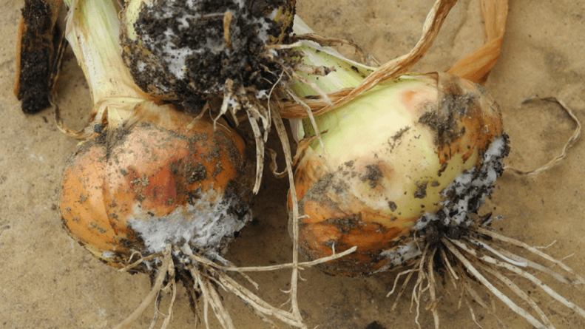
Because of the long-term survival of the pathogen, fungicides remain the most effective control option. However, successful control depends heavily on correct timing. Growers can use a white rot degree day prediction model, which measures soil temperature and calculates cumulative degree days from planting. This model helps identify when conditions are favourable for infection and when fungicides should be applied.
Research has shown that fungicide applications are most effective when applied between 100- and 150-degree days after planting. Without treatment, the first infected plants are typically observed at around 250 degree days. By using the prediction model, growers can apply fungicides before infection occurs, improving disease control and reducing crop losses.
An effective management programme should combine different fungicide groups to reduce the risk of resistance developing. Products such as Sercadis have performed well in New Zealand trials and can form part of a rotation programme alongside DMI and QoI fungicides. Growers should always follow label recommendations and be aware of restrictions on the number of applications permitted from each chemical group.
Other important considerations include seed treatments and export market requirements. Seed coatings containing SDHI fungicides count toward the maximum number of SDHI applications allowed in an onion crop. Since SDHI fungicides carry a higher risk of resistance development, growers should follow resistance management strategies and avoid excessive use of the same active ingredient.
By combining disease forecasting tools, carefully timed fungicide applications, and resistance management practices, growers can significantly improve their control of onion white rot and protect crop productivity.
Sample answers
- What is onion white rot, and what causes the disease?
Onion white rot is a serious fungal disease that affects onions and other plants in the onion family. It is caused by the fungus Sclerotium cepivorum. The disease attacks the roots and base of the onion bulb, reducing the plant's ability to take up water and nutrients. This can lead to poor growth, reduced yields, and even crop failure. White rot is considered one of the most difficult onion diseases to control because the fungus can survive in the soil for many years.
- Describe three symptoms of white rot that growers might observe in infected onion plants.
There are several signs that indicate a plant may be infected with white rot:
- Yellowing leaves – The leaves begin to turn yellow as the plant becomes unhealthy.
- Wilting and stunted growth – Infected plants often appear weak, smaller than normal, and may wilt even when soil moisture is adequate.
- White fungal growth and black sclerotia – At the base of the bulb and roots, growers may see fluffy white fungal growth. Small black structures called sclerotia also develop. These are the resting bodies of the fungus and are an important sign of infection.
- Why is onion white rot difficult to control using crop rotation alone?
White rot is difficult to control with crop rotation because the fungus produces black resting bodies called sclerotia. These sclerotia can remain dormant in the soil for many years, even when onions are not being grown. While crop rotation can help manage some diseases, white rot survives much longer than typical rotation periods. Even rotating crops for more than two or three years will not completely remove the disease from an infected paddock. This means other management methods, such as fungicides and disease forecasting, are needed.
- How does the white rot degree day prediction model help growers manage the disease?
The white rot degree day prediction model measures soil temperature and calculates the accumulation of heat units, known as degree days, from the time onions are planted. Because disease development is linked to temperature, the model helps predict when infection is most likely to occur.
By tracking degree days, growers can identify high-risk periods before symptoms appear. This allows them to apply fungicides at the most effective time rather than waiting until disease damage becomes visible. The model therefore helps growers make more informed and proactive disease management decisions.
- Why is the timing of fungicide applications important for controlling white rot?
Timing is important because fungicides work best when applied before or during the early stages of infection. The article explains that fungicides should ideally be applied between 100- and 150-degree days after planting. If growers wait too long, the disease may already be established in the crop.
Without treatment, the first infected plants are often found at around 250 degree days after planting. Applying fungicides at the correct time provides protection before infection becomes widespread, improving disease control and reducing crop losses.
- The article recommends rotating different fungicide groups. Why is this important for long-term disease management?
Rotating fungicide groups helps prevent the fungus from developing resistance to a particular chemical. If the same fungicide is used repeatedly, some fungal populations may survive and become resistant. Over time, the product becomes less effective.
Using different fungicide groups, such as SDHI, DMI, and QoI fungicides, reduces the selection pressure on the fungus. This helps preserve the effectiveness of available fungicides and ensures growers have useful disease control options in the future. Resistance management is an important part of sustainable crop production.
- If you were an onion grower, how would using disease forecasting tools and carefully timed fungicide applications help you improve both crop health and sustainability? Explain your answer.
If I were an onion grower, I would use disease forecasting tools because they would help me make decisions based on scientific evidence rather than guesswork. The white rot degree day model would allow me to identify when disease risk is increasing and apply fungicides only when necessary.
This approach would improve crop health because fungicides would be applied at the most effective time, helping to prevent infections before they become serious. It would also improve sustainability by reducing unnecessary chemical applications, lowering costs, and decreasing environmental impacts. In addition, using fungicides more carefully would help prevent resistance from developing, ensuring these products remain effective for future crops. Overall, combining disease forecasting with well-timed fungicide applications would help produce healthier onion crops while using resources more efficiently and responsibly.

