Potato Production in New Zealand Case Study
Teachers’ Guide
Introduction
Potatoes are one of the most important crops grown in New Zealand. The commercial potato industry is a high-yield sector valued at over $1.4 million, with major production regions in Auckland, Waikato, Manawatu–Whanganui, and Canterbury. Yields can exceed 50 tonnes per hectare, placing New Zealand among the highest producers in the world.
Successful potato production relies on fertile, free-draining soils and the use of certified seed potatoes, which are typically planted between September and December. Harvest usually occurs 110–120 days after planting.
As of the 2024/25 season, there are approximately 151 potato growers in New Zealand cultivating a total of 10,358 hectares. This includes 962 hectares dedicated to seed potatoes, 4,554 hectares for table potatoes, and 4,842 hectares for processing potatoes.
Data from Fresh facts24/25

The focus of this case study is the commercial production of potatoes for the fresh and processing markets in New Zealand. It specifically examines the cultivation of main-crop potato cultivars for these markets and does not cover the production of specialty potato varieties such as Perlas, Inca Gold, Apache, or Purple Passion.
Key learning outcomes: Students will be able to
- Discuss where potatoes are grown commercially and explain why.
- Describe the potato sectors within the industry.
- Explain the potato attributes required by specific markets.
- Describe the management practices involved in growing potatoes commercially.
- Discuss challenges facing the industry.
- Discuss the importance of biosecurity and crop protection.

Supporting resources
- Potato Production Case Study
- Potato Growing Glossary of Terms
- Activities 3-4 Investigations and 5 (WS)
- Activity 6 Field trip to potato grower (WS)
- Market requirements (TN)
- Potato Growth Stages - (TN)
- Processing Market Requirements Summary (TN)
- Potato-varieties-2013-poster.
- EPA approves new potato disease chemical (WS)
PowerPoints
- Common Potato Pests and Diseases
- Growing Potatoes
- Specific Gravity and testing activities
- Potato Varieties.
Videos
- Potatoes New Zealand https://potatoesnz.co.nz/
- Growing potatoes commercially videos
- Growing Potatoes in NZ
- Wilcox Perlas New Season Potatoes: How we grow, harvest and pack them
- Wilcox and Sons on the importance of information - technology
- Ohakune Potato Harvesting- https://www.youtube.com/watch?v=awNcWK4eo3gandt=52s
Challenge Resources
- Challenge NZ growers are facing
- NZ Potato Growers Focus on Converting High Yields into Greater Market Value (WS)
- NZ potato growers focus on value creation amid market and climate challenges (WS)
- Potato growers eye innovation.
- Spud growers seek fair returns
Biosecurity resources
- Potato Sector Risk Organism
- Common Potato Pests & Diseases
- See Potatoes Biosecurity resources in folder
Additional Resources
Highlighted below are some additional potato resources. These resources are not included in this case study, but you could integrate them when you are planning.
- Unit 7: Potatoes resource
Unit 7: Potatoes is a unit of work designed to increase student awareness and understanding of the importance of potatoes in New Zealand and globally, as well as how they are grown. The key learning outcomes include developing an understanding of:
- Why potatoes are an important crop in New Zealand and worldwide
- The growth process of potato plants
- The history of potatoes
- Māori potatoes
- The differences between potatoes and sweet potatoes (kūmara)
- Where and how potatoes are grown in New Zealand
This unit provides information, links to resources, and a range of learning activities that offer a sound introduction to potatoes.
- Potatoes New Zealand Resources
See folder for additional resources. These are a series of potato activities to further illustrate concepts. Pick relevant ones.
- Processing video
Inside The Potato Chip Factory That Runs 24/7 | Full Episode
This is an Australian production that show processing potatoes into chips.
Recommendations
Within each case study there are multiple activities for students to complete. We recommend you select the activity or activities that best suit your students.

Find out what your students know.
Ask selected questions to brainstorm ideas on commercial potato growing in New Zealand.
- Do you think potatoes are an important commercial crop in New Zealand? Why or why not?
- Where in New Zealand are potatoes grown? Can you name any regions?
- Why do you think potatoes are grown in these regions?
- What makes these regions suitable for growing potatoes commercially?
- What conditions do potatoes need to grow well?
- Can you name any varieties of potato?
- How long do you think it takes to grow potatoes from sowing to harvest?
- Make a list of management practices potatoes growers use to grow potato on a sustainable crop?
- What challenges do you think potato growers are facing?

Activity 1: Brainstorm
Work in groups to discuss, share and write down your ideas
- What other questions do you have about growing potatoes?
- Make a list of things you are curious to learn more about growing potatoes?
Fun fact: Potatoes were the first vegetable grown in space!
In 1995, NASA and the University of Wisconsin–Madison successfully grew potatoes aboard the space shuttle as part of research into feeding astronauts on long missions. Scientists wanted to see whether potatoes could become a reliable food source for future space travel to places like Mars.

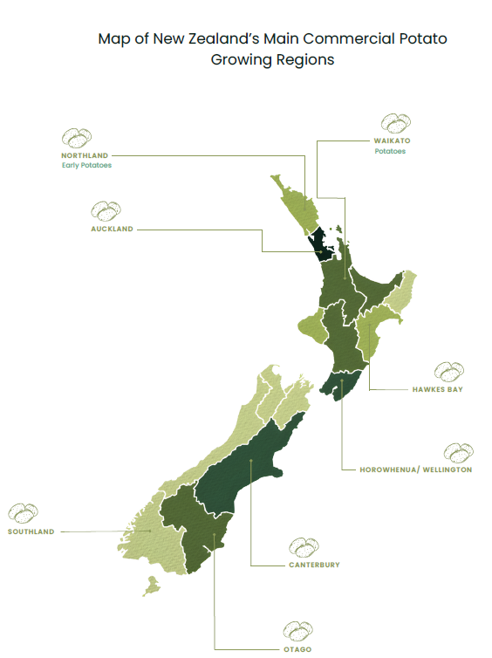
Potato growing regions include Auckland, Waikato, Hawkes Bay, Ohakune, Manawatu-Wanganui and Canterbury and Southland.
Potatoes thrive in temperate climates and are relatively frost tolerant during early growth. However, frost event during flowering or near harvest can significantly reduce yields. Potatoes require consistent moisture, but waterlogged soil should be avoided as they lead to disease and poor tuber development.
The ideal soil for potatoes is a light to medium loam with good drainage. The recommended soil pH is between 5.5-6.5. A well-planned rotation supports soil health and improves long term productive and sustainability of the cropping systems
The ideal conditions for growing potatoes include:
- Temperature range between 18°C–25°C
- Frost free
- Deep (45–60 cm or more), well-drained soil
Potato varieties.
- Refer Potato Varieties Poster and PPT Potato varieties
There are about 50 varieties of potatoes grown in New Zealand. Some main varieties are Nadine, Agria, Moonlight, Desiree, Rua, Red Rascal, Russett Burbank and Innovator.
Potatoes can be divided into two groups. Fresh, sometimes referred to as table potatoes, and process potatoes. Selecting the right variety is essential, as each has unique traits that influence market suitability, yield potential and end use quality.
Characteristics / traits of potatoes
- Taste: These potatoes are known for their flavour and versatility across cooking methods such as boiling, mashing, roasting and flying.
- High yielding: Varieties produce high yields, making them ideal for commercial growers.
- Early maturing; These potatoes reach harvest readiness sooner allowing for quicker turnover and reduced exposure to seasonal risks.
- Smooth skin: These potatoes have a clean uniform appearance, which is preferred for fresh market presentation.
- Dry matter content: Processing varieties are selected for their high dry matter which improves texture and frying quality.
Some varieties have many of these characteristics. Growers consider factors such as soil compatibility, disease resistance, storage requirements and the market requirements when choosing which varieties to plant.
Market requirements
Fresh Markets
Fresh market potatoes are grown for cooking and eating. These are the potatoes typically found in supermarkets and are suitable for baking, frying, boiling, or roasting. Different varieties are grown for different cooking methods.
Qualities consumers look for:
- Size and shape: Medium-sized (about 8–12 cm), round or oval
- Smooth skin: Free from cuts, bruises, or blemishes
- Shallow eyes: Easier to peel
- Flesh colour: Even and visually appealing
- Good storage ability: Remains fresh for longer periods
- Cooking quality: Good taste and suitable texture when cooked
Common fresh market varieties include:
- Nadine: A popular waxy, white-skinned potato with smooth skin and high yields. Best suited to boiling and salads.
- Red Rascal: A red-skinned, white-fleshed general-purpose variety suitable for a range of cooking methods.
- Desiree: A pink-skinned, cream-fleshed general-purpose potato with good cooking versatility.
- Highlander: A high-yielding, oval-shaped potato with white skin and white flesh. Known for its excellent flavour and suitability for boiling.
Common dual-purpose varieties include:
Dual-purpose potatoes are suitable for both fresh and processing markets.
- Agria: A high-yielding, yellow-fleshed variety. Excellent for mashing, roasting, and chips.
- Rua: A high-yielding, white-fleshed variety suitable for mashing, roasting, and chips.
- Moonlight: A versatile, high-yielding variety with good drought and wind tolerance. Suitable for mashing, roasting, and chips.
Processed potatoes
Processing potatoes are grown specifically for products such as French fries, crisps, mashed potatoes, and other value-added potato foods. They are supplied to processing factories where they are cut, cooked, fried, or frozen into finished products.
These varieties are selected for their high dry matter content, suitable shape, and strong frying performance. Together, these characteristics make them industry standards for producing consistent, high-quality processed potato products.
Qualities processors look for:
- High dry matter (low moisture): Produces crispier fries, higher yield, and less oil absorption.
- Low sugar content (°Brix < 5): Ensures a light golden colour when fried; high sugar leads to dark, burnt-looking products.
- Minimal defects: Free from bruising, cuts, greening, disease, soil, and stones.
- Correct size: Larger potatoes are preferred for fries; medium to large potatoes are ideal for crisps.
- Suitable shape: Long, oval potatoes are best for fries; round to oval shapes are ideal for crisps.
- Processing efficiency: Uniform size and shape reduce waste and improve final product quality.
Common processing varieties include:
- Russet Burbank and Ranger Russet: Industry-standard fry varieties with high dry matter and ideal blocky shape.
- Innovator: Widely used for both fries and crisps due to its high dry matter, consistent shape, and reliable frying quality.
- Mustang: A crisping variety with good dry matter, consistent shape, and reliable processing performance.
- Lady Rosetta: A specialist crisping variety known for high dry matter, low sugar levels, and excellent frying quality.
For more information on market requirement and potatoes varieties refer to
- PPT Potato varieties
- Market requirements teachers notes.
Note:
This case study covers only a selection of common potato varieties used in different markets. Many additional varieties exist for specific growing conditions, markets, and processing requirements.

Activities: 2-5 PPT Potato Specific gravity and testing activities or Activities 3-5 Potato Investigation (WS)
Do:
- Activity 2: Calculating the specific gravity
- Activity 3: Testing potatoes for sugar content
- Activity 4: Testing the impact of storage on Sugar content
- Activity 5: Process potato discussion questions

Growing potatoes
Note:
The following information on growing potatoes commercially is purposefully generalised. For specific and regional information contact and visit a local grower. The Field trip to potato grower worksheet is a set of questions that you can revise to suit your class and the purpose of the field trip.
Activity 6: Field trip to potato grower (WS)

The New Zealand potato industry operates year-round, using staggered sowing and harvesting to supply the domestic table market continuously and meet the demands of process markets.
Potatoes typically take 100-130 days to mature and be ready for harvest.
Growers implement key management practices to produce sustainable, high-yielding, high-quality potato crops, including:
- Careful site selection based on a planned crop rotation
- Establishment of a fine, firm seedbed with optimal soil pH and fertility
- Purchasing certified seed
- Staggered seeding using precision equipment
- Ongoing crop monitoring and the use of integrated pest management techniques
- Targeted nutrient and water management
- Efficient harvest management

Watch videos (PPT Growing Potatoes)
Select the videos best suited to your class.
- Growing Potatoes in NZ
- Wilcox and Sons on the importance of information - technology
- Ohakune Potato Harvesting- https://www.youtube.com/watch?v=awNcWK4eo3gandt=52s
- Perlas New Season Potatoes: How we grow, harvest and pack them

Activity 7: Calendar of operations (PPT Growing Potatoes)
Brainstorm and list all the management practices required to produce a potato crop, starting from site selection and ending at harvest.
- Identify the key management practices involved in potato production.
- Arrange the practices in the order they would be carried out during the growing season.
- Group the practices under the following stages:
- Establishment (pre-planting and planting activities)
- Growth (crop management during the growing season)
- Harvest (activities leading up to and including harvest)
- Create a flow diagram that clearly shows the order of management practices from site selection through to harvest.

Calendar of operations (PPT Growing Potatoes)
A calendar of operations is a schedule that identifies the key management practices undertaken at different stages of crop production, from establishment through to harvest.
Note:
The first calendar of operations (Fig 1) outlines the key management practices used in the production of a commercial potato crop. While these practices are generally consistent, the timing and specific management decisions may vary between growers within a region and across different regions due to factors such as climate, soil conditions, and market requirements.
Some large-scale potato growers operate across multiple regions to ensure a consistent year-round supply and to meet market demand.
The second calendar of operations (Fig2) outlines the key management practices used in the production of a commercial main-crop Agria potato crop in the Waikato region.

Fig 1
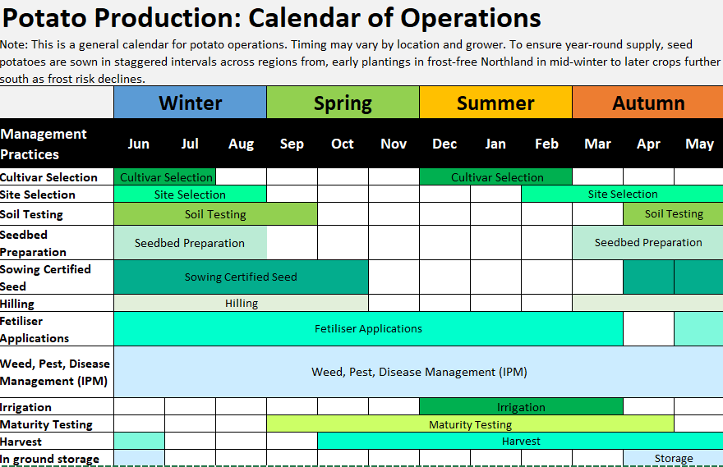
Fig 2
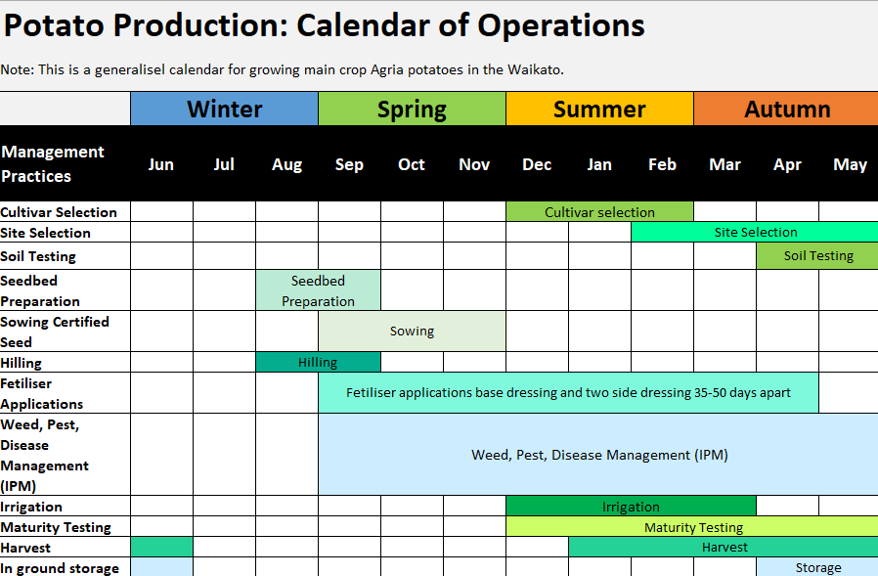

Crop establishment
Site selection
Site selection is a critical step in successful commercial potato production, as it directly influences crop yield, quality, and long-term sustainability. Growers must carefully evaluate factors such as field history, climate, and soil conditions to ensure the site can support healthy plant growth and tuber development. A suitable site typically has well-structured, fertile soil, a favourable climate with minimal frost risk, and good drainage with reliable moisture supply. Proper crop rotation, appropriate soil pH, and low pest and disease pressure are also essential. By selecting the right site, growers can maximise productivity, reduce risks, and produce high-quality potatoes for both fresh and processing markets.
- Field history and crop rotation
- Previous land use is important. Potatoes are often planted in fields that have been in permanent pasture for several years, as these soils are typically well-structured and fertile.
- Potatoes are usually grown in the same field only once every four to five years to prevent the build-up of soil-borne pests and diseases, such as potato cyst nematode.
- Soil fertility should be assessed before planting to ensure it can support healthy crop growth.
- Existing weeds, pests, and diseases must be carefully evaluated and managed prior to planting.
- A well-planned crop rotation supports soil health and improves the long-term productivity and sustainability of the farming system.
- Climate factors
- Temperature: Potatoes grow best in temperatures between 10–25°C.
- Frost: While potatoes can tolerate light frost during early growth, a frost-free period is essential during flowering and near harvest, as frost can significantly reduce yields.
- Rainfall and irrigation: Consistent moisture is required for optimal growth, so adequate rainfall or reliable irrigation is essential.
- Drainage: Waterlogged soils must be avoided, as they can lead to disease and poor tuber development.
- Wind: Strong winds can damage plants, increase disease risk through plant injury, and accelerate soil moisture loss.
- Soil type and conditions
- Potatoes can grow in a range of soil types, including clay loam, silt loam, sandy loam, peat, and alluvial soils.
- The ideal soil is a light to medium loam that is deep, friable, and well-drained, while still having good water-holding capacity.
- Soil pH should ideally be between 5.5 and 6.5pH, as this range supports nutrient availability and reduces the risk of diseases such as common scab.
- Good soil structure is essential to allow proper root growth and tuber development.
- Growers also consider soil water-holding capacity when selecting potato varieties and planning harvest timing.

Seed potatoes
Seed potatoes are the starting point for every successful crop. They are specially grown and certified to be free from disease, which helps ensure strong growth and reliable yields. Each seed potato is a living plant starter, carrying the genetic potential of the chosen variety, whether it is an early, maincrop, or speciality potato.
Seed potatoes should be sourced from trusted growers who meet strict certification standards for quality and health. This allows growers to plant with confidence, knowing their crop has the best possible start.
Seedbed preparation
Before planting soil should be cultivated to a depth of at least 25cm to support strong root development and tuber expansion. The soil should be friable and well drained, with a structure that supports moisture retention without waterlogging. Raised beds, farrows or ridges are recommended to improve drainage and reduce compaction particularly in heavier soils.
Planting
Whole seed potatoes, typically 40–55 mm in diameter, are planted into furrows using a precision planter and then covered with soil.
Planting time varies depending on location. It generally begins earlier in Northland and Auckland than in regions such as Waikato, Ohakune, and Canterbury.
Seed potatoes are planted when soil temperatures are rising and the risk of frost is minimal, as emergence occurs approximately 21 days after planting.
Correct spacing is essential for good air circulation, sunlight exposure and optimal tuber size. Spacing will depend on variety and market requirements. The following recommended planting guidelines are for main crop varieties:
- In-row spacing 25-35cm between tubers
- Row spacing 70-90cm between rows
- Planting depth 10-15 cm
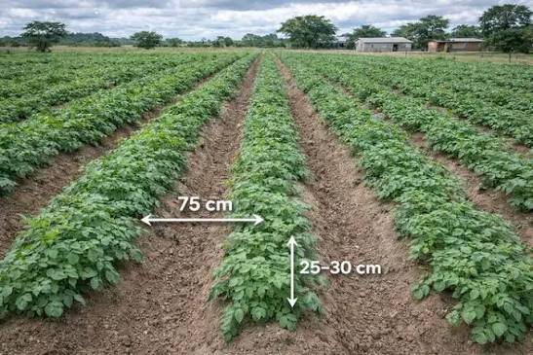
Crop growth
Potato growth occurs in five main stages over approximately 110–130 days to maturity; sprout development and leaf emergence (around 21 days), vegetative growth, tuber initiation, tuber bulking, and maturation. Key stages include initial foliage growth, flowering, which signals tuber initiation, and vine senescence (vine death), which indicates that the tubers are mature and ready for harvest.
Management practices such as hilling, fertiliser application, irrigation, and pest and disease monitoring help maximise yield by supporting both above- and below-ground growth throughout these stages.
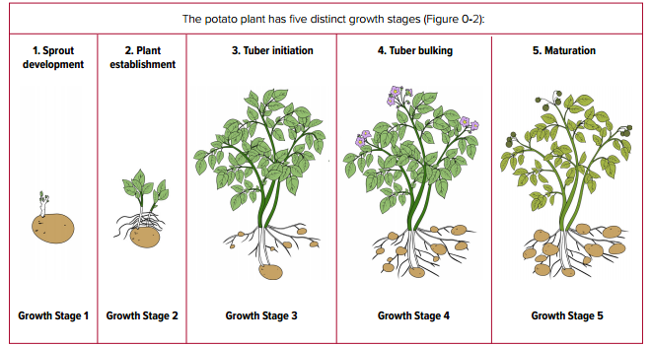
Hilling
Hilling is a management practice where soil is pulled up and piled around the base of the growing potato plant.
As the plant grows, soil from between the rows is used to form a mound (or “hill”) around the stems. This process is usually carried out more than once during the growing season.
The first hilling is typically done when plants reach 12–20 cm in height, followed by a second hilling 2–3 weeks later. This management practice protects developing tubers from exposure to sunlight, which can cause greening, and encourages secondary tuber formation, improving both yield and plant stability.
Nutrient management
Potatoes need a well-balanced nutrient programme to support healthy foliage, strong root development, and high-quality tuber formation. Fertiliser use is guided by soil testing to ensure nutrients are supplied in the correct amounts, avoiding both deficiencies and excesses.
A two-phase fertiliser approach is commonly used:

Phase 1: Early growth (Foliage development)
- Nitrogen (N): Essential for early growth, promoting strong leaf and stem development. Apply 150–200 kg/ha, usually in split doses to reduce leaching and maintain steady availability.
- Phosphorus (P): Applied at 40–60 kg/ha to support root development and early plant vigour.

Phase 2: Tuber Bulking
- Occurs approximately 4–10 weeks after emergence.
- The focus shifts to potassium (K), which is essential for tuber size, skin quality, and storage life. Apply 150–250 kg/ha of potassium.
- Micronutrients such as magnesium (Mg) and boron (B) may also be applied depending on soil test results, especially in sandy or low-organic soils.
Key nutrients
- Potatoes are heavy feeders and require a balanced supply of nitrogen (N), phosphorus (P), potassium (K), calcium (Ca), and magnesium (Mg), along with trace elements.
- Potassium (K): Most important for yield and tuber quality; supports water regulation and disease resistance.
- Nitrogen (N): Promotes early vegetative growth, but excess can reduce tuber formation.
- Phosphorus (P): Essential for root growth and tuber initiation.
- Calcium (Ca): Strengthens cell walls, reduces internal defects, and improves tuber firmness.
- Magnesium (Mg): Supports photosynthesis and healthy foliage.
Fertiliser management
- Soil testing is carried out before planting to identify nutrient requirements.
- A base application of phosphorus, potassium, and magnesium is usually applied before planting.
- Nitrogen is not applied at this stage and is instead added during early crop growth.
- Two side dressings are applied during growth 35-50 days apart.
Irrigation
Effective water management is critical for successful potato production, particularly during the tuber initiation and bulking stages. Maintaining consistent soil moisture promotes uniform tuber growth, maximises yield, and supports the development of high-quality potatoes. However, excessive irrigation, especially close to harvest, can increase the risk of tuber cracking, disease development, and harvesting difficulties.
- In regions with high rainfall, irrigation requirements may be reduced or limited to periods of dry weather.
- In regions with low or unreliable rainfall, irrigation is essential to maintain steady crop growth and optimise yields.
- A consistent and even water supply throughout the growing season is necessary to produce uniform, high-quality tubers.
Water availability has a significant influence on both potato growth and tuber quality:
- Insufficient soil moisture can reduce tuber size and yield and may contribute to physiological disorders such as hollow heart.
- Fluctuations in soil moisture can result in uneven growth, leading to defects such as knobbly or cracked tubers.
- Excessive soil moisture can restrict oxygen availability in the root zone and increase the risk of tuber rots and other soil-borne diseases.
Soil moisture monitoring technology plays an important role in irrigation management by measuring soil water levels and tracking nutrient movement within the soil profile. This helps ensure nutrients remain within the root zone, reducing the risk of leaching. The data also supports precise irrigation scheduling, allowing water to be applied at the right time and in the correct amounts to meet crop requirements, improve water-use efficiency, and minimise nutrient losses.
Pest and disease management
Growing potatoes involves a range of pest and disease risks that can significantly affect yield, tuber quality, and overall crop marketability.
Several insect pests can impact potato crops, making early monitoring of both pests and beneficial organisms essential for effective management. Regular field scouting and the use of smart traps help detect pest activity at an early stage. When pest populations exceed threshold levels, timely intervention can be implemented before they reach damaging levels.
Potatoes are also susceptible to a wide range of diseases, many of which are strongly influenced by environmental conditions such as temperature, humidity, and soil moisture, as well as by planting and irrigation practices. Good agronomic management, combined with disease-monitoring technologies that provide early warnings of high infection risk, plays a key role in reducing disease pressure.
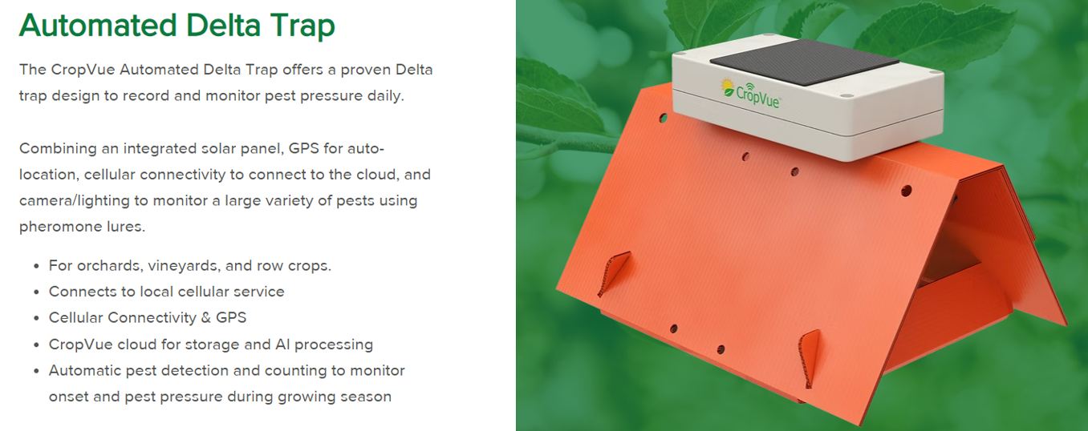
To minimise the spread of pests and diseases, strict biosecurity and hygiene practices are essential. These include cleaning machinery and equipment between paddocks, avoiding the movement of soil and plant material between sites, and using certified clean seed. Integrating these practices with careful crop rotation, regular monitoring, and early detection helps protect crop health while maintaining yield and quality.
Common Potato Pest and Disease Risks in Potato Production
Ref PPT Common Potato Pest and Diseases
Pests | Diseases
Potato tuber moth  Tomato-Potato Psyllid  Aphids  Wireworms  Potato cyst nematode (PCN) | Late blight  Early blight  Sclerotinia  Black scurf  Dry rot  Silver scurf  Blackleg / Soft rot  Common scab  Bacterial wilt  Zebra chip  Powdery scab  Potato virus Y (PVY)  Potato leafroll virus (PLRV)  Potato virus X (PVX)

Weed management
Weeds compete with potato plants for essential nutrients, moisture, and light, and can also act as hosts for pests and diseases that reduce tuber quality and overall yield.
Maintaining weed-free rows early in the growing season is critical to ensure strong crop establishment and vigorous plant growth. Effective early control gives potato plants the best opportunity to outcompete weeds throughout the season.
Growers may use a combination of mechanical cultivation and pre-emergence herbicides to suppress weed emergence and growth. These methods can be effective when timed correctly and integrated into an overall weed management plan.
However, care must be taken during cultivation to avoid damaging developing tubers, disturbing root systems, or causing soil compaction, all of which can negatively affect crop development and yield potential.
Maturity
The criteria used to determine potato maturity vary depending on the intended market. For the fresh market, a crop is considered mature when the tubers have reached the desired size. In contrast, dry matter content and specific gravity are the key indicators of maturity for processing crops.
Once the crop has reached maturity, the foliage is removed through a process known as desiccation or defoliation. This process provides several benefits:
- Encourages the conversion of sugars into starch, improving storage life and processing quality.
- Allows tuber skins to firm and fully develop, reducing susceptibility to damage during harvest and improving shelf life and marketability.
- Improves harvesting efficiency by removing excess foliage and facilitating easier lifting of the crop.
Harvesting
At harvest, potatoes are lifted from the field row by row using specialised harvesting equipment. The tubers are handled carefully to minimise bruising and mechanical damage. An initial grading process is often carried out in the field, where soil, plant debris, and damaged tubers are removed before the crop is placed into bins and transported to the packhouse.
Maincrop and processing potatoes can remain in the ground under suitable soil conditions until they are required to meet market demand. However, late-season crops are generally harvested before the first heavy frost.
Frost can cause starch within the tubers to convert into sugars, which is undesirable for processing potatoes. High sugar levels can lead to excessive browning during the production of chips and crisps, reducing both product quality and market value.
Post-Harvest Handling
Potatoes destined for the fresh market are washed, graded, and sorted through several stages to ensure they meet quality and size specifications. They are then packed into bags, cartons, or bulk bins according to retailer and customer requirements before being distributed to market.
Potatoes grown for processing are typically cured after harvest for 10–14 days in a warm, humid environment. This curing period promotes wound healing by allowing minor skin injuries to seal, reducing moisture loss and the risk of disease infection. Curing also helps prepare the tubers for long-term storage or transport to processing facilities.
Above ground storage
Proper storage is essential for maintaining tuber quality and minimising losses after harvest. Potatoes are commonly stored in temperature- and humidity-controlled facilities designed to maintain optimal conditions throughout the storage period.
For most table (fresh market) potatoes, ideal storage temperatures range from 4–8°C in a dark, well-ventilated environment with high relative humidity. These conditions help reduce moisture loss, minimise shrinkage, prevent greening and sprouting, and preserve tuber texture and quality.
Processing potatoes are often stored at slightly warmer temperatures to reduce the accumulation of sugars, which can negatively affect frying quality. Careful monitoring of temperature, humidity, and airflow throughout storage is critical to maintaining quality and ensuring potatoes meet market and processing requirements.

Activity 8: Do Potato Production Questions (WS)

Challenges Facing New Zealand Potato Growers
Activity 9: Brainstorming challenges facing New Zealand potato growers.
Working in groups:
- Brainstorm and write a list of challenges that New Zealand potato growers may face when producing potatoes commercially.
- Read one of the worksheets below about current issues affecting the potato industry.
- “NZ Potato Growers Focus on Converting High Yields into Greater Market Value” (WS) and complete questions
OR
- “NZ potato growers focus on value creation amid market and climate challenges” (WS) and complete questions
- Review and revise your challenge list.
- Add any new challenges.
- Remove any ideas that are not relevant.
- Rank the challenges from most significant to least significant.
- Share your findings with the class and explain which challenges you think have the greatest impact on New Zealand potato production and why.

New Zealand's potato industry is one of the country's most productive and valuable horticultural sectors, supplying both domestic and international markets with high-quality fresh and processed potatoes. However, growers are facing an increasingly complex range of challenges that affect their ability to remain profitable and sustainable. Rising production costs, climate variability, increasing regulatory requirements, loss of productive land, market pressures, and changing consumer preferences are all placing greater demands on the industry. While New Zealand growers continue to achieve some of the highest potato yields in the world, success is no longer measured solely by production volume. Instead, the industry's focus is shifting towards creating greater value through exports, processing, product innovation, and market development. The future success of the sector will depend on its ability to manage these challenges while balancing productivity, environmental responsibility, and profitability.

Key challenges
Climate variability and extreme weather
One of the biggest challenges is the increasing frequency of extreme weather events. Heavy rainfall, storms, droughts, waterlogging, and harvest delays can significantly reduce yield and quality. Wet conditions also increase disease pressure and make harvesting more difficult, creating greater production risks for growers.

Rising Production Costs
The cost of key inputs such as fuel, fertiliser, machinery, labour, and compliance continues to rise. These increasing expenses reduce profit margins and mean that higher yields do not always translate into higher returns for growers.
Market pressure and price volatility
Potato prices are heavily influenced by supply and demand. Large harvests can create oversupply, placing downward pressure on prices, particularly for growers selling on the open market. While processing contracts provide some price stability, growers remain vulnerable to fluctuations in domestic and international markets.
Regulatory and Compliance Requirements
Growers face increasing environmental regulations relating to water use, nutrient management, soil conservation, and environmental protection. While these regulations aim to improve sustainability, they can increase compliance costs and limit production flexibility. The industry also argues that regulations do not always recognise the role potatoes play within wider crop rotation and mixed farming systems.
Loss of productive land
Urban expansion and infrastructure development are reducing the availability of high-quality horticultural land. The loss of prime cropping soils places pressure on growers to increase production from a smaller land base and can shorten crop rotation cycles, increasing pest and disease risks.
Pest, disease, and biosecurity risks
Potatoes are susceptible to a wide range of pests and diseases that can affect both yield and tuber quality. Climate change may further increase disease pressure in some regions. In addition, biosecurity threats remain a constant concern, requiring strict monitoring, hygiene, and management practices to protect the industry.
Changing consumer preferences
Consumer perceptions and purchasing habits are evolving. Some consumers view potatoes as an unhealthy carbohydrate, while others seek convenient, ready-to-cook products. To meet these changing demands, growers are diversifying into specialty varieties and value-added products that appeal to modern lifestyles and niche markets.

Activity 10: Research challenges facing New Zealand potato growers
New Zealand potato growers face a range of challenges that affect how they grow food and make a living.
Task: Individually or in groups choose ONE of the following topics to research:
- Climate variability and extreme weather
- Rising production costs
- Market pressure and price volatility
- Loss of productive land
- Environmental regulations and sustainability pressures
- Consumer perception and demand trends

- Research your chosen challenge
- What is this challenge?
- Why is it happening in New Zealand?
- How does it affect potato growers?

- Describe at least two effects of this challenge, such as:
- Economic - money, profits
- Environmental - land, water, soil
- Social - jobs, communities, food supply

- Suggest at least two ways this challenge could be managed or reduced.
Explain how each solution would help growers.

- Presentation - Choose one format:
- Poster
- Slide presentation
- Written report

Biosecurity is a major and growing concern for New Zealand potato growers.
Biosecurity is a major and growing concern for New Zealand potato growers. These challenges involve preventing new pests and diseases from entering the country, limiting their spread within New Zealand, and managing those that are extremely difficult to eradicate once established.
Key biosecurity challenges include
- Risk of new pests and diseases entering New Zealand
Because New Zealand is geographically isolated, it has relatively few major potato pests but, that advantage is fragile. There is constant risk of harmful organisms arriving through:
- Imported seed potatoes or plant material
- Machinery, soil, or packaging
- Increased global trade and travel

- Soil-borne diseases that are hard to eliminate
Some potato diseases live in the soil and are extremely difficult to remove once established, such as:
- Potato cyst nematode
- Powdery scab
These can:
- Reduce yields significantly
- Restrict where potatoes can be grown
- Require long crop rotations (years without potatoes)

- Spread between farms - on-farm biosecurity gaps
Even if pests are already in the country, stopping their spread is a big challenge:
- Machinery moving between farms can carry contaminated soil
- Workers and vehicles can spread pathogens
- Poor hygiene practices increase risk
Once a disease spreads, it can affect entire growing regions.

- Limited control options
For some pests and diseases, there are:
- Few effective chemical treatments
- Increasing restrictions on pesticide use
- Reliance on prevention rather than cure
This makes biosecurity, keeping threats out, far more important than trying to fix problems later.

- High economic impact if an outbreak occurs
If a serious pest or disease establishes:
- Yields drop
- Export markets could be restricted
- Farms may face long-term land-use limitations
Because potatoes are a key crop, a major outbreak could affect the wider horticulture sector.

On-farm biosecurity
On-farm biosecurity refers to the practices and procedures used to prevent the introduction and spread of pests, diseases, and weeds on a farm. It is a critical part of modern agriculture and horticulture because once harmful organisms become established, they can be very difficult and expensive to control. Strong biosecurity helps protect crop health, maintain productivity, and ensure the quality and marketability of produce.

Activity 11: On-farm biosecurity
- In groups, brainstorm a list of on-farm biosecurity measures that a commercial potato grower could use to prevent the introduction and spread of pests and diseases.
- Share your ideas with the rest of the class.

Activity12: Protecting New Zealand Potatoes – Researching a biosecurity risk.
Background
Potatoes are an important crop in New Zealand. They are used for fresh food as well as products like chips and fries.
New Zealand is an island country, so it has strong biosecurity rules to help keep out pests and diseases. However, some harmful organisms can still enter the country and spread through soil, plants, machinery, or water. If this happens, they can seriously damage crops and farming businesses.
Task: Choose ONE biosecurity risk
- A pest or disease of potatoes that is already in New Zealand
OR
A pest or disease that is not in New Zealand but has been identified by Potatoes New Zealand as a high-risk Potato Sector Risk Organism.
See Potato Sector Risk Organisms or visit Sector Risk Organisms
Research questions to consider
- What is it?
- What is the pest or disease called?
- What type of organism is it (fungus, bacteria, virus, or parasite)?

- How does it spread?
- Does it spread through soil, water, insects, plants, or machines?
- How could it accidentally enter New Zealand?

- Why is it a problem for potato farmers?
- What damage does it cause to potato crops?
- Does it affect how much is grown (yield), quality, or cost of growing?

- Why is it hard to control?
- Can it survive in soil for a long time?
- Are there treatments available, or is prevention more important?

- How can it be prevented or managed in New Zealand?
- What do growers do to stop it spreading?
- What do border checks or biosecurity rules help with this problem?

Presentation - choose ONE of the following options
A: Poster
Include:
- name of your biosecurity risk
- pictures or a simple diagram
- key facts in bullet points
- how to prevent or manage it
B: Short report
Include:
- headings for each question
- clear explanations in your own words
- at least one picture with a caption
C: Slide presentation
Include:
- clear headings on each slide
- short bullet points
- images or diagrams
- one final slide: “How we can stop it spreading”

Extension challenge questions
- What could happen to food prices or exports if this disease spread widely in New Zealand?
- Compare your biosecurity risk with another student’s and decide which is more serious and why

Helpful search ideas
Try searching:
- “The name of the pest or disease”
- “Potatoes NZ biosecurity”
- “How potato pests spread” “
- “Key biosecurity threat to NZ potatoes”

