New Zealand Potato Growers Focus on
Converting High Yields into Greater Market Value
https://www.potatopro.com/news/2026/new-zealand-potato-growers-focus-converting-high-yields-greater-market-value?
February 19, 2026
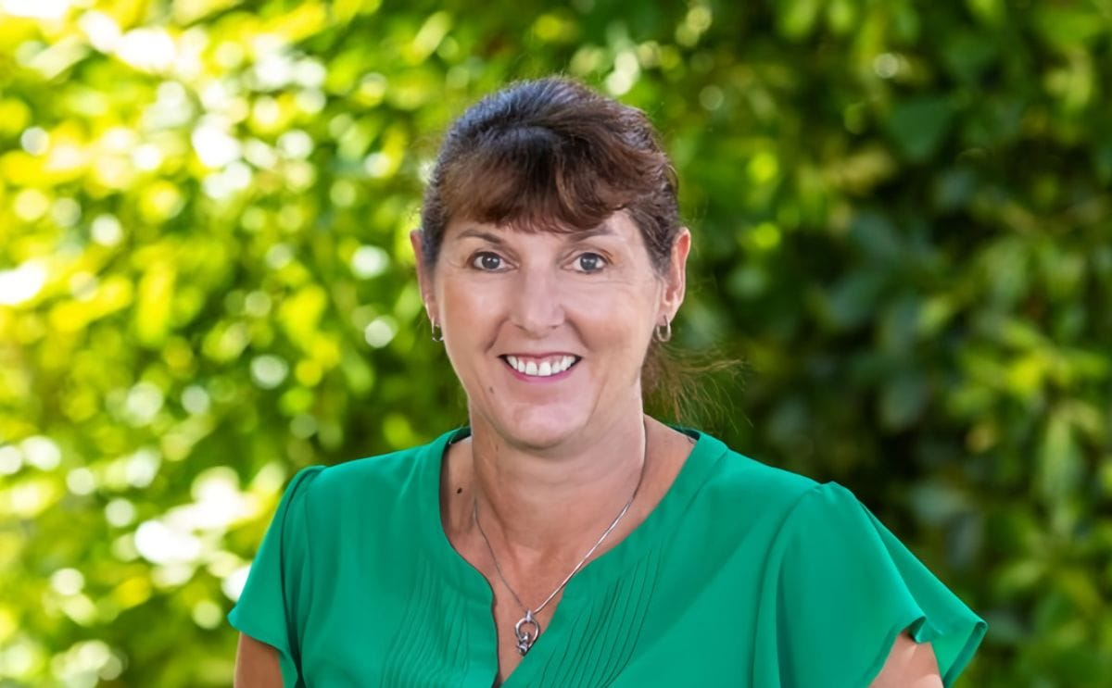
Kate Trufitt’s six-month journey at the helm of Potatoes NZ
New Zealand potato growers are focusing on turning higher yields into greater value as they navigate fluctuating markets, rising costs, and increasing climate pressures, according to Potatoes New Zealand Chief Executive Kate Trufitt. She said the global potato sector is facing a mix of challenges and opportunities linked to production volumes, shifting demand, climate variability, and evolving consumer and export trends.
Kate Trufitt, Chief Executive of Potatoes New Zealand: "New Zealand's sector is responding by prioritising value creation from high yields, alongside responsible environmental and market management."
Like other agricultural commodities, grower returns are strongly influenced by supply and demand. Record crops can place downward pressure on prices when demand and market access do not expand at the same pace. Processing contracts provide greater price stability, while open-market potatoes typically feel price pressure first.
Despite larger harvests, higher production costs continue to squeeze margins, meaning increased yield does not automatically translate into lower farm-gate prices.
Kate Trufitt: "Short-term volume growth can soften prices, but efficiency and market development protect returns in the medium term. Our focus is on turning additional volume into value through exports, processing, product innovation and new market opportunities."
Production structure remains stable
Fresh Facts data shows New Zealand produced 518,282 tonnes of potatoes last season, split across seed (4%), table (40%), and processed (56%). Variations are driven mainly by seasonal and market conditions rather than structural industry shifts.
The processing sector continues to support technology investment, while the table market underpins regional employment and domestic food security. High-quality seed remains critical for yield and disease management.
Weather and resilience challenges
Variable weather conditions, including waterlogging, disease pressure and delayed harvesting, are increasingly affecting yield and quality. Storm events and a poor summer season have also damaged infrastructure and reduced output in some regions, particularly in the South Island.
Kate Trufitt: "While potatoes are a resilient crop, they are increasingly exposed to the risks of extreme weather events, prompting ongoing risk-management efforts by growers and industry bodies."
Driving higher yields on less land
New Zealand growers achieve yields of 50–80 tonnes per hectare, supported by a temperate climate, fertile soils, strong agronomy and certified seed standards. Advances in genetics, precision farming, crop rotation and pest management continue to lift productivity while reducing land use.
Innovations such as hydroponic systems are also being explored globally, while urban expansion is increasing pressure on high-quality cropping land. The industry continues to advocate for the protection of prime soils and balanced spatial planning to safeguard future production. Overall, the sector’s strategy centres on improving efficiency, strengthening markets and converting volume gains into long-term value rather than relying solely on production growth.

Questions.
- Describe 3 challenges potato growers in New Zealand are currently facing.
- How are these challenges impacting potato growing businesses?
- For one challenge, explain what growers are doing to reduce its impact on their business?
- Growers are trying to turn “high yields into greater value.” What does this mean?
- Why can a large potato harvest sometimes lead to lower prices for farmers?
- What role do processing contracts play in helping farmers compared to selling on the open market?
Sample answers
- Describe 3 challenges potato growers in New Zealand are currently facing.
- Fluctuating markets and prices (prices go up and down depending on supply and demand).
- Rising production costs (fuel, fertiliser, labour, and machinery are becoming more expensive).
- Climate and weather variability (heavy rain, storms, and dry periods can damage crops and delay harvests).
- How are these challenges impacting potato growing businesses?
These challenges reduce growers’ profits and make farming riskier. Even if farmers grow more potatoes, they may not earn more money because costs are higher and prices can drop when there is a large harvest. Weather damage can also reduce crop quality and yield, meaning less product to sell.

- For one challenge, explain what growers are doing to reduce its impact on their business.
For market price changes, growers are using processing contracts (e.g., for chips and fries) to get more stable prices. This helps protect them from sudden price drops in the open market. Some growers are also focusing on exports, innovation, and improving efficiency to increase value rather than just production.

- Growers are trying to turn “high yields into greater value.” What does this mean?
It means that instead of just growing more potatoes, farmers want to make more money from what they grow. They are trying to improve profits by finding better markets, processing potatoes into products, or exporting them, rather than relying only on selling raw potatoes.

- Why can a large potato harvest sometimes lead to lower prices for farmers?
When there is a large harvest, there are more potatoes available than people or companies want to buy. This oversupply means buyers can pay less because potatoes are easier to get, so prices drop.

- What role do processing contracts play in helping farmers compared to selling on the open market?
Processing contracts give farmers a fixed or more stable price for their potatoes, which makes income more predictable. In contrast, the open market price changes depending on supply and demand, which can be risky because prices may drop suddenly.

