Potato growers eye innovation, growth
https://www.ruralnewsgroup.co.nz/hort-news/hort-opinion/potato-growers-eye-innovation-growth
Written by Kate Trufitt - Kate Trufitt is chief executive of Potatoes NZ.
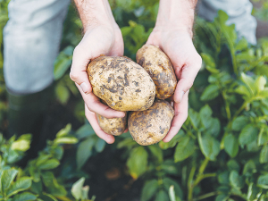

Potato growers are excited about the many opportunities that lie ahead.

OPINION: As we look back on the past year, I am proud to reflect on the remarkable progress and achievements that have defined our success.
Through teamwork, strategic initiatives, and focused leadership, we have reinforced our position within the industry and set the stage for even greater accomplishments in the year ahead.
2024 in Review
1. United voice and working together
This year, we made it a priority to amplify the voice of our growers; effective communication is the backbone of any successful organisation. We held several meetings with government representatives and minister to ensure that the perspectives of New Zealand potato growers were heard and understood. In addition, our presence at the World Potato Congress allowed us to forge valuable international relationships that will benefit New Zealand's potato industry for years to come.
2. Leadership in the field
Potatoes New Zealand's commitment to advancing the potato and vegetable industries was highlighted by the launch of the $4.7 million Sustainable Vegetable Systems (SVS) project, which was officially endorsed by Minister Nicola Grigg. We also shared our knowledge and expertise across New Zealand, attending Vegetable Research Roadshows and showcasing key Potatoes New Zealand projects. On the international front, we launched the International Partnership for Research and Development at the World Potato Congress, opening doors for global collaboration.
3. Working together
2024 was also defined by valuable collaborations across the industry. By partnering with other vegetable groups and key stakeholders, we were able to deliver stronger results for our members, leveraging shared resources and expertise to drive progress and address shared challenges.
Looking Ahead to 2025
As we look toward the coming year, we are excited about the many opportunities that lie ahead. Our focus will continue to be on growth, innovation, and building a strong, sustainable future for the New Zealand potato industry.
We have some exciting initiatives launching soon that align with our strategic goal of growing great people. Thank you for your ongoing support of the potato industry.

