EPA approves new potato disease chemical
April 8, 2026
https://www.farmersweekly.co.nz/news/epa-approves-new-potato-disease-chemical/
New tool for growers takes a step closer to reaching market in New Zealand.
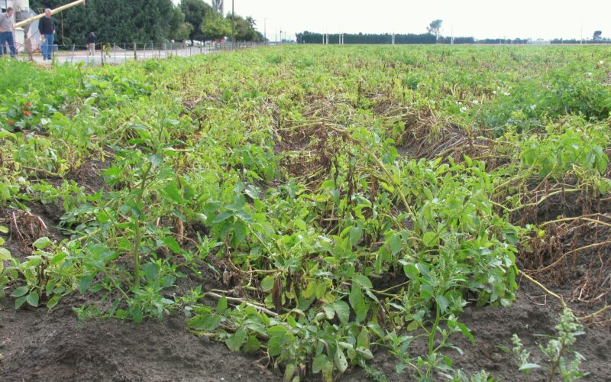Vibrance Premium can be applied to seed tubers before planting and will control black scurf, silver scurf, black dot, fusarium dry rot and gangrene and suppress common scab.

The Environmental Protection Authority (EPA) has approved a new fungicide seed treatment to control disease on potatoes.
Syngenta Crop Protection applied to introduce Vibrance Premium, a fungicide containing 40 g/L sedaxane and 50 g/L fludioxonil, to New Zealand.
Vibrance Premium can be applied to seed tubers before planting and will control black scurf, silver scurf, black dot, fusarium dry rot and gangrene, and suppress common scab.
Sedaxane is a new active ingredient to New Zealand.
Fludioxonil is approved for use in New Zealand in other products for the control of rhizoctonia and silver scurf.
Vibrance Premium is a new mixture of the two active ingredients.
Syngenta Crop Protection Limited said combining the two active ingredients into one formulation will effectively control a broader spectrum of soil-borne, seed-borne, and storage disease in potatoes.
The EPA said it carried out human health and environmental risk assessments for the fungicide, with risks low and manageable with controls.
Vibrance Premium has already been approved for use in Australia and Europe.
EPA chief executive Dr Allan Freeth said the new chemical was approved following rigorous evidence-based assessment.
The fungicide can only be handled by professional operators.
As the substance is intended for agricultural use, it will also need approval from the Ministry for Primary Industries before it can be used in New Zealand.
Pukekawa potato and onion grower Chris Nicholson told Farmers Weekly it takes a very long time to get new products onto the market and it is always a good thing when growers have new options.
He said if growers don’t abuse chemicals with overuse, leading to chemical resistance, then “we will have products for the rest of our lives”.

Questions
- Why is EPA approval important before a new fungicide such as Vibrance Premium can be used in New Zealand?
- How could the approval of Vibrance Premium benefit potato growers?
- Why is it important that new agricultural chemicals are tested and assessed before they are sold to farmers?
- Chris Nicholson said growers should avoid overusing chemicals. Why is this important, and what might happen if disease-causing organisms become resistant to fungicides?

Answers
- Why is EPA approval important before a new fungicide such as Vibrance Premium can be used in New Zealand?
EPA approval is important because it ensures that a new chemical has been carefully assessed for risks to human health and the environment before it is used. The EPA carries out scientific evaluations to determine whether the product can be used safely and whether any risks can be managed through regulations and controls. This helps protect farmers, consumers, wildlife, water sources, and the wider environment.

- How could the approval of Vibrance Premium benefit potato growers?
The approval of Vibrance Premium could benefit potato growers in several ways:
- It provides control of a wider range of potato diseases, including black scurf, silver scurf, black dot, fusarium dry rot, and gangrene.
- It helps suppress common scab, which can affect potato quality.
- Healthier seed potatoes can lead to stronger crop establishment and higher yields.
- Growers gain access to a new disease management tool, giving them more options when managing disease risks.
- Better disease control can improve the quality and marketability of potatoes.

- Why is it important that new agricultural chemicals are tested and assessed before they are sold to farmers? How does this help protect consumers who buy and eat potatoes?
Testing and assessment ensure that agricultural chemicals are effective and safe to use. Scientists evaluate whether the product could harm people, animals, plants, or the environment. They also determine how the chemical should be applied safely.
This protects consumers because it helps ensure that potatoes entering the food supply are produced using products that meet strict safety standards. Careful testing reduces the risk of harmful chemical residues on food and helps maintain public confidence in New Zealand's food production systems.

- Chris Nicholson said growers should avoid overusing chemicals. Why is this important, and what might happen if disease-causing organisms become resistant to fungicides?
Overusing chemicals can lead to fungicide resistance. This occurs when fungi or other disease-causing organisms adapt and are no longer controlled by the chemical.
If resistance develops:
- Fungicides become less effective or stop working altogether.
- Growers may experience greater crop losses from disease.
- More expensive or alternative treatments may be required.
- Potato yields and quality may decrease.
- Consumers could face higher food prices due to increased production costs.
- Using chemicals responsibly helps ensure they remain effective for many years and supports sustainable crop production.

